  Year 4 · Multiplication and division A · Step 8  7 times-table and division facts | 
  Year 4 · Multiplication and division A · Step 8
  7 times-table and division facts
  1 | Complete the number sentences to describe the array.  
     | × |  | =
     | × |  | =
     | ÷ |  | =
     | ÷ |  | =
  1 | Complete the number sentences to describe the array.
     | × |  | =
     | × |  | =
     | ÷ |  | =
     | ÷ |  | =
  2 | Complete the number track. It counts up in 7s.  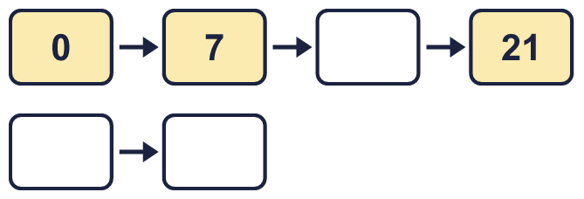
  2 | Complete the number track. It counts up in 7s.
  3 | Work out the multiplications.  a) 6 × 7 =  b) 7 × 10 =  c) 5 × 7 =
  3 | Work out the multiplications.  a) 6 × 7 =  b) 7 × 10 =  c) 5 × 7 =
  4 | Work out the divisions.  a) 28 ÷ 7 =  b) 14 ÷ 7 =  c) 42 ÷ 7 =
  4 | Work out the divisions.  a) 28 ÷ 7 =  b) 14 ÷ 7 =  c) 42 ÷ 7 =
  5 | Write the missing number in each calculation.
    a) |  | ÷ 7 | = | 2
    b) | 84 ÷ 7 | =
    c) | 7 × |  | = | 77
  5 | Write the missing number in each calculation.
    a) |  | ÷ 7 | = | 2
    b) | 84 ÷ 7 | =
    c) | 7 × |  | = | 77
  6 | Circle the multiples of 7. Write them below.  35 91 27 49 41 24
  6 | Circle the multiples of 7. Write them below.  35 91 27 49 41 24
  7 | Work out the calculations.  a) 3 × 7 =  b) 63 ÷ 7 =  c) 70 ÷ 10 =
  7 | Work out the calculations.  a) 3 × 7 =  b) 63 ÷ 7 =  c) 70 ÷ 10 =
  8 | Complete the number track. It counts down in 7s.  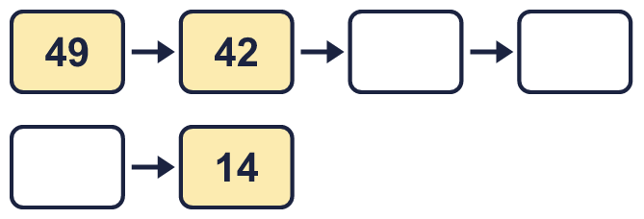
  8 | Complete the number track. It counts down in 7s.

  9 | Write true or false for each statement.
    a) | 8 × 7 = 7 × 7 + 7
    b) | 8 × 7 = 7 × 7 + 8
    c) | 8 × 7 = 7 × 8
    d) | 8 × 7 = 8 × 8 - 7
  9 | Write true or false for each statement.
    a) | 8 × 7 = 7 × 7 + 7
    b) | 8 × 7 = 7 × 7 + 8
    c) | 8 × 7 = 7 × 8
    d) | 8 × 7 = 8 × 8 - 7
  10 | Is Boba correct? Circle yes or no.  Yes / No  What is the correct answer?  Explain Boba’s mistake.
    
  10 | Is Boba correct? Circle yes or no.  Yes / No  What is the correct answer?  Explain Boba’s mistake.
  11 | Sort the numbers into the table. Write none if a box is empty. 37 98 17 63 28 84 57 41
    Multiples of 7 and even:
    Multiples of 7 and odd:
    Not multiples of 7 and even:
    Not multiples of 7 and odd:
  11 | Sort the numbers into the table. Write none if a box is empty. 37 98 17 63 28 84 57 41
    Multiples of 7 and even:
    Multiples of 7 and odd:
    Not multiples of 7 and even:
    Not multiples of 7 and odd:
  12 | a) Use these facts to work out 7 × 25.  b) Now work out 175 ÷ 7.
     | 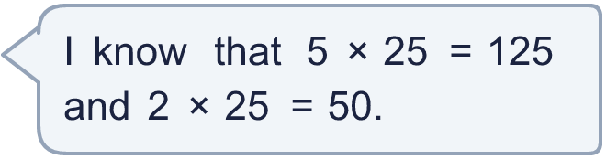
  12 | a) Use these facts to work out 7 × 25.  b) Now work out 175 ÷ 7.
  13 | There are 7 players in a team. 3 teams have signed up for a tournament.  a) How many players have signed up?  b) The tournament needs 49 players. How many more teams are needed?
  13 | There are 7 players in a team. 3 teams have signed up for a tournament.  a) How many players have signed up?  b) The tournament needs 49 players. How many more teams are needed?
  14 | Write three different multiples of 7 that are between 30 and 60.
  14 | Write three different multiples of 7 that are between 30 and 60.

Year 4 · Multiplication and division A · Step 8
7 times-table and division facts
Answers (teacher copy)

  1 | Complete the number sentences to describe the array.  4 × 7 = 28  7 × 4 = 28  28 ÷ 7 = 4  28 ÷ 4 = 7
  2 | Complete the number track. It counts up in 7s.  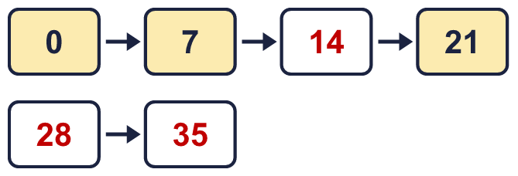
  3 | Work out the multiplications.  a) 6 × 7 = 42  b) 7 × 10 = 70  c) 5 × 7 = 35
  4 | Work out the divisions.  a) 28 ÷ 7 = 4  b) 14 ÷ 7 = 2  c) 42 ÷ 7 = 6
  5 | Write the missing number in each calculation.  a) 14 ÷ 7 = 2  b) 84 ÷ 7 = 12  c) 7 × 11 = 77
  6 | Circle the multiples of 7. Write them below.  35 91 27 49 41 24  35, 49, 91
  7 | Work out the calculations.  a) 3 × 7 = 21  b) 63 ÷ 7 = 9  c) 70 ÷ 10 = 7
  8 | Complete the number track. It counts down in 7s.  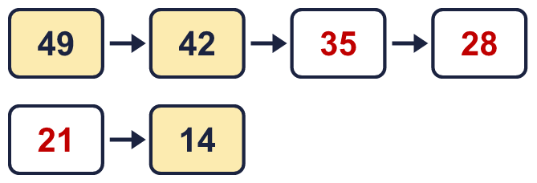
  9 | Write true or false for each statement.  a) 8 × 7 = 7 × 7 + 7 True  b) 8 × 7 = 7 × 7 + 8 False  c) 8 × 7 = 7 × 8 True  d) 8 × 7 = 8 × 8 - 7 False
  10 | Is Boba correct? Circle yes or no.  Yes / No  What is the correct answer? 28  Explain Boba’s mistake.  4 × 7 = 28. Boba’s answer is not 4 groups of 7: 4 groups of 7 make 28.
  11 | Sort the numbers into the table. Write none if a box is empty. 37 98 17 63 28 84 57 41  Multiples of 7 and even: 28, 84, 98  Multiples of 7 and odd: 63  Not multiples of 7 and even: none  Not multiples of 7 and odd: 17, 37, 41, 57
  12 | a) Use these facts to work out 7 × 25. 175  b) Now work out 175 ÷ 7. 25
  13 | There are 7 players in a team. 3 teams have signed up for a tournament.  a) How many players have signed up? 21  b) The tournament needs 49 players. How many more teams are needed? 4
  14 | Write three different multiples of 7 that are between 30 and 60.  for example 35, 42, 49

