  Year 4 · Multiplication and division A · Step 3  6 times-table and division facts | 
  Year 4 · Multiplication and division A · Step 3
  6 times-table and division facts
  1 | Complete the number sentences to describe the array.  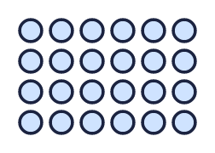
     | × |  | =
     | × |  | =
     | ÷ |  | =
     | ÷ |  | =
  1 | Complete the number sentences to describe the array.
     | × |  | =
     | × |  | =
     | ÷ |  | =
     | ÷ |  | =
  2 | Complete the number track. It counts up in 6s.  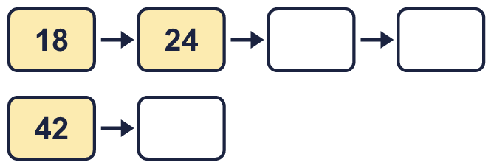
  2 | Complete the number track. It counts up in 6s.
  3 | Work out the multiplications.  a) 11 × 6 =  b) 6 × 6 =  c) 5 × 6 =
  3 | Work out the multiplications.  a) 11 × 6 =  b) 6 × 6 =  c) 5 × 6 =
  4 | Work out the divisions.  a) 24 ÷ 6 =  b) 18 ÷ 6 =  c) 72 ÷ 6 =
  4 | Work out the divisions.  a) 24 ÷ 6 =  b) 18 ÷ 6 =  c) 72 ÷ 6 =
  5 | Write the missing number in each calculation.
    a) | 6 × |  | = | 18
    b) | 60 ÷ 6 | =
    c) |  | × 6 | = | 72
  5 | Write the missing number in each calculation.
    a) | 6 × |  | = | 18
    b) | 60 ÷ 6 | =
    c) |  | × 6 | = | 72
  6 | Circle the multiples of 6. Write them below.  10 24 66 69 52 48
  6 | Circle the multiples of 6. Write them below.  10 24 66 69 52 48
  7 | Work out the calculations.  a) 24 ÷ 4 =  b) 6 × 6 =  c) 9 × 6 =
  7 | Work out the calculations.  a) 24 ÷ 4 =  b) 6 × 6 =  c) 9 × 6 =
  8 | Complete the number track. It counts down in 6s.  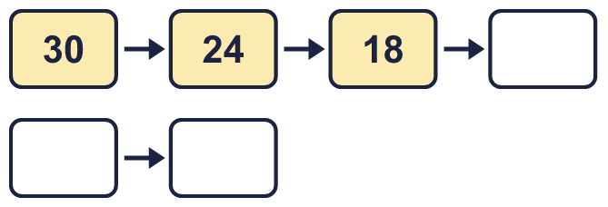
  8 | Complete the number track. It counts down in 6s.

  9 | Write true or false for each statement.
    a) | 5 × 6 = 5 × 7 - 6
    b) | 5 × 6 = 6 × 6 + 6
    c) | 10 × 6 = 5 × 12
    d) | 5 × 6 = 6 × 6 - 6
  9 | Write true or false for each statement.
    a) | 5 × 6 = 5 × 7 - 6
    b) | 5 × 6 = 6 × 6 + 6
    c) | 10 × 6 = 5 × 12
    d) | 5 × 6 = 6 × 6 - 6
  10 | Is Boba correct? Circle yes or no.  Yes / No  What is the correct answer?  Explain Boba’s mistake.
    
  10 | Is Boba correct? Circle yes or no.  Yes / No  What is the correct answer?  Explain Boba’s mistake.
  11 | Sort the numbers into the table. Write none if a box is empty. 87 18 53 60 25 54 75 96
    Multiples of 6 and even:
    Multiples of 6 and odd:
    Not multiples of 6 and even:
    Not multiples of 6 and odd:
  11 | Sort the numbers into the table. Write none if a box is empty. 87 18 53 60 25 54 75 96
    Multiples of 6 and even:
    Multiples of 6 and odd:
    Not multiples of 6 and even:
    Not multiples of 6 and odd:
  12 | a) Use this fact to work out 6 × 16.  b) Now work out 96 ÷ 6.
     | 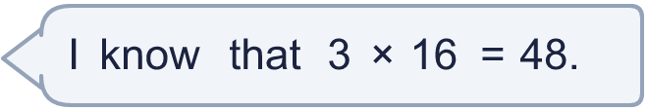
  12 | a) Use this fact to work out 6 × 16.  b) Now work out 96 ÷ 6.
  13 | There are 6 players in a team. 6 teams have signed up for a tournament.  a) How many players have signed up?  b) The tournament needs 66 players. How many more teams are needed?
  13 | There are 6 players in a team. 6 teams have signed up for a tournament.  a) How many players have signed up?  b) The tournament needs 66 players. How many more teams are needed?
  14 | Write three different multiples of 6 that are between 20 and 50.
  14 | Write three different multiples of 6 that are between 20 and 50.

Year 4 · Multiplication and division A · Step 3
6 times-table and division facts
Answers (teacher copy)

  1 | Complete the number sentences to describe the array.  4 × 6 = 24  6 × 4 = 24  24 ÷ 6 = 4  24 ÷ 4 = 6
  2 | Complete the number track. It counts up in 6s.  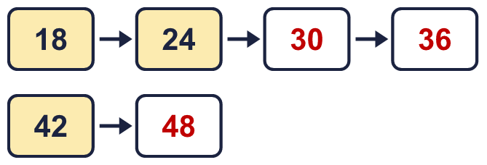
  3 | Work out the multiplications.  a) 11 × 6 = 66  b) 6 × 6 = 36  c) 5 × 6 = 30
  4 | Work out the divisions.  a) 24 ÷ 6 = 4  b) 18 ÷ 6 = 3  c) 72 ÷ 6 = 12
  5 | Write the missing number in each calculation.  a) 6 × 3 = 18  b) 60 ÷ 6 = 10  c) 12 × 6 = 72
  6 | Circle the multiples of 6. Write them below.  10 24 66 69 52 48  24, 48, 66
  7 | Work out the calculations.  a) 24 ÷ 4 = 6  b) 6 × 6 = 36  c) 9 × 6 = 54
  8 | Complete the number track. It counts down in 6s.  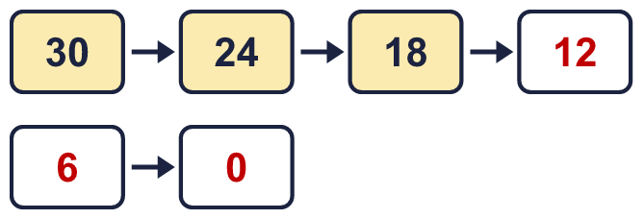
  9 | Write true or false for each statement.  a) 5 × 6 = 5 × 7 - 6 False  b) 5 × 6 = 6 × 6 + 6 False  c) 10 × 6 = 5 × 12 True  d) 5 × 6 = 6 × 6 - 6 True
  10 | Is Boba correct? Circle yes or no.  Yes / No  What is the correct answer? 36  Explain Boba’s mistake.  6 × 6 = 36. Boba’s answer is not 6 groups of 6: 6 groups of 6 make 36.
  11 | Sort the numbers into the table. Write none if a box is empty. 87 18 53 60 25 54 75 96  Multiples of 6 and even: 18, 54, 60, 96  Multiples of 6 and odd: none  Not multiples of 6 and even: none  Not multiples of 6 and odd: 25, 53, 75, 87
  12 | a) Use this fact to work out 6 × 16. 96  b) Now work out 96 ÷ 6. 16
  13 | There are 6 players in a team. 6 teams have signed up for a tournament.  a) How many players have signed up? 36  b) The tournament needs 66 players. How many more teams are needed? 5
  14 | Write three different multiples of 6 that are between 20 and 50.  for example 24, 30, 36

