  Year 4 · Multiplication and division A · Step 10  12 times-table and division facts | 
  Year 4 · Multiplication and division A · Step 10
  12 times-table and division facts
  1 | Complete the number sentences to describe the array.  
     | × |  | =
     | × |  | =
     | ÷ |  | =
     | ÷ |  | =
  1 | Complete the number sentences to describe the array.
     | × |  | =
     | × |  | =
     | ÷ |  | =
     | ÷ |  | =
  2 | Complete the number track. It counts up in 12s.  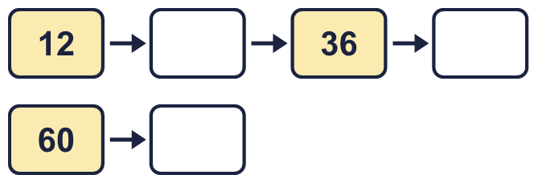
  2 | Complete the number track. It counts up in 12s.
  3 | Work out the multiplications.  a) 9 × 12 =  b) 12 × 7 =  c) 5 × 12 =
  3 | Work out the multiplications.  a) 9 × 12 =  b) 12 × 7 =  c) 5 × 12 =
  4 | Work out the divisions.  a) 132 ÷ 12 =  b) 108 ÷ 12 =  c) 72 ÷ 12 =
  4 | Work out the divisions.  a) 132 ÷ 12 =  b) 108 ÷ 12 =  c) 72 ÷ 12 =
  5 | Write the missing number in each calculation.
    a) | 72 ÷ 12 | =
    b) |  | × 12 | = | 120
    c) |  | ÷ 12 | = | 4
  5 | Write the missing number in each calculation.
    a) | 72 ÷ 12 | =
    b) |  | × 12 | = | 120
    c) |  | ÷ 12 | = | 4
  6 | Circle the multiples of 12. Write them below.  34 48 87 92 96 12
  6 | Circle the multiples of 12. Write them below.  34 48 87 92 96 12
  7 | Work out the calculations.  a) 6 × 12 =  b) 144 ÷ 12 =  c) 132 ÷ 11 =
  7 | Work out the calculations.  a) 6 × 12 =  b) 144 ÷ 12 =  c) 132 ÷ 11 =
  8 | Complete the number track. It counts down in 12s.  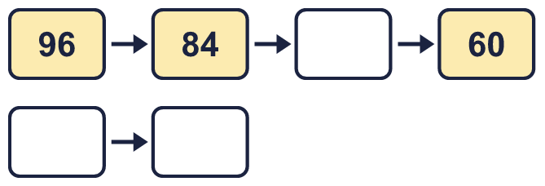
  8 | Complete the number track. It counts down in 12s.

  9 | Write true or false for each statement.
    a) | 5 × 12 = 12 × 5
    b) | 5 × 12 = 4 × 12 + 12
    c) | 5 × 12 = 6 × 12 + 12
    d) | 5 × 12 = 4 × 12 + 5
  9 | Write true or false for each statement.
    a) | 5 × 12 = 12 × 5
    b) | 5 × 12 = 4 × 12 + 12
    c) | 5 × 12 = 6 × 12 + 12
    d) | 5 × 12 = 4 × 12 + 5
  10 | Is Boba correct? Circle yes or no.  Yes / No  What is the correct answer?  Explain Boba’s mistake.
    
  10 | Is Boba correct? Circle yes or no.  Yes / No  What is the correct answer?  Explain Boba’s mistake.
  11 | Sort the numbers into the table. Write none if a box is empty. 27 72 48 97 62 24 20 60
    Multiples of 12 and even:
    Multiples of 12 and odd:
    Not multiples of 12 and even:
    Not multiples of 12 and odd:
  11 | Sort the numbers into the table. Write none if a box is empty. 27 72 48 97 62 24 20 60
    Multiples of 12 and even:
    Multiples of 12 and odd:
    Not multiples of 12 and even:
    Not multiples of 12 and odd:
  12 | a) Use these facts to work out 12 × 27.  b) Now work out 324 ÷ 12.
     | 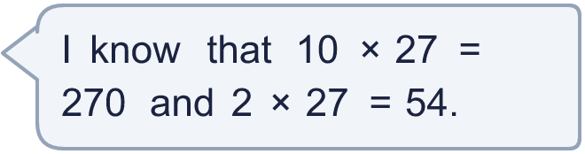
  12 | a) Use these facts to work out 12 × 27.  b) Now work out 324 ÷ 12.
  13 | There are 12 players in a team. 3 teams have signed up for a tournament.  a) How many players have signed up?  b) The tournament needs 60 players. How many more teams are needed?
  13 | There are 12 players in a team. 3 teams have signed up for a tournament.  a) How many players have signed up?  b) The tournament needs 60 players. How many more teams are needed?
  14 | Write three different multiples of 12 that are between 20 and 70.
  14 | Write three different multiples of 12 that are between 20 and 70.

Year 4 · Multiplication and division A · Step 10
12 times-table and division facts
Answers (teacher copy)

  1 | Complete the number sentences to describe the array.  2 × 12 = 24  12 × 2 = 24  24 ÷ 12 = 2  24 ÷ 2 = 12
  2 | Complete the number track. It counts up in 12s.  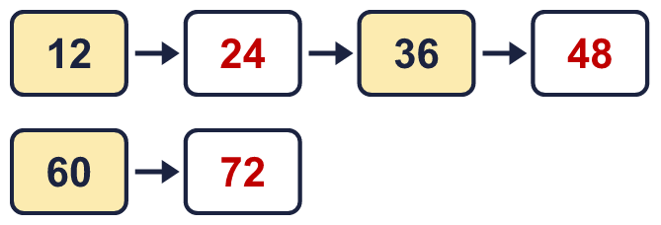
  3 | Work out the multiplications.  a) 9 × 12 = 108  b) 12 × 7 = 84  c) 5 × 12 = 60
  4 | Work out the divisions.  a) 132 ÷ 12 = 11  b) 108 ÷ 12 = 9  c) 72 ÷ 12 = 6
  5 | Write the missing number in each calculation.  a) 72 ÷ 12 = 6  b) 10 × 12 = 120  c) 48 ÷ 12 = 4
  6 | Circle the multiples of 12. Write them below.  34 48 87 92 96 12  12, 48, 96
  7 | Work out the calculations.  a) 6 × 12 = 72  b) 144 ÷ 12 = 12  c) 132 ÷ 11 = 12
  8 | Complete the number track. It counts down in 12s.  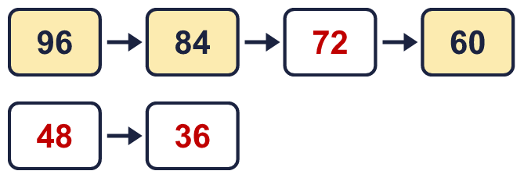
  9 | Write true or false for each statement.  a) 5 × 12 = 12 × 5 True  b) 5 × 12 = 4 × 12 + 12 True  c) 5 × 12 = 6 × 12 + 12 False  d) 5 × 12 = 4 × 12 + 5 False
  10 | Is Boba correct? Circle yes or no.  Yes / No  What is the correct answer? 108  Explain Boba’s mistake.  9 × 12 = 108. Boba’s answer is not 9 groups of 12: 9 groups of 12 make 108.
  11 | Sort the numbers into the table. Write none if a box is empty. 27 72 48 97 62 24 20 60  Multiples of 12 and even: 24, 48, 60, 72  Multiples of 12 and odd: none  Not multiples of 12 and even: 20, 62  Not multiples of 12 and odd: 27, 97
  12 | a) Use these facts to work out 12 × 27. 324  b) Now work out 324 ÷ 12. 27
  13 | There are 12 players in a team. 3 teams have signed up for a tournament.  a) How many players have signed up? 36  b) The tournament needs 60 players. How many more teams are needed? 2
  14 | Write three different multiples of 12 that are between 20 and 70.  for example 24, 36, 48

