  Year 4 · Multiplication and division A · Step 9  11 times-table and division facts | 
  Year 4 · Multiplication and division A · Step 9
  11 times-table and division facts
  1 | Complete the number sentences to describe the array.  
     | × |  | =
     | × |  | =
     | ÷ |  | =
     | ÷ |  | =
  1 | Complete the number sentences to describe the array.
     | × |  | =
     | × |  | =
     | ÷ |  | =
     | ÷ |  | =
  2 | Complete the number track. It counts up in 11s.  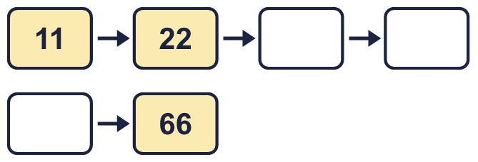
  2 | Complete the number track. It counts up in 11s.
  3 | Work out the multiplications.  a) 9 × 11 =  b) 11 × 3 =  c) 8 × 11 =
  3 | Work out the multiplications.  a) 9 × 11 =  b) 11 × 3 =  c) 8 × 11 =
  4 | Work out the divisions.  a) 132 ÷ 11 =  b) 121 ÷ 11 =  c) 55 ÷ 11 =
  4 | Work out the divisions.  a) 132 ÷ 11 =  b) 121 ÷ 11 =  c) 55 ÷ 11 =
  5 | Write the missing number in each calculation.
    a) | 55 ÷ 11 | =
    b) |  | ÷ 11 | = | 11
    c) | 11 × |  | = | 132
  5 | Write the missing number in each calculation.
    a) | 55 ÷ 11 | =
    b) |  | ÷ 11 | = | 11
    c) | 11 × |  | = | 132
  6 | Circle the multiples of 11. Write them below.  99 76 36 26 88 44
  6 | Circle the multiples of 11. Write them below.  99 76 36 26 88 44
  7 | Work out the calculations.  a) 121 ÷ 11 =  b) 66 ÷ 6 =  c) 3 × 11 =
  7 | Work out the calculations.  a) 121 ÷ 11 =  b) 66 ÷ 6 =  c) 3 × 11 =
  8 | Complete the number track. It counts down in 11s.  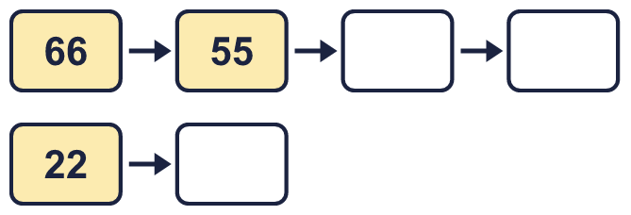
  8 | Complete the number track. It counts down in 11s.

  9 | Write true or false for each statement.
    a) | 9 × 11 = 11 × 10
    b) | 9 × 11 = 8 × 11 + 9
    c) | 9 × 11 = 10 × 11 - 11
    d) | 18 × 11 = 9 × 22
  9 | Write true or false for each statement.
    a) | 9 × 11 = 11 × 10
    b) | 9 × 11 = 8 × 11 + 9
    c) | 9 × 11 = 10 × 11 - 11
    d) | 18 × 11 = 9 × 22
  10 | Is Boba correct? Circle yes or no.  Yes / No  What is the correct answer?  Explain Boba’s mistake.
    
  10 | Is Boba correct? Circle yes or no.  Yes / No  What is the correct answer?  Explain Boba’s mistake.
  11 | Sort the numbers into the table. Write none if a box is empty. 67 61 23 33 88 11 99 17
    Multiples of 11 and even:
    Multiples of 11 and odd:
    Not multiples of 11 and even:
    Not multiples of 11 and odd:
  11 | Sort the numbers into the table. Write none if a box is empty. 67 61 23 33 88 11 99 17
    Multiples of 11 and even:
    Multiples of 11 and odd:
    Not multiples of 11 and even:
    Not multiples of 11 and odd:
  12 | a) Use this fact to work out 11 × 29.  b) Now work out 319 ÷ 11.
     | 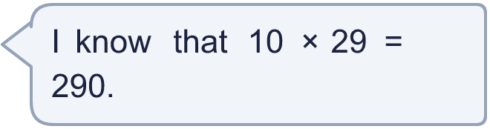
  12 | a) Use this fact to work out 11 × 29.  b) Now work out 319 ÷ 11.
  13 | There are 11 players in a team. 4 teams have signed up for a tournament.  a) How many players have signed up?  b) The tournament needs 88 players. How many more teams are needed?
  13 | There are 11 players in a team. 4 teams have signed up for a tournament.  a) How many players have signed up?  b) The tournament needs 88 players. How many more teams are needed?
  14 | Write three different multiples of 11 that are between 30 and 70.
  14 | Write three different multiples of 11 that are between 30 and 70.

Year 4 · Multiplication and division A · Step 9
11 times-table and division facts
Answers (teacher copy)

  1 | Complete the number sentences to describe the array.  2 × 11 = 22  11 × 2 = 22  22 ÷ 11 = 2  22 ÷ 2 = 11
  2 | Complete the number track. It counts up in 11s.  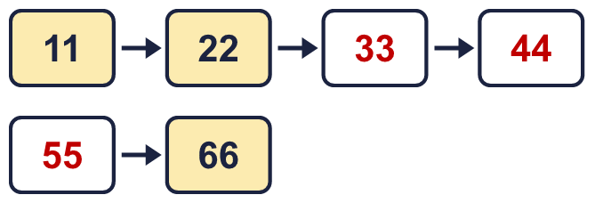
  3 | Work out the multiplications.  a) 9 × 11 = 99  b) 11 × 3 = 33  c) 8 × 11 = 88
  4 | Work out the divisions.  a) 132 ÷ 11 = 12  b) 121 ÷ 11 = 11  c) 55 ÷ 11 = 5
  5 | Write the missing number in each calculation.  a) 55 ÷ 11 = 5  b) 121 ÷ 11 = 11  c) 11 × 12 = 132
  6 | Circle the multiples of 11. Write them below.  99 76 36 26 88 44  44, 88, 99
  7 | Work out the calculations.  a) 121 ÷ 11 = 11  b) 66 ÷ 6 = 11  c) 3 × 11 = 33
  8 | Complete the number track. It counts down in 11s.  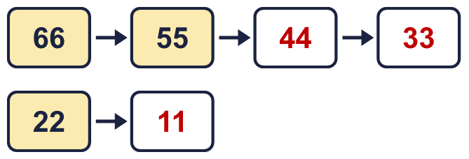
  9 | Write true or false for each statement.  a) 9 × 11 = 11 × 10 False  b) 9 × 11 = 8 × 11 + 9 False  c) 9 × 11 = 10 × 11 - 11 True  d) 18 × 11 = 9 × 22 True
  10 | Is Boba correct? Circle yes or no.  Yes / No  What is the correct answer? 66  Explain Boba’s mistake.  6 × 11 = 66. Boba’s answer is not 6 groups of 11: 6 groups of 11 make 66.
  11 | Sort the numbers into the table. Write none if a box is empty. 67 61 23 33 88 11 99 17  Multiples of 11 and even: 88  Multiples of 11 and odd: 11, 33, 99  Not multiples of 11 and even: none  Not multiples of 11 and odd: 17, 23, 61, 67
  12 | a) Use this fact to work out 11 × 29. 319  b) Now work out 319 ÷ 11. 29
  13 | There are 11 players in a team. 4 teams have signed up for a tournament.  a) How many players have signed up? 44  b) The tournament needs 88 players. How many more teams are needed? 4
  14 | Write three different multiples of 11 that are between 30 and 70.  for example 33, 44, 55

