  Year 4 · Area · Step 1  What is area | 
  Year 4 · Area · Step 1
  What is area
  1 | Use the diagram to complete the sentences.  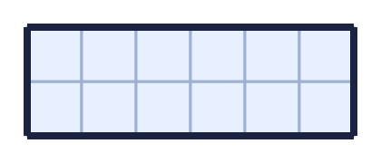
    Each row has |  | squares.
    There are |  | rows.
    There are |  | squares altogether.
    The area is |  | squares
  1 | Use the diagram to complete the sentences.
    Each row has |  | squares.
    There are |  | rows.
    There are |  | squares altogether.
    The area is |  | squares
  2 | Count the squares to find the area of the rectangle.  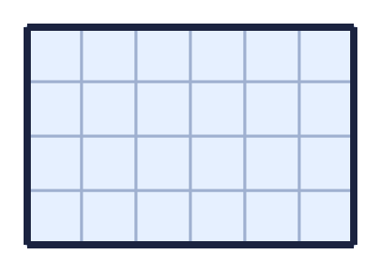
    The area is |  | squares
  2 | Count the squares to find the area of the rectangle.
    The area is |  | squares
  3 | Count the squares to work out the area of each shape.  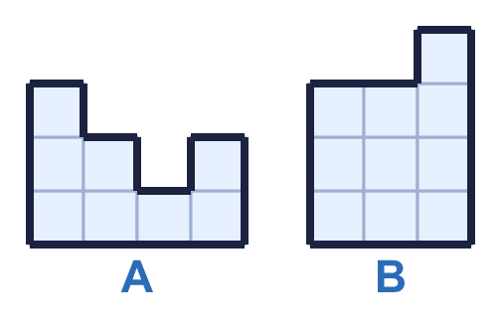
    a) Shape A: |  | squares
    b) Shape B: |  | squares
  3 | Count the squares to work out the area of each shape.
    a) Shape A: |  | squares
    b) Shape B: |  | squares
  4 | Which shape has the greatest area? Write its letter.  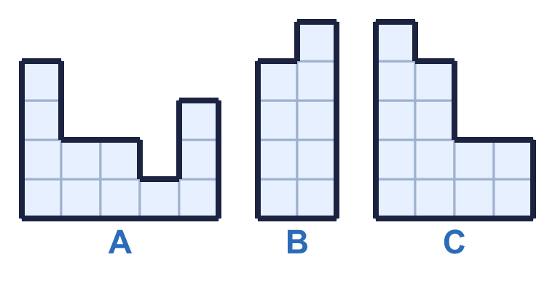
    Answer:
  4 | Which shape has the greatest area? Write its letter.
    Answer:
  5 | Which shapes have an area of 12 squares? Write the letters.  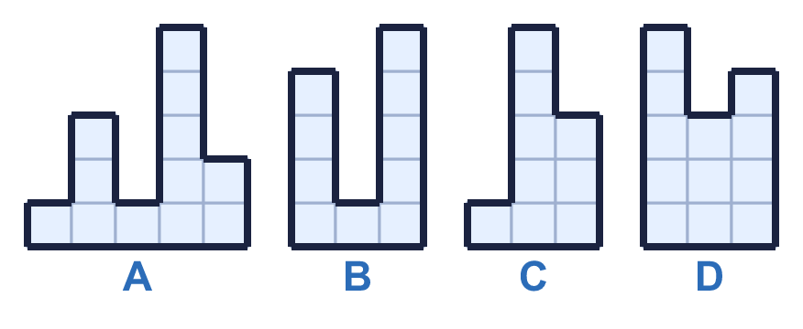
  5 | Which shapes have an area of 12 squares? Write the letters.
  6 | Use the diagram to complete the sentences.  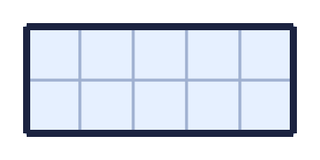
    Each row has |  | squares.
    There are |  | rows.
    There are |  | squares altogether.
    The area is |  | squares
  6 | Use the diagram to complete the sentences.
    Each row has |  | squares.
    There are |  | rows.
    There are |  | squares altogether.
    The area is |  | squares
  7 | Count the squares to work out the area of each shape.  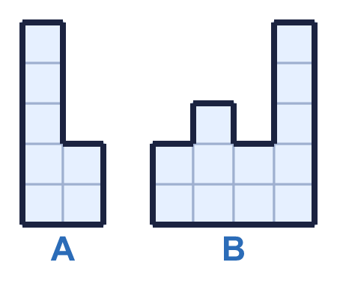
    a) Shape A: |  | squares
    b) Shape B: |  | squares
  7 | Count the squares to work out the area of each shape.
    a) Shape A: |  | squares
    b) Shape B: |  | squares
  8 | Which shape has the greatest area? Write its letter.  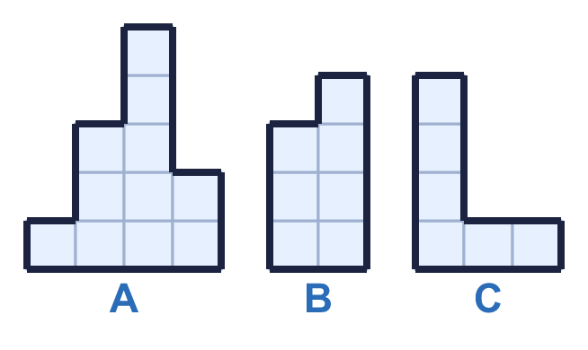
    Answer:
  8 | Which shape has the greatest area? Write its letter.
    Answer:

  9 | 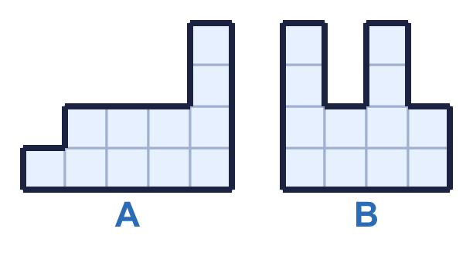  Do you agree with Boba? Circle yes or no.  Yes / No  Explain how you know.
     | 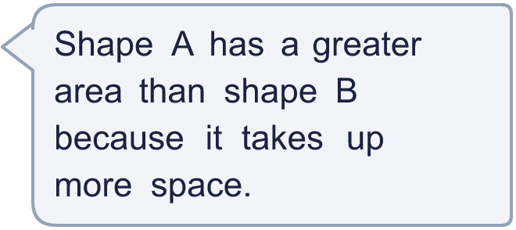
  9 | Do you agree with Boba? Circle yes or no.  Yes / No  Explain how you know.
  10 | Work out the area of each shape. Then work out the total area of both shapes.  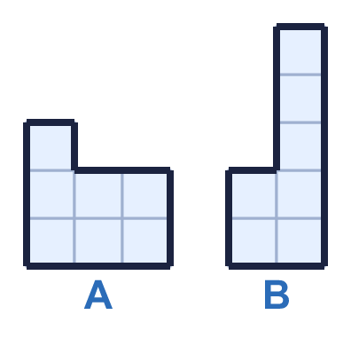
    Area of A: |  | squares
    Area of B: |  | squares
    Total area: |  | squares
  10 | Work out the area of each shape. Then work out the total area of both shapes.
    Area of A: |  | squares
    Area of B: |  | squares
    Total area: |  | squares
  11 | 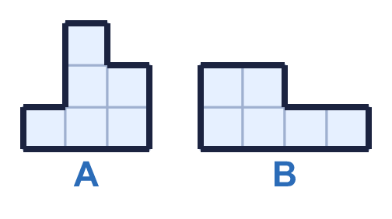  Do you agree with Boba? Circle yes or no.  Yes / No  Explain how you know.
  11 | Do you agree with Boba? Circle yes or no.  Yes / No  Explain how you know.
  12 | Put the shapes in order of area. Start with the shape with the smallest area.  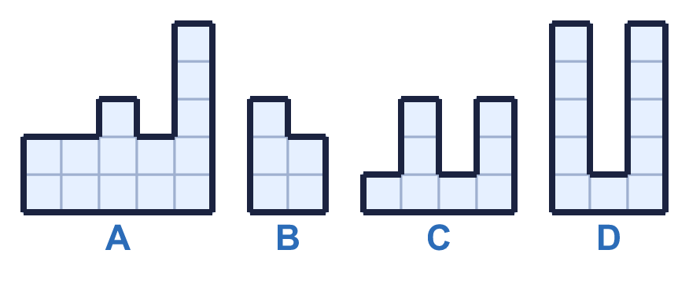
  12 | Put the shapes in order of area. Start with the shape with the smallest area.
  13 | Rectangles have sides that are whole numbers of squares. A 2 by 6 rectangle is the same as a 6 by 2 rectangle.  How many different rectangles have an area of 12 squares?
    rectangles
  13 | Rectangles have sides that are whole numbers of squares. A 2 by 6 rectangle is the same as a 6 by 2 rectangle.  How many different rectangles have an area of 12 squares?
    rectangles
  14 | Work out the area of each shape. What is the difference between the areas?  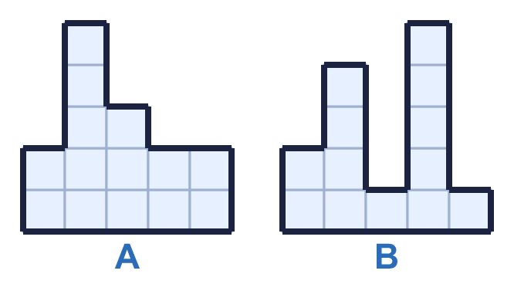
    Area of A: |  | squares
    Area of B: |  | squares
    Difference: |  | squares
  14 | Work out the area of each shape. What is the difference between the areas?
    Area of A: |  | squares
    Area of B: |  | squares
    Difference: |  | squares

Year 4 · Area · Step 1
What is area
Answers (teacher copy)

  1 | Use the diagram to complete the sentences.  Each row has 6 squares.  There are 2 rows.  There are 12 squares altogether.  The area is 12 squares
  2 | Count the squares to find the area of the rectangle.  The area is 24 squares
  3 | Count the squares to work out the area of each shape.  a) Shape A: 8 squares  b) Shape B: 10 squares
  4 | Which shape has the greatest area? Write its letter.  Answer: C
  5 | Which shapes have an area of 12 squares? Write the letters.  A, D
  6 | Use the diagram to complete the sentences.  Each row has 5 squares.  There are 2 rows.  There are 10 squares altogether.  The area is 10 squares
  7 | Count the squares to work out the area of each shape.  a) Shape A: 7 squares  b) Shape B: 12 squares
  8 | Which shape has the greatest area? Write its letter.  Answer: A
  9 | Do you agree with Boba? Circle yes or no.  Yes / No  Explain how you know.  Shape A has an area of 11 squares and shape B has an area of 12 squares.
  10 | Work out the area of each shape. Then work out the total area of both shapes.  Area of A: 7 squares  Area of B: 7 squares  Total area: 14 squares
  11 | Do you agree with Boba? Circle yes or no.  Yes / No  Explain how you know.  Shape A has an area of 6 squares and shape B has an area of 6 squares. The areas are the same.
  12 | Put the shapes in order of area. Start with the shape with the smallest area.  B, C, D, A
  13 | Rectangles have sides that are whole numbers of squares. A 2 by 6 rectangle is the same as a 6 by 2 rectangle.  How many different rectangles have an area of 12 squares?  3 rectangles
  14 | Work out the area of each shape. What is the difference between the areas?  Area of A: 14 squares  Area of B: 13 squares  Difference: 1 squares

