  Year 4 · Area · Step 3  Make shapes | 
  Year 4 · Area · Step 3
  Make shapes
  1 | Draw a shape with an area of 8 squares on squared paper.  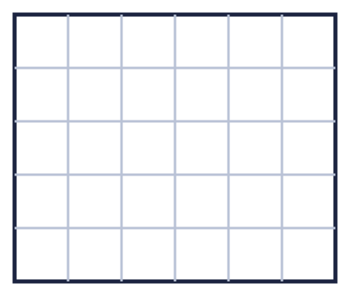
  1 | Draw a shape with an area of 8 squares on squared paper.
  2 | This shape has an area of 8 squares. Draw the shape again and add squares to make an area of 11 squares.  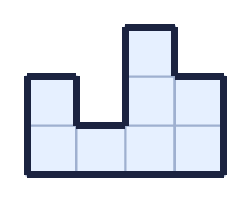
  2 | This shape has an area of 8 squares. Draw the shape again and add squares to make an area of 11 squares.
  3 | Draw a shape with an area of 13 squares on squared paper.
  3 | Draw a shape with an area of 13 squares on squared paper.
  4 | Add squares to this shape to make it into a square.  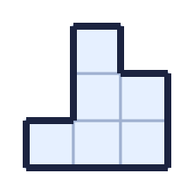
    What is the area of the square you make?
    squares
  4 | Add squares to this shape to make it into a square.
    What is the area of the square you make?
    squares
  5 | This shape has an area of 6 squares. Draw the shape again and add squares to make an area of 10 squares.  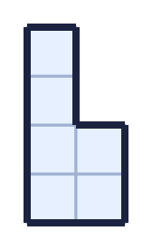
  5 | This shape has an area of 6 squares. Draw the shape again and add squares to make an area of 10 squares.
  6 | Draw a shape with an area of 6 squares on squared paper.
  6 | Draw a shape with an area of 6 squares on squared paper.
  7 | Count the squares to find the area of the rectangle.  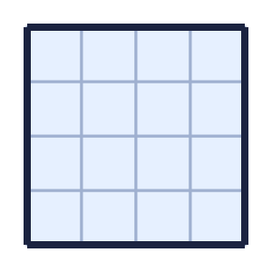
    The area is |  | squares
  7 | Count the squares to find the area of the rectangle.
    The area is |  | squares
  8 | Which shapes have an area of 12 squares? Write the letters.  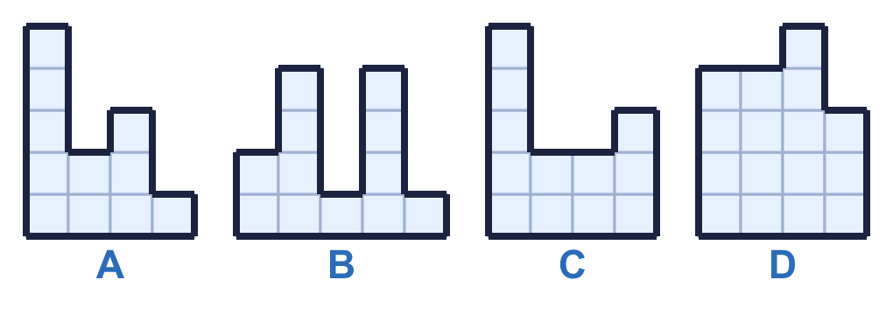
  8 | Which shapes have an area of 12 squares? Write the letters.

  9 | 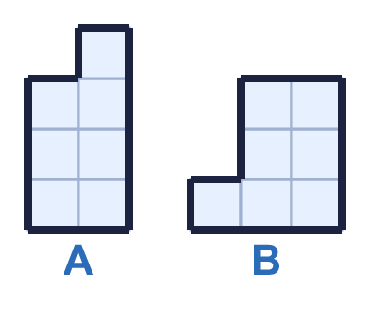  Do you agree with Boba? Circle yes or no.  Yes / No  Explain how you know.
     | 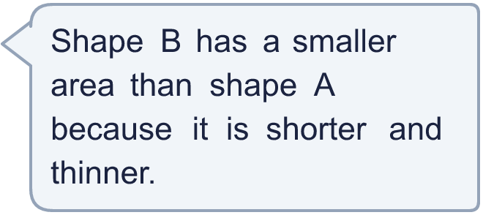
  9 | Do you agree with Boba? Circle yes or no.  Yes / No  Explain how you know.
  10 | Add squares to this shape to make it into a square.  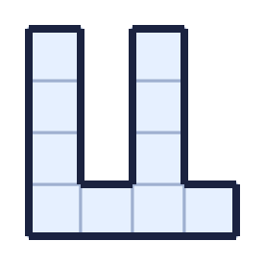
    What is the area of the square you make?
    squares
  10 | Add squares to this shape to make it into a square.
    What is the area of the square you make?
    squares
  11 | Rectangles have sides that are whole numbers of squares. A 2 by 6 rectangle is the same as a 6 by 2 rectangle.  How many different rectangles have an area of 24 squares?
    rectangles
  11 | Rectangles have sides that are whole numbers of squares. A 2 by 6 rectangle is the same as a 6 by 2 rectangle.  How many different rectangles have an area of 24 squares?
    rectangles
  12 | Draw a shape with an area of 6 squares on squared paper.
  12 | Draw a shape with an area of 6 squares on squared paper.
  13 | Write <, > or = to compare the areas of the shapes.  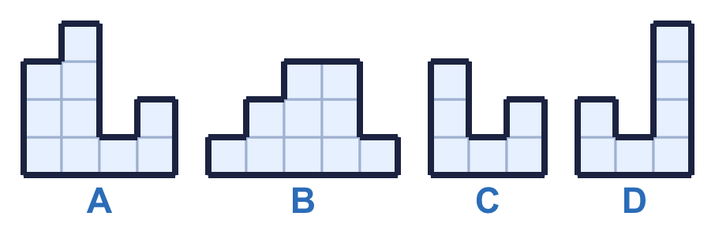
    A |  | B
    C |  | D
  13 | Write <, > or = to compare the areas of the shapes.
    A |  | B
    C |  | D
  14 | This shape has an area of 7 squares. Draw the shape again and add squares to make an area of 10 squares.  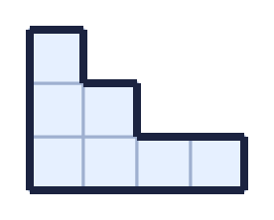
  14 | This shape has an area of 7 squares. Draw the shape again and add squares to make an area of 10 squares.

Year 4 · Area · Step 3
Make shapes
Answers (teacher copy)

  1 | Draw a shape with an area of 8 squares on squared paper.  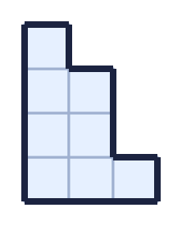
  2 | This shape has an area of 8 squares. Draw the shape again and add squares to make an area of 11 squares.  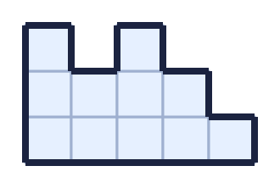
  3 | Draw a shape with an area of 13 squares on squared paper.  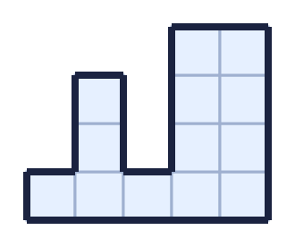
  4 | Add squares to this shape to make it into a square.  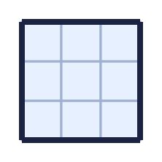  What is the area of the square you make? 9 squares
  5 | This shape has an area of 6 squares. Draw the shape again and add squares to make an area of 10 squares.  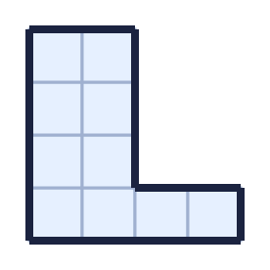
  6 | Draw a shape with an area of 6 squares on squared paper.  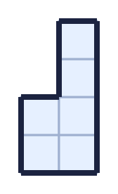
  7 | Count the squares to find the area of the rectangle.  The area is 16 squares
  8 | Which shapes have an area of 12 squares? Write the letters.  B, C
  9 | Do you agree with Boba? Circle yes or no.  Yes / No  Explain how you know.  Shape A has an area of 7 squares and shape B has an area of 7 squares. The areas are the same.
  10 | Add squares to this shape to make it into a square.  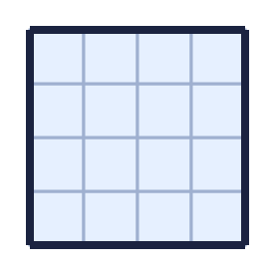  What is the area of the square you make? 16 squares
  11 | Rectangles have sides that are whole numbers of squares. A 2 by 6 rectangle is the same as a 6 by 2 rectangle.  How many different rectangles have an area of 24 squares?  4 rectangles
  12 | Draw a shape with an area of 6 squares on squared paper.  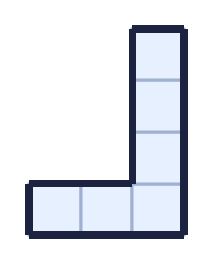
  13 | Write <, > or = to compare the areas of the shapes.  A = B  C < D
  14 | This shape has an area of 7 squares. Draw the shape again and add squares to make an area of 10 squares.  