  Year 4 · Area · Step 2  Count squares | 
  Year 4 · Area · Step 2
  Count squares
  1 | Count the squares to find the area of the rectangle.  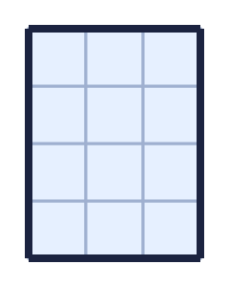
    The area is |  | squares
  1 | Count the squares to find the area of the rectangle.
    The area is |  | squares
  2 | Count the squares to work out the area of each shape.  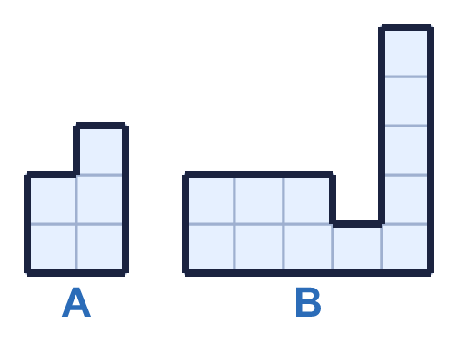
    a) Shape A: |  | squares
    b) Shape B: |  | squares
  2 | Count the squares to work out the area of each shape.
    a) Shape A: |  | squares
    b) Shape B: |  | squares
  3 | Use the diagram to complete the sentences.  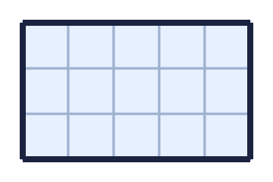
    Each row has |  | squares.
    There are |  | rows.
    There are |  | squares altogether.
    The area is |  | squares
  3 | Use the diagram to complete the sentences.
    Each row has |  | squares.
    There are |  | rows.
    There are |  | squares altogether.
    The area is |  | squares
  4 | Work out the area of each shape. Then work out the total area of both shapes.  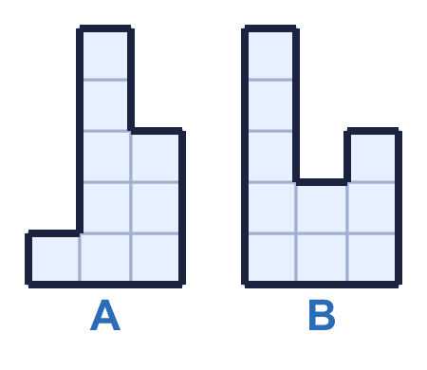
    Area of A: |  | squares
    Area of B: |  | squares
    Total area: |  | squares
  4 | Work out the area of each shape. Then work out the total area of both shapes.
    Area of A: |  | squares
    Area of B: |  | squares
    Total area: |  | squares
  5 | Count the squares to work out the area of each shape.  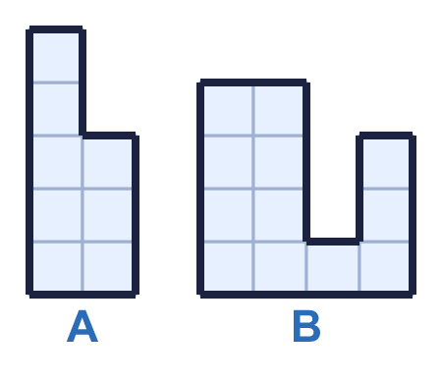
    a) Shape A: |  | squares
    b) Shape B: |  | squares
  5 | Count the squares to work out the area of each shape.
    a) Shape A: |  | squares
    b) Shape B: |  | squares
  6 | Which shapes have an area of 8 squares? Write the letters.  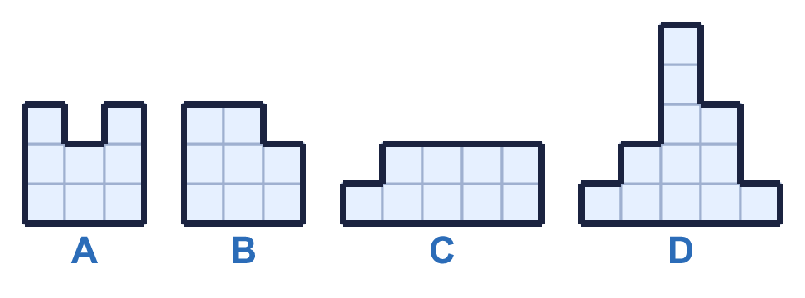
  6 | Which shapes have an area of 8 squares? Write the letters.
  7 | Work out the area of each shape. What is the difference between the areas?  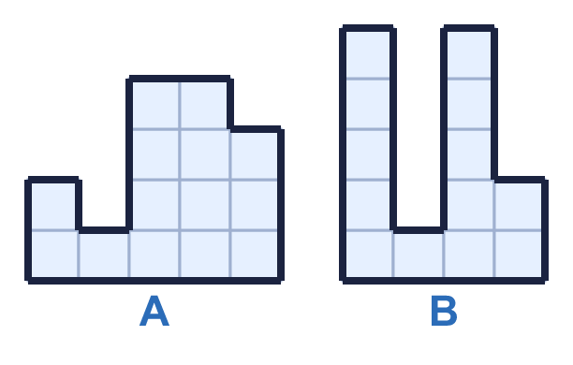
    Area of A: |  | squares
    Area of B: |  | squares
    Difference: |  | squares
  7 | Work out the area of each shape. What is the difference between the areas?
    Area of A: |  | squares
    Area of B: |  | squares
    Difference: |  | squares
  8 | Count the squares to find the area of the rectangle.  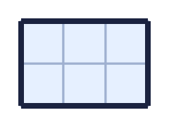
    The area is |  | squares
  8 | Count the squares to find the area of the rectangle.
    The area is |  | squares

  9 | 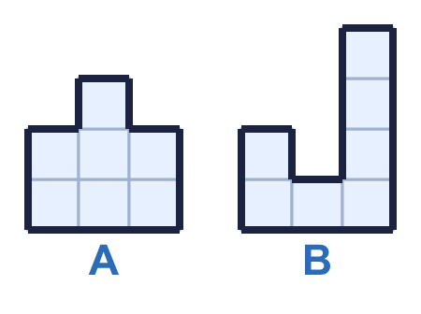  Do you agree with Boba? Circle yes or no.  Yes / No  Explain how you know.
     | 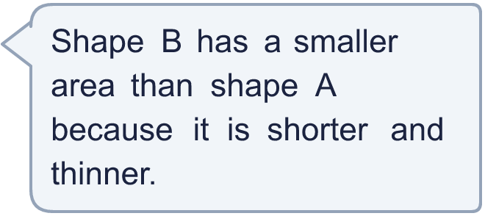
  9 | Do you agree with Boba? Circle yes or no.  Yes / No  Explain how you know.
  10 | Rectangles have sides that are whole numbers of squares. A 2 by 6 rectangle is the same as a 6 by 2 rectangle.  How many different rectangles have an area of 18 squares?
    rectangles
  10 | Rectangles have sides that are whole numbers of squares. A 2 by 6 rectangle is the same as a 6 by 2 rectangle.  How many different rectangles have an area of 18 squares?
    rectangles
  11 | Put the shapes in order of area. Start with the shape with the smallest area.  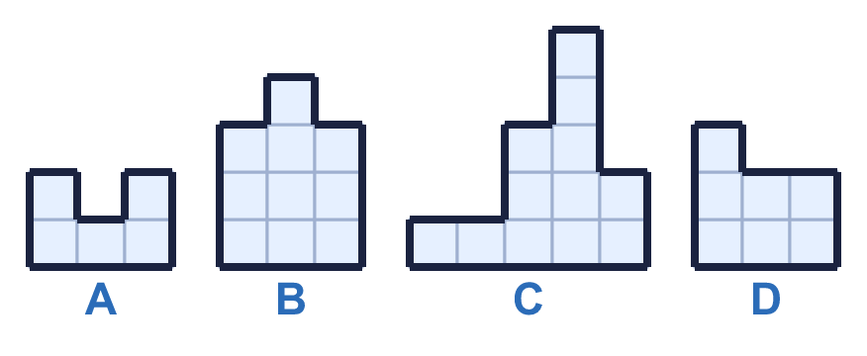
  11 | Put the shapes in order of area. Start with the shape with the smallest area.
  12 | Work out the area of each shape. Then work out the total area of both shapes.  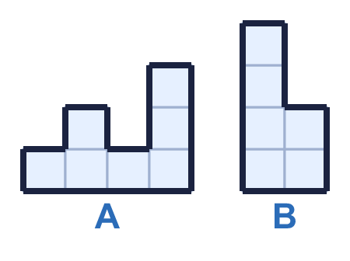
    Area of A: |  | squares
    Area of B: |  | squares
    Total area: |  | squares
  12 | Work out the area of each shape. Then work out the total area of both shapes.
    Area of A: |  | squares
    Area of B: |  | squares
    Total area: |  | squares
  13 | Work out the area of each shape. What is the difference between the areas?  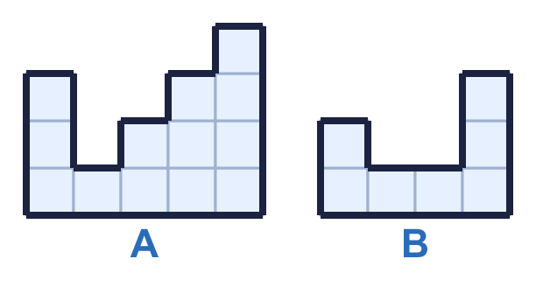
    Area of A: |  | squares
    Area of B: |  | squares
    Difference: |  | squares
  13 | Work out the area of each shape. What is the difference between the areas?
    Area of A: |  | squares
    Area of B: |  | squares
    Difference: |  | squares
  14 | 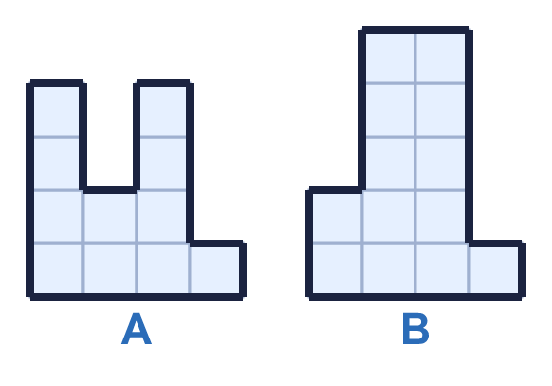  Do you agree with Boba? Circle yes or no.  Yes / No  Explain how you know.
    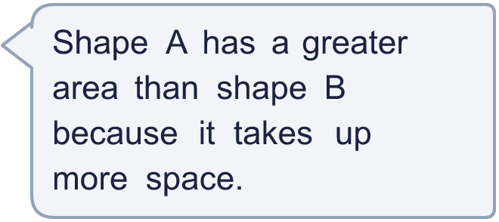
  14 | Do you agree with Boba? Circle yes or no.  Yes / No  Explain how you know.

Year 4 · Area · Step 2
Count squares
Answers (teacher copy)

  1 | Count the squares to find the area of the rectangle.  The area is 12 squares
  2 | Count the squares to work out the area of each shape.  a) Shape A: 5 squares  b) Shape B: 12 squares
  3 | Use the diagram to complete the sentences.  Each row has 5 squares.  There are 3 rows.  There are 15 squares altogether.  The area is 15 squares
  4 | Work out the area of each shape. Then work out the total area of both shapes.  Area of A: 9 squares  Area of B: 10 squares  Total area: 19 squares
  5 | Count the squares to work out the area of each shape.  a) Shape A: 8 squares  b) Shape B: 12 squares
  6 | Which shapes have an area of 8 squares? Write the letters.  A, B
  7 | Work out the area of each shape. What is the difference between the areas?  Area of A: 14 squares  Area of B: 13 squares  Difference: 1 squares
  8 | Count the squares to find the area of the rectangle.  The area is 6 squares
  9 | Do you agree with Boba? Circle yes or no.  Yes / No  Explain how you know.  Shape A has an area of 7 squares and shape B has an area of 7 squares. The areas are the same.
  10 | Rectangles have sides that are whole numbers of squares. A 2 by 6 rectangle is the same as a 6 by 2 rectangle.  How many different rectangles have an area of 18 squares?  3 rectangles
  11 | Put the shapes in order of area. Start with the shape with the smallest area.  A, D, B, C
  12 | Work out the area of each shape. Then work out the total area of both shapes.  Area of A: 7 squares  Area of B: 6 squares  Total area: 13 squares
  13 | Work out the area of each shape. What is the difference between the areas?  Area of A: 13 squares  Area of B: 7 squares  Difference: 6 squares
  14 | Do you agree with Boba? Circle yes or no.  Yes / No  Explain how you know.  Shape A has an area of 11 squares and shape B has an area of 13 squares.

