  Year 4 · Area · Step 4  Compare areas | 
  Year 4 · Area · Step 4
  Compare areas
  1 | Which shape has the greatest area? Write its letter.  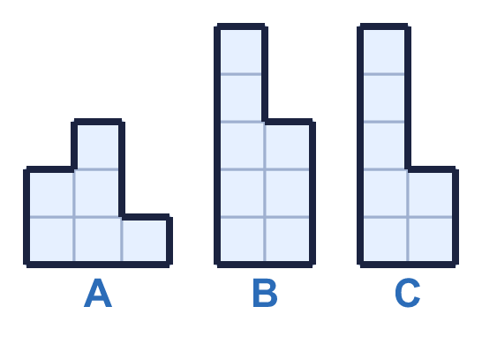
    Answer:
  1 | Which shape has the greatest area? Write its letter.
    Answer:
  2 | Write <, > or = to compare the areas of the shapes.  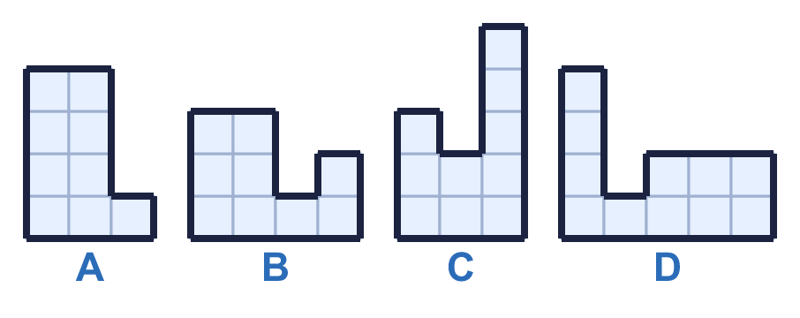
    A |  | B
    C |  | D
  2 | Write <, > or = to compare the areas of the shapes.
    A |  | B
    C |  | D
  3 | Put the shapes in order of area. Start with the shape with the smallest area.  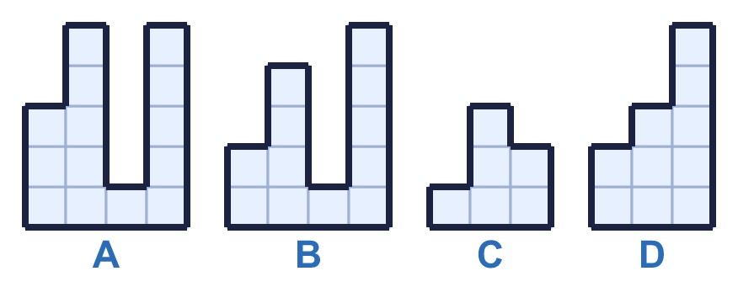
  3 | Put the shapes in order of area. Start with the shape with the smallest area.
  4 | Write <, > or = to compare the areas of the shapes.  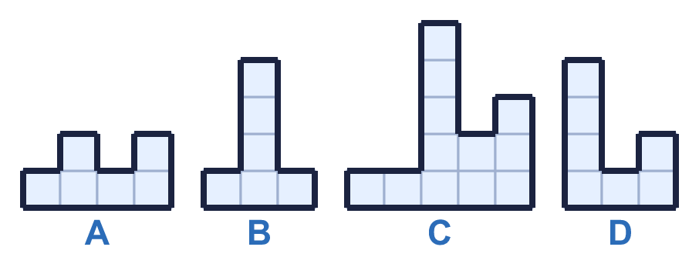
    A |  | B
    C |  | D
  4 | Write <, > or = to compare the areas of the shapes.
    A |  | B
    C |  | D
  5 | Which shape has the greatest area? Write its letter.  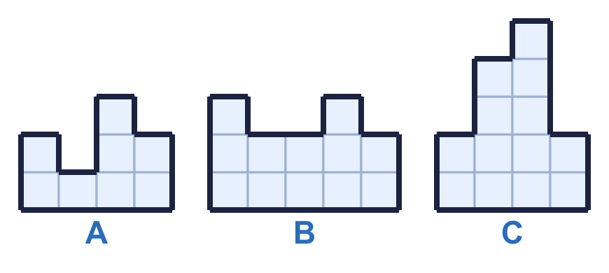
    Answer:
  5 | Which shape has the greatest area? Write its letter.
    Answer:
  6 | Work out the area of each shape. What is the difference between the areas?  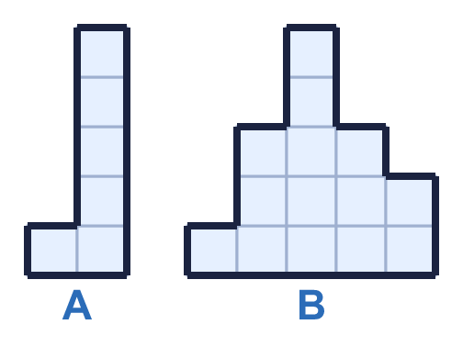
    Area of A: |  | squares
    Area of B: |  | squares
    Difference: |  | squares
  6 | Work out the area of each shape. What is the difference between the areas?
    Area of A: |  | squares
    Area of B: |  | squares
    Difference: |  | squares
  7 | Which shapes have an area of 10 squares? Write the letters.  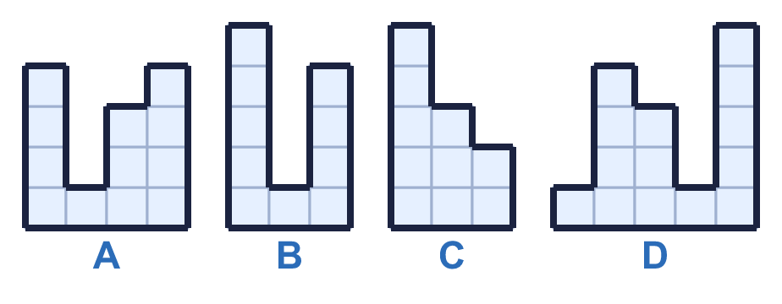
  7 | Which shapes have an area of 10 squares? Write the letters.
  8 | Write <, > or = to compare the areas of the shapes.  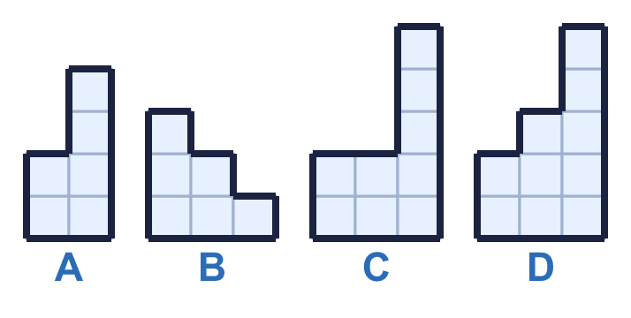
    A |  | B
    C |  | D
  8 | Write <, > or = to compare the areas of the shapes.
    A |  | B
    C |  | D

  9 | 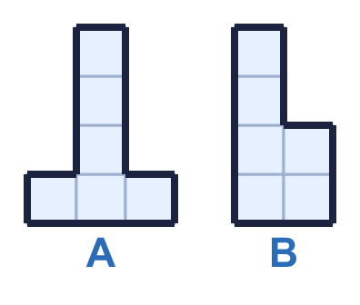  Do you agree with Boba? Circle yes or no.  Yes / No  Explain how you know.
     | 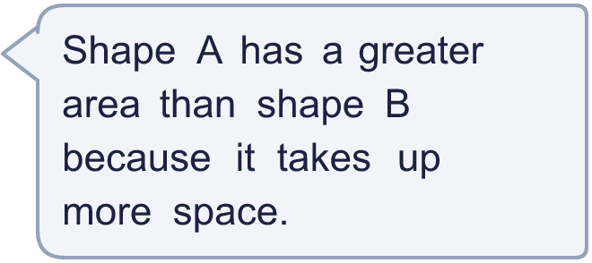
  9 | Do you agree with Boba? Circle yes or no.  Yes / No  Explain how you know.
  10 | Put the shapes in order of area. Start with the shape with the smallest area.  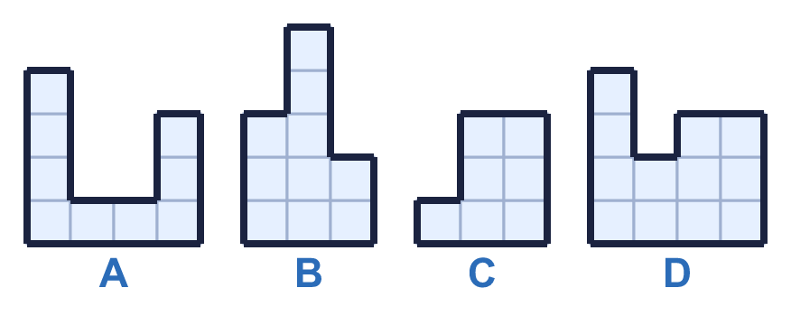
  10 | Put the shapes in order of area. Start with the shape with the smallest area.
  11 | Work out the area of each shape. What is the difference between the areas?  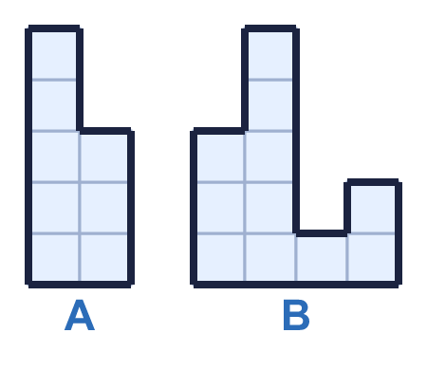
    Area of A: |  | squares
    Area of B: |  | squares
    Difference: |  | squares
  11 | Work out the area of each shape. What is the difference between the areas?
    Area of A: |  | squares
    Area of B: |  | squares
    Difference: |  | squares
  12 | 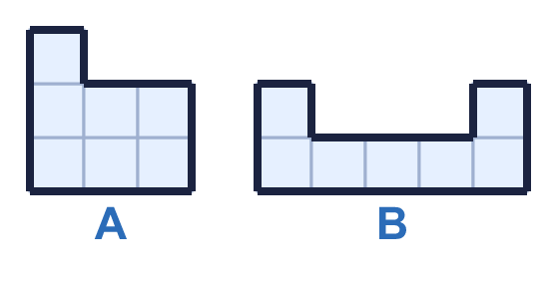  Do you agree with Boba? Circle yes or no.  Yes / No  Explain how you know.
  12 | Do you agree with Boba? Circle yes or no.  Yes / No  Explain how you know.
  13 | Work out the area of each shape. Then work out the total area of both shapes.  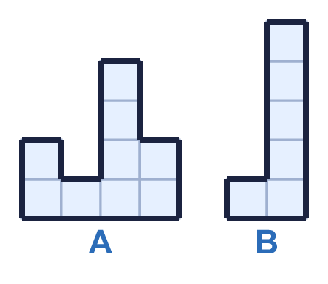
    Area of A: |  | squares
    Area of B: |  | squares
    Total area: |  | squares
  13 | Work out the area of each shape. Then work out the total area of both shapes.
    Area of A: |  | squares
    Area of B: |  | squares
    Total area: |  | squares
  14 | Write <, > or = to compare the areas of the shapes.  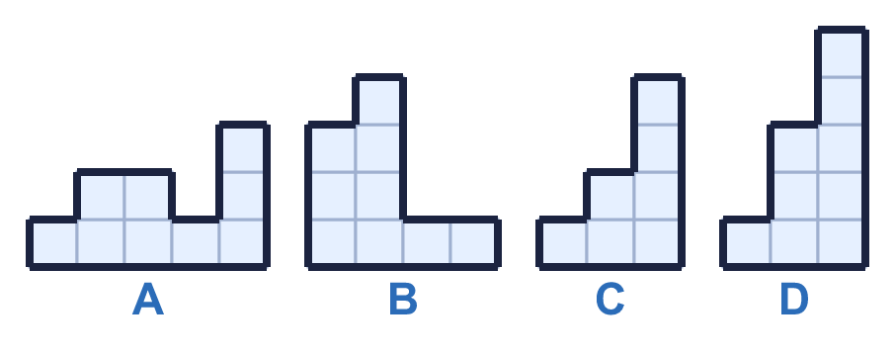
    A |  | B
    C |  | D
  14 | Write <, > or = to compare the areas of the shapes.
    A |  | B
    C |  | D

Year 4 · Area · Step 4
Compare areas
Answers (teacher copy)

  1 | Which shape has the greatest area? Write its letter.  Answer: B
  2 | Write <, > or = to compare the areas of the shapes.  A = B  C < D
  3 | Put the shapes in order of area. Start with the shape with the smallest area.  C, D, B, A
  4 | Write <, > or = to compare the areas of the shapes.  A = B  C > D
  5 | Which shape has the greatest area? Write its letter.  Answer: C
  6 | Work out the area of each shape. What is the difference between the areas?  Area of A: 6 squares  Area of B: 14 squares  Difference: 8 squares
  7 | Which shapes have an area of 10 squares? Write the letters.  B, C
  8 | Write <, > or = to compare the areas of the shapes.  A = B  C < D
  9 | Do you agree with Boba? Circle yes or no.  Yes / No  Explain how you know.  Shape A has an area of 6 squares and shape B has an area of 6 squares. The areas are the same.
  10 | Put the shapes in order of area. Start with the shape with the smallest area.  C, A, B, D
  11 | Work out the area of each shape. What is the difference between the areas?  Area of A: 8 squares  Area of B: 11 squares  Difference: 3 squares
  12 | Do you agree with Boba? Circle yes or no.  Yes / No  Explain how you know.  Shape A has an area of 7 squares and shape B has an area of 7 squares. The areas are the same.
  13 | Work out the area of each shape. Then work out the total area of both shapes.  Area of A: 9 squares  Area of B: 6 squares  Total area: 15 squares
  14 | Write <, > or = to compare the areas of the shapes.  A = B  C < D

