  Year 4 · Addition and subtraction · Step 5  Subtract two 4-digit numbers with no exchange | 
  Year 4 · Addition and subtraction · Step 5
  Subtract two 4-digit numbers with no exchange
  1 | Complete the column subtraction. Write the missing digits in the answer.  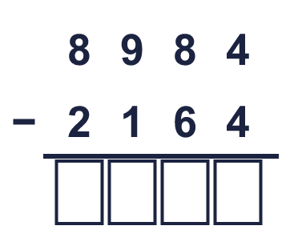
  1 | Complete the column subtraction. Write the missing digits in the answer.
  2 | Work out the subtractions.  a) 759 − 721 =  b) 9,997 − 275 =  c) 9,884 − 6,144 =
  2 | Work out the subtractions.  a) 759 − 721 =  b) 9,997 − 275 =  c) 9,884 − 6,144 =
  3 | Work out the subtractions. Write the units in your answer.  a) £2,482 − £182 =  b) 3,999 g − 2,768 g =  c) 6,732 cm − 401 cm =
  3 | Work out the subtractions. Write the units in your answer.  a) £2,482 − £182 =  b) 3,999 g − 2,768 g =  c) 6,732 cm − 401 cm =
  4 | Work out the subtractions. They all start with 9,257.  a) 9,257 − 2,324 =  b) 9,257 − 2,152 =  c) 9,257 − 3,553 =
  4 | Work out the subtractions. They all start with 9,257.  a) 9,257 − 2,324 =  b) 9,257 − 2,152 =  c) 9,257 − 3,553 =
  5 | Work out the subtractions.  a) 7,167 − 33 =  b) 6,703 − 501 =  c) 6,551 − 321 =  d) 9,755 − 2,742 =
  5 | Work out the subtractions.  a) 7,167 − 33 =  b) 6,703 − 501 =  c) 6,551 − 321 =  d) 9,755 − 2,742 =
  6 | A family has £6,775 in the bank. They spend £3,900 on a holiday.  a) How much money do they have left?  Sydney is 9,073 miles from London and 8,539 miles from New York.  b) How much further is Sydney from London than from New York?
  6 | A family has £6,775 in the bank. They spend £3,900 on a holiday.  a) How much money do they have left?  Sydney is 9,073 miles from London and 8,539 miles from New York.  b) How much further is Sydney from London than from New York?
  7 | Write the missing digits in the calculation.  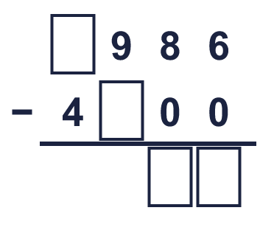
  7 | Write the missing digits in the calculation.
  8 | Look at the bar model. Subtract to find the missing part.  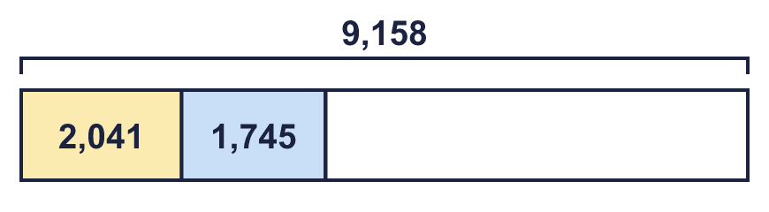
  8 | Look at the bar model. Subtract to find the missing part.

  9 | 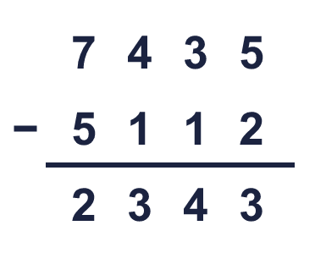  Is Boba correct? Circle yes or no.  Yes / No  What is the correct answer?  Explain Boba’s mistake.
     | 
  9 | Is Boba correct? Circle yes or no.  Yes / No  What is the correct answer?  Explain Boba’s mistake.
  10 | Teddy and Jack play a computer game. Teddy scores 3,660 points. Jack scores 2,463 fewer points than Teddy.  a) How many points does Jack score?  b) How many points do they score altogether?
  10 | Teddy and Jack play a computer game. Teddy scores 3,660 points. Jack scores 2,463 fewer points than Teddy.  a) How many points does Jack score?  b) How many points do they score altogether?
  11 | 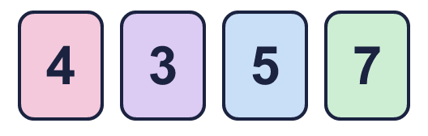  The difference between their numbers is between 1,000 and 3,000.  What numbers could Ron and Eva have made? Write two different pairs.
     | 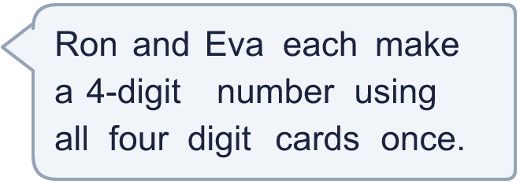
  11 | The difference between their numbers is between 1,000 and 3,000.  What numbers could Ron and Eva have made? Write two different pairs.
  12 | Rosie works out 7,255 − 970 by taking away 1,000 first.  a) 7,255 − 1,000 =  c) 7,255 − 970 =
    b) | Now she must add back
    to get the answer.
  12 | Rosie works out 7,255 − 970 by taking away 1,000 first.  a) 7,255 − 1,000 =  c) 7,255 − 970 =
    b) | Now she must add back
    to get the answer.
  13 | Write the missing number in each subtraction.
    a) | 7,338 − |  | = 4,677
    b) |  | − 1,720 = 3,275
  13 | Write the missing number in each subtraction.
    a) | 7,338 − |  | = 4,677
    b) |  | − 1,720 = 3,275
  14 | Write two different subtractions of two 4-digit numbers with an answer of exactly 1,234.
  14 | Write two different subtractions of two 4-digit numbers with an answer of exactly 1,234.

Year 4 · Addition and subtraction · Step 5
Subtract two 4-digit numbers with no exchange
Answers (teacher copy)

  1 | Complete the column subtraction. Write the missing digits in the answer.  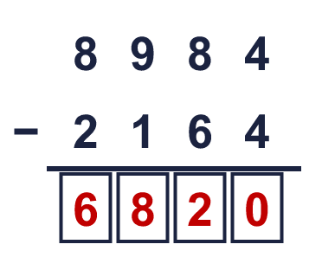  Answer: 6,820
  2 | Work out the subtractions.  a) 759 − 721 = 38  b) 9,997 − 275 = 9,722  c) 9,884 − 6,144 = 3,740
  3 | Work out the subtractions. Write the units in your answer.  a) £2,482 − £182 = £2,300  b) 3,999 g − 2,768 g = 1,231 g  c) 6,732 cm − 401 cm = 6,331 cm
  4 | Work out the subtractions. They all start with 9,257.  a) 9,257 − 2,324 = 6,933  b) 9,257 − 2,152 = 7,105  c) 9,257 − 3,553 = 5,704
  5 | Work out the subtractions.  a) 7,167 − 33 = 7,134  b) 6,703 − 501 = 6,202  c) 6,551 − 321 = 6,230  d) 9,755 − 2,742 = 7,013
  6 | A family has £6,775 in the bank. They spend £3,900 on a holiday.  a) How much money do they have left? £2,875  Sydney is 9,073 miles from London and 8,539 miles from New York.  b) How much further is Sydney from London than from New York? 534 miles
  7 | Write the missing digits in the calculation.  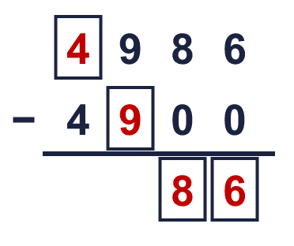  Missing digits, from top to bottom and left to right: 4 9 8 6
  8 | Look at the bar model. Subtract to find the missing part.  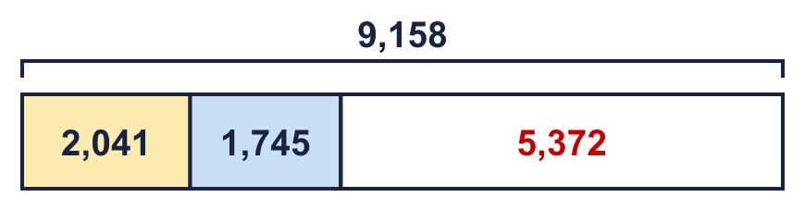  The missing part is 5,372
  9 | Is Boba correct? Circle yes or no.  Yes / No  What is the correct answer? 2,323  Explain Boba’s mistake.  7,435 − 5,112 = 2,323. Boba made a mistake in the tens column. The tens digit of the answer should be the same as in 2,323.
  10 | Teddy and Jack play a computer game. Teddy scores 3,660 points. Jack scores 2,463 fewer points than Teddy.  a) How many points does Jack score? 1,197  b) How many points do they score altogether? 4,857
  11 | The difference between their numbers is between 1,000 and 3,000.  What numbers could Ron and Eva have made? Write two different pairs.  for example 5,734 and 4,537; 5,734 and 3,547
  12 | Rosie works out 7,255 − 970 by taking away 1,000 first.  a) 7,255 − 1,000 = 6,255  b) Now she must add back 30 to get the answer.  c) 7,255 − 970 = 6,285
  13 | Write the missing number in each subtraction.  a) 7,338 − 2,661 = 4,677  b) 4,995 − 1,720 = 3,275
  14 | Write two different subtractions of two 4-digit numbers with an answer of exactly 1,234.  for example 3,234 − 2,000 and 4,334 − 3,100

