  Year 4 · Addition and subtraction · Step 7  Subtract two 4-digit numbers with more than one exchange | 
  Year 4 · Addition and subtraction · Step 7
  Subtract two 4-digit numbers with more than one exchange
  1 | Complete the column subtraction. Write the missing digits in the answer.  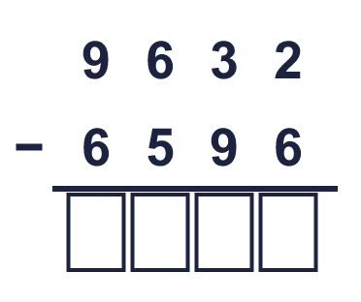
  1 | Complete the column subtraction. Write the missing digits in the answer.
  2 | Work out the subtractions.  a) 810 − 289 =  b) 8,952 − 496 =  c) 7,620 − 6,584 =
  2 | Work out the subtractions.  a) 810 − 289 =  b) 8,952 − 496 =  c) 7,620 − 6,584 =
  3 | Work out the subtractions. Write the units in your answer.  a) £7,164 − £765 =  b) 7,010 g − 3,186 g =  c) 6,775 cm − 297 cm =
  3 | Work out the subtractions. Write the units in your answer.  a) £7,164 − £765 =  b) 7,010 g − 3,186 g =  c) 6,775 cm − 297 cm =
  4 | Work out the subtractions. They all start with 6,475.  a) 6,475 − 2,931 =  b) 6,475 − 2,664 =  c) 6,475 − 2,153 =
  4 | Work out the subtractions. They all start with 6,475.  a) 6,475 − 2,931 =  b) 6,475 − 2,664 =  c) 6,475 − 2,153 =
  5 | Work out the subtractions. Take care with the zeros.  a) 7,000 − 223 =  b) 6,003 − 1,907 =  c) 10,000 − 8,841 =
  5 | Work out the subtractions. Take care with the zeros.  a) 7,000 − 223 =  b) 6,003 − 1,907 =  c) 10,000 − 8,841 =
  6 | A family has £7,633 in the bank. They spend £4,800 on a holiday.  a) How much money do they have left?  Sydney is 9,241 miles from London and 8,740 miles from New York.  b) How much further is Sydney from London than from New York?
  6 | A family has £7,633 in the bank. They spend £4,800 on a holiday.  a) How much money do they have left?  Sydney is 9,241 miles from London and 8,740 miles from New York.  b) How much further is Sydney from London than from New York?
  7 | Write the missing digits in the calculation.  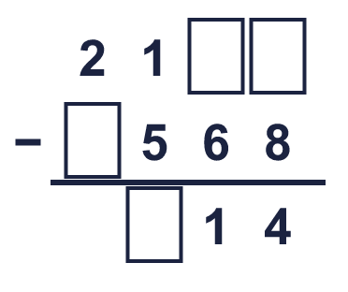
  7 | Write the missing digits in the calculation.
  8 | Look at the bar model. Subtract to find the missing part.  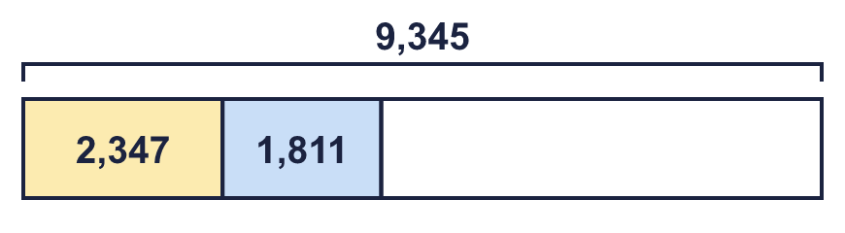
  8 | Look at the bar model. Subtract to find the missing part.

  9 | 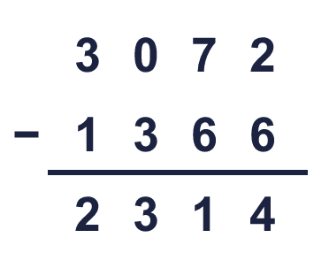  Is Boba correct? Circle yes or no.  Yes / No  What is the correct answer?  Explain Boba’s mistake.
     | 
  9 | Is Boba correct? Circle yes or no.  Yes / No  What is the correct answer?  Explain Boba’s mistake.
  10 | Teddy and Jack play a computer game. Teddy scores 4,684 points. Jack scores 2,352 fewer points than Teddy.  a) How many points does Jack score?  b) How many points do they score altogether?
  10 | Teddy and Jack play a computer game. Teddy scores 4,684 points. Jack scores 2,352 fewer points than Teddy.  a) How many points does Jack score?  b) How many points do they score altogether?
  11 | 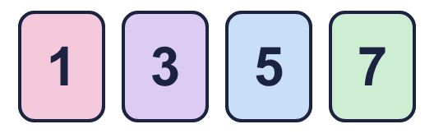  The difference between their numbers is between 1,000 and 3,000.  What numbers could Ron and Eva have made? Write two different pairs.
     | 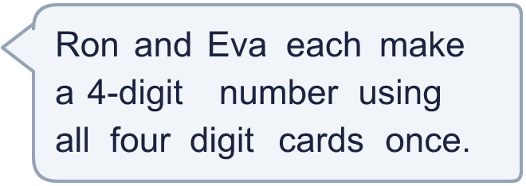
  11 | The difference between their numbers is between 1,000 and 3,000.  What numbers could Ron and Eva have made? Write two different pairs.
  12 | Rosie works out 6,262 − 961 by taking away 1,000 first.  a) 6,262 − 1,000 =  c) 6,262 − 961 =
    b) | Now she must add back
    to get the answer.
  12 | Rosie works out 6,262 − 961 by taking away 1,000 first.  a) 6,262 − 1,000 =  c) 6,262 − 961 =
    b) | Now she must add back
    to get the answer.
  13 | Write the missing number in each subtraction.
    a) | 9,435 − |  | = 7,788
    b) |  | − 1,620 = 2,142
  13 | Write the missing number in each subtraction.
    a) | 9,435 − |  | = 7,788
    b) |  | − 1,620 = 2,142
  14 | Write two different subtractions of two 4-digit numbers with an answer of exactly 1,234.
  14 | Write two different subtractions of two 4-digit numbers with an answer of exactly 1,234.

Year 4 · Addition and subtraction · Step 7
Subtract two 4-digit numbers with more than one exchange
Answers (teacher copy)

  1 | Complete the column subtraction. Write the missing digits in the answer.  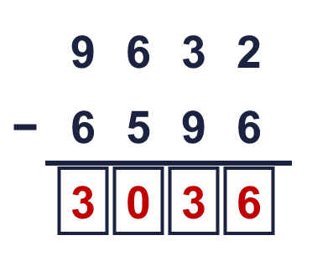  Answer: 3,036
  2 | Work out the subtractions.  a) 810 − 289 = 521  b) 8,952 − 496 = 8,456  c) 7,620 − 6,584 = 1,036
  3 | Work out the subtractions. Write the units in your answer.  a) £7,164 − £765 = £6,399  b) 7,010 g − 3,186 g = 3,824 g  c) 6,775 cm − 297 cm = 6,478 cm
  4 | Work out the subtractions. They all start with 6,475.  a) 6,475 − 2,931 = 3,544  b) 6,475 − 2,664 = 3,811  c) 6,475 − 2,153 = 4,322
  5 | Work out the subtractions. Take care with the zeros.  a) 7,000 − 223 = 6,777  b) 6,003 − 1,907 = 4,096  c) 10,000 − 8,841 = 1,159
  6 | A family has £7,633 in the bank. They spend £4,800 on a holiday.  a) How much money do they have left? £2,833  Sydney is 9,241 miles from London and 8,740 miles from New York.  b) How much further is Sydney from London than from New York? 501 miles
  7 | Write the missing digits in the calculation.  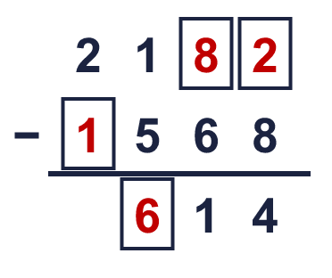  Missing digits, from top to bottom and left to right: 8 2 1 6
  8 | Look at the bar model. Subtract to find the missing part.  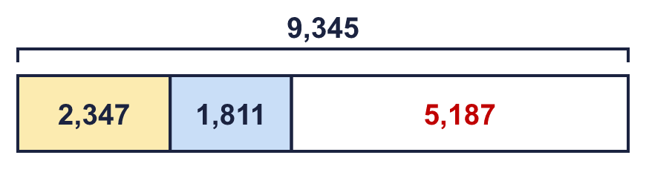  The missing part is 5,187
  9 | Is Boba correct? Circle yes or no.  Yes / No  What is the correct answer? 1,706  Explain Boba’s mistake.  3,072 − 1,366 = 1,706. Boba took the smaller digit from the bigger digit in every column. When the top digit is smaller, exchange from the next column.
  10 | Teddy and Jack play a computer game. Teddy scores 4,684 points. Jack scores 2,352 fewer points than Teddy.  a) How many points does Jack score? 2,332  b) How many points do they score altogether? 7,016
  11 | The difference between their numbers is between 1,000 and 3,000.  What numbers could Ron and Eva have made? Write two different pairs.  for example 3,751 and 1,375; 3,571 and 1,375
  12 | Rosie works out 6,262 − 961 by taking away 1,000 first.  a) 6,262 − 1,000 = 5,262  b) Now she must add back 39 to get the answer.  c) 6,262 − 961 = 5,301
  13 | Write the missing number in each subtraction.  a) 9,435 − 1,647 = 7,788  b) 3,762 − 1,620 = 2,142
  14 | Write two different subtractions of two 4-digit numbers with an answer of exactly 1,234.  for example 3,234 − 2,000 and 4,334 − 3,100

