  Year 4 · Addition and subtraction · Step 8  Efficient subtraction | 
  Year 4 · Addition and subtraction · Step 8
  Efficient subtraction
  1 | Work out the subtractions by counting on.  a) 607 − 591 =  b) 3,007 − 2,996 =  c) 2,008 − 1,991 =  d) 204 − 192 =
  1 | Work out the subtractions by counting on.  a) 607 − 591 =  b) 3,007 − 2,996 =  c) 2,008 − 1,991 =  d) 204 − 192 =
  2 | Work out the subtractions from round numbers.  a) 900 − 866 =  b) 3,000 − 2,522 =  c) 600 − 579 =  d) 6,000 − 5,781 =
  2 | Work out the subtractions from round numbers.  a) 900 − 866 =  b) 3,000 − 2,522 =  c) 600 − 579 =  d) 6,000 − 5,781 =
  3 | Rosie works out 300 − 244 by taking 1 from both numbers. Work out both calculations.  a) 299 − 243 =  b) 300 − 244 =
  3 | Rosie works out 300 − 244 by taking 1 from both numbers. Work out both calculations.  a) 299 − 243 =  b) 300 − 244 =
  4 | Work out the subtractions. Write the units in your answer.  a) £4,000 − £3,109 =  b) 700 g − 644 g =  c) 10,000 mm − 2,631 mm =
  4 | Work out the subtractions. Write the units in your answer.  a) £4,000 − £3,109 =  b) 700 g − 644 g =  c) 10,000 mm − 2,631 mm =
  5 | Work out the subtractions in your head. Look carefully at the second number.  a) 5,579 − 997 =  b) 8,077 − 998 =  c) 6,966 − 2,999 =  d) 7,562 − 1,999 =
  5 | Work out the subtractions in your head. Look carefully at the second number.  a) 5,579 − 997 =  b) 8,077 − 998 =  c) 6,966 − 2,999 =  d) 7,562 − 1,999 =
  6 | Write the missing number in each subtraction.
    a) | 804 − |  | = 6
    b) | 8,004 − |  | = 17
    c) | 5,804 − |  | = 25
  6 | Write the missing number in each subtraction.
    a) | 804 − |  | = 6
    b) | 8,004 − |  | = 17
    c) | 5,804 − |  | = 25
  7 | A theme park has 6,403 light bulbs. 1,629 of the light bulbs are blue.  a) How many bulbs are not blue?  b) 439 of the bulbs that are not blue are red. How many bulbs are not blue or red?
  7 | A theme park has 6,403 light bulbs. 1,629 of the light bulbs are blue.  a) How many bulbs are not blue?  b) 439 of the bulbs that are not blue are red. How many bulbs are not blue or red?
  8 | Eva works out 7,449 − 2,999 by subtracting 3,000 first and then adding 1. Work out both calculations.  a) 7,449 − 3,000 =  b) 7,449 − 2,999 =
  8 | Eva works out 7,449 − 2,999 by subtracting 3,000 first and then adding 1. Work out both calculations.  a) 7,449 − 3,000 =  b) 7,449 − 2,999 =

  9 | Is Boba correct? Circle yes or no.  Yes / No  What is the correct answer?  Explain Boba’s mistake.
     | 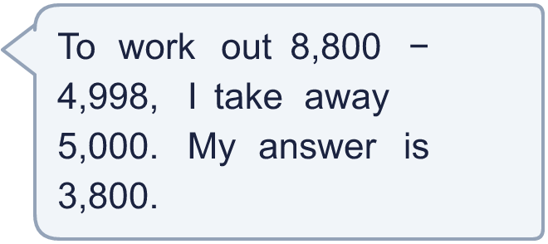
  9 | Is Boba correct? Circle yes or no.  Yes / No  What is the correct answer?  Explain Boba’s mistake.
  10
    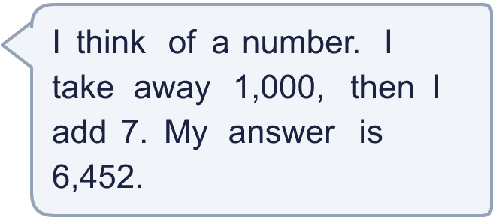
  10
  11 | A shop has £7,000. It spends £2,997 on stock and £201 on rent.
    How much money is left?
  11 | A shop has £7,000. It spends £2,997 on stock and £201 on rent.
    How much money is left?
  12 | Write the missing number in each calculation.
    a) | 4,100 − |  | = 993
    b) |  | − 1,995 = 3,000
  12 | Write the missing number in each calculation.
    a) | 4,100 − |  | = 993
    b) |  | − 1,995 = 3,000
  13 | A tank holds 10,000 ml of water. 6,990 ml is used. Then 231 ml is added.
    a) | How much water is in the tank now?
    ml
  13 | A tank holds 10,000 ml of water. 6,990 ml is used. Then 231 ml is added.
    a) | How much water is in the tank now?
    ml
  14 | Write two different subtractions of two 4-digit numbers with an answer of exactly 198.
  14 | Write two different subtractions of two 4-digit numbers with an answer of exactly 198.

Year 4 · Addition and subtraction · Step 8
Efficient subtraction
Answers (teacher copy)

  1 | Work out the subtractions by counting on.  a) 607 − 591 = 16  b) 3,007 − 2,996 = 11  c) 2,008 − 1,991 = 17  d) 204 − 192 = 12
  2 | Work out the subtractions from round numbers.  a) 900 − 866 = 34  b) 3,000 − 2,522 = 478  c) 600 − 579 = 21  d) 6,000 − 5,781 = 219
  3 | Rosie works out 300 − 244 by taking 1 from both numbers. Work out both calculations.  a) 299 − 243 = 56  b) 300 − 244 = 56
  4 | Work out the subtractions. Write the units in your answer.  a) £4,000 − £3,109 = £891  b) 700 g − 644 g = 56 g  c) 10,000 mm − 2,631 mm = 7,369 mm
  5 | Work out the subtractions in your head. Look carefully at the second number.  a) 5,579 − 997 = 4,582  b) 8,077 − 998 = 7,079  c) 6,966 − 2,999 = 3,967  d) 7,562 − 1,999 = 5,563
  6 | Write the missing number in each subtraction.  a) 804 − 798 = 6  b) 8,004 − 7,987 = 17  c) 5,804 − 5,779 = 25
  7 | A theme park has 6,403 light bulbs. 1,629 of the light bulbs are blue.  a) How many bulbs are not blue? 4,774  b) 439 of the bulbs that are not blue are red. How many bulbs are not blue or red? 4,335
  8 | Eva works out 7,449 − 2,999 by subtracting 3,000 first and then adding 1. Work out both calculations.  a) 7,449 − 3,000 = 4,449  b) 7,449 − 2,999 = 4,450
  9 | Is Boba correct? Circle yes or no.  Yes / No  What is the correct answer? 3,802  Explain Boba’s mistake.  8,800 − 4,998 = 3,802. Boba took away 2 too many, so 2 must be added back.
  10 | What number did I start with? 7,445
  11 | A shop has £7,000. It spends £2,997 on stock and £201 on rent.  How much money is left? £3,802
  12 | Write the missing number in each calculation.  a) 4,100 − 3,107 = 993  b) 4,995 − 1,995 = 3,000
  13 | A tank holds 10,000 ml of water. 6,990 ml is used. Then 231 ml is added.  a) How much water is in the tank now? 3,241 ml
  14 | Write two different subtractions of two 4-digit numbers with an answer of exactly 198.  for example 6,198 − 6,000 and 7,201 − 7,003

