  Year 4 · Addition and subtraction · Step 10  Checking strategies | 
  Year 4 · Addition and subtraction · Step 10
  Checking strategies
  1 | Circle the subtractions that can be used to check the addition 554 + 154 = 708.  A) 708 − 554  B) 708 − 154  C) 554 − 154  D) 554 − 708
  1 | Circle the subtractions that can be used to check the addition 554 + 154 = 708.  A) 708 − 554  B) 708 − 154  C) 554 − 154  D) 554 − 708
  2 | Circle the additions that can be used to check the subtraction 8,696 − 4,235 = 4,461.  A) 4,235 + 4,461  B) 4,461 + 4,235  C) 8,696 + 4,461  D) 8,696 + 4,235
  2 | Circle the additions that can be used to check the subtraction 8,696 − 4,235 = 4,461.  A) 4,235 + 4,461  B) 4,461 + 4,235  C) 8,696 + 4,461  D) 8,696 + 4,235
  3 | Work out each calculation. Then check it with the inverse operation.  a) 866 + 5,216 =  Check: your answer − 5,216 =  b) 7,277 − 489 =  Check: your answer + 489 =
  3 | Work out each calculation. Then check it with the inverse operation.  a) 866 + 5,216 =  Check: your answer − 5,216 =  b) 7,277 − 489 =  Check: your answer + 489 =
  4 | Use an inverse operation to check each answer. Is it correct? Circle yes or no.  a) 2,467 + 2,368 = 4,835  Check: 4,835 − 2,368 =  Yes / No  b) 1,762 + 3,358 = 5,130  Check: 5,130 − 3,358 =  Yes / No
  4 | Use an inverse operation to check each answer. Is it correct? Circle yes or no.  a) 2,467 + 2,368 = 4,835  Check: 4,835 − 2,368 =  Yes / No  b) 1,762 + 3,358 = 5,130  Check: 5,130 − 3,358 =  Yes / No
  5 | Complete the fact family for the part-whole model.  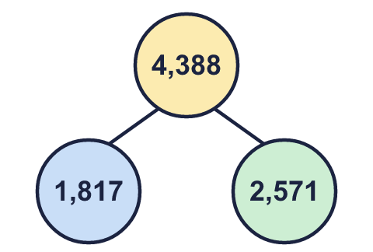  a) 1,817 + 2,571 =  b) 2,571 + 1,817 =  c) 4,388 − 1,817 =  d) 4,388 − 2,571 =
  5 | Complete the fact family for the part-whole model.  a) 1,817 + 2,571 =  b) 2,571 + 1,817 =  c) 4,388 − 1,817 =  d) 4,388 − 2,571 =
  6 | Work out each subtraction. Then check it with the inverse operation.  a) 9,000 − 1,458 =  Check: your answer + 1,458 =  b) 5,004 − 2,288 =  Check: your answer + 2,288 =
  6 | Work out each subtraction. Then check it with the inverse operation.  a) 9,000 − 1,458 =  Check: your answer + 1,458 =  b) 5,004 − 2,288 =  Check: your answer + 2,288 =
  7 | Match each addition to the subtraction that checks it.  1) 3,817 + 3,121 = 6,938  2) 1,881 + 1,415 = 3,296  3) 1,945 + 1,212 = 3,157  A) 6,938 − 3,121 = 3,817  B) 3,157 − 1,212 = 1,945  C) 3,296 − 1,415 = 1,881
    1 matches |  | 2 matches
    3 matches
  7 | Match each addition to the subtraction that checks it.  1) 3,817 + 3,121 = 6,938  2) 1,881 + 1,415 = 3,296  3) 1,945 + 1,212 = 3,157  A) 6,938 − 3,121 = 3,817  B) 3,157 − 1,212 = 1,945  C) 3,296 − 1,415 = 1,881
    1 matches |  | 2 matches
    3 matches
  8 | Use inverse operations to find the missing numbers.
    a) |  | + 1,585 = 4,936
    b) |  | − 414 = 3,351
    c) | 4,936 − |  | = 3,351
  8 | Use inverse operations to find the missing numbers.
    a) |  | + 1,585 = 4,936
    b) |  | − 414 = 3,351
    c) | 4,936 − |  | = 3,351

  9 | Is this a good idea? Circle yes or no.  Yes / No  Explain why.
     | 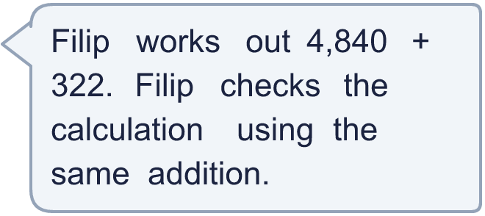
  9 | Is this a good idea? Circle yes or no.  Yes / No  Explain why.
  10 | Use a subtraction to check Dora’s answer.  Check: 5,469 − 3,537 =  Is the answer correct? Circle yes or no.  Yes / No  The correct answer is
     | 
  10 | Use a subtraction to check Dora’s answer.  Check: 5,469 − 3,537 =  Is the answer correct? Circle yes or no.  Yes / No  The correct answer is
  11 | Check: 5,400 + 1,997 =  Is Boba correct? Circle yes or no.  Yes / No  What is the correct answer?
    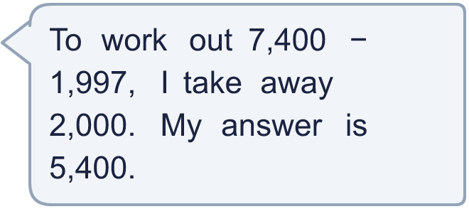
  11 | Check: 5,400 + 1,997 =  Is Boba correct? Circle yes or no.  Yes / No  What is the correct answer?
  12 | Write an addition that you can use to check the subtraction 7,270 − 2,300.
  12 | Write an addition that you can use to check the subtraction 7,270 − 2,300.
  13 | Use an addition to check Boba’s answer.  Check: 6,489 + 1,718 =  Is the subtraction correct? Circle yes or no.  Yes / No  The correct answer is
    
  13 | Use an addition to check Boba’s answer.  Check: 6,489 + 1,718 =  Is the subtraction correct? Circle yes or no.  Yes / No  The correct answer is
  14 | Check your answer by adding.
    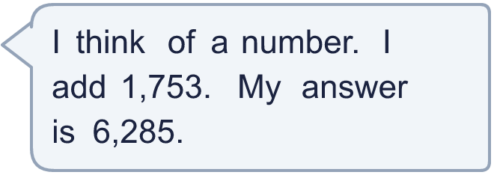
  14 | Check your answer by adding.

Year 4 · Addition and subtraction · Step 10
Checking strategies
Answers (teacher copy)

  1 | Circle the subtractions that can be used to check the addition 554 + 154 = 708.  A) 708 − 554  B) 708 − 154  C) 554 − 154  D) 554 − 708  The calculations that check it are A, B
  2 | Circle the additions that can be used to check the subtraction 8,696 − 4,235 = 4,461.  A) 4,235 + 4,461  B) 4,461 + 4,235  C) 8,696 + 4,461  D) 8,696 + 4,235  The calculations that check it are A, B
  3 | Work out each calculation. Then check it with the inverse operation.  a) 866 + 5,216 = 6,082  Check: your answer − 5,216 = 866  b) 7,277 − 489 = 6,788  Check: your answer + 489 = 7,277
  4 | Use an inverse operation to check each answer. Is it correct? Circle yes or no.  a) 2,467 + 2,368 = 4,835  Check: 4,835 − 2,368 = 2,467  Yes / No  b) 1,762 + 3,358 = 5,130  Check: 5,130 − 3,358 = 1,772  Yes / No
  5 | Complete the fact family for the part-whole model.  a) 1,817 + 2,571 = 4,388  b) 2,571 + 1,817 = 4,388  c) 4,388 − 1,817 = 2,571  d) 4,388 − 2,571 = 1,817
  6 | Work out each subtraction. Then check it with the inverse operation.  a) 9,000 − 1,458 = 7,542  Check: your answer + 1,458 = 9,000  b) 5,004 − 2,288 = 2,716  Check: your answer + 2,288 = 5,004
  7 | Match each addition to the subtraction that checks it.  1) 3,817 + 3,121 = 6,938  2) 1,881 + 1,415 = 3,296  3) 1,945 + 1,212 = 3,157  A) 6,938 − 3,121 = 3,817  B) 3,157 − 1,212 = 1,945  C) 3,296 − 1,415 = 1,881  1 matches A 2 matches C 3 matches B
  8 | Use inverse operations to find the missing numbers.  a) 3,351 + 1,585 = 4,936  b) 3,765 − 414 = 3,351  c) 4,936 − 1,585 = 3,351
  9 | Is this a good idea? Circle yes or no.  Yes / No  Explain why.  No. Doing the same addition again can repeat the same mistake. Filip should check with a subtraction: 5,162 − 322 should make 4,840.
  10 | Use a subtraction to check Dora’s answer.  Check: 5,469 − 3,537 = 1,932  Is the answer correct? Circle yes or no.  Yes / No  The correct answer is 5,369
  11 | Check: 5,400 + 1,997 = 7,397  Is Boba correct? Circle yes or no.  Yes / No  What is the correct answer? 5,403
  12 | Write an addition that you can use to check the subtraction 7,270 − 2,300.  2,300 + 4,970 = 7,270
  13 | Use an addition to check Boba’s answer.  Check: 6,489 + 1,718 = 8,207  Is the subtraction correct? Circle yes or no.  Yes / No  The correct answer is 4,761
  14 | What number did I start with? 4,532  Check your answer by adding.

