  Year 4 · Addition and subtraction · Step 3  Add two 4-digit numbers with one exchange | 
  Year 4 · Addition and subtraction · Step 3
  Add two 4-digit numbers with one exchange
  1 | Complete the column addition. Write the missing digits in the answer.  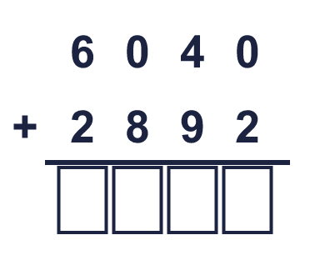
  1 | Complete the column addition. Write the missing digits in the answer.
  2 | Work out the additions.  a) 372 + 260 =  b) 4,646 + 345 =  c) 1,526 + 2,209 =
  2 | Work out the additions.  a) 372 + 260 =  b) 4,646 + 345 =  c) 1,526 + 2,209 =
  3 | Work out the additions. Write the units in your answer.  a) £3,338 + £5,359 =  b) 1,933 cm + 8,039 cm =  c) 1,170 g + 8,344 g =
  3 | Work out the additions. Write the units in your answer.  a) £3,338 + £5,359 =  b) 1,933 cm + 8,039 cm =  c) 1,170 g + 8,344 g =
  4 | Only part of the second number changes each time.  a) 2,438 + 2,600 =  b) 2,438 + 2,602 =  c) 2,438 + 3,550 =
  4 | Only part of the second number changes each time.  a) 2,438 + 2,600 =  b) 2,438 + 2,602 =  c) 2,438 + 3,550 =
  5 | Write the missing number in each addition.
    a) | 578 + |  | = 1,000
    b) | 2,589 + |  | = 10,000
    c) |  | + 6,340 = 10,000
    d) |  | + 3,945 = 5,575
  5 | Write the missing number in each addition.
    a) | 578 + |  | = 1,000
    b) | 2,589 + |  | = 10,000
    c) |  | + 6,340 = 10,000
    d) |  | + 3,945 = 5,575
  6 | Work out the additions.  a) 3,190 + 2,135 =  b) 1,231 + 4,684 =  c) 5,209 + 249 =
  6 | Work out the additions.  a) 3,190 + 2,135 =  b) 1,231 + 4,684 =  c) 5,209 + 249 =
  7 | Tia scores 2,370 points in a game. Zach scores 2,311 more points than Tia.  a) How many points does Zach score?  b) How many points do they score together?
  7 | Tia scores 2,370 points in a game. Zach scores 2,311 more points than Tia.  a) How many points does Zach score?  b) How many points do they score together?
  8 | Write the missing digits in the calculation.  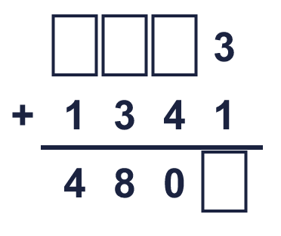
  8 | Write the missing digits in the calculation.

  9 | Work out the three additions.  a) 4,946 + 1,986 =  b) 4,946 + 2,006 =  c) 4,946 + 2,176 =  d) How much greater is the answer to c) than the answer to a)?
     | 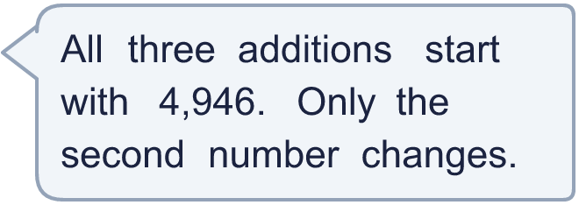
  9 | Work out the three additions.  a) 4,946 + 1,986 =  b) 4,946 + 2,006 =  c) 4,946 + 2,176 =  d) How much greater is the answer to c) than the answer to a)?
  10 | 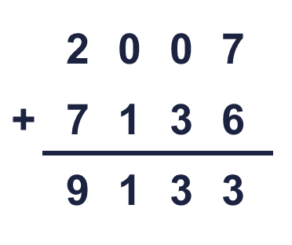  Is Boba correct? Circle yes or no.  Yes / No  What is the correct answer?  Explain Boba’s mistake.
     | 
  10 | Is Boba correct? Circle yes or no.  Yes / No  What is the correct answer?  Explain Boba’s mistake.
  11 | Three friends play a computer game. Josh scores 1,767 points, Kim scores 1,446 points and Bobby scores 1,319 points.  a) How many points do they score altogether?  b) How many more points do Josh and Kim score together than Bobby?
  11 | Three friends play a computer game. Josh scores 1,767 points, Kim scores 1,446 points and Bobby scores 1,319 points.  a) How many points do they score altogether?  b) How many more points do Josh and Kim score together than Bobby?
  12 | A factory packs marbles into boxes. A large box holds 2,850 marbles, a medium box holds 2,350 and a small box holds 1,350.  a) How many marbles are in one large box and one small box?  b) How many marbles are in one box of each size?
  12 | A factory packs marbles into boxes. A large box holds 2,850 marbles, a medium box holds 2,350 and a small box holds 1,350.  a) How many marbles are in one large box and one small box?  b) How many marbles are in one box of each size?
  13 | Look at the bar model. Add the parts to find the whole.  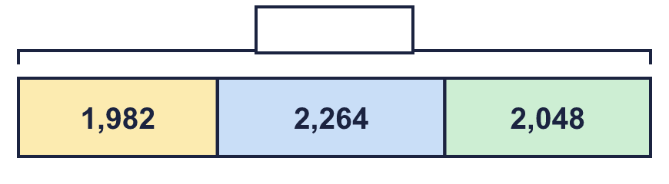
  13 | Look at the bar model. Add the parts to find the whole.
  14 | Write two different additions of two 4-digit numbers that make exactly 8,000.
  14 | Write two different additions of two 4-digit numbers that make exactly 8,000.

Year 4 · Addition and subtraction · Step 3
Add two 4-digit numbers with one exchange
Answers (teacher copy)

  1 | Complete the column addition. Write the missing digits in the answer.  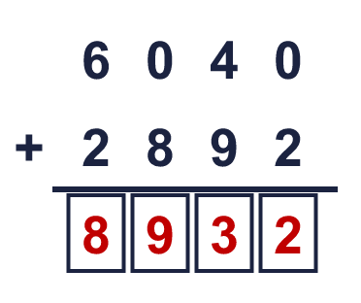  Answer: 8,932
  2 | Work out the additions.  a) 372 + 260 = 632  b) 4,646 + 345 = 4,991  c) 1,526 + 2,209 = 3,735
  3 | Work out the additions. Write the units in your answer.  a) £3,338 + £5,359 = £8,697  b) 1,933 cm + 8,039 cm = 9,972 cm  c) 1,170 g + 8,344 g = 9,514 g
  4 | Only part of the second number changes each time.  a) 2,438 + 2,600 = 5,038  b) 2,438 + 2,602 = 5,040  c) 2,438 + 3,550 = 5,988
  5 | Write the missing number in each addition.  a) 578 + 422 = 1,000  b) 2,589 + 7,411 = 10,000  c) 3,660 + 6,340 = 10,000  d) 1,630 + 3,945 = 5,575
  6 | Work out the additions.  a) 3,190 + 2,135 = 5,325  b) 1,231 + 4,684 = 5,915  c) 5,209 + 249 = 5,458
  7 | Tia scores 2,370 points in a game. Zach scores 2,311 more points than Tia.  a) How many points does Zach score? 4,681  b) How many points do they score together? 7,051
  8 | Write the missing digits in the calculation.  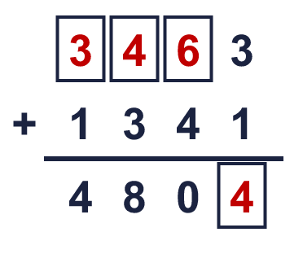  Missing digits, from top to bottom and left to right: 3 4 6 4
  9 | Work out the three additions.  a) 4,946 + 1,986 = 6,932  b) 4,946 + 2,006 = 6,952  c) 4,946 + 2,176 = 7,122  d) How much greater is the answer to c) than the answer to a)? 190
  10 | Is Boba correct? Circle yes or no.  Yes / No  What is the correct answer? 9,143  Explain Boba’s mistake.  2,007 + 7,136 = 9,143. Boba did not carry the 1 into the tens column.
  11 | Three friends play a computer game. Josh scores 1,767 points, Kim scores 1,446 points and Bobby scores 1,319 points.  a) How many points do they score altogether? 4,532  b) How many more points do Josh and Kim score together than Bobby? 1,894
  12 | A factory packs marbles into boxes. A large box holds 2,850 marbles, a medium box holds 2,350 and a small box holds 1,350.  a) How many marbles are in one large box and one small box? 4,200  b) How many marbles are in one box of each size? 6,550
  13 | Look at the bar model. Add the parts to find the whole.  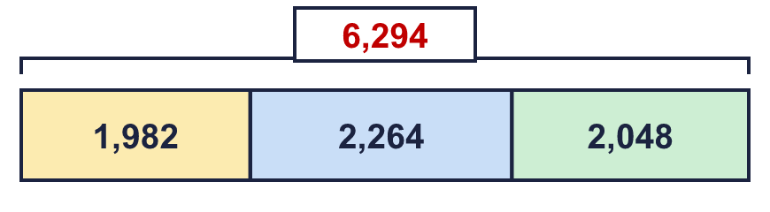  The whole is 6,294
  14 | Write two different additions of two 4-digit numbers that make exactly 8,000.  for example 3,500 + 4,500 and 3,000 + 5,000

