  Year 4 · Addition and subtraction · Step 2  Add two 4-digit numbers with no exchange | 
  Year 4 · Addition and subtraction · Step 2
  Add two 4-digit numbers with no exchange
  1 | Complete the column addition. Write the missing digits in the answer.  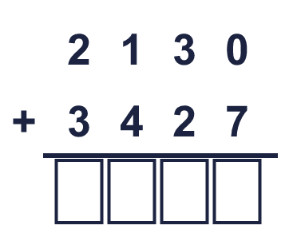
  1 | Complete the column addition. Write the missing digits in the answer.
  2 | Work out the additions.  a) 152 + 137 =  b) 7,156 + 623 =  c) 1,150 + 3,441 =
  2 | Work out the additions.  a) 152 + 137 =  b) 7,156 + 623 =  c) 1,150 + 3,441 =
  3 | Work out the additions. Write the units in your answer.  a) £3,215 + £6,260 =  b) 3,215 cm + 3,404 cm =  c) 1,044 g + 3,431 g =
  3 | Work out the additions. Write the units in your answer.  a) £3,215 + £6,260 =  b) 3,215 cm + 3,404 cm =  c) 1,044 g + 3,431 g =
  4 | Only part of the second number changes each time.  a) 2,487 + 2,800 =  b) 2,487 + 2,806 =  c) 2,487 + 3,540 =
  4 | Only part of the second number changes each time.  a) 2,487 + 2,800 =  b) 2,487 + 2,806 =  c) 2,487 + 3,540 =
  5 | Write the missing number in each addition.
    a) | 646 + |  | = 1,000
    b) | 7,626 + |  | = 10,000
    c) |  | + 5,330 = 10,000
    d) |  | + 4,745 = 9,575
  5 | Write the missing number in each addition.
    a) | 646 + |  | = 1,000
    b) | 7,626 + |  | = 10,000
    c) |  | + 5,330 = 10,000
    d) |  | + 4,745 = 9,575
  6 | Work out the additions.  a) 1,221 + 5,067 =  b) 2,304 + 6,385 =  c) 5,002 + 204 =
  6 | Work out the additions.  a) 1,221 + 5,067 =  b) 2,304 + 6,385 =  c) 5,002 + 204 =
  7 | Tia scores 1,879 points in a game. Zach scores 1,161 more points than Tia.  a) How many points does Zach score?  b) How many points do they score together?
  7 | Tia scores 1,879 points in a game. Zach scores 1,161 more points than Tia.  a) How many points does Zach score?  b) How many points do they score together?
  8 | Write the missing digits in the calculation.  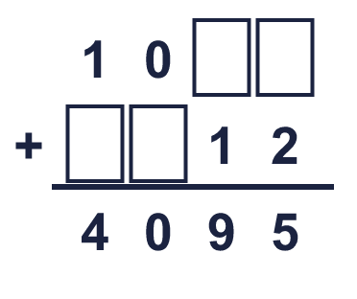
  8 | Write the missing digits in the calculation.

  9 | Work out the three additions.  a) 4,868 + 3,726 =  b) 4,868 + 3,736 =  c) 4,868 + 4,216 =  d) How much greater is the answer to c) than the answer to a)?
     | 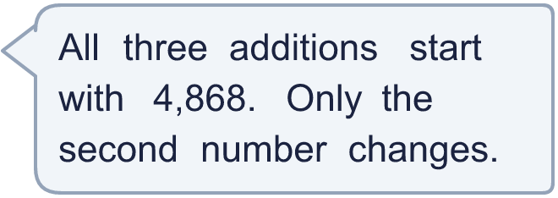
  9 | Work out the three additions.  a) 4,868 + 3,726 =  b) 4,868 + 3,736 =  c) 4,868 + 4,216 =  d) How much greater is the answer to c) than the answer to a)?
  10 | 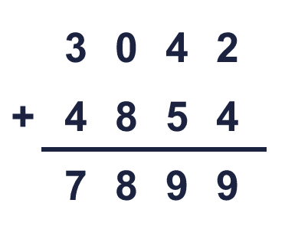  Is Boba correct? Circle yes or no.  Yes / No  What is the correct answer?  Explain Boba’s mistake.
     | 
  10 | Is Boba correct? Circle yes or no.  Yes / No  What is the correct answer?  Explain Boba’s mistake.
  11 | Three friends play a computer game. Josh scores 2,220 points, Kim scores 2,383 points and Bobby scores 1,447 points.  a) How many points do they score altogether?  b) How many more points do Josh and Kim score together than Bobby?
  11 | Three friends play a computer game. Josh scores 2,220 points, Kim scores 2,383 points and Bobby scores 1,447 points.  a) How many points do they score altogether?  b) How many more points do Josh and Kim score together than Bobby?
  12 | A factory packs marbles into boxes. A large box holds 3,250 marbles, a medium box holds 2,050 and a small box holds 1,650.  a) How many marbles are in one large box and one small box?  b) How many marbles are in one box of each size?
  12 | A factory packs marbles into boxes. A large box holds 3,250 marbles, a medium box holds 2,050 and a small box holds 1,650.  a) How many marbles are in one large box and one small box?  b) How many marbles are in one box of each size?
  13 | Look at the bar model. Add the parts to find the whole.  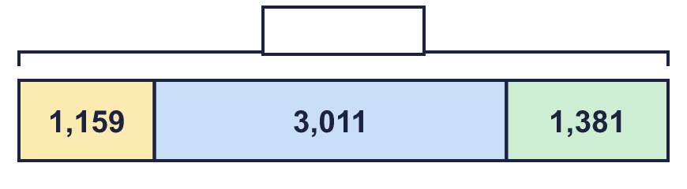
  13 | Look at the bar model. Add the parts to find the whole.
  14 | Write two different additions of two 4-digit numbers that make exactly 9,000.
  14 | Write two different additions of two 4-digit numbers that make exactly 9,000.

Year 4 · Addition and subtraction · Step 2
Add two 4-digit numbers with no exchange
Answers (teacher copy)

  1 | Complete the column addition. Write the missing digits in the answer.  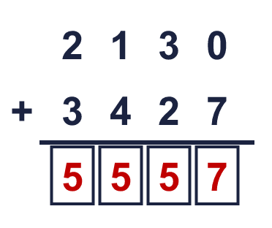  Answer: 5,557
  2 | Work out the additions.  a) 152 + 137 = 289  b) 7,156 + 623 = 7,779  c) 1,150 + 3,441 = 4,591
  3 | Work out the additions. Write the units in your answer.  a) £3,215 + £6,260 = £9,475  b) 3,215 cm + 3,404 cm = 6,619 cm  c) 1,044 g + 3,431 g = 4,475 g
  4 | Only part of the second number changes each time.  a) 2,487 + 2,800 = 5,287  b) 2,487 + 2,806 = 5,293  c) 2,487 + 3,540 = 6,027
  5 | Write the missing number in each addition.  a) 646 + 354 = 1,000  b) 7,626 + 2,374 = 10,000  c) 4,670 + 5,330 = 10,000  d) 4,830 + 4,745 = 9,575
  6 | Work out the additions.  a) 1,221 + 5,067 = 6,288  b) 2,304 + 6,385 = 8,689  c) 5,002 + 204 = 5,206
  7 | Tia scores 1,879 points in a game. Zach scores 1,161 more points than Tia.  a) How many points does Zach score? 3,040  b) How many points do they score together? 4,919
  8 | Write the missing digits in the calculation.  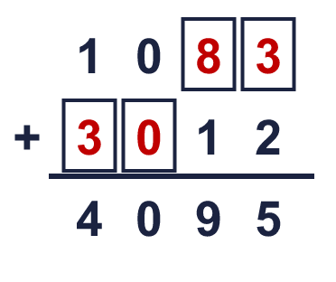  Missing digits, from top to bottom and left to right: 8 3 3 0
  9 | Work out the three additions.  a) 4,868 + 3,726 = 8,594  b) 4,868 + 3,736 = 8,604  c) 4,868 + 4,216 = 9,084  d) How much greater is the answer to c) than the answer to a)? 490
  10 | Is Boba correct? Circle yes or no.  Yes / No  What is the correct answer? 7,896  Explain Boba’s mistake.  3,042 + 4,854 = 7,896. Boba made a mistake in the ones column. The digits in that column should add to the ones digit of 7,896.
  11 | Three friends play a computer game. Josh scores 2,220 points, Kim scores 2,383 points and Bobby scores 1,447 points.  a) How many points do they score altogether? 6,050  b) How many more points do Josh and Kim score together than Bobby? 3,156
  12 | A factory packs marbles into boxes. A large box holds 3,250 marbles, a medium box holds 2,050 and a small box holds 1,650.  a) How many marbles are in one large box and one small box? 4,900  b) How many marbles are in one box of each size? 6,950
  13 | Look at the bar model. Add the parts to find the whole.  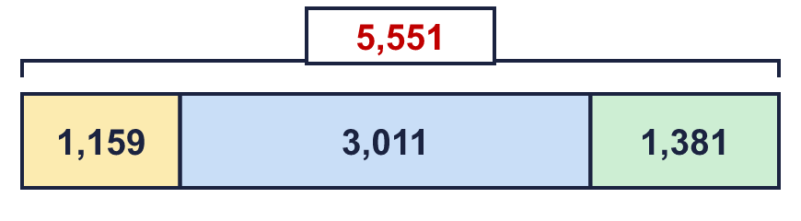  The whole is 5,551
  14 | Write two different additions of two 4-digit numbers that make exactly 9,000.  for example 4,000 + 5,000 and 3,500 + 5,500

