  Year 4 · Addition and subtraction · Step 4  Add two 4-digit numbers with more than one exchange | 
  Year 4 · Addition and subtraction · Step 4
  Add two 4-digit numbers with more than one exchange
  1 | Complete the column addition. Write the missing digits in the answer.  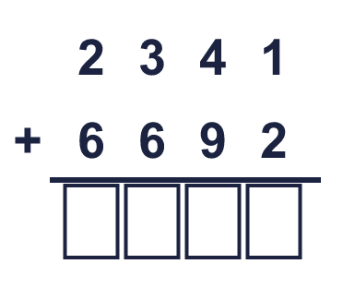
  1 | Complete the column addition. Write the missing digits in the answer.
  2 | Work out the additions.  a) 847 + 671 =  b) 6,509 + 683 =  c) 6,679 + 1,665 =
  2 | Work out the additions.  a) 847 + 671 =  b) 6,509 + 683 =  c) 6,679 + 1,665 =
  3 | Work out the additions. Write the units in your answer.  a) £2,999 + £5,856 =  b) 4,477 cm + 3,449 cm =  c) 1,519 g + 4,893 g =
  3 | Work out the additions. Write the units in your answer.  a) £2,999 + £5,856 =  b) 4,477 cm + 3,449 cm =  c) 1,519 g + 4,893 g =
  4 | Only part of the second number changes each time.  a) 2,378 + 1,800 =  b) 2,378 + 1,802 =  c) 2,378 + 2,710 =
  4 | Only part of the second number changes each time.  a) 2,378 + 1,800 =  b) 2,378 + 1,802 =  c) 2,378 + 2,710 =
  5 | Write the missing number in each addition.
    a) | 612 + |  | = 1,000
    b) | 6,744 + |  | = 10,000
    c) |  | + 6,290 = 10,000
    d) |  | + 2,445 = 5,075
  5 | Write the missing number in each addition.
    a) | 612 + |  | = 1,000
    b) | 6,744 + |  | = 10,000
    c) |  | + 6,290 = 10,000
    d) |  | + 2,445 = 5,075
  6 | Work out the additions.  a) 5,992 + 3,291 =  b) 6,452 + 1,765 =  c) 1,338 + 672 =
  6 | Work out the additions.  a) 5,992 + 3,291 =  b) 6,452 + 1,765 =  c) 1,338 + 672 =
  7 | Tia scores 1,924 points in a game. Zach scores 1,741 more points than Tia.  a) How many points does Zach score?  b) How many points do they score together?
  7 | Tia scores 1,924 points in a game. Zach scores 1,741 more points than Tia.  a) How many points does Zach score?  b) How many points do they score together?
  8 | Write the missing digits in the calculation.  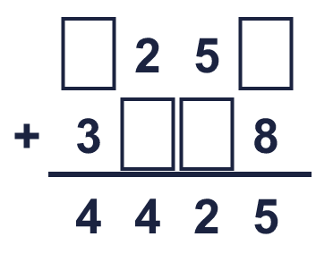
  8 | Write the missing digits in the calculation.

  9 | Work out the three additions.  a) 3,879 + 1,646 =  b) 3,879 + 1,666 =  c) 3,879 + 1,936 =  d) How much greater is the answer to c) than the answer to a)?
     | 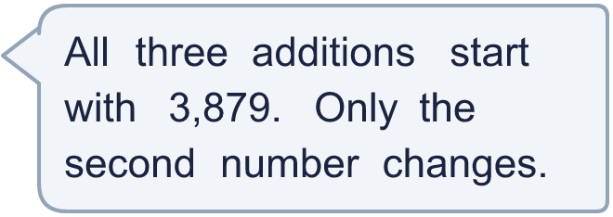
  9 | Work out the three additions.  a) 3,879 + 1,646 =  b) 3,879 + 1,666 =  c) 3,879 + 1,936 =  d) How much greater is the answer to c) than the answer to a)?
  10 | 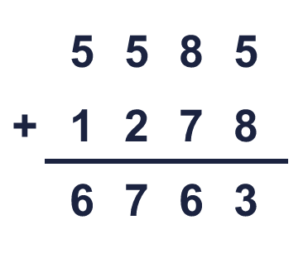  Is Boba correct? Circle yes or no.  Yes / No  What is the correct answer?  Explain Boba’s mistake.
     | 
  10 | Is Boba correct? Circle yes or no.  Yes / No  What is the correct answer?  Explain Boba’s mistake.
  11 | Three friends play a computer game. Josh scores 1,284 points, Kim scores 2,227 points and Bobby scores 1,618 points.  a) How many points do they score altogether?  b) How many more points do Josh and Kim score together than Bobby?
  11 | Three friends play a computer game. Josh scores 1,284 points, Kim scores 2,227 points and Bobby scores 1,618 points.  a) How many points do they score altogether?  b) How many more points do Josh and Kim score together than Bobby?
  12 | A factory packs marbles into boxes. A large box holds 2,550 marbles, a medium box holds 1,950 and a small box holds 1,650.  a) How many marbles are in one large box and one small box?  b) How many marbles are in one box of each size?
  12 | A factory packs marbles into boxes. A large box holds 2,550 marbles, a medium box holds 1,950 and a small box holds 1,650.  a) How many marbles are in one large box and one small box?  b) How many marbles are in one box of each size?
  13 | Look at the bar model. Add the parts to find the whole.  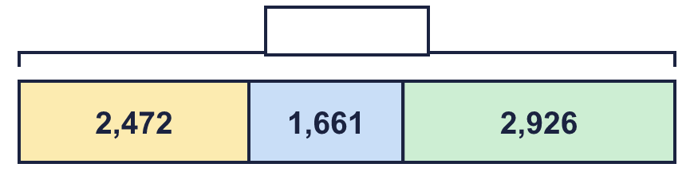
  13 | Look at the bar model. Add the parts to find the whole.
  14 | Write two different additions of two 4-digit numbers that make exactly 9,000.
  14 | Write two different additions of two 4-digit numbers that make exactly 9,000.

Year 4 · Addition and subtraction · Step 4
Add two 4-digit numbers with more than one exchange
Answers (teacher copy)

  1 | Complete the column addition. Write the missing digits in the answer.  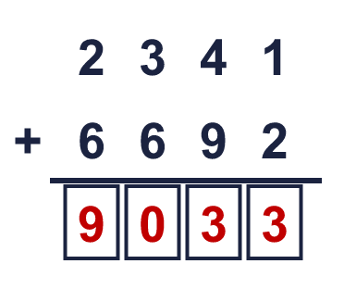  Answer: 9,033
  2 | Work out the additions.  a) 847 + 671 = 1,518  b) 6,509 + 683 = 7,192  c) 6,679 + 1,665 = 8,344
  3 | Work out the additions. Write the units in your answer.  a) £2,999 + £5,856 = £8,855  b) 4,477 cm + 3,449 cm = 7,926 cm  c) 1,519 g + 4,893 g = 6,412 g
  4 | Only part of the second number changes each time.  a) 2,378 + 1,800 = 4,178  b) 2,378 + 1,802 = 4,180  c) 2,378 + 2,710 = 5,088
  5 | Write the missing number in each addition.  a) 612 + 388 = 1,000  b) 6,744 + 3,256 = 10,000  c) 3,710 + 6,290 = 10,000  d) 2,630 + 2,445 = 5,075
  6 | Work out the additions.  a) 5,992 + 3,291 = 9,283  b) 6,452 + 1,765 = 8,217  c) 1,338 + 672 = 2,010
  7 | Tia scores 1,924 points in a game. Zach scores 1,741 more points than Tia.  a) How many points does Zach score? 3,665  b) How many points do they score together? 5,589
  8 | Write the missing digits in the calculation.  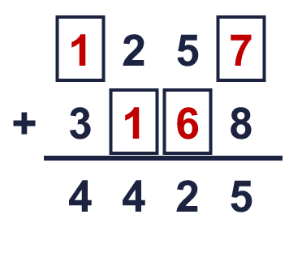  Missing digits, from top to bottom and left to right: 1 7 1 6
  9 | Work out the three additions.  a) 3,879 + 1,646 = 5,525  b) 3,879 + 1,666 = 5,545  c) 3,879 + 1,936 = 5,815  d) How much greater is the answer to c) than the answer to a)? 290
  10 | Is Boba correct? Circle yes or no.  Yes / No  What is the correct answer? 6,863  Explain Boba’s mistake.  5,585 + 1,278 = 6,863. Boba did not carry the 1 into the hundreds column.
  11 | Three friends play a computer game. Josh scores 1,284 points, Kim scores 2,227 points and Bobby scores 1,618 points.  a) How many points do they score altogether? 5,129  b) How many more points do Josh and Kim score together than Bobby? 1,893
  12 | A factory packs marbles into boxes. A large box holds 2,550 marbles, a medium box holds 1,950 and a small box holds 1,650.  a) How many marbles are in one large box and one small box? 4,200  b) How many marbles are in one box of each size? 6,150
  13 | Look at the bar model. Add the parts to find the whole.  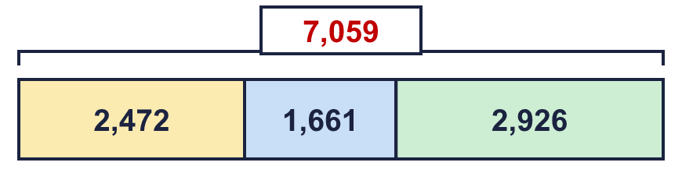  The whole is 7,059
  14 | Write two different additions of two 4-digit numbers that make exactly 9,000.  for example 4,000 + 5,000 and 3,500 + 5,500

