  Year 4 · Addition and subtraction · Step 1  Add and subtract 1s, 10s, 100s and 1,000s | 
  Year 4 · Addition and subtraction · Step 1
  Add and subtract 1s, 10s, 100s and 1,000s
  1 | Work out the additions. They all start with 4,331.  a) 4,331 + 2 =  b) 4,331 + 20 =  c) 4,331 + 400 =  d) 4,331 + 4,000 =
  1 | Work out the additions. They all start with 4,331.  a) 4,331 + 2 =  b) 4,331 + 20 =  c) 4,331 + 400 =  d) 4,331 + 4,000 =
  2 | Work out the subtractions. They all start with 5,897.  a) 5,897 − 4 =  b) 5,897 − 30 =  c) 5,897 − 400 =  d) 5,897 − 4,000 =
  2 | Work out the subtractions. They all start with 5,897.  a) 5,897 − 4 =  b) 5,897 − 30 =  c) 5,897 − 400 =  d) 5,897 − 4,000 =
  3 | Each addition needs an exchange. Work them out.  a) 5,326 + 8 =  b) 6,593 + 90 =  c) 8,849 + 500 =
  3 | Each addition needs an exchange. Work them out.  a) 5,326 + 8 =  b) 6,593 + 90 =  c) 8,849 + 500 =
  4 | Each subtraction needs an exchange. Work them out.  a) 8,353 − 8 =  b) 4,638 − 60 =  c) 6,037 − 100 =
  4 | Each subtraction needs an exchange. Work them out.  a) 8,353 − 8 =  b) 4,638 − 60 =  c) 6,037 − 100 =
  5 | Write the missing number in each calculation.
    a) | 7,974 + |  | = 8,274
    b) | 7,974 − |  | = 7,934
    c) |  | + 2,000 = 9,872
  5 | Write the missing number in each calculation.
    a) | 7,974 + |  | = 8,274
    b) | 7,974 − |  | = 7,934
    c) |  | + 2,000 = 9,872
  6 | Work out the calculations. Write the units in your answer.  a) £6,499 + £400 =  b) 5,116 g − 60 g =  c) 7,237 m + 2,000 m =
  6 | Work out the calculations. Write the units in your answer.  a) £6,499 + £400 =  b) 5,116 g − 60 g =  c) 7,237 m + 2,000 m =
  7 | Malachi has £5,065 in the bank.  a) He puts in £200 more. How much money does he have now?  b) Then he puts in £800 more. How much now?
  7 | Malachi has £5,065 in the bank.  a) He puts in £200 more. How much money does he have now?  b) Then he puts in £800 more. How much now?
  8 | These calculations change more than one column. Work them out.  a) 8,907 + 100 =  b) 3,991 + 10 =  c) 1,999 + 1 =  d) 4,000 − 1 =
  8 | These calculations change more than one column. Work them out.  a) 8,907 + 100 =  b) 3,991 + 10 =  c) 1,999 + 1 =  d) 4,000 − 1 =

  9 | Do you agree with Boba? Circle yes or no.  Yes / No  Explain your answer.
    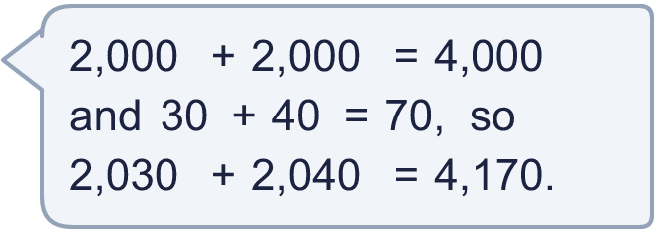
  9 | Do you agree with Boba? Circle yes or no.  Yes / No  Explain your answer.
  10 | Is each statement true? Circle yes or no.  a) Subtracting 99 is the same as subtracting 100 and taking away 1.  Yes / No  b) Subtracting 9 is the same as subtracting 10 and adding 1.  Yes / No
  10 | Is each statement true? Circle yes or no.  a) Subtracting 99 is the same as subtracting 100 and taking away 1.  Yes / No  b) Subtracting 9 is the same as subtracting 10 and adding 1.  Yes / No
  11 | Complete the calculations.  a) 38 + 48 =  b) 380 + 480 =  c) 3,800 + 4,800 =  d) How many times as big is the answer to c) as the answer to a)?
     | 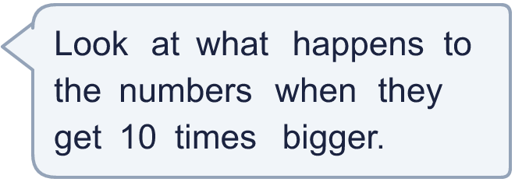
  11 | Complete the calculations.  a) 38 + 48 =  b) 380 + 480 =  c) 3,800 + 4,800 =  d) How many times as big is the answer to c) as the answer to a)?
  12 | Is Boba correct? Circle yes or no.  Yes / No  What is the correct answer?  Explain Boba’s mistake.
     | 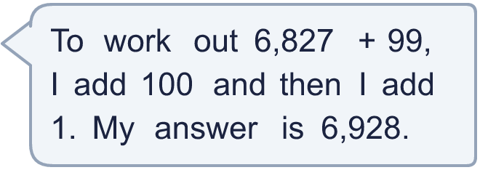
  12 | Is Boba correct? Circle yes or no.  Yes / No  What is the correct answer?  Explain Boba’s mistake.
  13 | What number did I start with?
    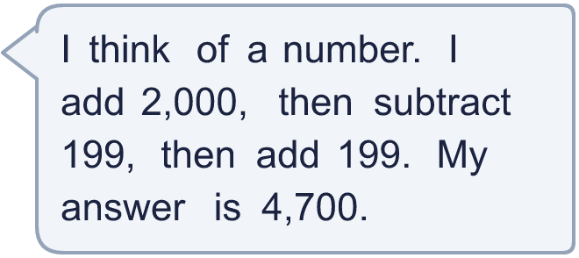
  13 | What number did I start with?
  14 | Write two different additions that add 99 to a 4-digit number. Each answer must be between 4,000 and 5,000.
  14 | Write two different additions that add 99 to a 4-digit number. Each answer must be between 4,000 and 5,000.

Year 4 · Addition and subtraction · Step 1
Add and subtract 1s, 10s, 100s and 1,000s
Answers (teacher copy)

  1 | Work out the additions. They all start with 4,331.  a) 4,331 + 2 = 4,333  b) 4,331 + 20 = 4,351  c) 4,331 + 400 = 4,731  d) 4,331 + 4,000 = 8,331
  2 | Work out the subtractions. They all start with 5,897.  a) 5,897 − 4 = 5,893  b) 5,897 − 30 = 5,867  c) 5,897 − 400 = 5,497  d) 5,897 − 4,000 = 1,897
  3 | Each addition needs an exchange. Work them out.  a) 5,326 + 8 = 5,334  b) 6,593 + 90 = 6,683  c) 8,849 + 500 = 9,349
  4 | Each subtraction needs an exchange. Work them out.  a) 8,353 − 8 = 8,345  b) 4,638 − 60 = 4,578  c) 6,037 − 100 = 5,937
  5 | Write the missing number in each calculation.  a) 7,974 + 300 = 8,274  b) 7,974 − 40 = 7,934  c) 7,872 + 2,000 = 9,872
  6 | Work out the calculations. Write the units in your answer.  a) £6,499 + £400 = £6,899  b) 5,116 g − 60 g = 5,056 g  c) 7,237 m + 2,000 m = 9,237 m
  7 | Malachi has £5,065 in the bank.  a) He puts in £200 more. How much money does he have now? £5,265  b) Then he puts in £800 more. How much now? £6,065
  8 | These calculations change more than one column. Work them out.  a) 8,907 + 100 = 9,007  b) 3,991 + 10 = 4,001  c) 1,999 + 1 = 2,000  d) 4,000 − 1 = 3,999
  9 | Do you agree with Boba? Circle yes or no.  Yes / No  Explain your answer.  2,030 + 2,040 = 4,070. 4,000 + 70 = 4,070.
  10 | Is each statement true? Circle yes or no.  a) Subtracting 99 is the same as subtracting 100 and taking away 1.  Yes / No  b) Subtracting 9 is the same as subtracting 10 and adding 1.  Yes / No
  11 | Complete the calculations.  a) 38 + 48 = 86  b) 380 + 480 = 860  c) 3,800 + 4,800 = 8,600  d) How many times as big is the answer to c) as the answer to a)? 100
  12 | Is Boba correct? Circle yes or no.  Yes / No  What is the correct answer? 6,926  Explain Boba’s mistake.  6,827 + 99 = 6,926. Boba should take away 1 after adding 100, not add 1.
  13 | What number did I start with? 2,700
  14 | Write two different additions that add 99 to a 4-digit number. Each answer must be between 4,000 and 5,000.  for example 3,910 + 99 = 4,009 and 4,400 + 99 = 4,499

