  Year 3 · Time · Step 6  Years, months and days | 
  Year 3 · Time · Step 6
  Years, months and days
  1 | How many days are there in each month?
    a) April: |  | days
    b) December: |  | days
    c) May: |  | days
  1 | How many days are there in each month?
    a) April: |  | days
    b) December: |  | days
    c) May: |  | days
  2 | Complete the statements.
    a) 8 years = |  | months
    b) 6 years = |  | months
    c) 3 years = |  | months
  2 | Complete the statements.
    a) 8 years = |  | months
    b) 6 years = |  | months
    c) 3 years = |  | months
  3 | Which of these months have 31 days? Write the letters.  A: October  B: November  C: August  D: September
  3 | Which of these months have 31 days? Write the letters.  A: October  B: November  C: August  D: September
  4 | How many days are there in February in the year 2027? (A leap year has 29 days in February.)
    February: |  | days
  4 | How many days are there in February in the year 2027? (A leap year has 29 days in February.)
    February: |  | days
  5 | Complete the statements.
    a) 108 months = |  | years
    b) 5 years = |  | months
    c) 60 months = |  | years
  5 | Complete the statements.
    a) 108 months = |  | years
    b) 5 years = |  | months
    c) 60 months = |  | years
  6 | Write the day of the week.
    a) 25 days before a Wednesday:
    b) 23 days before a Saturday:
  6 | Write the day of the week.
    a) 25 days before a Wednesday:
    b) 23 days before a Saturday:
  7 | Complete the statements.
    a) 3 weeks = |  | days
    b) 63 days = |  | weeks
    c) 4 weeks = |  | days
  7 | Complete the statements.
    a) 3 weeks = |  | days
    b) 63 days = |  | weeks
    c) 4 weeks = |  | days
  8 | How many days are there in each month?
    a) November: |  | days
    b) June: |  | days
    c) August: |  | days
  8 | How many days are there in each month?
    a) November: |  | days
    b) June: |  | days
    c) August: |  | days

  9 | Is Tiny correct? Circle yes or no.  Yes / No  Explain how you know.
     | 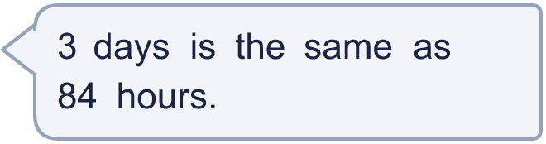
  9 | Is Tiny correct? Circle yes or no.  Yes / No  Explain how you know.
  10 | Which of these months have 31 days? Write the letters.  A: July  B: November  C: August  D: April
  10 | Which of these months have 31 days? Write the letters.  A: July  B: November  C: August  D: April
  11 | Dora watches a film that lasts 3 hours 30 minutes.
    How many minutes is that?
    minutes
  11 | Dora watches a film that lasts 3 hours 30 minutes.
    How many minutes is that?
    minutes
  12 | Is Boba correct? Circle yes or no.  Yes / No  Explain how you know.
    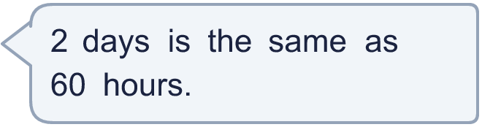
  12 | Is Boba correct? Circle yes or no.  Yes / No  Explain how you know.
  13 | Write the day of the week.
    a) 17 days after a Wednesday:
    b) 30 days after a Tuesday:
  13 | Write the day of the week.
    a) 17 days after a Wednesday:
    b) 30 days after a Tuesday:
  14 | How many days are there in February in the year 2020? (A leap year has 29 days in February.)
    February: |  | days
  14 | How many days are there in February in the year 2020? (A leap year has 29 days in February.)
    February: |  | days

Year 3 · Time · Step 6
Years, months and days
Answers (teacher copy)

  1 | How many days are there in each month?  a) April: 30 days  b) December: 31 days  c) May: 31 days
  2 | Complete the statements.  a) 8 years = 96 months  b) 6 years = 72 months  c) 3 years = 36 months
  3 | Which of these months have 31 days? Write the letters.  A: October  B: November  C: August  D: September  A, C
  4 | How many days are there in February in the year 2027? (A leap year has 29 days in February.)  February: 28 days
  5 | Complete the statements.  a) 108 months = 9 years  b) 5 years = 60 months  c) 60 months = 5 years
  6 | Write the day of the week.  a) 25 days before a Wednesday: Saturday  b) 23 days before a Saturday: Thursday
  7 | Complete the statements.  a) 3 weeks = 21 days  b) 63 days = 9 weeks  c) 4 weeks = 28 days
  8 | How many days are there in each month?  a) November: 30 days  b) June: 30 days  c) August: 31 days
  9 | Is Tiny correct? Circle yes or no.  Yes / No  Explain how you know.  3 days = 3 × 24 hours = 72 hours.
  10 | Which of these months have 31 days? Write the letters.  A: July  B: November  C: August  D: April  A, C
  11 | Dora watches a film that lasts 3 hours 30 minutes.  How many minutes is that? 210 minutes
  12 | Is Boba correct? Circle yes or no.  Yes / No  Explain how you know.  2 days = 2 × 24 hours = 48 hours.
  13 | Write the day of the week.  a) 17 days after a Wednesday: Saturday  b) 30 days after a Tuesday: Thursday
  14 | How many days are there in February in the year 2020? (A leap year has 29 days in February.)  February: 29 days

