  Year 3 · Time · Step 5  Use am and pm | 
  Year 3 · Time · Step 5
  Use am and pm
  1 | Write the time shown on each clock. Use am or pm.  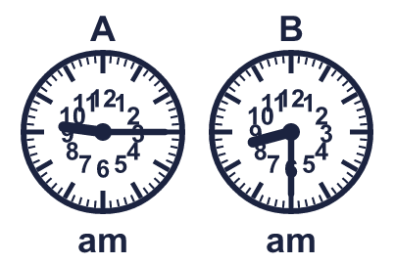
    A:
    B:
  1 | Write the time shown on each clock. Use am or pm.
    A:
    B:
  2 | Is each time in the morning or the afternoon? Write the word.  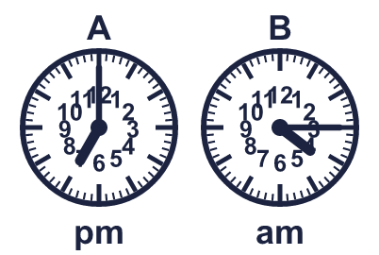
    A:
    B:
  2 | Is each time in the morning or the afternoon? Write the word.
    A:
    B:
  3 | Write each time as a digital time.
    a) quarter past 7:
    b) half past 1:
    c) quarter past 2:
  3 | Write each time as a digital time.
    a) quarter past 7:
    b) half past 1:
    c) quarter past 2:
  4 | Write the time shown on each clock. Use am or pm.  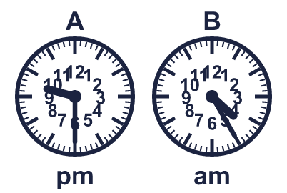
    A:
    B:
  4 | Write the time shown on each clock. Use am or pm.
    A:
    B:
  5 | A digital clock shows 1:15 am. Which analogue clock shows the same time? Write the letter.  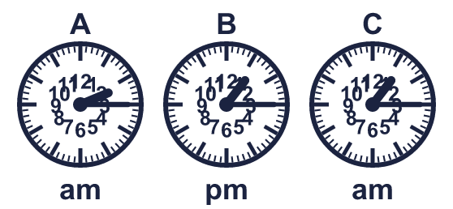
  5 | A digital clock shows 1:15 am. Which analogue clock shows the same time? Write the letter.
  6 | A swimming lesson starts at 7:50 am. It lasts 1 hour 45 minutes.  What time does it end?
  6 | A swimming lesson starts at 7:50 am. It lasts 1 hour 45 minutes.  What time does it end?
  7 | Is each time in the morning or the afternoon? Write the word.  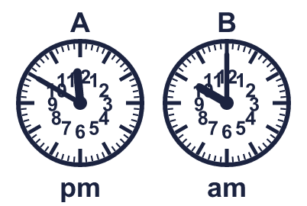
    A:
    B:
  7 | Is each time in the morning or the afternoon? Write the word.
    A:
    B:
  8 | Leo's lesson starts at 9:10 am and ends at 9:55 am.
    How many minutes does the lesson last?
    minutes
  8 | Leo's lesson starts at 9:10 am and ends at 9:55 am.
    How many minutes does the lesson last?
    minutes

  9 | 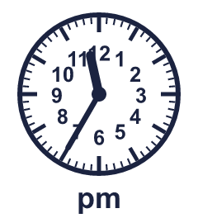  Is Boba correct? Circle yes or no.  Yes / No  Explain how you know.
     | 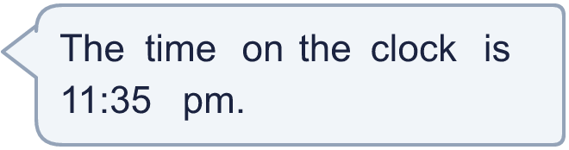
  9 | Is Boba correct? Circle yes or no.  Yes / No  Explain how you know.
  10 | Ron's lesson starts at 8:20 am and ends at 9:00 am.
    How many minutes does the lesson last?
    minutes
  10 | Ron's lesson starts at 8:20 am and ends at 9:00 am.
    How many minutes does the lesson last?
    minutes
  11 | Amir leaves home at the time shown on the clock. The journey takes 1 hour 35 minutes.  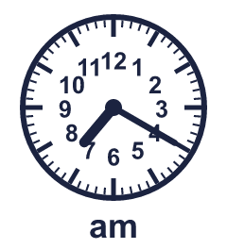  What time does Amir arrive?
  11 | Amir leaves home at the time shown on the clock. The journey takes 1 hour 35 minutes.  What time does Amir arrive?
  12 | Is Boba correct? Circle yes or no.  Yes / No  Explain how you know.
    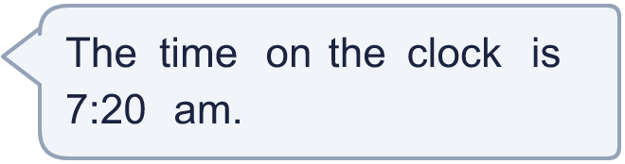
  12 | Is Boba correct? Circle yes or no.  Yes / No  Explain how you know.
  13 | A concert starts at 11:05 pm. It lasts 1 hour 50 minutes.  What time does it end?
  13 | A concert starts at 11:05 pm. It lasts 1 hour 50 minutes.  What time does it end?
  14 | 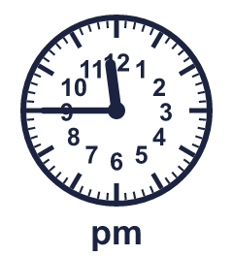  Is Boba correct? Circle yes or no.  Yes / No  Explain how you know.
    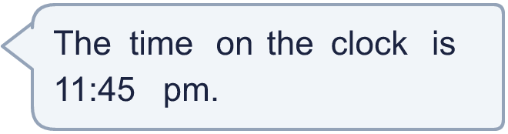
  14 | Is Boba correct? Circle yes or no.  Yes / No  Explain how you know.

Year 3 · Time · Step 5
Use am and pm
Answers (teacher copy)

  1 | Write the time shown on each clock. Use am or pm.  A: 9:15 am  B: 8:30 am
  2 | Is each time in the morning or the afternoon? Write the word.  A: afternoon  B: morning
  3 | Write each time as a digital time.  a) quarter past 7: 7:15  b) half past 1: 1:30  c) quarter past 2: 2:15
  4 | Write the time shown on each clock. Use am or pm.  A: 9:30 pm  B: 4:25 am
  5 | A digital clock shows 1:15 am. Which analogue clock shows the same time? Write the letter.  C
  6 | A swimming lesson starts at 7:50 am. It lasts 1 hour 45 minutes.  What time does it end? 9:35 am
  7 | Is each time in the morning or the afternoon? Write the word.  A: afternoon  B: morning
  8 | Leo's lesson starts at 9:10 am and ends at 9:55 am.  How many minutes does the lesson last? 45 minutes
  9 | Is Boba correct? Circle yes or no.  Yes / No  Explain how you know.  The hour hand is just past 11 and the minute hand shows 35 minutes, so the time is 11:35 pm.
  10 | Ron's lesson starts at 8:20 am and ends at 9:00 am.  How many minutes does the lesson last? 40 minutes
  11 | Amir leaves home at the time shown on the clock. The journey takes 1 hour 35 minutes.  What time does Amir arrive? 8:55 am
  12 | Is Boba correct? Circle yes or no.  Yes / No  Explain how you know.  The hour hand is just past 7 and the minute hand shows 20 minutes, so the time is 7:20 am.
  13 | A concert starts at 11:05 pm. It lasts 1 hour 50 minutes.  What time does it end? 12:55 am
  14 | Is Boba correct? Circle yes or no.  Yes / No  Explain how you know.  The hour hand is just past 11 and the minute hand shows 45 minutes, so the time is 11:45 pm.

