  Year 3 · Time · Step 3  Tell the time to the nearest minute | 
  Year 3 · Time · Step 3
  Tell the time to the nearest minute
  1 | Write the time shown on each clock.  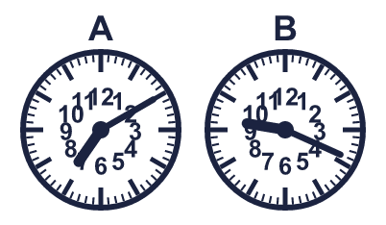
    A:
    B:
  1 | Write the time shown on each clock.
    A:
    B:
  2 | Write each time as a digital time.
    a) 25 minutes past 1:
    b) quarter to 3:
    c) 5 minutes to 12:
  2 | Write each time as a digital time.
    a) 25 minutes past 1:
    b) quarter to 3:
    c) 5 minutes to 12:
  3 | A digital clock shows 3:13 pm. Which analogue clock shows the same time? Write the letter.  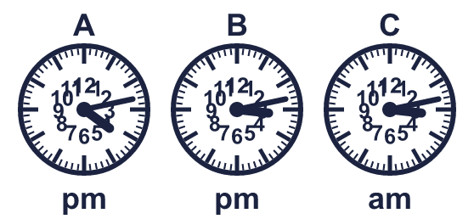
  3 | A digital clock shows 3:13 pm. Which analogue clock shows the same time? Write the letter.
  4 | Nina's lesson starts at 9:05 am and ends at 9:40 am.
    How many minutes does the lesson last?
    minutes
  4 | Nina's lesson starts at 9:05 am and ends at 9:40 am.
    How many minutes does the lesson last?
    minutes
  5 | Write the time shown on each clock.  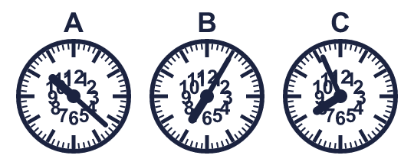
    A:
    B:
    C:
  5 | Write the time shown on each clock.
    A:
    B:
    C:
  6 | A football match starts at 9:05 am. It lasts 2 hours 5 minutes.  What time does it end?
  6 | A football match starts at 9:05 am. It lasts 2 hours 5 minutes.  What time does it end?
  7 | Write the time shown on each clock.  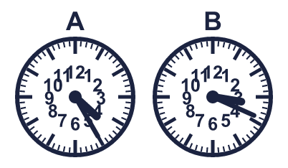
    A:
    B:
  7 | Write the time shown on each clock.
    A:
    B:
  8 | Write each time as a digital time.
    a) quarter past 12:
    b) 5 minutes to 9:
    c) quarter past 2:
  8 | Write each time as a digital time.
    a) quarter past 12:
    b) 5 minutes to 9:
    c) quarter past 2:

  9 | 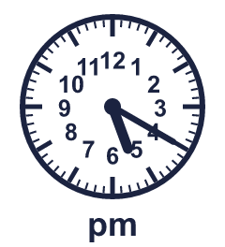  Is Boba correct? Circle yes or no.  Yes / No  Explain how you know.
     | 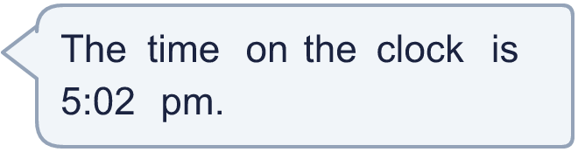
  9 | Is Boba correct? Circle yes or no.  Yes / No  Explain how you know.
  10 | Zach's lesson starts at 10:40 am and ends at 11:20 am.
    How many minutes does the lesson last?
    minutes
  10 | Zach's lesson starts at 10:40 am and ends at 11:20 am.
    How many minutes does the lesson last?
    minutes
  11 | 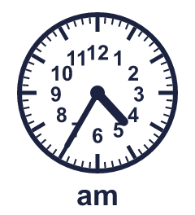  Is Boba correct? Circle yes or no.  Yes / No  Explain how you know.
    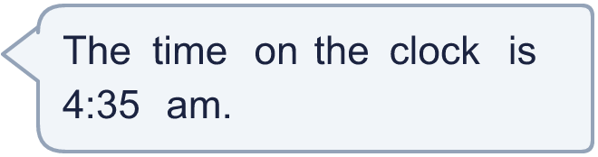
  11 | Is Boba correct? Circle yes or no.  Yes / No  Explain how you know.
  12 | Ron leaves home at the time shown on the clock. The journey takes 45 minutes.  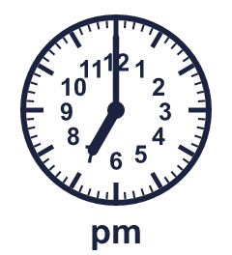  What time does Ron arrive?
  12 | Ron leaves home at the time shown on the clock. The journey takes 45 minutes.  What time does Ron arrive?
  13 | 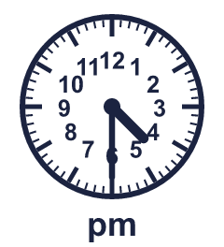  Is Boba correct? Circle yes or no.  Yes / No  Explain how you know.
    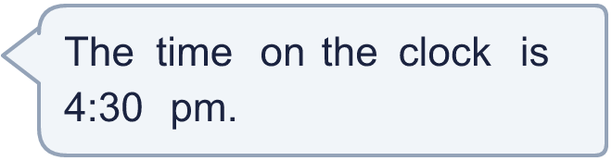
  13 | Is Boba correct? Circle yes or no.  Yes / No  Explain how you know.
  14 | Write the time shown on each clock.  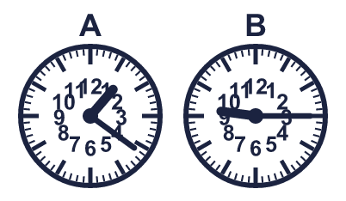
    A:
    B:
  14 | Write the time shown on each clock.
    A:
    B:

Year 3 · Time · Step 3
Tell the time to the nearest minute
Answers (teacher copy)

  1 | Write the time shown on each clock.  A: 7:10  B: 9:19
  2 | Write each time as a digital time.  a) 25 minutes past 1: 1:25  b) quarter to 3: 2:45  c) 5 minutes to 12: 11:55
  3 | A digital clock shows 3:13 pm. Which analogue clock shows the same time? Write the letter.  B
  4 | Nina's lesson starts at 9:05 am and ends at 9:40 am.  How many minutes does the lesson last? 35 minutes
  5 | Write the time shown on each clock.  A: 10:22  B: 7:05  C: 7:56
  6 | A football match starts at 9:05 am. It lasts 2 hours 5 minutes.  What time does it end? 11:10 am
  7 | Write the time shown on each clock.  A: 4:25  B: 3:19
  8 | Write each time as a digital time.  a) quarter past 12: 12:15  b) 5 minutes to 9: 8:55  c) quarter past 2: 2:15
  9 | Is Boba correct? Circle yes or no.  Yes / No  Explain how you know.  The hour hand is just past 5 and the minute hand shows 20 minutes, so the time is 5:20 pm.
  10 | Zach's lesson starts at 10:40 am and ends at 11:20 am.  How many minutes does the lesson last? 40 minutes
  11 | Is Boba correct? Circle yes or no.  Yes / No  Explain how you know.  The hour hand is just past 4 and the minute hand shows 35 minutes, so the time is 4:35 am.
  12 | Ron leaves home at the time shown on the clock. The journey takes 45 minutes.  What time does Ron arrive? 7:45 pm
  13 | Is Boba correct? Circle yes or no.  Yes / No  Explain how you know.  The hour hand is just past 4 and the minute hand shows 30 minutes, so the time is 4:30 pm.
  14 | Write the time shown on each clock.  A: 1:21  B: 9:15

