  Year 3 · Time · Step 2  Tell the time to 5 minutes | 
  Year 3 · Time · Step 2
  Tell the time to 5 minutes
  1 | Write the time shown on each clock.  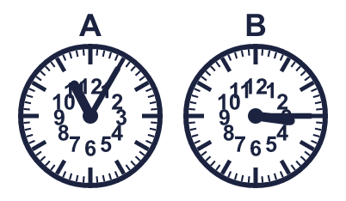
    A:
    B:
  1 | Write the time shown on each clock.
    A:
    B:
  2 | Write each time as a digital time.
    a) half past 8:
    b) 20 minutes past 8:
    c) 20 minutes to 10:
  2 | Write each time as a digital time.
    a) half past 8:
    b) 20 minutes past 8:
    c) 20 minutes to 10:
  3 | A digital clock shows 3:45 am. Which analogue clock shows the same time? Write the letter.  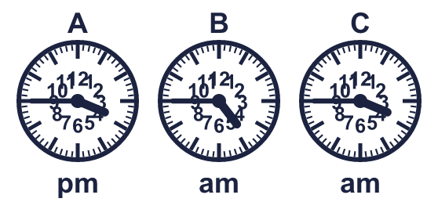
  3 | A digital clock shows 3:45 am. Which analogue clock shows the same time? Write the letter.
  4 | Mo's lesson starts at 10:10 am and ends at 11:05 am.
    How many minutes does the lesson last?
    minutes
  4 | Mo's lesson starts at 10:10 am and ends at 11:05 am.
    How many minutes does the lesson last?
    minutes
  5 | Write the time shown on each clock.  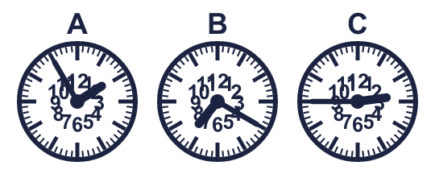
    A:
    B:
    C:
  5 | Write the time shown on each clock.
    A:
    B:
    C:
  6 | Write each time as a digital time.
    a) half past 3:
    b) half past 2:
    c) quarter to 5:
  6 | Write each time as a digital time.
    a) half past 3:
    b) half past 2:
    c) quarter to 5:
  7 | A film starts at 11:50 pm. It lasts 2 hours 10 minutes.  What time does it end?
  7 | A film starts at 11:50 pm. It lasts 2 hours 10 minutes.  What time does it end?
  8 | Write the time shown on each clock.  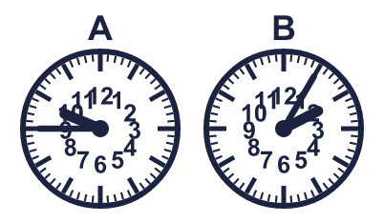
    A:
    B:
  8 | Write the time shown on each clock.
    A:
    B:

  9 | 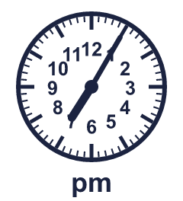  Is Boba correct? Circle yes or no.  Yes / No  Explain how you know.
     | 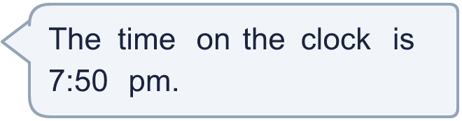
  9 | Is Boba correct? Circle yes or no.  Yes / No  Explain how you know.
  10 | Ron's lesson starts at 8:25 am and ends at 9:05 am.
    How many minutes does the lesson last?
    minutes
  10 | Ron's lesson starts at 8:25 am and ends at 9:05 am.
    How many minutes does the lesson last?
    minutes
  11 | 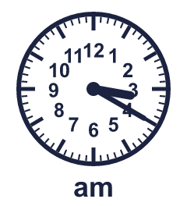  Is Boba correct? Circle yes or no.  Yes / No  Explain how you know.
    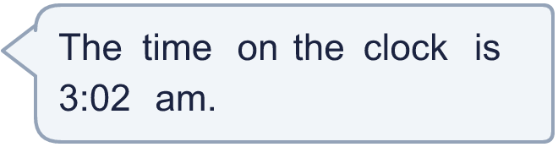
  11 | Is Boba correct? Circle yes or no.  Yes / No  Explain how you know.
  12 | Kim leaves home at the time shown on the clock. The journey takes 45 minutes.  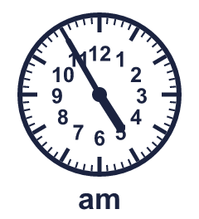  What time does Kim arrive?
  12 | Kim leaves home at the time shown on the clock. The journey takes 45 minutes.  What time does Kim arrive?
  13 | 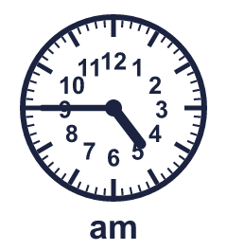  Is Boba correct? Circle yes or no.  Yes / No  Explain how you know.
    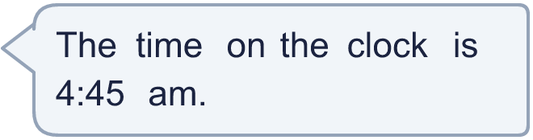
  13 | Is Boba correct? Circle yes or no.  Yes / No  Explain how you know.
  14 | Write each time as a digital time.
    a) quarter to 1:
    b) 20 minutes past 6:
    c) quarter past 2:
  14 | Write each time as a digital time.
    a) quarter to 1:
    b) 20 minutes past 6:
    c) quarter past 2:

Year 3 · Time · Step 2
Tell the time to 5 minutes
Answers (teacher copy)

  1 | Write the time shown on each clock.  A: 11:05  B: 3:15
  2 | Write each time as a digital time.  a) half past 8: 8:30  b) 20 minutes past 8: 8:20  c) 20 minutes to 10: 9:40
  3 | A digital clock shows 3:45 am. Which analogue clock shows the same time? Write the letter.  C
  4 | Mo's lesson starts at 10:10 am and ends at 11:05 am.  How many minutes does the lesson last? 55 minutes
  5 | Write the time shown on each clock.  A: 1:55  B: 7:20  C: 2:45
  6 | Write each time as a digital time.  a) half past 3: 3:30  b) half past 2: 2:30  c) quarter to 5: 4:45
  7 | A film starts at 11:50 pm. It lasts 2 hours 10 minutes.  What time does it end? 2:00 am
  8 | Write the time shown on each clock.  A: 9:45  B: 2:05
  9 | Is Boba correct? Circle yes or no.  Yes / No  Explain how you know.  The hour hand is just past 7 and the minute hand shows 5 minutes, so the time is 7:05 pm.
  10 | Ron's lesson starts at 8:25 am and ends at 9:05 am.  How many minutes does the lesson last? 40 minutes
  11 | Is Boba correct? Circle yes or no.  Yes / No  Explain how you know.  The hour hand is just past 3 and the minute hand shows 20 minutes, so the time is 3:20 am.
  12 | Kim leaves home at the time shown on the clock. The journey takes 45 minutes.  What time does Kim arrive? 5:40 am
  13 | Is Boba correct? Circle yes or no.  Yes / No  Explain how you know.  The hour hand is just past 4 and the minute hand shows 45 minutes, so the time is 4:45 am.
  14 | Write each time as a digital time.  a) quarter to 1: 12:45  b) 20 minutes past 6: 6:20  c) quarter past 2: 2:15

