  Year 3 · Time · Step 12  Solve problems with time | 
  Year 3 · Time · Step 12
  Solve problems with time
  1 | A concert starts at 8:45 pm. It lasts 50 minutes.  What time does it end?
  1 | A concert starts at 8:45 pm. It lasts 50 minutes.  What time does it end?
  2 | How much time passes between the start and the end? Write the hours and minutes.
    a) 9:30 am to 2:25 pm: |  | hours
    minutes
    b) 10:05 am to 1:10 pm: |  | hours
    minutes
  2 | How much time passes between the start and the end? Write the hours and minutes.
    a) 9:30 am to 2:25 pm: |  | hours
    minutes
    b) 10:05 am to 1:10 pm: |  | hours
    minutes
  3 | Tom watches a football match that lasts 2 hours 30 minutes.
    How many minutes is that?
    minutes
  3 | Tom watches a football match that lasts 2 hours 30 minutes.
    How many minutes is that?
    minutes
  4 | A film ends at 11:05 am. It lasted 1 hour 45 minutes.  What time did it start?
  4 | A film ends at 11:05 am. It lasted 1 hour 45 minutes.  What time did it start?
  5 | Amir leaves home at the time shown on the clock. The journey takes 1 hour 35 minutes.  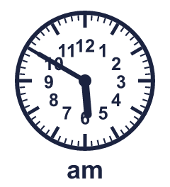  What time does Amir arrive?
  5 | Amir leaves home at the time shown on the clock. The journey takes 1 hour 35 minutes.  What time does Amir arrive?
  6 | Zach takes 5 minutes 15 seconds to run round a field.
    How many seconds is that?
    seconds
  6 | Zach takes 5 minutes 15 seconds to run round a field.
    How many seconds is that?
    seconds
  7 | Mo's lesson starts at 11:15 am and ends at 11:50 am.
    How many minutes does the lesson last?
    minutes
  7 | Mo's lesson starts at 11:15 am and ends at 11:50 am.
    How many minutes does the lesson last?
    minutes
  8 | Complete the statements.
    a) 3 hours 30 minutes =
    minutes
    b) 2 hours 45 minutes =
    minutes
    c) 1 hour 15 minutes =
    minutes
  8 | Complete the statements.
    a) 3 hours 30 minutes =
    minutes
    b) 2 hours 45 minutes =
    minutes
    c) 1 hour 15 minutes =
    minutes

  9 | Is Tiny correct? Circle yes or no.  Yes / No  Explain how you know.
     | 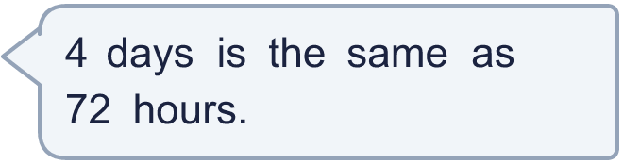
  9 | Is Tiny correct? Circle yes or no.  Yes / No  Explain how you know.
  10 | A concert starts at 7:35 pm. It lasts 1 hour 35 minutes.  What time does it end?
  10 | A concert starts at 7:35 pm. It lasts 1 hour 35 minutes.  What time does it end?
  11 | How much time passes between the start and the end? Write the hours and minutes.
    a) 8:30 am to 2:20 pm: |  | hours
    minutes
  11 | How much time passes between the start and the end? Write the hours and minutes.
    a) 8:30 am to 2:20 pm: |  | hours
    minutes
  12 | Dora watches a bus journey that lasts 2 hours 10 minutes.
    How many minutes is that?
    minutes
  12 | Dora watches a bus journey that lasts 2 hours 10 minutes.
    How many minutes is that?
    minutes
  13 | Kim leaves home at the time shown on the clock. The journey takes 50 minutes.  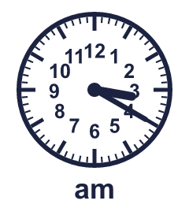  What time does Kim arrive?
  13 | Kim leaves home at the time shown on the clock. The journey takes 50 minutes.  What time does Kim arrive?
  14 | Is Boba correct? Circle yes or no.  Yes / No  Explain how you know.
    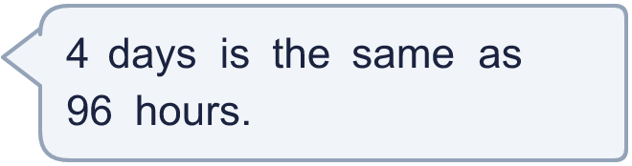
  14 | Is Boba correct? Circle yes or no.  Yes / No  Explain how you know.

Year 3 · Time · Step 12
Solve problems with time
Answers (teacher copy)

  1 | A concert starts at 8:45 pm. It lasts 50 minutes.  What time does it end? 9:35 pm
  2 | How much time passes between the start and the end? Write the hours and minutes.  a) 9:30 am to 2:25 pm: 4 hours 55 minutes  b) 10:05 am to 1:10 pm: 3 hours 5 minutes
  3 | Tom watches a football match that lasts 2 hours 30 minutes.  How many minutes is that? 150 minutes
  4 | A film ends at 11:05 am. It lasted 1 hour 45 minutes.  What time did it start? 9:20 am
  5 | Amir leaves home at the time shown on the clock. The journey takes 1 hour 35 minutes.  What time does Amir arrive? 7:25 am
  6 | Zach takes 5 minutes 15 seconds to run round a field.  How many seconds is that? 315 seconds
  7 | Mo's lesson starts at 11:15 am and ends at 11:50 am.  How many minutes does the lesson last? 35 minutes
  8 | Complete the statements.  a) 3 hours 30 minutes = 210 minutes  b) 2 hours 45 minutes = 165 minutes  c) 1 hour 15 minutes = 75 minutes
  9 | Is Tiny correct? Circle yes or no.  Yes / No  Explain how you know.  4 days = 4 × 24 hours = 96 hours.
  10 | A concert starts at 7:35 pm. It lasts 1 hour 35 minutes.  What time does it end? 9:10 pm
  11 | How much time passes between the start and the end? Write the hours and minutes.  a) 8:30 am to 2:20 pm: 5 hours 50 minutes
  12 | Dora watches a bus journey that lasts 2 hours 10 minutes.  How many minutes is that? 130 minutes
  13 | Kim leaves home at the time shown on the clock. The journey takes 50 minutes.  What time does Kim arrive? 4:10 am
  14 | Is Boba correct? Circle yes or no.  Yes / No  Explain how you know.  4 days = 4 × 24 hours = 96 hours.

