  Year 3 · Time · Step 1  Roman numerals to 12 | 
  Year 3 · Time · Step 1
  Roman numerals to 12
  1 | Write each number in Roman numerals.
    a) | 3
    b) | 2
    c) | 6
  1 | Write each number in Roman numerals.
    a) | 3
    b) | 2
    c) | 6
  2 | Write each Roman numeral as a number.
    a) | III
    b) | I
    c) | IV
  2 | Write each Roman numeral as a number.
    a) | III
    b) | I
    c) | IV
  3 | Write each number in Roman numerals.
    a) | 11
    b) | 5
    c) | 1
  3 | Write each number in Roman numerals.
    a) | 11
    b) | 5
    c) | 1
  4 | Write each Roman numeral as a number.
    a) | V
    b) | X
    c) | XII
  4 | Write each Roman numeral as a number.
    a) | V
    b) | X
    c) | XII
  5 | Write each number in Roman numerals.
    a) | 6
    b) | 10
    c) | 9
  5 | Write each number in Roman numerals.
    a) | 6
    b) | 10
    c) | 9
  6 | Write each Roman numeral as a number.
    a) | X
    b) | IX
    c) | VI
  6 | Write each Roman numeral as a number.
    a) | X
    b) | IX
    c) | VI
  7 | Write each number in Roman numerals.
    a) | 5
    b) | 8
    c) | 1
  7 | Write each number in Roman numerals.
    a) | 5
    b) | 8
    c) | 1
  8 | Write each Roman numeral as a number.
    a) | X
    b) | XII
    c) | III
  8 | Write each Roman numeral as a number.
    a) | X
    b) | XII
    c) | III

  9 | Is Boba correct? Circle yes or no.  Yes / No  Explain how you know.
     | 
  9 | Is Boba correct? Circle yes or no.  Yes / No  Explain how you know.
  10 | Is Boba correct? Circle yes or no.  Yes / No  Explain how you know.
    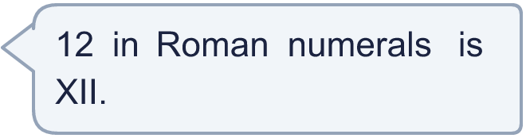
  10 | Is Boba correct? Circle yes or no.  Yes / No  Explain how you know.
  11 | Write each number in Roman numerals.
    a) | 5
    b) | 10
    c) | 4
  11 | Write each number in Roman numerals.
    a) | 5
    b) | 10
    c) | 4
  12 | Is Boba correct? Circle yes or no.  Yes / No  Explain how you know.
    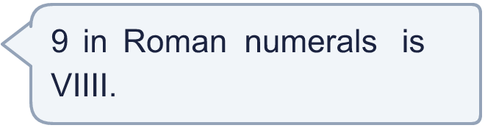
  12 | Is Boba correct? Circle yes or no.  Yes / No  Explain how you know.
  13 | Write each Roman numeral as a number.
    a) | XI
    b) | IX
    c) | XII
  13 | Write each Roman numeral as a number.
    a) | XI
    b) | IX
    c) | XII
  14 | Is Tiny correct? Circle yes or no.  Yes / No  Explain how you know.
    
  14 | Is Tiny correct? Circle yes or no.  Yes / No  Explain how you know.

Year 3 · Time · Step 1
Roman numerals to 12
Answers (teacher copy)

  1 | Write each number in Roman numerals.  a) 3 III  b) 2 II  c) 6 VI
  2 | Write each Roman numeral as a number.  a) III 3  b) I 1  c) IV 4
  3 | Write each number in Roman numerals.  a) 11 XI  b) 5 V  c) 1 I
  4 | Write each Roman numeral as a number.  a) V 5  b) X 10  c) XII 12
  5 | Write each number in Roman numerals.  a) 6 VI  b) 10 X  c) 9 IX
  6 | Write each Roman numeral as a number.  a) X 10  b) IX 9  c) VI 6
  7 | Write each number in Roman numerals.  a) 5 V  b) 8 VIII  c) 1 I
  8 | Write each Roman numeral as a number.  a) X 10  b) XII 12  c) III 3
  9 | Is Boba correct? Circle yes or no.  Yes / No  Explain how you know.  5 in Roman numerals is V.
  10 | Is Boba correct? Circle yes or no.  Yes / No  Explain how you know.  12 in Roman numerals is XII.
  11 | Write each number in Roman numerals.  a) 5 V  b) 10 X  c) 4 IV
  12 | Is Boba correct? Circle yes or no.  Yes / No  Explain how you know.  9 in Roman numerals is IX.
  13 | Write each Roman numeral as a number.  a) XI 11  b) IX 9  c) XII 12
  14 | Is Tiny correct? Circle yes or no.  Yes / No  Explain how you know.  10 in Roman numerals is X.

