  Year 3 · Time · Step 4  Read time on a digital clock | 
  Year 3 · Time · Step 4
  Read time on a digital clock
  1 | A digital clock shows 2:20 am. Which analogue clock shows the same time? Write the letter.  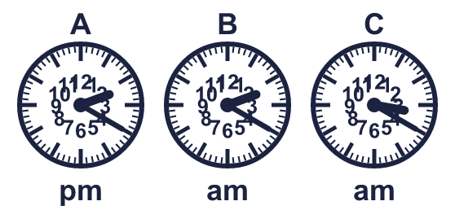
  1 | A digital clock shows 2:20 am. Which analogue clock shows the same time? Write the letter.
  2 | Write each time as a digital time.
    a) 5 minutes past 1:
    b) 5 minutes to 7:
    c) quarter past 3:
  2 | Write each time as a digital time.
    a) 5 minutes past 1:
    b) 5 minutes to 7:
    c) quarter past 3:
  3 | A digital clock shows 7:30 pm. Which analogue clock shows the same time? Write the letter.  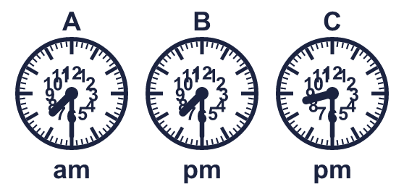
  3 | A digital clock shows 7:30 pm. Which analogue clock shows the same time? Write the letter.
  4 | Write each time as a digital time.
    a) quarter past 2:
    b) quarter past 5:
    c) quarter to 2:
  4 | Write each time as a digital time.
    a) quarter past 2:
    b) quarter past 5:
    c) quarter to 2:
  5 | Max's lesson starts at 10:15 am and ends at 10:50 am.
    How many minutes does the lesson last?
    minutes
  5 | Max's lesson starts at 10:15 am and ends at 10:50 am.
    How many minutes does the lesson last?
    minutes
  6 | Write the time shown on each clock.  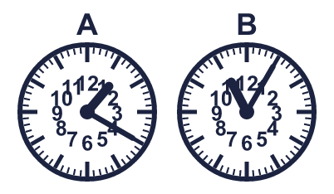
    A:
    B:
  6 | Write the time shown on each clock.
    A:
    B:
  7 | A football match starts at 7:45 pm. It lasts 1 hour 20 minutes.  What time does it end?
  7 | A football match starts at 7:45 pm. It lasts 1 hour 20 minutes.  What time does it end?
  8 | A digital clock shows 4:30 am. Which analogue clock shows the same time? Write the letter.  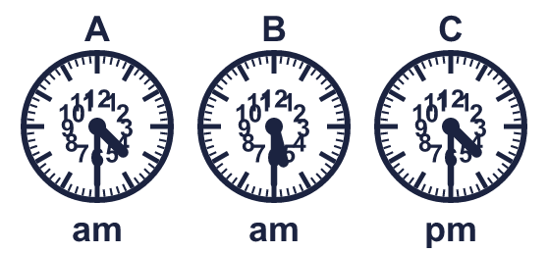
  8 | A digital clock shows 4:30 am. Which analogue clock shows the same time? Write the letter.

  9 | 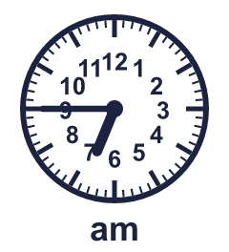  Is Boba correct? Circle yes or no.  Yes / No  Explain how you know.
     | 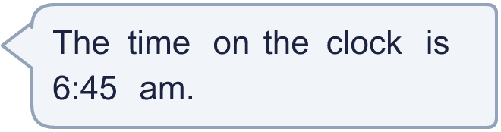
  9 | Is Boba correct? Circle yes or no.  Yes / No  Explain how you know.
  10 | Leo leaves home at the time shown on the clock. The journey takes 1 hour 45 minutes.  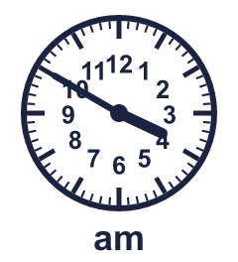  What time does Leo arrive?
  10 | Leo leaves home at the time shown on the clock. The journey takes 1 hour 45 minutes.  What time does Leo arrive?
  11 | 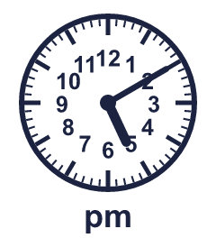  Is Boba correct? Circle yes or no.  Yes / No  Explain how you know.
    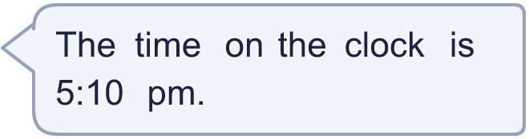
  11 | Is Boba correct? Circle yes or no.  Yes / No  Explain how you know.
  12 | Filip's lesson starts at 11:10 am and ends at 12:00 pm.
    How many minutes does the lesson last?
    minutes
  12 | Filip's lesson starts at 11:10 am and ends at 12:00 pm.
    How many minutes does the lesson last?
    minutes
  13 | A digital clock shows 10:05 pm. Which analogue clock shows the same time? Write the letter.  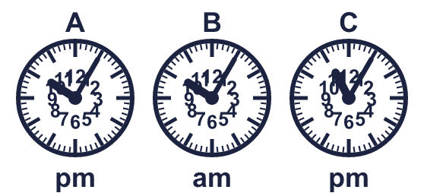
  13 | A digital clock shows 10:05 pm. Which analogue clock shows the same time? Write the letter.
  14 | 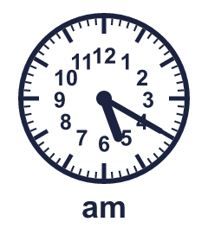  Is Boba correct? Circle yes or no.  Yes / No  Explain how you know.
    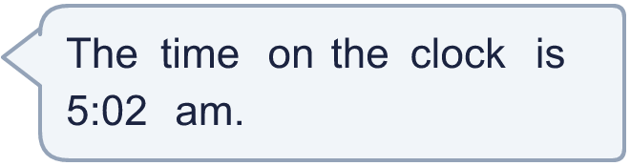
  14 | Is Boba correct? Circle yes or no.  Yes / No  Explain how you know.

Year 3 · Time · Step 4
Read time on a digital clock
Answers (teacher copy)

  1 | A digital clock shows 2:20 am. Which analogue clock shows the same time? Write the letter.  B
  2 | Write each time as a digital time.  a) 5 minutes past 1: 1:05  b) 5 minutes to 7: 6:55  c) quarter past 3: 3:15
  3 | A digital clock shows 7:30 pm. Which analogue clock shows the same time? Write the letter.  B
  4 | Write each time as a digital time.  a) quarter past 2: 2:15  b) quarter past 5: 5:15  c) quarter to 2: 1:45
  5 | Max's lesson starts at 10:15 am and ends at 10:50 am.  How many minutes does the lesson last? 35 minutes
  6 | Write the time shown on each clock.  A: 1:20  B: 11:05
  7 | A football match starts at 7:45 pm. It lasts 1 hour 20 minutes.  What time does it end? 9:05 pm
  8 | A digital clock shows 4:30 am. Which analogue clock shows the same time? Write the letter.  A
  9 | Is Boba correct? Circle yes or no.  Yes / No  Explain how you know.  The hour hand is just past 6 and the minute hand shows 45 minutes, so the time is 6:45 am.
  10 | Leo leaves home at the time shown on the clock. The journey takes 1 hour 45 minutes.  What time does Leo arrive? 5:35 am
  11 | Is Boba correct? Circle yes or no.  Yes / No  Explain how you know.  The hour hand is just past 5 and the minute hand shows 10 minutes, so the time is 5:10 pm.
  12 | Filip's lesson starts at 11:10 am and ends at 12:00 pm.  How many minutes does the lesson last? 50 minutes
  13 | A digital clock shows 10:05 pm. Which analogue clock shows the same time? Write the letter.  A
  14 | Is Boba correct? Circle yes or no.  Yes / No  Explain how you know.  The hour hand is just past 5 and the minute hand shows 20 minutes, so the time is 5:20 am.

