  Year 3 · Time · Step 10  Minutes and seconds | 
  Year 3 · Time · Step 10
  Minutes and seconds
  1 | Complete the statements.
    a) 3 minutes = |  | seconds
    b) 2 minutes = |  | seconds
    c) 6 minutes = |  | seconds
  1 | Complete the statements.
    a) 3 minutes = |  | seconds
    b) 2 minutes = |  | seconds
    c) 6 minutes = |  | seconds
  2 | Complete the statements.
    a) 240 seconds = |  | minutes
    b) 540 seconds = |  | minutes
    c) 120 seconds = |  | minutes
  2 | Complete the statements.
    a) 240 seconds = |  | minutes
    b) 540 seconds = |  | minutes
    c) 120 seconds = |  | minutes
  3 | Work out the minutes and seconds.
    210 seconds = |  | minutes
    seconds
  3 | Work out the minutes and seconds.
    210 seconds = |  | minutes
    seconds
  4 | Complete the statements.
    a) 4 minutes 20 seconds =
    seconds
    b) 3 minutes 15 seconds =
    seconds
    c) 1 minute 30 seconds =
    seconds
  4 | Complete the statements.
    a) 4 minutes 20 seconds =
    seconds
    b) 3 minutes 15 seconds =
    seconds
    c) 1 minute 30 seconds =
    seconds
  5 | Complete the statements.
    a) 9 minutes = |  | seconds
    b) 420 seconds = |  | minutes
    c) 4 minutes = |  | seconds
  5 | Complete the statements.
    a) 9 minutes = |  | seconds
    b) 420 seconds = |  | minutes
    c) 4 minutes = |  | seconds
  6 | Work out the minutes and seconds.
    280 seconds = |  | minutes
    seconds
  6 | Work out the minutes and seconds.
    280 seconds = |  | minutes
    seconds
  7 | Write <, > or = in each box.
    a) | 6 weeks |  | 41 days
    b) | 7 minutes |  | 420 seconds
    c) | 5 hours |  | 320 minutes
  7 | Write <, > or = in each box.
    a) | 6 weeks |  | 41 days
    b) | 7 minutes |  | 420 seconds
    c) | 5 hours |  | 320 minutes
  8 | Write the lengths of time in order, starting with the shortest.  165 seconds 1 hour 42 minutes 1 hour 29 minutes 2 hours
  8 | Write the lengths of time in order, starting with the shortest.  165 seconds 1 hour 42 minutes 1 hour 29 minutes 2 hours

  9 | Is Boba correct? Circle yes or no.  Yes / No  Explain how you know.
     | 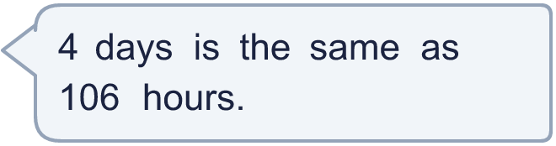
  9 | Is Boba correct? Circle yes or no.  Yes / No  Explain how you know.
  10 | Tom takes 2 minutes 30 seconds to run round a field.
    How many seconds is that?
    seconds
  10 | Tom takes 2 minutes 30 seconds to run round a field.
    How many seconds is that?
    seconds
  11 | Write <, > or = in each box.
    a) | 3 hours |  | 180 minutes
    b) | 3 minutes |  | 170 seconds
    c) | 7 hours |  | 430 minutes
  11 | Write <, > or = in each box.
    a) | 3 hours |  | 180 minutes
    b) | 3 minutes |  | 170 seconds
    c) | 7 hours |  | 430 minutes
  12 | Is Boba correct? Circle yes or no.  Yes / No  Explain how you know.
    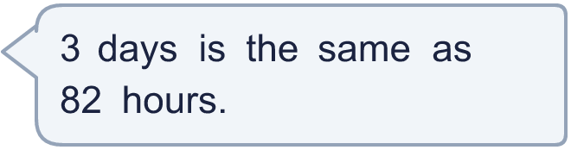
  12 | Is Boba correct? Circle yes or no.  Yes / No  Explain how you know.
  13 | Zach takes 4 minutes 45 seconds to run round a field.
    How many seconds is that?
    seconds
  13 | Zach takes 4 minutes 45 seconds to run round a field.
    How many seconds is that?
    seconds
  14 | Work out the minutes and seconds.
    320 seconds = |  | minutes
    seconds
  14 | Work out the minutes and seconds.
    320 seconds = |  | minutes
    seconds

Year 3 · Time · Step 10
Minutes and seconds
Answers (teacher copy)

  1 | Complete the statements.  a) 3 minutes = 180 seconds  b) 2 minutes = 120 seconds  c) 6 minutes = 360 seconds
  2 | Complete the statements.  a) 240 seconds = 4 minutes  b) 540 seconds = 9 minutes  c) 120 seconds = 2 minutes
  3 | Work out the minutes and seconds.  210 seconds = 3 minutes 30 seconds
  4 | Complete the statements.  a) 4 minutes 20 seconds = 260 seconds  b) 3 minutes 15 seconds = 195 seconds  c) 1 minute 30 seconds = 90 seconds
  5 | Complete the statements.  a) 9 minutes = 540 seconds  b) 420 seconds = 7 minutes  c) 4 minutes = 240 seconds
  6 | Work out the minutes and seconds.  280 seconds = 4 minutes 40 seconds
  7 | Write <, > or = in each box.  a) 6 weeks > 41 days  b) 7 minutes = 420 seconds  c) 5 hours < 320 minutes
  8 | Write the lengths of time in order, starting with the shortest.  165 seconds 1 hour 42 minutes 1 hour 29 minutes 2 hours  165 seconds, 1 hour 29 minutes, 1 hour 42 minutes, 2 hours
  9 | Is Boba correct? Circle yes or no.  Yes / No  Explain how you know.  4 days = 4 × 24 hours = 96 hours.
  10 | Tom takes 2 minutes 30 seconds to run round a field.  How many seconds is that? 150 seconds
  11 | Write <, > or = in each box.  a) 3 hours = 180 minutes  b) 3 minutes > 170 seconds  c) 7 hours < 430 minutes
  12 | Is Boba correct? Circle yes or no.  Yes / No  Explain how you know.  3 days = 3 × 24 hours = 72 hours.
  13 | Zach takes 4 minutes 45 seconds to run round a field.  How many seconds is that? 285 seconds
  14 | Work out the minutes and seconds.  320 seconds = 5 minutes 20 seconds

