  Year 3 · Time · Step 8  Hours and minutes using start and end times | 
  Year 3 · Time · Step 8
  Hours and minutes using start and end times
  1 | How much time passes between the start and the end? Write the hours and minutes.
    a) 11:05 am to 4:10 pm: |  | hours
    minutes
    b) 9:45 am to 3:05 pm: |  | hours
    minutes
  1 | How much time passes between the start and the end? Write the hours and minutes.
    a) 11:05 am to 4:10 pm: |  | hours
    minutes
    b) 9:45 am to 3:05 pm: |  | hours
    minutes
  2 | Jo's lesson starts at 11:50 am and ends at 12:45 pm.
    How many minutes does the lesson last?
    minutes
  2 | Jo's lesson starts at 11:50 am and ends at 12:45 pm.
    How many minutes does the lesson last?
    minutes
  3 | How much time passes between the start and the end? Write the hours and minutes.
    a) 8:25 am to 1:50 pm: |  | hours
    minutes
    b) 11:20 am to 1:45 pm: |  | hours
    minutes
  3 | How much time passes between the start and the end? Write the hours and minutes.
    a) 8:25 am to 1:50 pm: |  | hours
    minutes
    b) 11:20 am to 1:45 pm: |  | hours
    minutes
  4 | Complete the statements.
    a) 8 hours = |  | minutes
    b) 120 minutes = |  | hours
    c) 7 hours = |  | minutes
  4 | Complete the statements.
    a) 8 hours = |  | minutes
    b) 120 minutes = |  | hours
    c) 7 hours = |  | minutes
  5 | How much time passes between the start and the end? Write the hours and minutes.
    a) 9:50 am to 2:15 pm: |  | hours
    minutes
    b) 10:45 am to 3:15 pm: |  | hours
    minutes
  5 | How much time passes between the start and the end? Write the hours and minutes.
    a) 9:50 am to 2:15 pm: |  | hours
    minutes
    b) 10:45 am to 3:15 pm: |  | hours
    minutes
  6 | Mo's lesson starts at 8:20 am and ends at 9:00 am.
    How many minutes does the lesson last?
    minutes
  6 | Mo's lesson starts at 8:20 am and ends at 9:00 am.
    How many minutes does the lesson last?
    minutes
  7 | How much time passes between the start and the end? Write the hours and minutes.
    a) 10:45 am to 3:20 pm: |  | hours
    minutes
  7 | How much time passes between the start and the end? Write the hours and minutes.
    a) 10:45 am to 3:20 pm: |  | hours
    minutes
  8 | Complete the statements.
    a) 2 hours 45 minutes =
    minutes
    b) 1 hour 40 minutes =
    minutes
    c) 3 hours 45 minutes =
    minutes
  8 | Complete the statements.
    a) 2 hours 45 minutes =
    minutes
    b) 1 hour 40 minutes =
    minutes
    c) 3 hours 45 minutes =
    minutes

  9 | Is Tiny correct? Circle yes or no.  Yes / No  Explain how you know.
     | 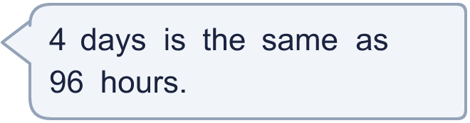
  9 | Is Tiny correct? Circle yes or no.  Yes / No  Explain how you know.
  10 | How much time passes between the start and the end? Write the hours and minutes.
    a) 9:05 am to 11:40 am: |  | hours
    minutes
    b) 8:45 am to 12:10 pm: |  | hours
    minutes
  10 | How much time passes between the start and the end? Write the hours and minutes.
    a) 9:05 am to 11:40 am: |  | hours
    minutes
    b) 8:45 am to 12:10 pm: |  | hours
    minutes
  11 | A swimming lesson starts at 10:50 pm. It lasts 1 hour 25 minutes.  What time does it end?
  11 | A swimming lesson starts at 10:50 pm. It lasts 1 hour 25 minutes.  What time does it end?
  12 | Is Tiny correct? Circle yes or no.  Yes / No  Explain how you know.
    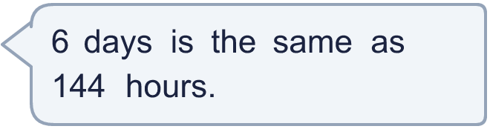
  12 | Is Tiny correct? Circle yes or no.  Yes / No  Explain how you know.
  13 | Ron's lesson starts at 9:15 am and ends at 9:50 am.
    How many minutes does the lesson last?
    minutes
  13 | Ron's lesson starts at 9:15 am and ends at 9:50 am.
    How many minutes does the lesson last?
    minutes
  14 | A swimming lesson ends at 11:35 pm. It lasted 1 hour 50 minutes.  What time did it start?
  14 | A swimming lesson ends at 11:35 pm. It lasted 1 hour 50 minutes.  What time did it start?

Year 3 · Time · Step 8
Hours and minutes using start and end times
Answers (teacher copy)

  1 | How much time passes between the start and the end? Write the hours and minutes.  a) 11:05 am to 4:10 pm: 5 hours 5 minutes  b) 9:45 am to 3:05 pm: 5 hours 20 minutes
  2 | Jo's lesson starts at 11:50 am and ends at 12:45 pm.  How many minutes does the lesson last? 55 minutes
  3 | How much time passes between the start and the end? Write the hours and minutes.  a) 8:25 am to 1:50 pm: 5 hours 25 minutes  b) 11:20 am to 1:45 pm: 2 hours 25 minutes
  4 | Complete the statements.  a) 8 hours = 480 minutes  b) 120 minutes = 2 hours  c) 7 hours = 420 minutes
  5 | How much time passes between the start and the end? Write the hours and minutes.  a) 9:50 am to 2:15 pm: 4 hours 25 minutes  b) 10:45 am to 3:15 pm: 4 hours 30 minutes
  6 | Mo's lesson starts at 8:20 am and ends at 9:00 am.  How many minutes does the lesson last? 40 minutes
  7 | How much time passes between the start and the end? Write the hours and minutes.  a) 10:45 am to 3:20 pm: 4 hours 35 minutes
  8 | Complete the statements.  a) 2 hours 45 minutes = 165 minutes  b) 1 hour 40 minutes = 100 minutes  c) 3 hours 45 minutes = 225 minutes
  9 | Is Tiny correct? Circle yes or no.  Yes / No  Explain how you know.  4 days = 4 × 24 hours = 96 hours.
  10 | How much time passes between the start and the end? Write the hours and minutes.  a) 9:05 am to 11:40 am: 2 hours 35 minutes  b) 8:45 am to 12:10 pm: 3 hours 25 minutes
  11 | A swimming lesson starts at 10:50 pm. It lasts 1 hour 25 minutes.  What time does it end? 12:15 am
  12 | Is Tiny correct? Circle yes or no.  Yes / No  Explain how you know.  6 days = 6 × 24 hours = 144 hours.
  13 | Ron's lesson starts at 9:15 am and ends at 9:50 am.  How many minutes does the lesson last? 35 minutes
  14 | A swimming lesson ends at 11:35 pm. It lasted 1 hour 50 minutes.  What time did it start? 9:45 pm

