  Year 3 · Time · Step 9  Hours and minutes using durations | 
  Year 3 · Time · Step 9
  Hours and minutes using durations
  1 | A film starts at 9:20 pm. It lasts 2 hours 5 minutes.  What time does it end?
  1 | A film starts at 9:20 pm. It lasts 2 hours 5 minutes.  What time does it end?
  2 | A swimming lesson ends at 10:35 pm. It lasted 50 minutes.  What time did it start?
  2 | A swimming lesson ends at 10:35 pm. It lasted 50 minutes.  What time did it start?
  3 | Complete the statements.
    a) 1 hour 30 minutes =
    minutes
    b) 2 hours 20 minutes =
    minutes
    c) 1 hour 40 minutes =
    minutes
  3 | Complete the statements.
    a) 1 hour 30 minutes =
    minutes
    b) 2 hours 20 minutes =
    minutes
    c) 1 hour 40 minutes =
    minutes
  4 | A concert starts at 9:15 pm. It lasts 2 hours 20 minutes.  What time does it end?
  4 | A concert starts at 9:15 pm. It lasts 2 hours 20 minutes.  What time does it end?
  5 | Tom leaves home at the time shown on the clock. The journey takes 1 hour 45 minutes.  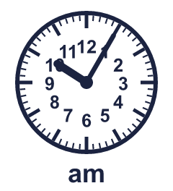  What time does Tom arrive?
  5 | Tom leaves home at the time shown on the clock. The journey takes 1 hour 45 minutes.  What time does Tom arrive?
  6 | A swimming lesson ends at 12:00 am. It lasted 2 hours 10 minutes.  What time did it start?
  6 | A swimming lesson ends at 12:00 am. It lasted 2 hours 10 minutes.  What time did it start?
  7 | Complete the statements.
    a) 7 hours = |  | minutes
    b) 240 minutes = |  | hours
    c) 6 hours = |  | minutes
  7 | Complete the statements.
    a) 7 hours = |  | minutes
    b) 240 minutes = |  | hours
    c) 6 hours = |  | minutes
  8 | A football match starts at 10:00 pm. It lasts 2 hours 20 minutes.  What time does it end?
  8 | A football match starts at 10:00 pm. It lasts 2 hours 20 minutes.  What time does it end?

  9 | Is Tiny correct? Circle yes or no.  Yes / No  Explain how you know.
     | 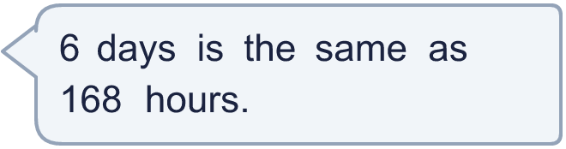
  9 | Is Tiny correct? Circle yes or no.  Yes / No  Explain how you know.
  10 | A concert starts at 11:45 am. It lasts 50 minutes.  What time does it end?
  10 | A concert starts at 11:45 am. It lasts 50 minutes.  What time does it end?
  11 | Nina leaves home at the time shown on the clock. The journey takes 1 hour 50 minutes.  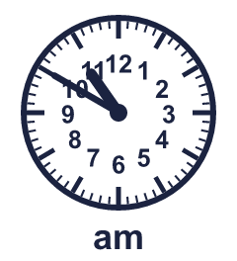  What time does Nina arrive?
  11 | Nina leaves home at the time shown on the clock. The journey takes 1 hour 50 minutes.  What time does Nina arrive?
  12 | Is Tiny correct? Circle yes or no.  Yes / No  Explain how you know.
    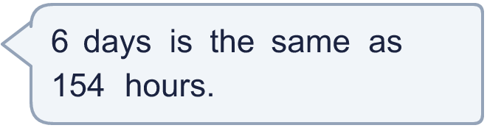
  12 | Is Tiny correct? Circle yes or no.  Yes / No  Explain how you know.
  13 | A film ends at 2:05 am. It lasted 2 hours 20 minutes.  What time did it start?
  13 | A film ends at 2:05 am. It lasted 2 hours 20 minutes.  What time did it start?
  14 | How much time passes between the start and the end? Write the hours and minutes.
    a) 7:40 am to 10:00 am: |  | hours
    minutes
  14 | How much time passes between the start and the end? Write the hours and minutes.
    a) 7:40 am to 10:00 am: |  | hours
    minutes

Year 3 · Time · Step 9
Hours and minutes using durations
Answers (teacher copy)

  1 | A film starts at 9:20 pm. It lasts 2 hours 5 minutes.  What time does it end? 11:25 pm
  2 | A swimming lesson ends at 10:35 pm. It lasted 50 minutes.  What time did it start? 9:45 pm
  3 | Complete the statements.  a) 1 hour 30 minutes = 90 minutes  b) 2 hours 20 minutes = 140 minutes  c) 1 hour 40 minutes = 100 minutes
  4 | A concert starts at 9:15 pm. It lasts 2 hours 20 minutes.  What time does it end? 11:35 pm
  5 | Tom leaves home at the time shown on the clock. The journey takes 1 hour 45 minutes.  What time does Tom arrive? 11:50 am
  6 | A swimming lesson ends at 12:00 am. It lasted 2 hours 10 minutes.  What time did it start? 9:50 pm
  7 | Complete the statements.  a) 7 hours = 420 minutes  b) 240 minutes = 4 hours  c) 6 hours = 360 minutes
  8 | A football match starts at 10:00 pm. It lasts 2 hours 20 minutes.  What time does it end? 12:20 am
  9 | Is Tiny correct? Circle yes or no.  Yes / No  Explain how you know.  6 days = 6 × 24 hours = 144 hours.
  10 | A concert starts at 11:45 am. It lasts 50 minutes.  What time does it end? 12:35 pm
  11 | Nina leaves home at the time shown on the clock. The journey takes 1 hour 50 minutes.  What time does Nina arrive? 12:40 pm
  12 | Is Tiny correct? Circle yes or no.  Yes / No  Explain how you know.  6 days = 6 × 24 hours = 144 hours.
  13 | A film ends at 2:05 am. It lasted 2 hours 20 minutes.  What time did it start? 11:45 pm
  14 | How much time passes between the start and the end? Write the hours and minutes.  a) 7:40 am to 10:00 am: 2 hours 20 minutes

