  Year 3 · Time · Step 7  Days and hours | 
  Year 3 · Time · Step 7
  Days and hours
  1 | Complete the statements.
    a) 4 days = |  | hours
    b) 3 days = |  | hours
    c) 5 days = |  | hours
  1 | Complete the statements.
    a) 4 days = |  | hours
    b) 3 days = |  | hours
    c) 5 days = |  | hours
  2 | Complete the statements.
    a) 72 hours = |  | days
    b) 96 hours = |  | days
    c) 120 hours = |  | days
  2 | Complete the statements.
    a) 72 hours = |  | days
    b) 96 hours = |  | days
    c) 120 hours = |  | days
  3 | Complete the statements.
    a) 6 weeks = |  | days
    b) 21 days = |  | weeks
    c) 8 weeks = |  | days
  3 | Complete the statements.
    a) 6 weeks = |  | days
    b) 21 days = |  | weeks
    c) 8 weeks = |  | days
  4 | Complete the statements.
    a) 2 days = |  | hours
    b) 48 hours = |  | days
    c) 6 days = |  | hours
  4 | Complete the statements.
    a) 2 days = |  | hours
    b) 48 hours = |  | days
    c) 6 days = |  | hours
  5 | Complete the statements.
    a) 4 weeks 1 day = |  | days
    b) 3 weeks 6 days = |  | days
    c) 3 weeks 5 days = |  | days
  5 | Complete the statements.
    a) 4 weeks 1 day = |  | days
    b) 3 weeks 6 days = |  | days
    c) 3 weeks 5 days = |  | days
  6 | Write <, > or = in each box.
    a) | 6 hours |  | 380 minutes
    b) | 3 hours |  | 200 minutes
    c) | 5 weeks |  | 42 days
  6 | Write <, > or = in each box.
    a) | 6 hours |  | 380 minutes
    b) | 3 hours |  | 200 minutes
    c) | 5 weeks |  | 42 days
  7 | Complete the statements.
    a) 2 days = |  | hours
    b) 72 hours = |  | days
    c) 6 weeks = |  | days
  7 | Complete the statements.
    a) 2 days = |  | hours
    b) 72 hours = |  | days
    c) 6 weeks = |  | days
  8 | Write the lengths of time in order, starting with the shortest.  6 minutes 266 seconds 5 minutes 2 hours
  8 | Write the lengths of time in order, starting with the shortest.  6 minutes 266 seconds 5 minutes 2 hours

  9 | Is Tiny correct? Circle yes or no.  Yes / No  Explain how you know.
     | 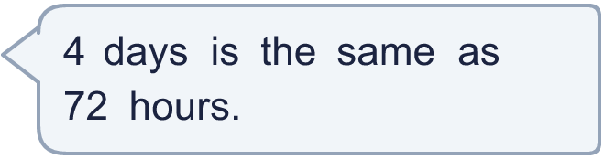
  9 | Is Tiny correct? Circle yes or no.  Yes / No  Explain how you know.
  10 | Write <, > or = in each box.
    a) | 6 minutes |  | 350 seconds
    b) | 3 weeks |  | 28 days
    c) | 9 minutes |  | 540 seconds
  10 | Write <, > or = in each box.
    a) | 6 minutes |  | 350 seconds
    b) | 3 weeks |  | 28 days
    c) | 9 minutes |  | 540 seconds
  11 | Tom watches a swimming lesson that lasts 2 hours 45 minutes.
    How many minutes is that?
    minutes
  11 | Tom watches a swimming lesson that lasts 2 hours 45 minutes.
    How many minutes is that?
    minutes
  12 | Is Boba correct? Circle yes or no.  Yes / No  Explain how you know.
    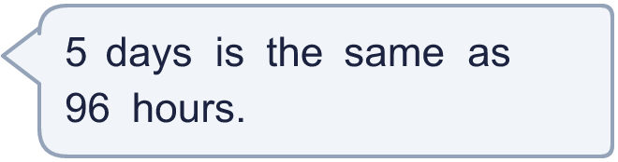
  12 | Is Boba correct? Circle yes or no.  Yes / No  Explain how you know.
  13 | Write <, > or = in each box.
    a) | 4 weeks |  | 27 days
    b) | 6 hours |  | 360 minutes
    c) | 9 minutes |  | 530 seconds
  13 | Write <, > or = in each box.
    a) | 4 weeks |  | 27 days
    b) | 6 hours |  | 360 minutes
    c) | 9 minutes |  | 530 seconds
  14 | Is Tiny correct? Circle yes or no.  Yes / No  Explain how you know.
    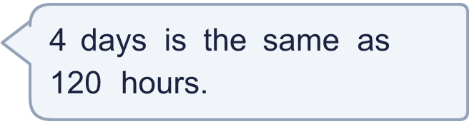
  14 | Is Tiny correct? Circle yes or no.  Yes / No  Explain how you know.

Year 3 · Time · Step 7
Days and hours
Answers (teacher copy)

  1 | Complete the statements.  a) 4 days = 96 hours  b) 3 days = 72 hours  c) 5 days = 120 hours
  2 | Complete the statements.  a) 72 hours = 3 days  b) 96 hours = 4 days  c) 120 hours = 5 days
  3 | Complete the statements.  a) 6 weeks = 42 days  b) 21 days = 3 weeks  c) 8 weeks = 56 days
  4 | Complete the statements.  a) 2 days = 48 hours  b) 48 hours = 2 days  c) 6 days = 144 hours
  5 | Complete the statements.  a) 4 weeks 1 day = 29 days  b) 3 weeks 6 days = 27 days  c) 3 weeks 5 days = 26 days
  6 | Write <, > or = in each box.  a) 6 hours < 380 minutes  b) 3 hours < 200 minutes  c) 5 weeks < 42 days
  7 | Complete the statements.  a) 2 days = 48 hours  b) 72 hours = 3 days  c) 6 weeks = 42 days
  8 | Write the lengths of time in order, starting with the shortest.  6 minutes 266 seconds 5 minutes 2 hours  266 seconds, 5 minutes, 6 minutes, 2 hours
  9 | Is Tiny correct? Circle yes or no.  Yes / No  Explain how you know.  4 days = 4 × 24 hours = 96 hours.
  10 | Write <, > or = in each box.  a) 6 minutes > 350 seconds  b) 3 weeks < 28 days  c) 9 minutes = 540 seconds
  11 | Tom watches a swimming lesson that lasts 2 hours 45 minutes.  How many minutes is that? 165 minutes
  12 | Is Boba correct? Circle yes or no.  Yes / No  Explain how you know.  5 days = 5 × 24 hours = 120 hours.
  13 | Write <, > or = in each box.  a) 4 weeks > 27 days  b) 6 hours = 360 minutes  c) 9 minutes > 530 seconds
  14 | Is Tiny correct? Circle yes or no.  Yes / No  Explain how you know.  4 days = 4 × 24 hours = 96 hours.

