  Year 3 · Statistics · Step 6  Two-way tables | 
  Year 3 · Statistics · Step 6
  Two-way tables
  1 | The table shows how many boys and girls came on each day.  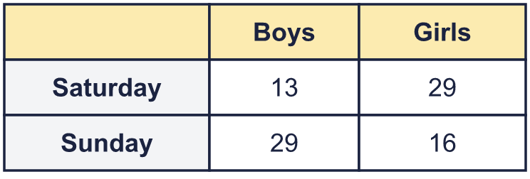
    How many boys came on Sunday?
    How many boys came on both days?
  1 | The table shows how many boys and girls came on each day.
    How many boys came on Sunday?
    How many boys came on both days?
  2 | The table shows how many boys and girls are in two classes.  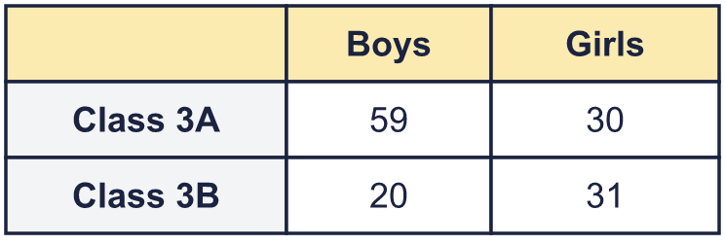
    Are there more boys or more girls?
    How many more?
  2 | The table shows how many boys and girls are in two classes.
    Are there more boys or more girls?
    How many more?
  3 | The table shows what some children have. Some numbers are missing. Work out the missing numbers and write them in the table.  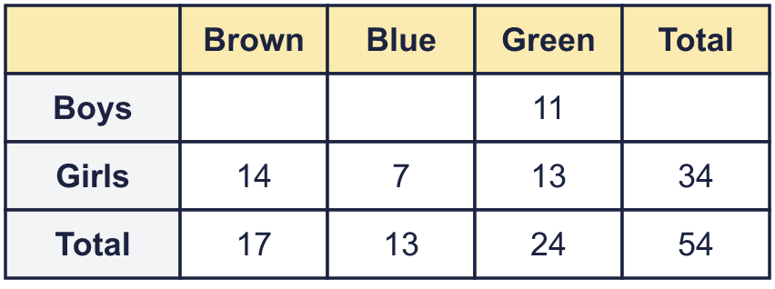
    How many girls have green?
  3 | The table shows what some children have. Some numbers are missing. Work out the missing numbers and write them in the table.
    How many girls have green?
  4 | The cinema has 100 seats. The table shows how many adults and children watched each showing.  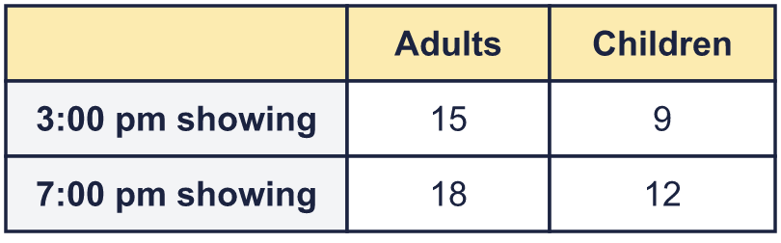
    How many seats were empty at the 3:00 pm showing?
  4 | The cinema has 100 seats. The table shows how many adults and children watched each showing.
    How many seats were empty at the 3:00 pm showing?
  5 | The table shows how many boys and girls came on each day.  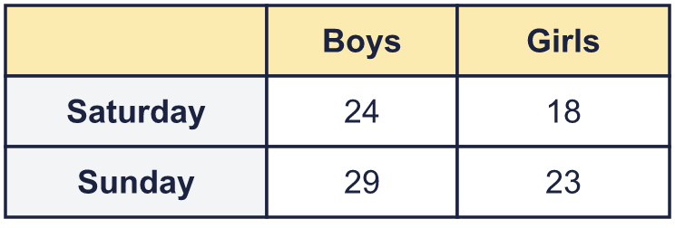
    How many boys came on Sunday?
    How many boys came on both days?
  5 | The table shows how many boys and girls came on each day.
    How many boys came on Sunday?
    How many boys came on both days?
  6 | The table shows what some children have. Some numbers are missing. Work out the missing numbers and write them in the table.  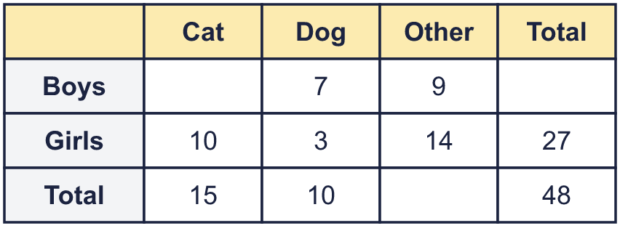
    How many boys have dog?
  6 | The table shows what some children have. Some numbers are missing. Work out the missing numbers and write them in the table.
    How many boys have dog?
  7 | The table shows how many boys and girls are in two classes.  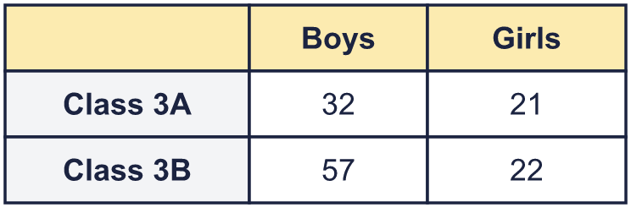
    Are there more boys or more girls?
    How many more?
  7 | The table shows how many boys and girls are in two classes.
    Are there more boys or more girls?
    How many more?
  8 | The cinema has 60 seats. The table shows how many adults and children watched each showing.  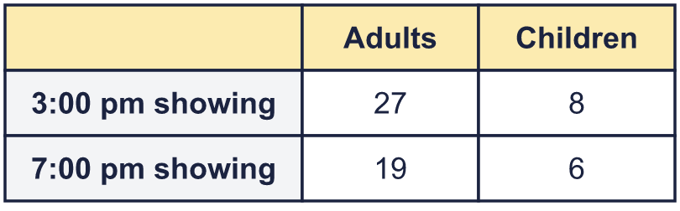
    How many seats were empty at the 7:00 pm showing?
  8 | The cinema has 60 seats. The table shows how many adults and children watched each showing.
    How many seats were empty at the 7:00 pm showing?

  9 | The table shows what some children have. Some numbers are missing. Work out the missing numbers and write them in the table.  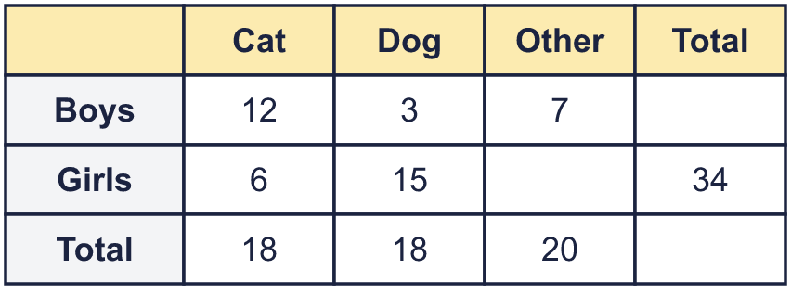
    How many girls have other?
  9 | The table shows what some children have. Some numbers are missing. Work out the missing numbers and write them in the table.
    How many girls have other?
  10 | The cinema has 100 seats. The table shows how many adults and children watched each showing.  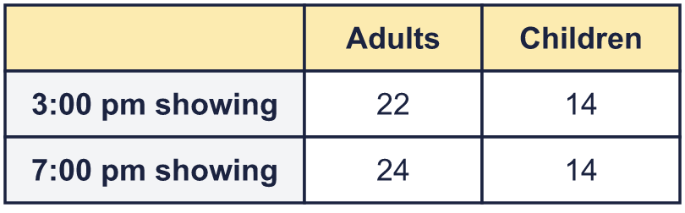
    How many seats were empty at the 3:00 pm showing?
  10 | The cinema has 100 seats. The table shows how many adults and children watched each showing.
    How many seats were empty at the 3:00 pm showing?
  11 | The table shows how many boys and girls are in two classes.  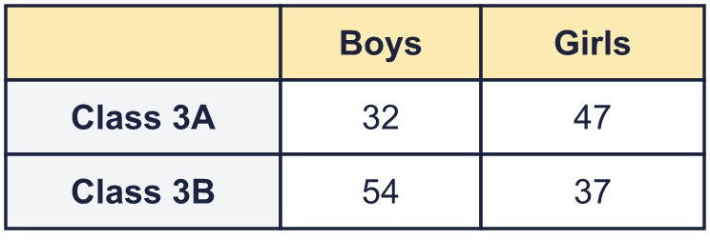
    Are there more boys or more girls?
    How many more?
  11 | The table shows how many boys and girls are in two classes.
    Are there more boys or more girls?
    How many more?
  12 | The table shows how many adults and children came on each film showing.  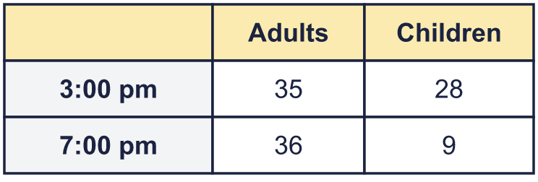
    How many children came on 7:00 pm?
    How many adults came on both showings?
  12 | The table shows how many adults and children came on each film showing.
    How many children came on 7:00 pm?
    How many adults came on both showings?
  13 | The table shows what some children have. Some numbers are missing. Work out the missing numbers and write them in the table.  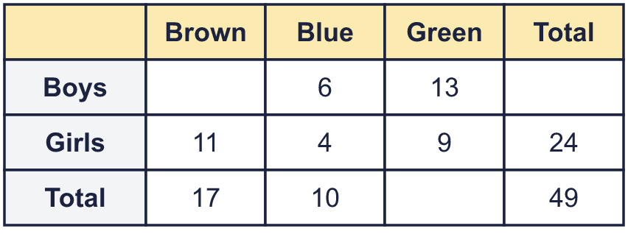
    How many boys have brown?
  13 | The table shows what some children have. Some numbers are missing. Work out the missing numbers and write them in the table.
    How many boys have brown?
  14 | The table shows how many boys and girls are in two classes.  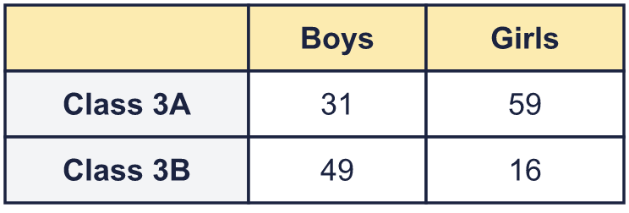
    Are there more boys or more girls?
    How many more?
  14 | The table shows how many boys and girls are in two classes.
    Are there more boys or more girls?
    How many more?

Year 3 · Statistics · Step 6
Two-way tables
Answers (teacher copy)

  1 | The table shows how many boys and girls came on each day.  How many boys came on Sunday? 29  How many boys came on both days? 42
  2 | The table shows how many boys and girls are in two classes.  Are there more boys or more girls? Boys  How many more? 18
  3 | The table shows what some children have. Some numbers are missing. Work out the missing numbers and write them in the table.  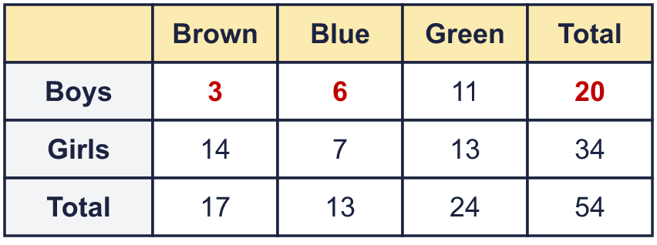  How many girls have green? 13
  4 | The cinema has 100 seats. The table shows how many adults and children watched each showing.  How many seats were empty at the 3:00 pm showing? 76
  5 | The table shows how many boys and girls came on each day.  How many boys came on Sunday? 29  How many boys came on both days? 53
  6 | The table shows what some children have. Some numbers are missing. Work out the missing numbers and write them in the table.  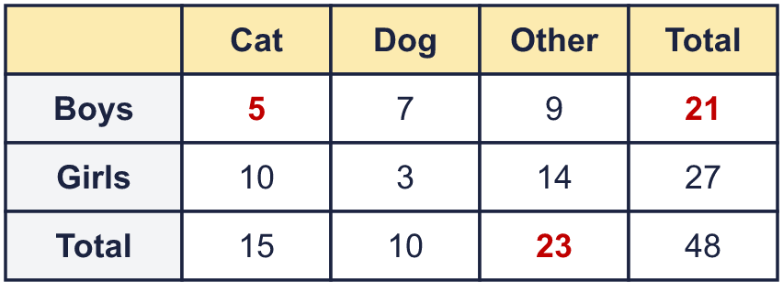  How many boys have dog? 7
  7 | The table shows how many boys and girls are in two classes.  Are there more boys or more girls? Boys  How many more? 46
  8 | The cinema has 60 seats. The table shows how many adults and children watched each showing.  How many seats were empty at the 7:00 pm showing? 35
  9 | The table shows what some children have. Some numbers are missing. Work out the missing numbers and write them in the table.  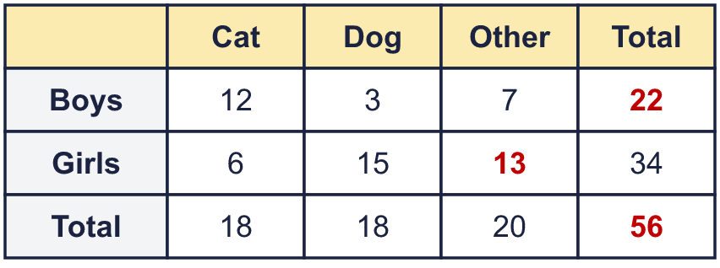  How many girls have other? 13
  10 | The cinema has 100 seats. The table shows how many adults and children watched each showing.  How many seats were empty at the 3:00 pm showing? 64
  11 | The table shows how many boys and girls are in two classes.  Are there more boys or more girls? Boys  How many more? 2
  12 | The table shows how many adults and children came on each film showing.  How many children came on 7:00 pm? 9  How many adults came on both showings? 71
  13 | The table shows what some children have. Some numbers are missing. Work out the missing numbers and write them in the table.  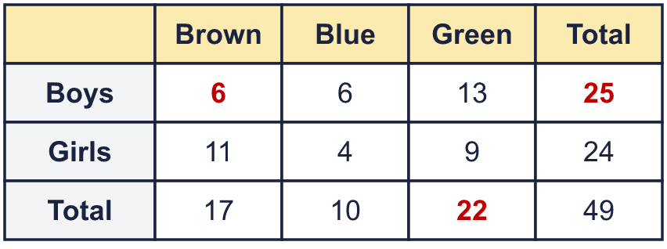  How many boys have brown? 6
  14 | The table shows how many boys and girls are in two classes.  Are there more boys or more girls? Boys  How many more? 5

