  Year 3 · Statistics · Step 1  Interpret pictograms | 
  Year 3 · Statistics · Step 1
  Interpret pictograms
  1 | The pictogram shows how many were counted.  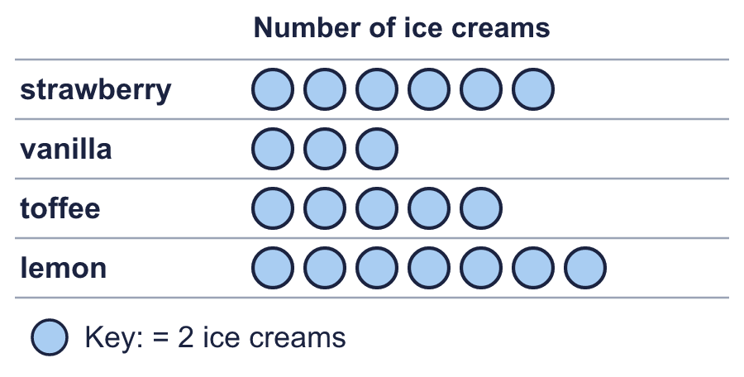
    How many lemon?
    How many vanilla?
  1 | The pictogram shows how many were counted.
    How many lemon?
    How many vanilla?
  2 | The pictogram shows how many were counted. Half a symbol stands for half of the key.  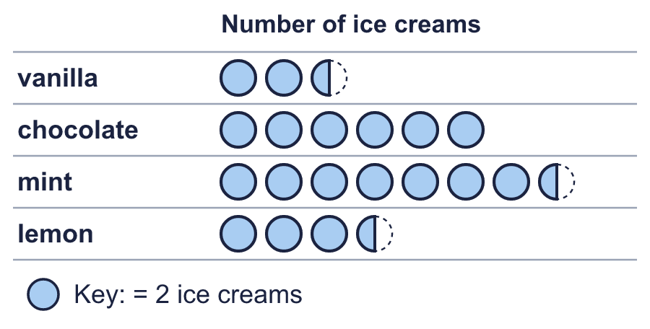
    How many vanilla?
    How many mint?
  2 | The pictogram shows how many were counted. Half a symbol stands for half of the key.
    How many vanilla?
    How many mint?
  3 | Look at the pictogram.  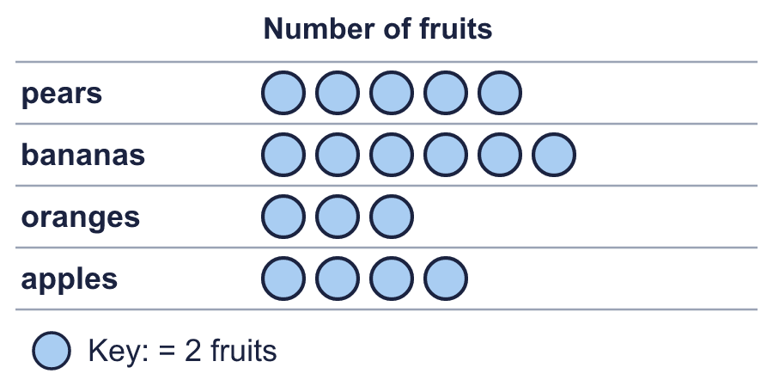
    How many does one symbol stand for?
    How many symbols are in the oranges row?
  3 | Look at the pictogram.
    How many does one symbol stand for?
    How many symbols are in the oranges row?
  4 | The pictogram shows how many were counted.  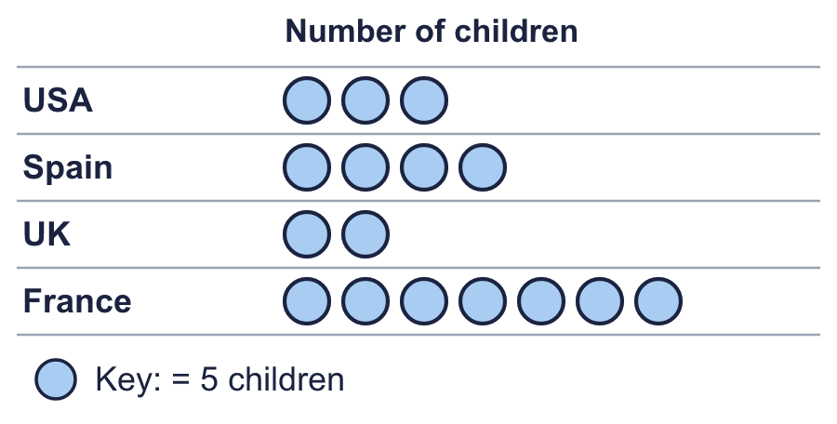
    How many France?
    How many USA?
  4 | The pictogram shows how many were counted.
    How many France?
    How many USA?
  5 | Look at the pictogram.  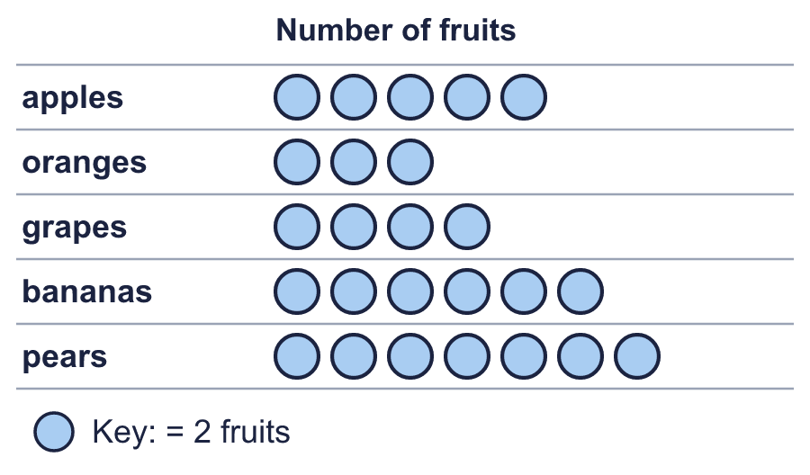
    How many were counted for pears and grapes together?
  5 | Look at the pictogram.
    How many were counted for pears and grapes together?
  6 | Look at the pictogram.  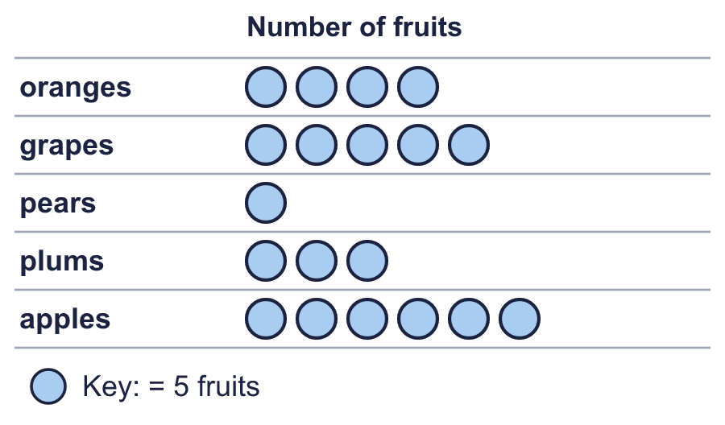
    How many more were counted for apples than for grapes?
  6 | Look at the pictogram.
    How many more were counted for apples than for grapes?
  7 | 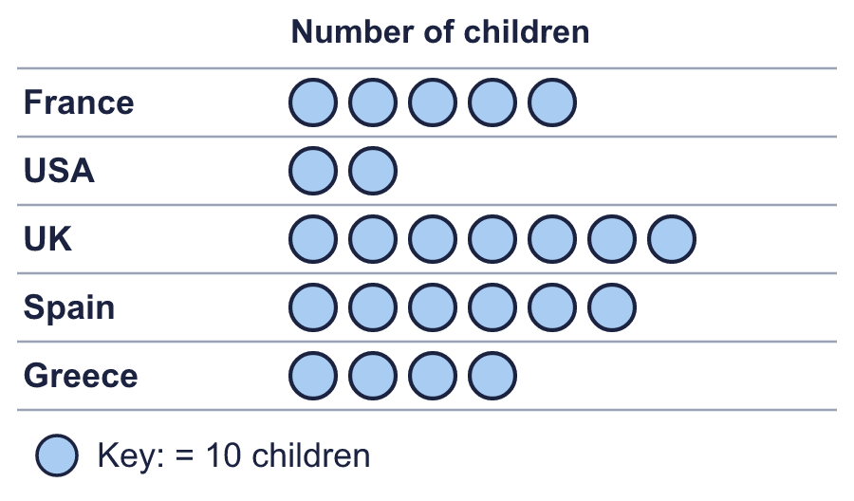
    Which row shows the most?
    Which row shows the least?
  7
    Which row shows the most?
    Which row shows the least?
  8 | Write <, > or = in the box.  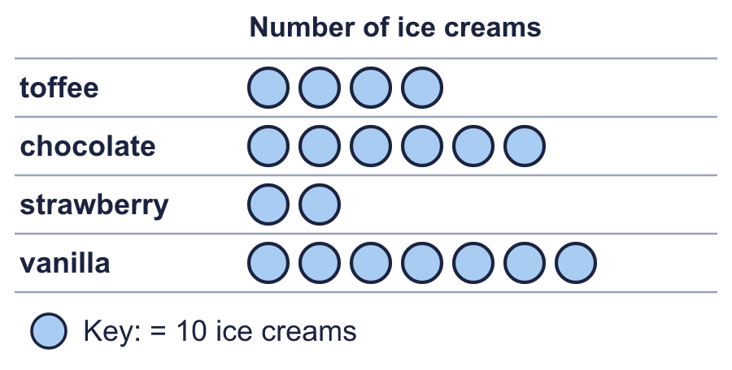
    chocolate |  | strawberry
  8 | Write <, > or = in the box.
    chocolate |  | strawberry

  9 | 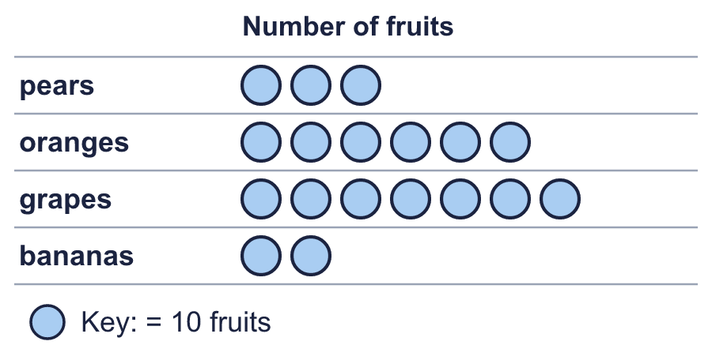  Is Jo correct? Circle yes or no.  Yes / No  Explain how you know.
     | 
  9 | Is Jo correct? Circle yes or no.  Yes / No  Explain how you know.
  10 | Look at the pictogram.  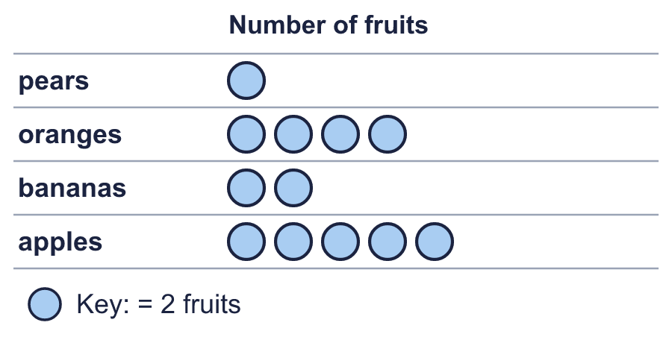
    How many were counted altogether?
  10 | Look at the pictogram.
    How many were counted altogether?
  11 | Look at the pictogram.  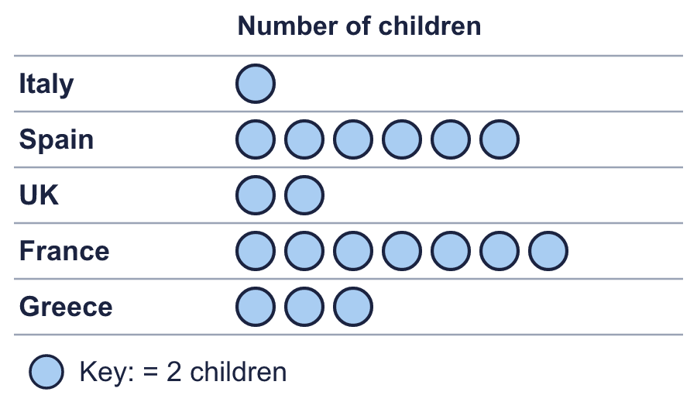
    How many more were counted for Spain than for Greece?
  11 | Look at the pictogram.
    How many more were counted for Spain than for Greece?
  12 | 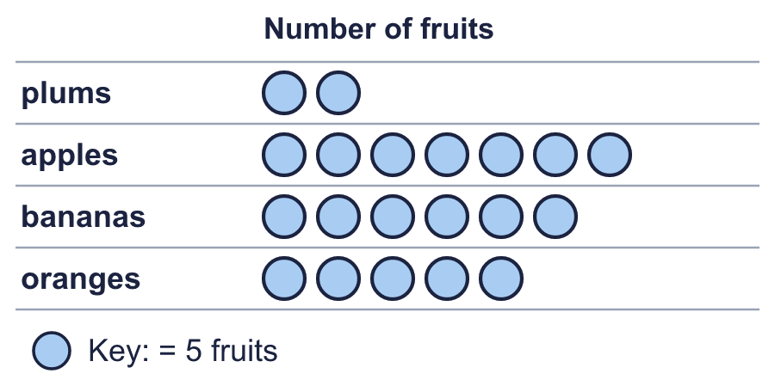  Boba draws the pictogram again. This time one symbol stands for 1 fruits.
    How many symbols does Boba draw for oranges?
  12 | Boba draws the pictogram again. This time one symbol stands for 1 fruits.
    How many symbols does Boba draw for oranges?
  13 | Look at the pictogram.  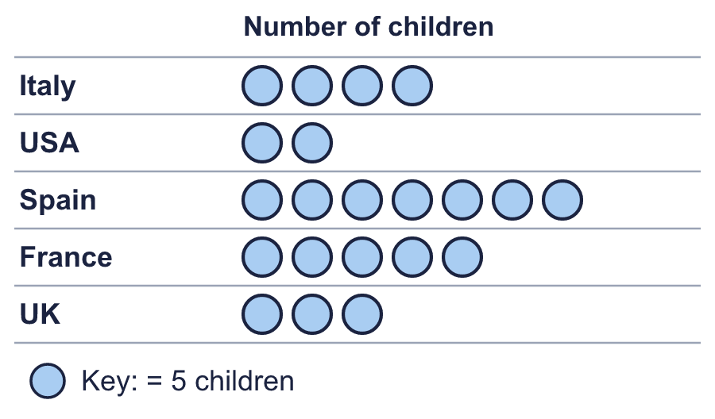
    How many were counted for France and USA together?
  13 | Look at the pictogram.
    How many were counted for France and USA together?
  14 | 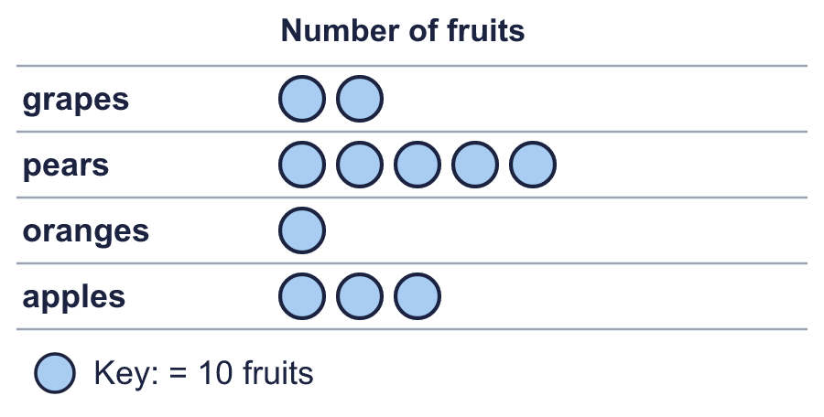  Is Leo correct? Circle yes or no.  Yes / No  Explain how you know.
    
  14 | Is Leo correct? Circle yes or no.  Yes / No  Explain how you know.

Year 3 · Statistics · Step 1
Interpret pictograms
Answers (teacher copy)

  1 | The pictogram shows how many were counted.  How many lemon? 14  How many vanilla? 6
  2 | The pictogram shows how many were counted. Half a symbol stands for half of the key.  How many vanilla? 5  How many mint? 15
  3 | Look at the pictogram.  How many does one symbol stand for? 2  How many symbols are in the oranges row? 3
  4 | The pictogram shows how many were counted.  How many France? 35  How many USA? 15
  5 | Look at the pictogram.  How many were counted for pears and grapes together? 22
  6 | Look at the pictogram.  How many more were counted for apples than for grapes? 5
  7 | Which row shows the most? UK  Which row shows the least? USA
  8 | Write <, > or = in the box.  chocolate > strawberry
  9 | Is Jo correct? Circle yes or no.  Yes / No  Explain how you know.  No. The pears row has 3 symbols and each symbol stands for 10, so it shows 30.
  10 | Look at the pictogram.  How many were counted altogether? 24
  11 | Look at the pictogram.  How many more were counted for Spain than for Greece? 6
  12 | Boba draws the pictogram again. This time one symbol stands for 1 fruits.  How many symbols does Boba draw for oranges? 25
  13 | Look at the pictogram.  How many were counted for France and USA together? 35
  14 | Is Leo correct? Circle yes or no.  Yes / No  Explain how you know.  Yes. The apples row has 3 symbols and each symbol stands for 10, so it shows 30.

