  Year 3 · Statistics · Step 3  Interpret bar charts | 
  Year 3 · Statistics · Step 3
  Interpret bar charts
  1 | The bar chart shows how many were counted.  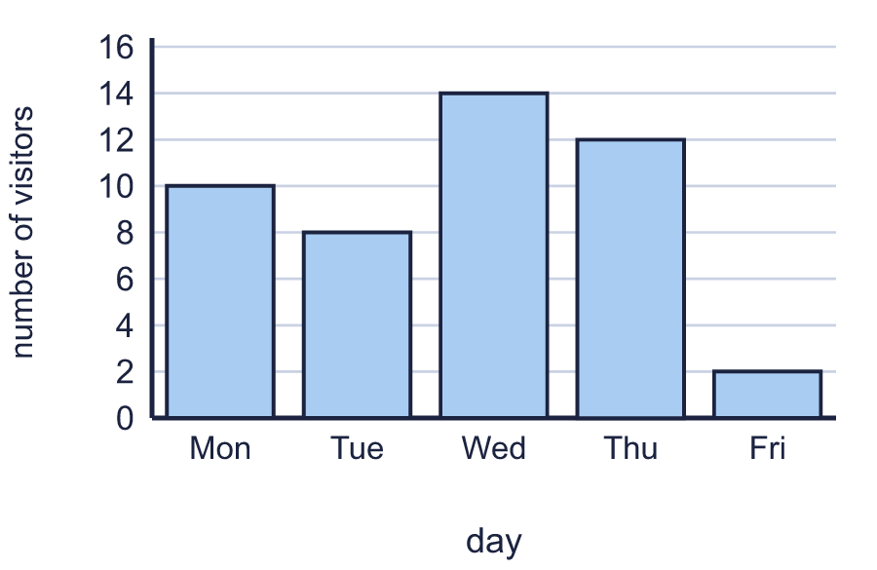
    How many were counted for Mon?
    How many were counted for Fri?
  1 | The bar chart shows how many were counted.
    How many were counted for Mon?
    How many were counted for Fri?
  2 | The bar chart shows how many were counted.  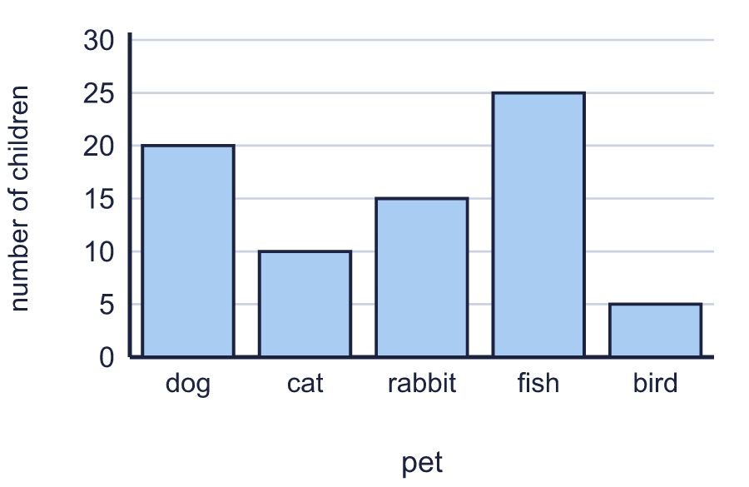
    How many were counted for dog?
    How many were counted for cat?
  2 | The bar chart shows how many were counted.
    How many were counted for dog?
    How many were counted for cat?
  3 | Use the bar chart to complete the table.  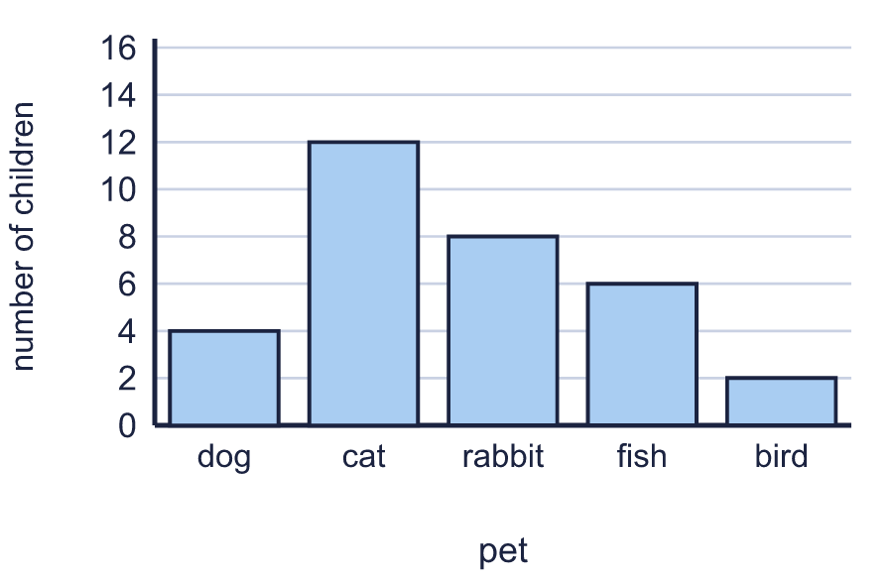
    dog:
    rabbit:
    bird:
  3 | Use the bar chart to complete the table.
    dog:
    rabbit:
    bird:
  4 | Look at the bar chart.  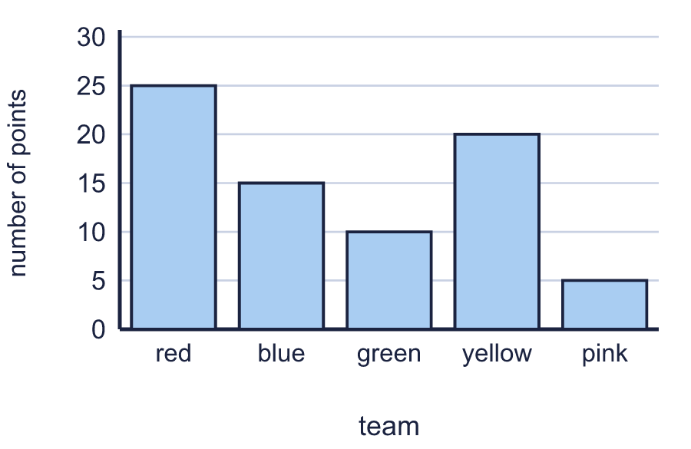
    Which has the most?
    Which has the least?
  4 | Look at the bar chart.
    Which has the most?
    Which has the least?
  5 | The bar chart shows how many were counted.  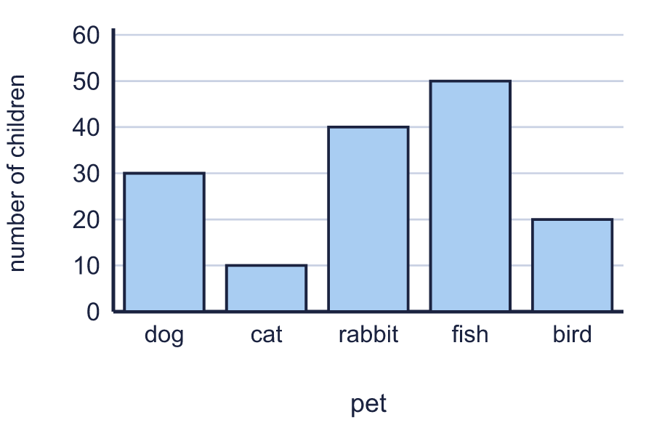
    How many were counted for cat?
    How many were counted for fish?
  5 | The bar chart shows how many were counted.
    How many were counted for cat?
    How many were counted for fish?
  6 | The bar chart shows how many were counted.  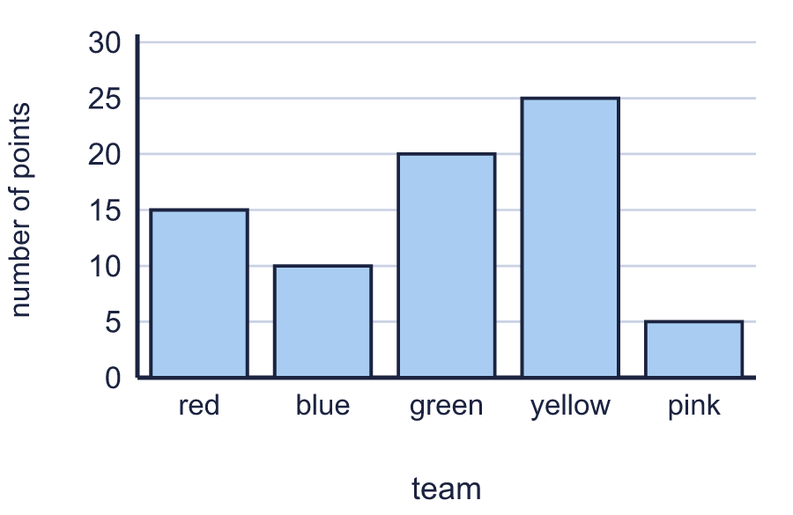
    How many were counted altogether?
  6 | The bar chart shows how many were counted.
    How many were counted altogether?
  7 | 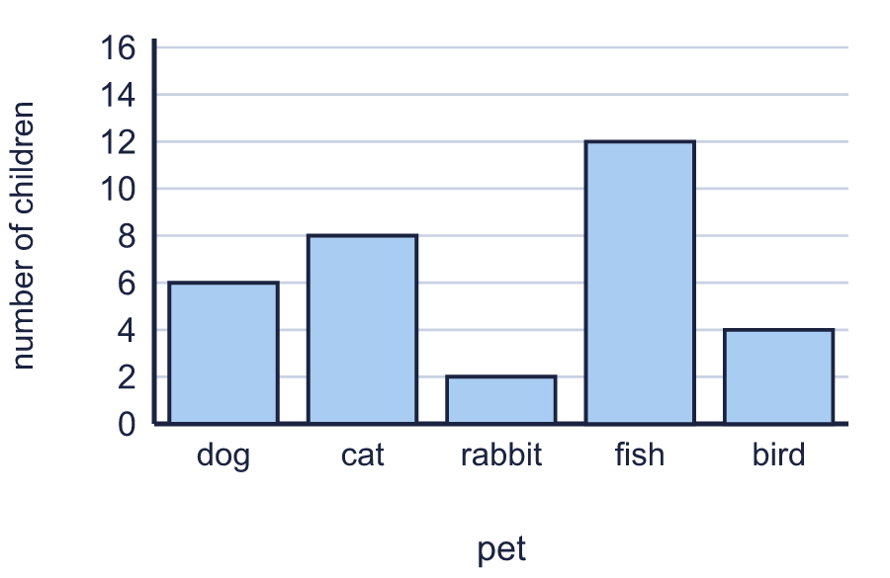
    How many more were counted for fish than for cat?
  7
    How many more were counted for fish than for cat?
  8 | The bar chart shows how many were counted.  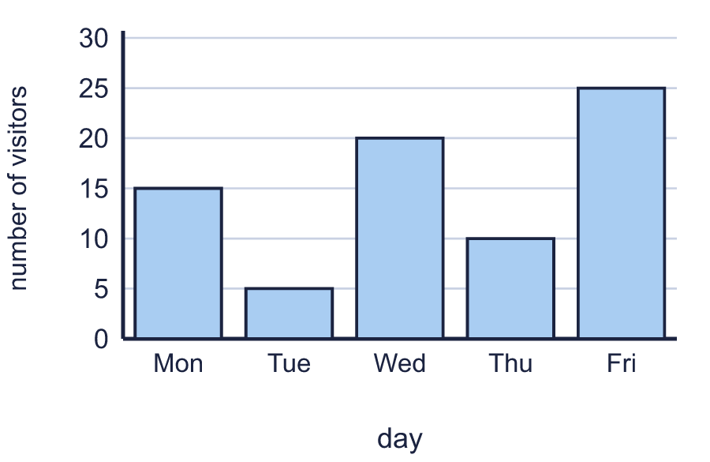
    How many were counted for Wed?
    How many were counted for Thu?
  8 | The bar chart shows how many were counted.
    How many were counted for Wed?
    How many were counted for Thu?

  9 | 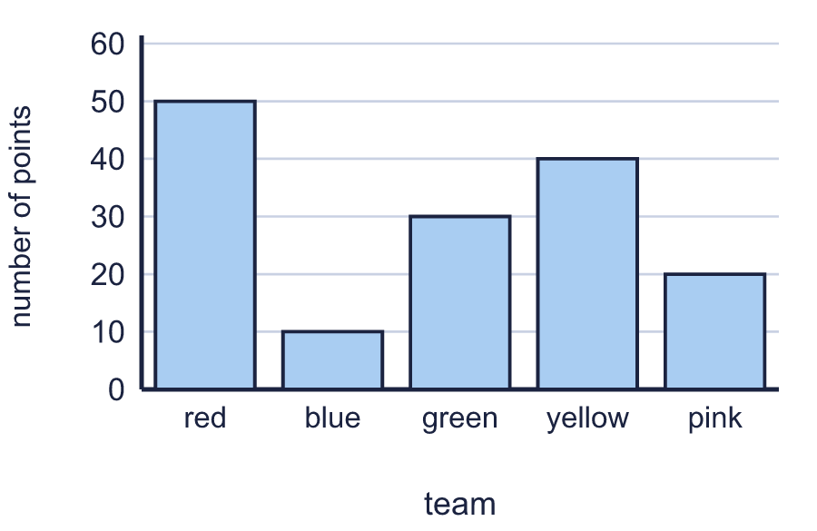
    How many more were counted for yellow than for blue?
  9
    How many more were counted for yellow than for blue?
  10 | The bar chart shows how many were counted.  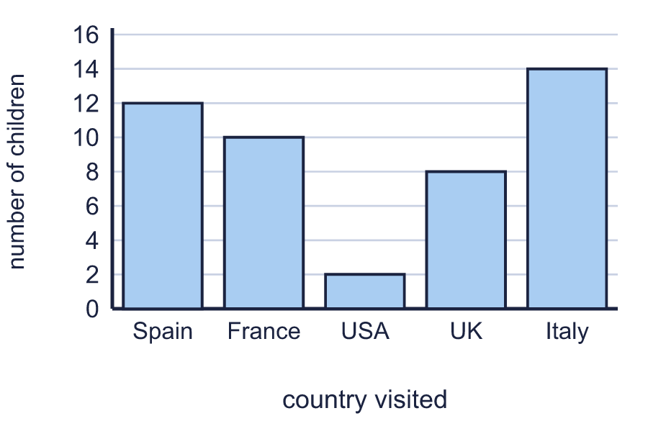
    How many were counted altogether?
  10 | The bar chart shows how many were counted.
    How many were counted altogether?
  11 | Look at the bar chart.  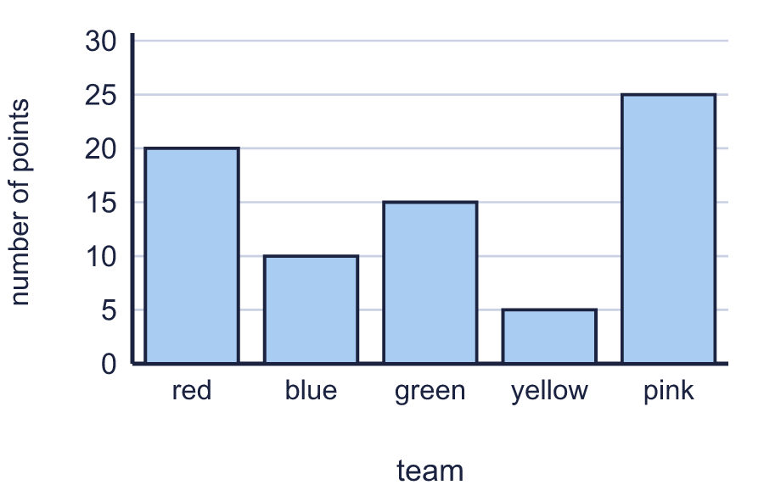
    Which has the most?
    Which has the least?
  11 | Look at the bar chart.
    Which has the most?
    Which has the least?
  12 | The bar chart shows how many were counted.  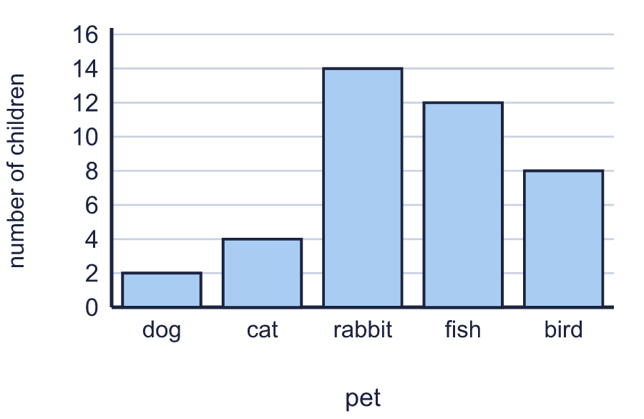
    How many were counted for rabbit?
    How many were counted for fish?
  12 | The bar chart shows how many were counted.
    How many were counted for rabbit?
    How many were counted for fish?
  13 | 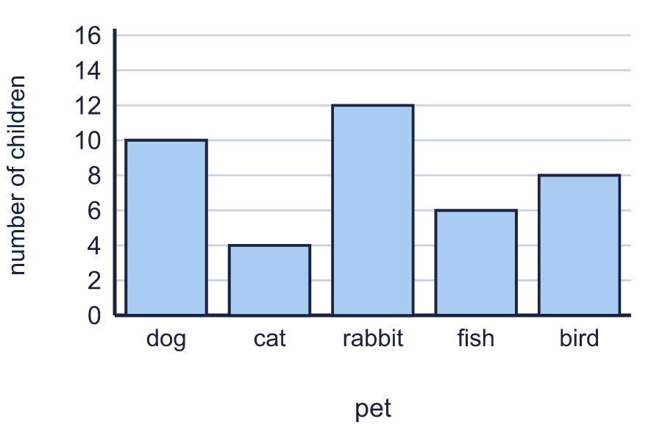
    How many more were counted for rabbit than for fish?
  13
    How many more were counted for rabbit than for fish?
  14 | Use the bar chart to complete the table.  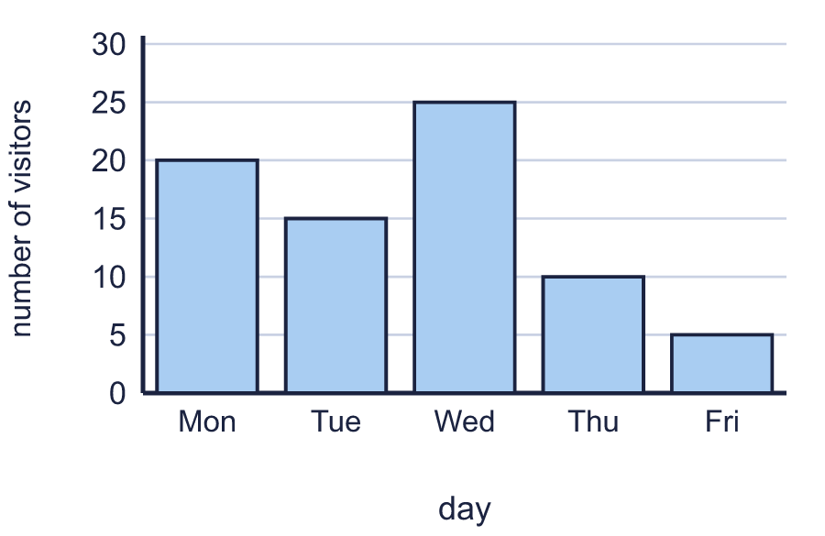
    Mon:
    Wed:
    Fri:
  14 | Use the bar chart to complete the table.
    Mon:
    Wed:
    Fri:

Year 3 · Statistics · Step 3
Interpret bar charts
Answers (teacher copy)

  1 | The bar chart shows how many were counted.  How many were counted for Mon? 10  How many were counted for Fri? 2
  2 | The bar chart shows how many were counted.  How many were counted for dog? 20  How many were counted for cat? 10
  3 | Use the bar chart to complete the table.  dog: 4  rabbit: 8  bird: 2
  4 | Look at the bar chart.  Which has the most? red  Which has the least? pink
  5 | The bar chart shows how many were counted.  How many were counted for cat? 10  How many were counted for fish? 50
  6 | The bar chart shows how many were counted.  How many were counted altogether? 75
  7 | How many more were counted for fish than for cat? 4
  8 | The bar chart shows how many were counted.  How many were counted for Wed? 20  How many were counted for Thu? 10
  9 | How many more were counted for yellow than for blue? 30
  10 | The bar chart shows how many were counted.  How many were counted altogether? 46
  11 | Look at the bar chart.  Which has the most? pink  Which has the least? yellow
  12 | The bar chart shows how many were counted.  How many were counted for rabbit? 14  How many were counted for fish? 12
  13 | How many more were counted for rabbit than for fish? 6
  14 | Use the bar chart to complete the table.  Mon: 20  Wed: 25  Fri: 5

