  Year 3 · Statistics · Step 2  Draw pictograms | 
  Year 3 · Statistics · Step 2
  Draw pictograms
  1 | Complete the pictogram to show that 10 fruits were counted for pears. Draw the symbols in your book.  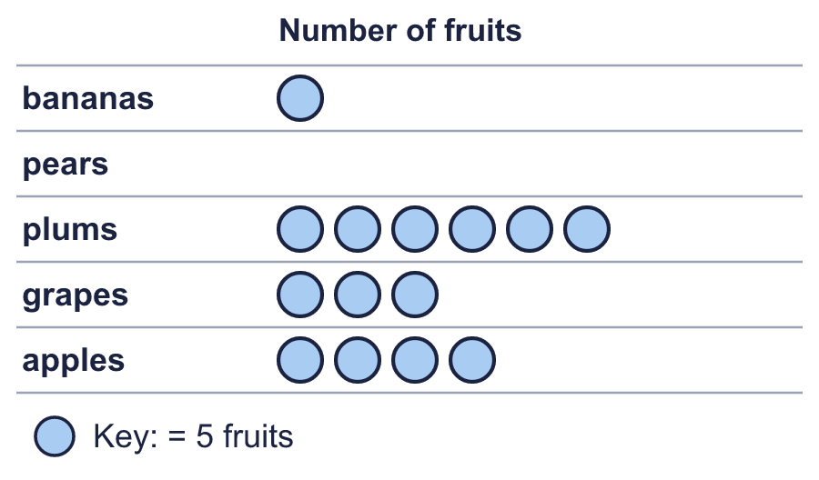
    How many symbols do you draw for pears?
    How many were counted for plums?
  1 | Complete the pictogram to show that 10 fruits were counted for pears. Draw the symbols in your book.
    How many symbols do you draw for pears?
    How many were counted for plums?
  2 | The pictogram shows how many were counted.  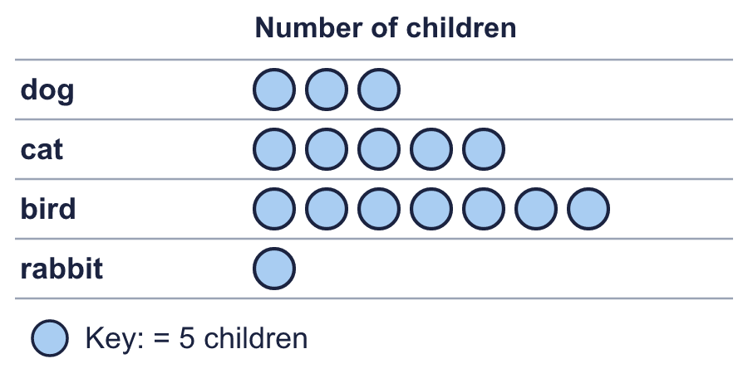
    How many bird?
    How many rabbit?
  2 | The pictogram shows how many were counted.
    How many bird?
    How many rabbit?
  3 | Complete the pictogram to show that 8 ice creams were counted for strawberry. Draw the symbols in your book.  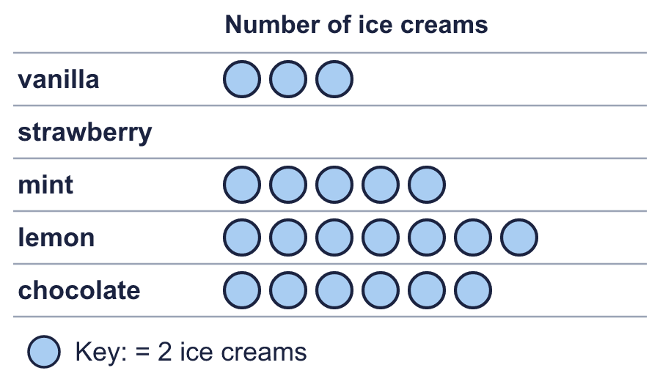
    How many symbols do you draw for strawberry?
    How many were counted for mint?
  3 | Complete the pictogram to show that 8 ice creams were counted for strawberry. Draw the symbols in your book.
    How many symbols do you draw for strawberry?
    How many were counted for mint?
  4 | Look at the pictogram.  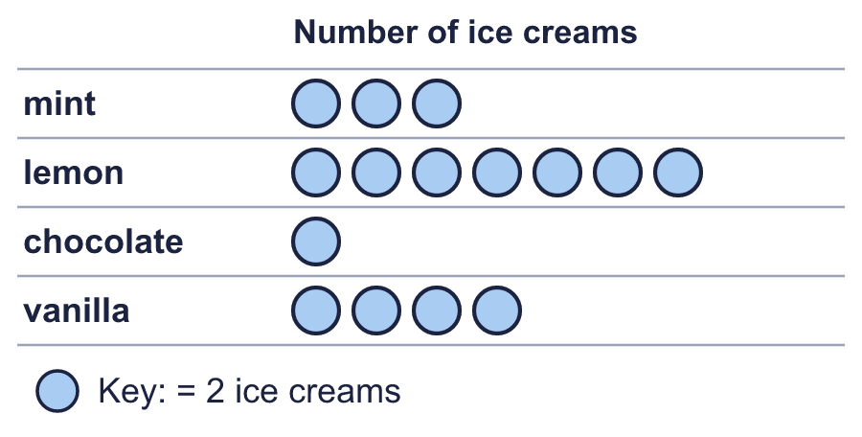
    How many does one symbol stand for?
    How many symbols are in the mint row?
  4 | Look at the pictogram.
    How many does one symbol stand for?
    How many symbols are in the mint row?
  5 | Complete the pictogram to show that 25 children were counted for fish. Draw the symbols in your book.  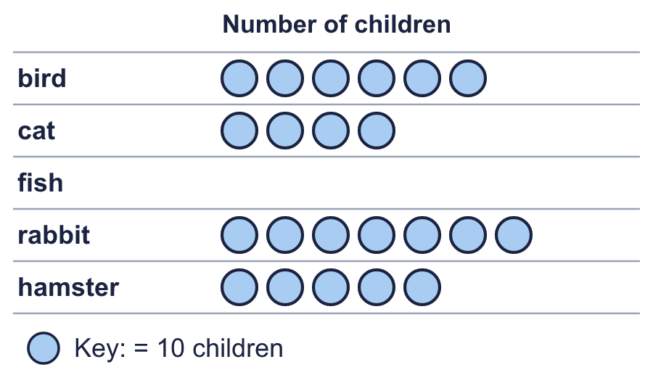
    How many symbols do you draw for fish?
    How many were counted for rabbit?
  5 | Complete the pictogram to show that 25 children were counted for fish. Draw the symbols in your book.
    How many symbols do you draw for fish?
    How many were counted for rabbit?
  6 | Look at the pictogram.  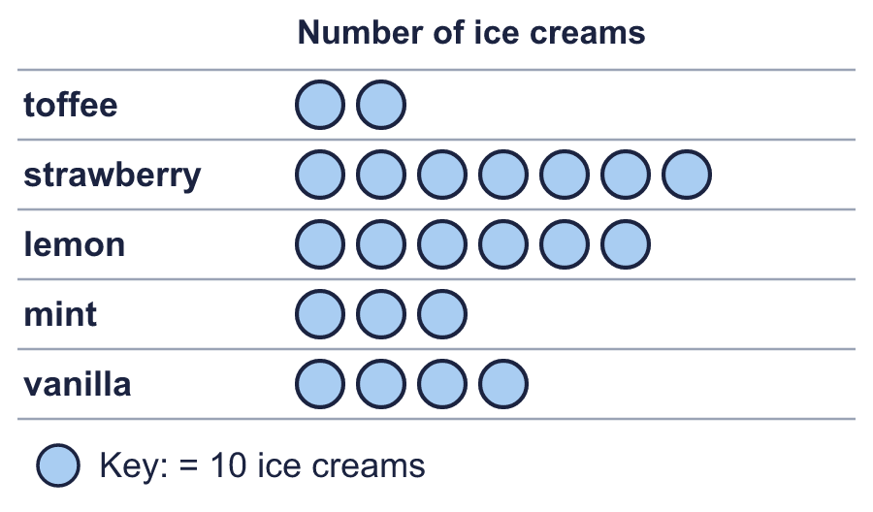
    How many were counted for lemon and vanilla together?
  6 | Look at the pictogram.
    How many were counted for lemon and vanilla together?
  7 | Complete the pictogram to show that 20 fruits were counted for bananas. Draw the symbols in your book.  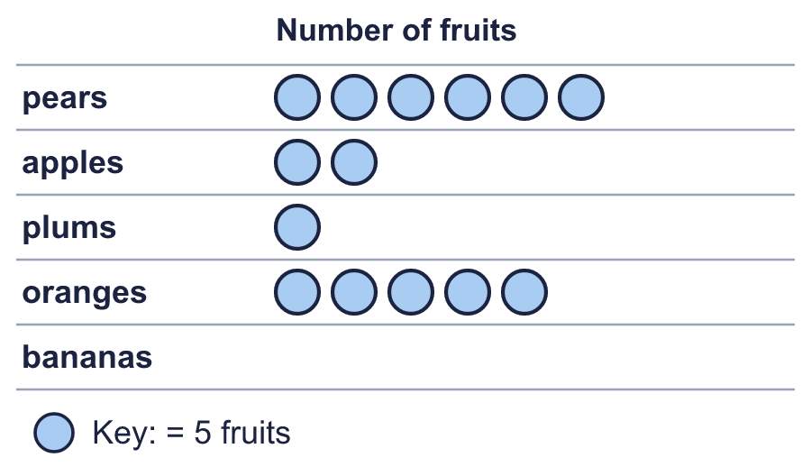
    How many symbols do you draw for bananas?
    How many were counted for pears?
  7 | Complete the pictogram to show that 20 fruits were counted for bananas. Draw the symbols in your book.
    How many symbols do you draw for bananas?
    How many were counted for pears?
  8 | 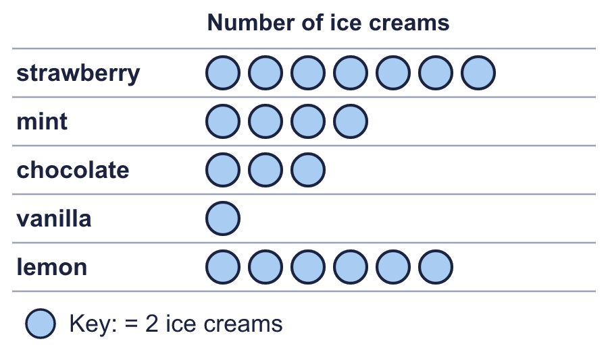
    Which row shows the most?
    Which row shows the least?
  8
    Which row shows the most?
    Which row shows the least?

  9 | Complete the pictogram to show that 8 children were counted for dog. Draw the symbols in your book.  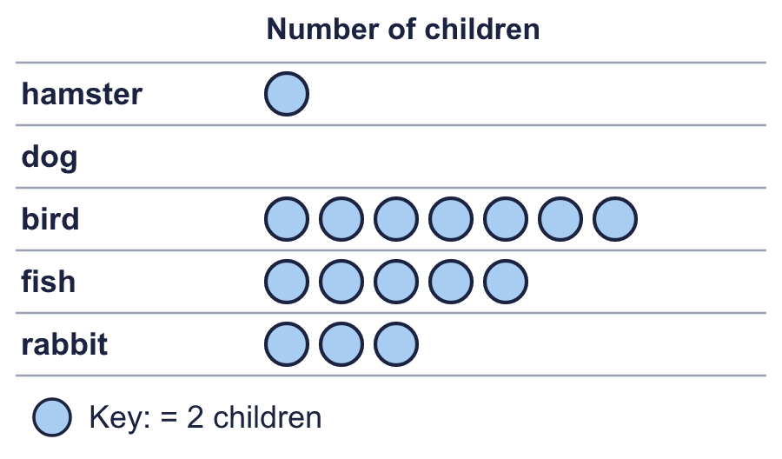
    How many symbols do you draw for dog?
    How many were counted for bird?
  9 | Complete the pictogram to show that 8 children were counted for dog. Draw the symbols in your book.
    How many symbols do you draw for dog?
    How many were counted for bird?
  10 | 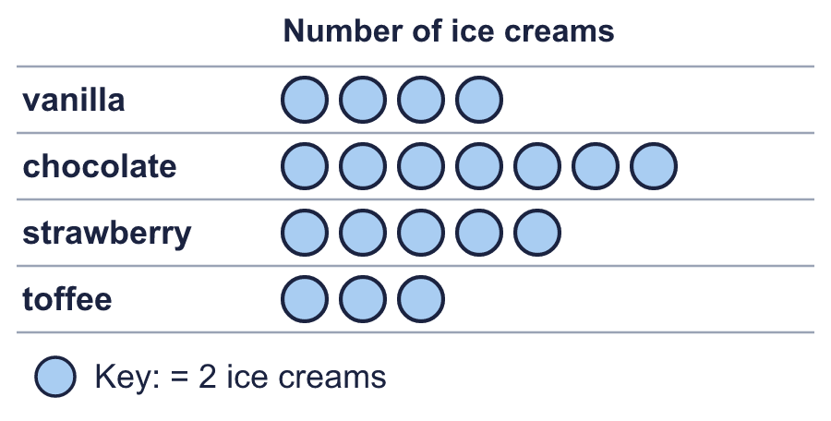  Is Eva correct? Circle yes or no.  Yes / No  Explain how you know.
     | 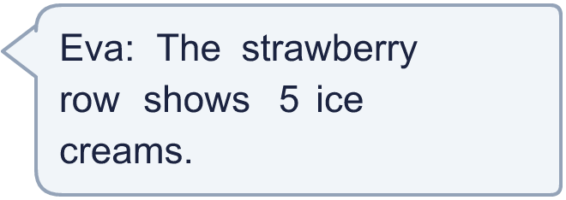
  10 | Is Eva correct? Circle yes or no.  Yes / No  Explain how you know.
  11 | Look at the pictogram.  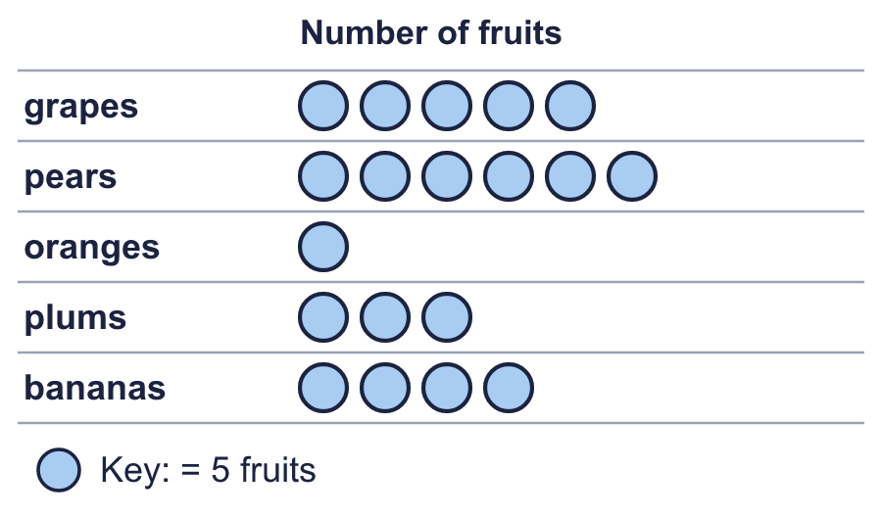
    How many more were counted for plums than for oranges?
  11 | Look at the pictogram.
    How many more were counted for plums than for oranges?
  12 | 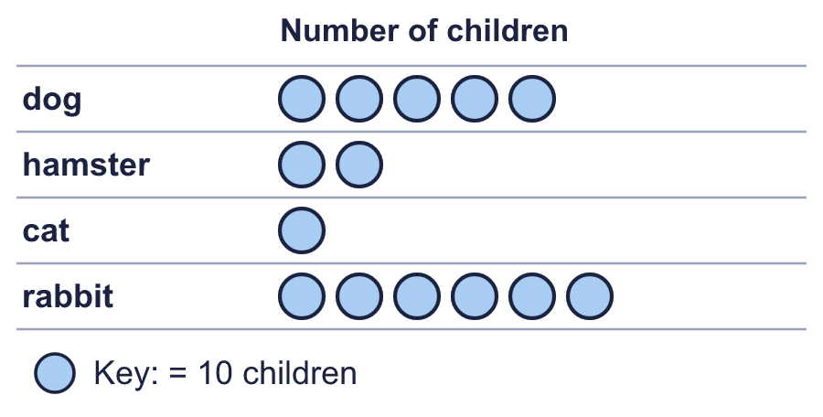  Boba draws the pictogram again. This time one symbol stands for 5 children.
    How many symbols does Boba draw for dog?
  12 | Boba draws the pictogram again. This time one symbol stands for 5 children.
    How many symbols does Boba draw for dog?
  13 | Look at the pictogram.  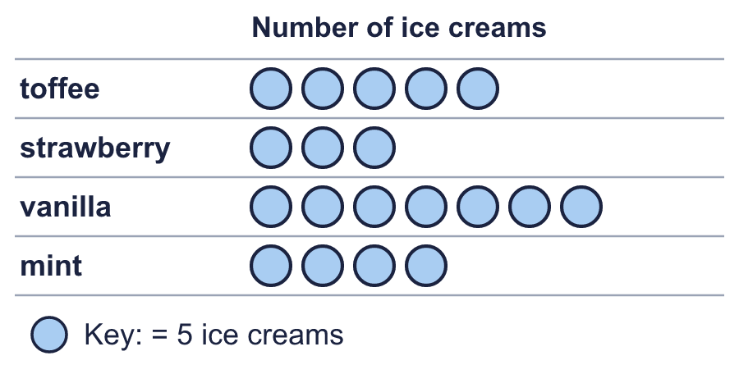
    How many were counted altogether?
  13 | Look at the pictogram.
    How many were counted altogether?
  14 | Complete the pictogram to show that 12 ice creams were counted for vanilla. Draw the symbols in your book.  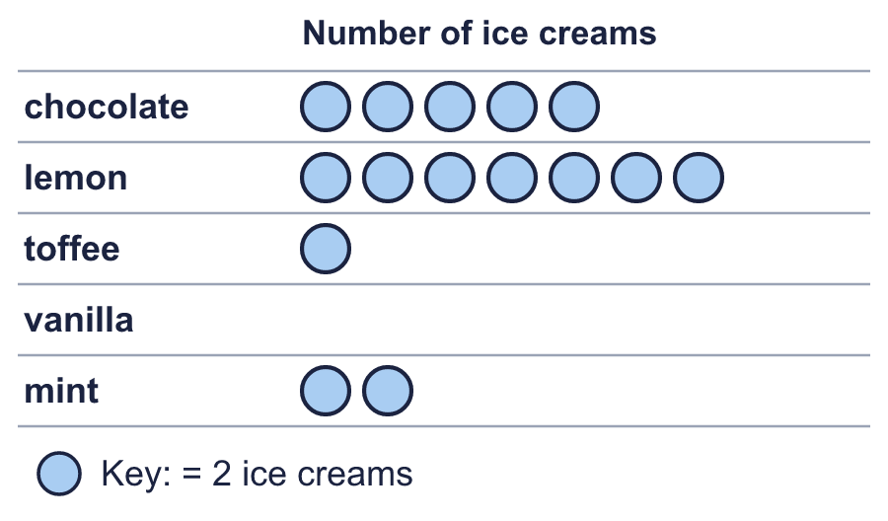
    How many symbols do you draw for vanilla?
    How many were counted for mint?
  14 | Complete the pictogram to show that 12 ice creams were counted for vanilla. Draw the symbols in your book.
    How many symbols do you draw for vanilla?
    How many were counted for mint?

Year 3 · Statistics · Step 2
Draw pictograms
Answers (teacher copy)

  1 | Complete the pictogram to show that 10 fruits were counted for pears. Draw the symbols in your book.  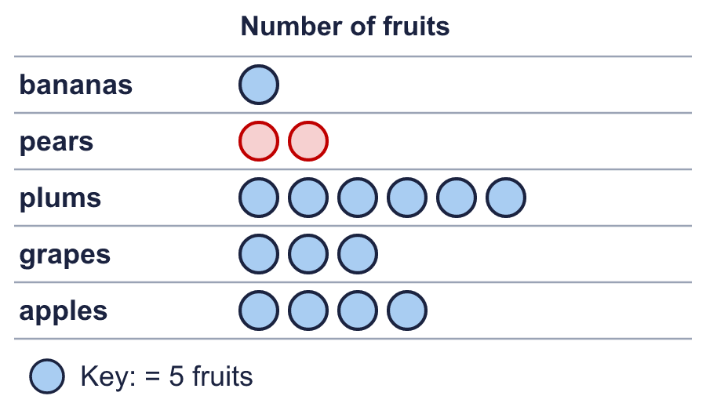  How many symbols do you draw for pears? 2  How many were counted for plums? 30
  2 | The pictogram shows how many were counted.  How many bird? 35  How many rabbit? 5
  3 | Complete the pictogram to show that 8 ice creams were counted for strawberry. Draw the symbols in your book.  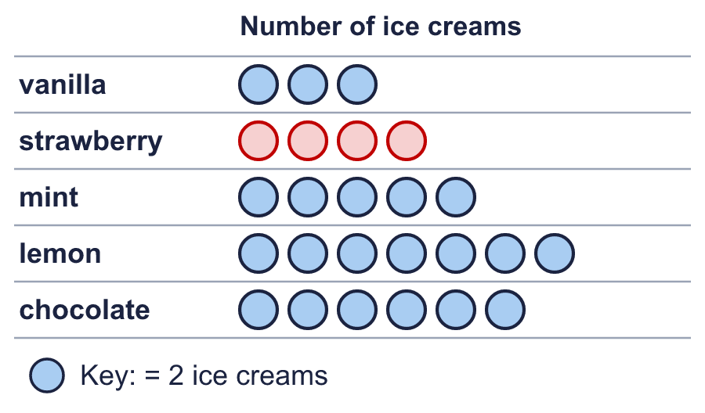  How many symbols do you draw for strawberry? 4  How many were counted for mint? 10
  4 | Look at the pictogram.  How many does one symbol stand for? 2  How many symbols are in the mint row? 3
  5 | Complete the pictogram to show that 25 children were counted for fish. Draw the symbols in your book.  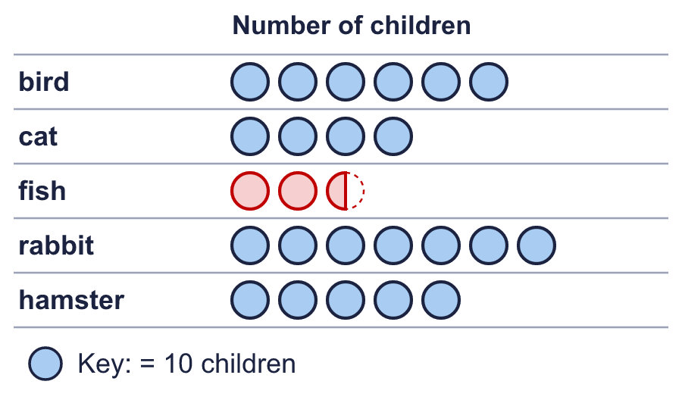  How many symbols do you draw for fish? 2.5  How many were counted for rabbit? 70
  6 | Look at the pictogram.  How many were counted for lemon and vanilla together? 100
  7 | Complete the pictogram to show that 20 fruits were counted for bananas. Draw the symbols in your book.  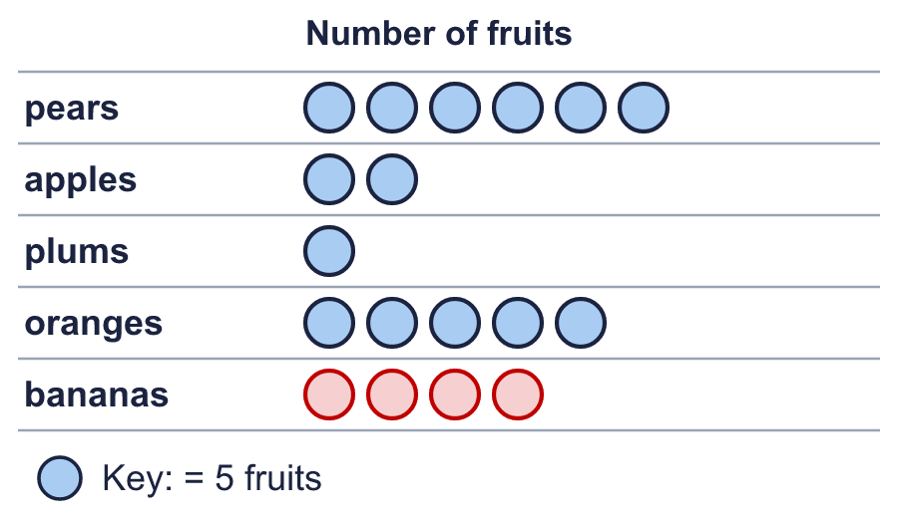  How many symbols do you draw for bananas? 4  How many were counted for pears? 30
  8 | Which row shows the most? strawberry  Which row shows the least? vanilla
  9 | Complete the pictogram to show that 8 children were counted for dog. Draw the symbols in your book.  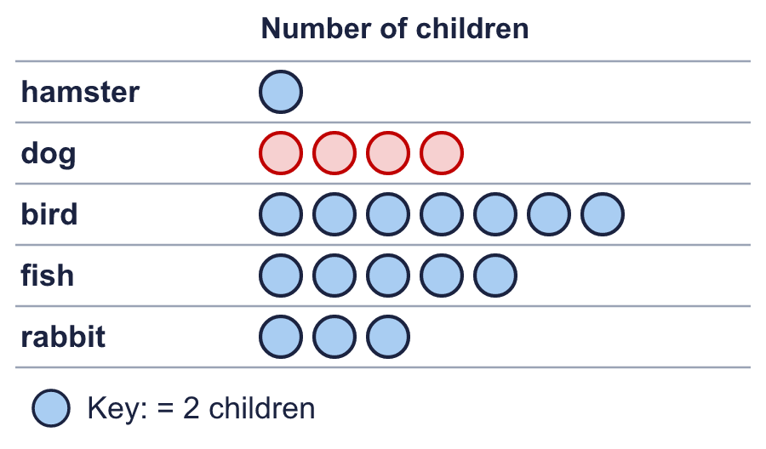  How many symbols do you draw for dog? 4  How many were counted for bird? 14
  10 | Is Eva correct? Circle yes or no.  Yes / No  Explain how you know.  No. The strawberry row has 5 symbols and each symbol stands for 2, so it shows 10.
  11 | Look at the pictogram.  How many more were counted for plums than for oranges? 10
  12 | Boba draws the pictogram again. This time one symbol stands for 5 children.  How many symbols does Boba draw for dog? 10
  13 | Look at the pictogram.  How many were counted altogether? 95
  14 | Complete the pictogram to show that 12 ice creams were counted for vanilla. Draw the symbols in your book.  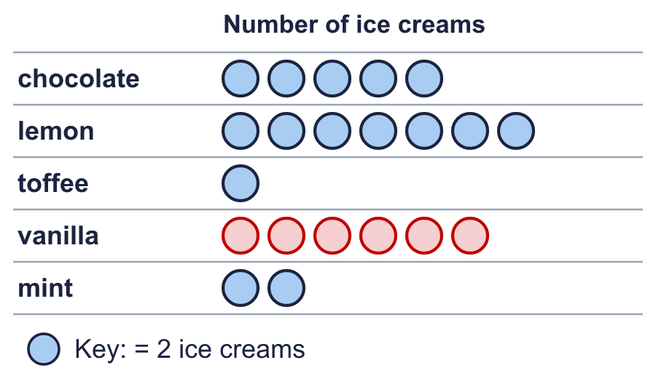  How many symbols do you draw for vanilla? 6  How many were counted for mint? 4

