  Year 3 · Statistics · Step 4  Draw bar charts | 
  Year 3 · Statistics · Step 4
  Draw bar charts
  1 | The table shows the number of children. Draw a bar chart of the data in your book. The scale goes up in 5s.  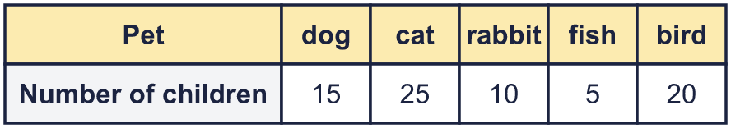
    Use your chart. How many more for cat than for fish?
  1 | The table shows the number of children. Draw a bar chart of the data in your book. The scale goes up in 5s.
    Use your chart. How many more for cat than for fish?
  2 | The table shows the number of children. Draw a bar chart of the data in your book. The scale goes up in 10s.  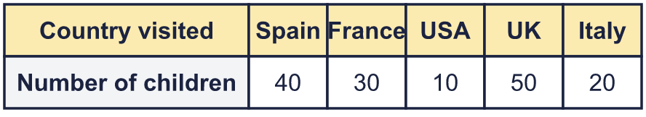
    Use your chart. How many more for UK than for USA?
  2 | The table shows the number of children. Draw a bar chart of the data in your book. The scale goes up in 10s.
    Use your chart. How many more for UK than for USA?
  3 | The bar chart shows how many were counted.  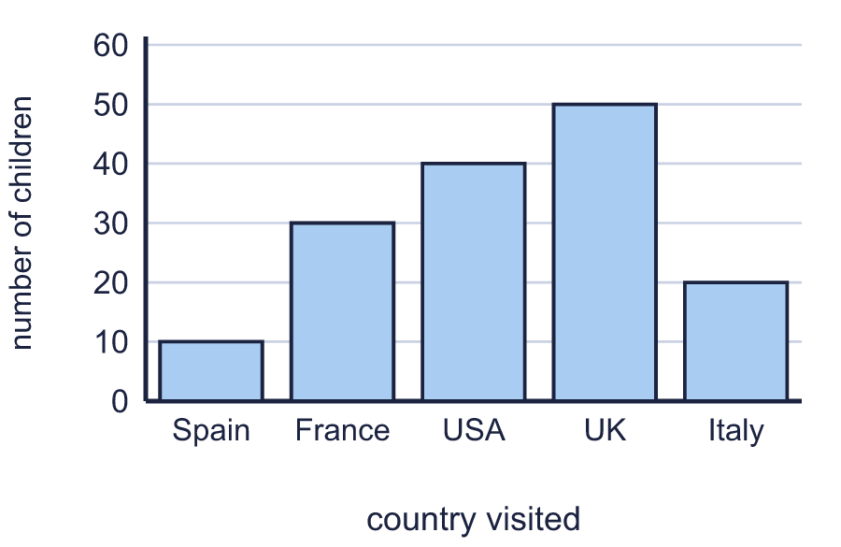
    How many were counted for USA?
    How many were counted for Italy?
  3 | The bar chart shows how many were counted.
    How many were counted for USA?
    How many were counted for Italy?
  4 | The table shows the number of points. Draw a bar chart of the data in your book. The scale goes up in 10s.  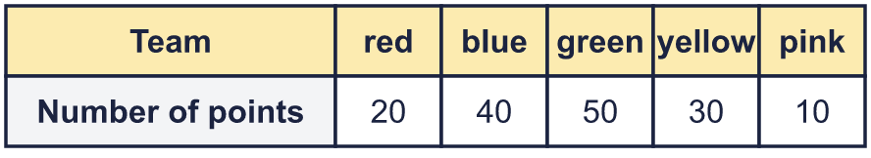
    Use your chart. How many more for green than for pink?
  4 | The table shows the number of points. Draw a bar chart of the data in your book. The scale goes up in 10s.
    Use your chart. How many more for green than for pink?
  5 | Look at the bar chart.  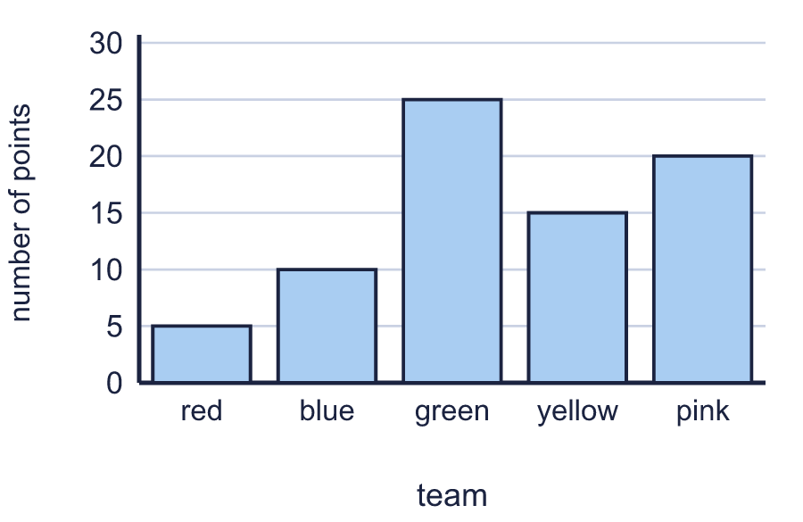
    Which has the most?
    Which has the least?
  5 | Look at the bar chart.
    Which has the most?
    Which has the least?
  6 | The bar chart shows how many were counted.  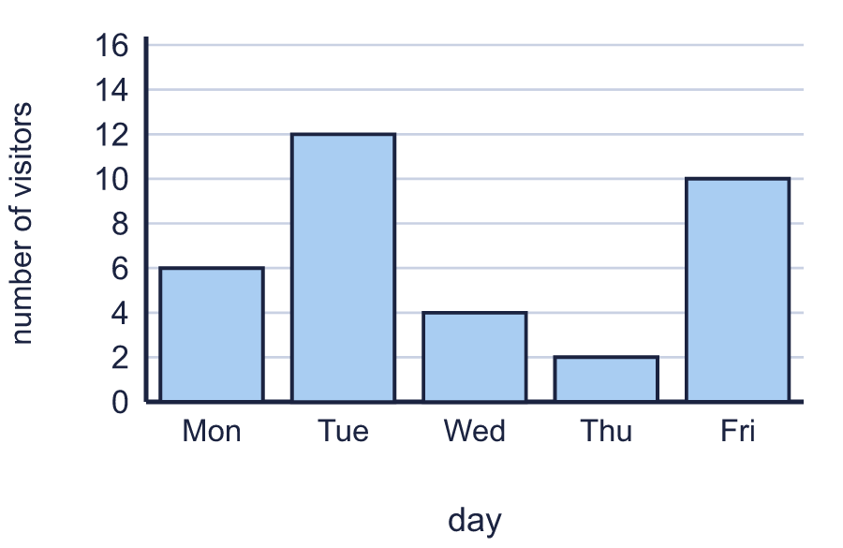
    How many were counted altogether?
  6 | The bar chart shows how many were counted.
    How many were counted altogether?
  7 | The table shows the number of points. Draw a bar chart of the data in your book. The scale goes up in 2s.  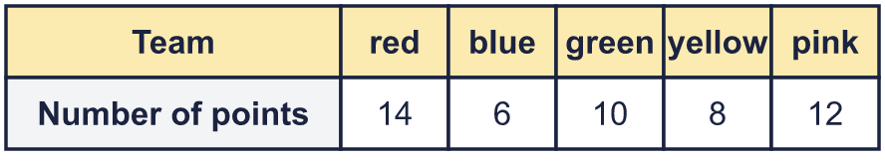
    Use your chart. How many more for red than for blue?
  7 | The table shows the number of points. Draw a bar chart of the data in your book. The scale goes up in 2s.
    Use your chart. How many more for red than for blue?
  8 | Use the bar chart to complete the table.  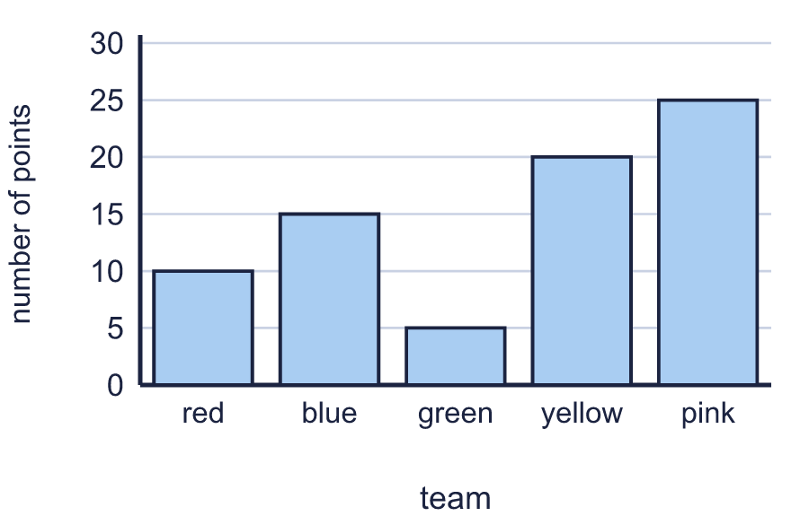
    red:
    green:
    pink:
  8 | Use the bar chart to complete the table.
    red:
    green:
    pink:

  9 | The table shows the number of visitors. Draw a bar chart of the data in your book. The scale goes up in 2s.  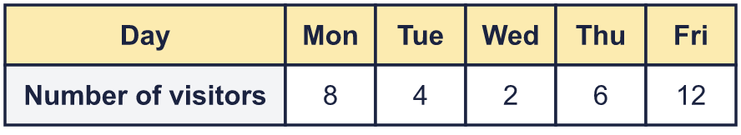
    Use your chart. How many more for Thu than for Tue?
  9 | The table shows the number of visitors. Draw a bar chart of the data in your book. The scale goes up in 2s.
    Use your chart. How many more for Thu than for Tue?
  10 | 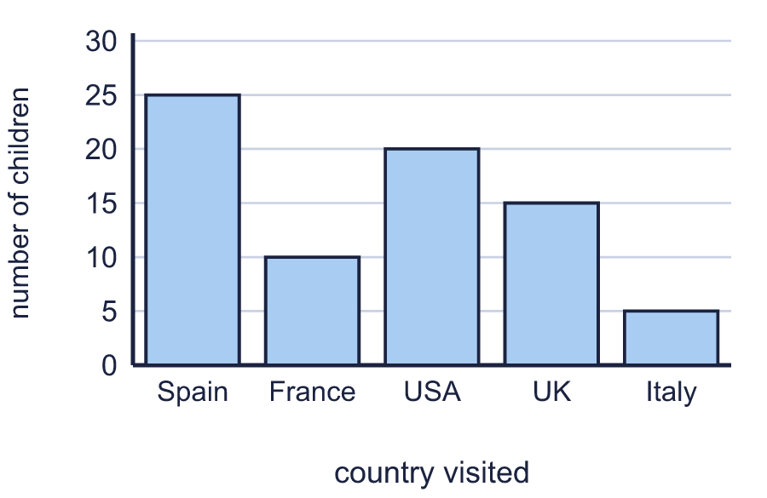
    How many more were counted for France than for Italy?
  10
    How many more were counted for France than for Italy?
  11 | The bar chart shows how many were counted.  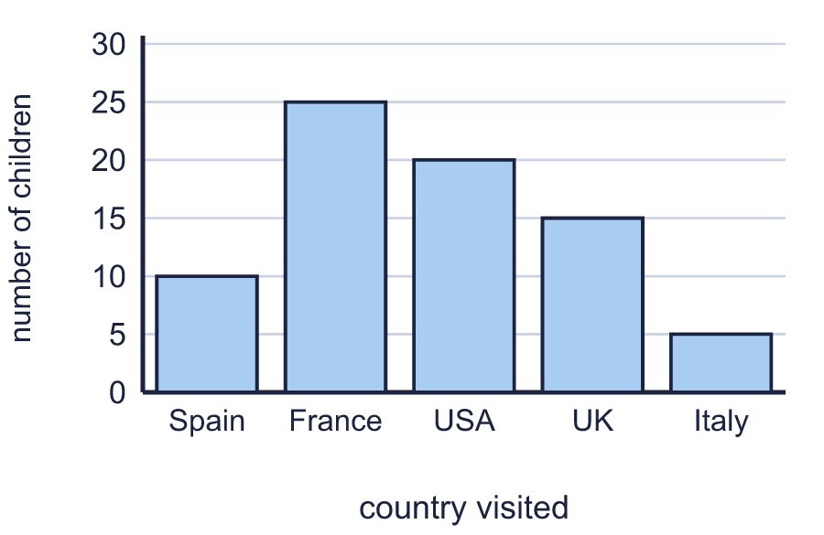
    How many were counted altogether?
  11 | The bar chart shows how many were counted.
    How many were counted altogether?
  12 | Look at the bar chart.  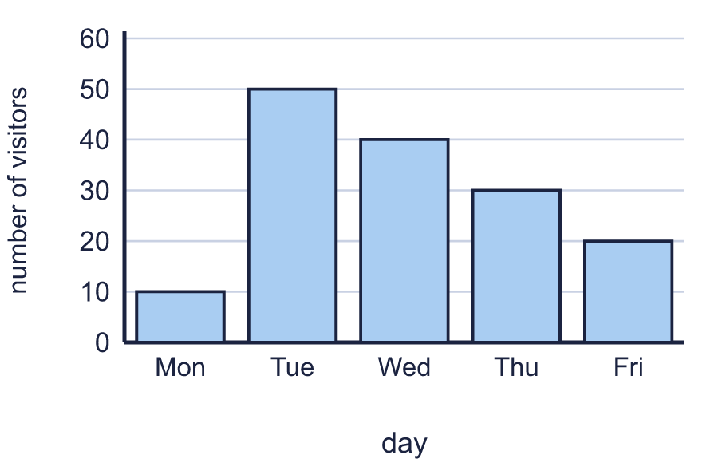
    Which has the most?
    Which has the least?
  12 | Look at the bar chart.
    Which has the most?
    Which has the least?
  13 | The table shows the number of children. Draw a bar chart of the data in your book. The scale goes up in 10s.  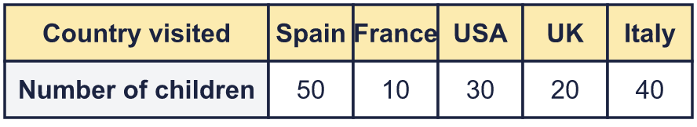
    Use your chart. How many more for USA than for France?
  13 | The table shows the number of children. Draw a bar chart of the data in your book. The scale goes up in 10s.
    Use your chart. How many more for USA than for France?
  14 | 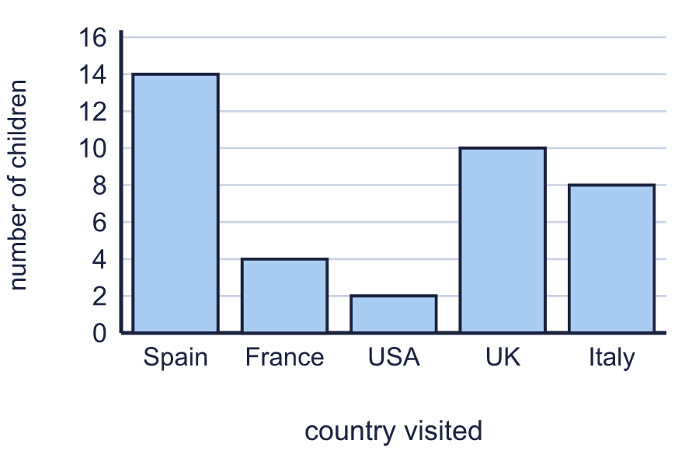
    How many more were counted for Spain than for Italy?
  14
    How many more were counted for Spain than for Italy?

Year 3 · Statistics · Step 4
Draw bar charts
Answers (teacher copy)

  1 | The table shows the number of children. Draw a bar chart of the data in your book. The scale goes up in 5s.  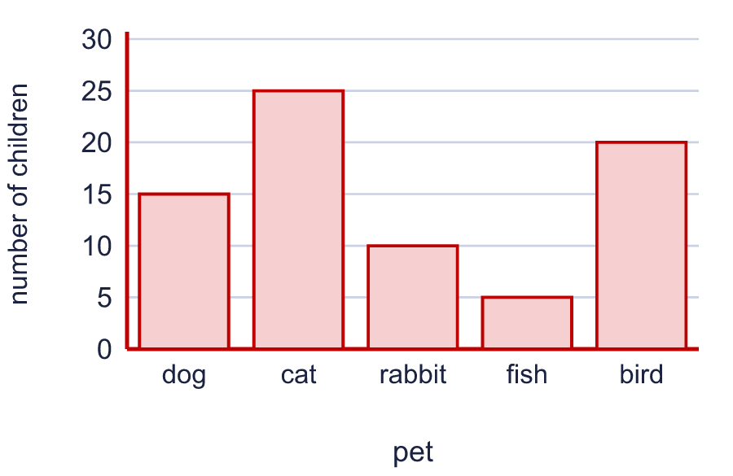  Use your chart. How many more for cat than for fish? 20
  2 | The table shows the number of children. Draw a bar chart of the data in your book. The scale goes up in 10s.  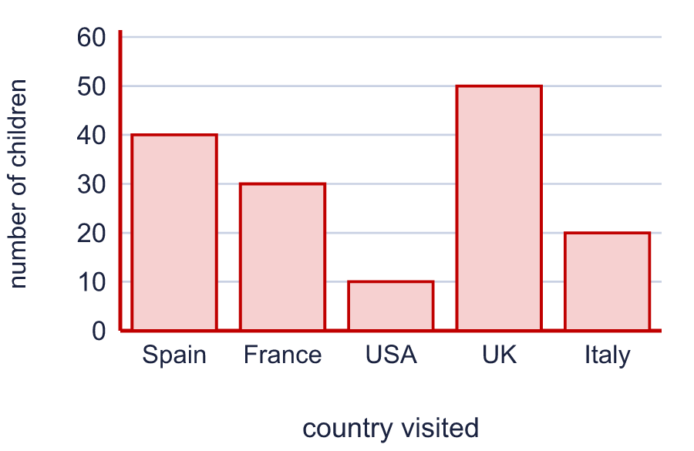  Use your chart. How many more for UK than for USA? 40
  3 | The bar chart shows how many were counted.  How many were counted for USA? 40  How many were counted for Italy? 20
  4 | The table shows the number of points. Draw a bar chart of the data in your book. The scale goes up in 10s.  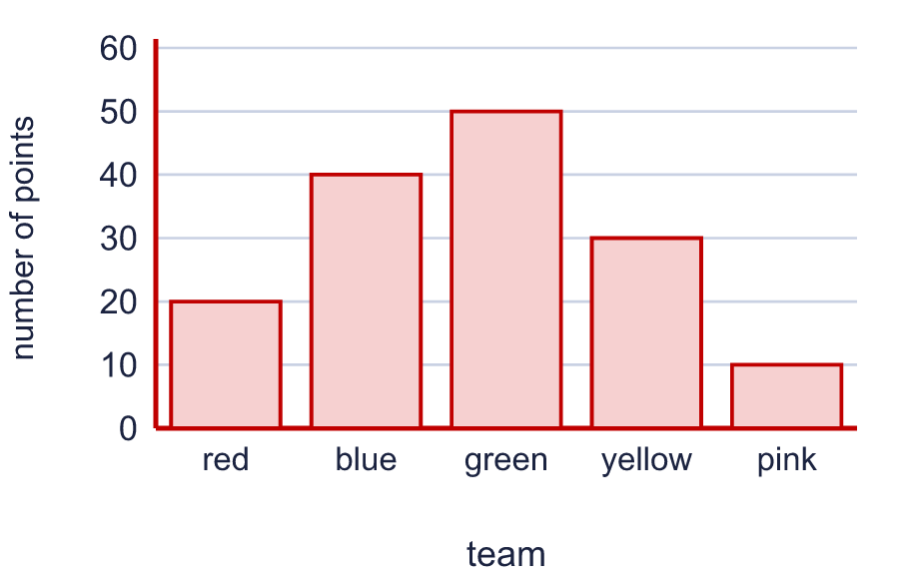  Use your chart. How many more for green than for pink? 40
  5 | Look at the bar chart.  Which has the most? green  Which has the least? red
  6 | The bar chart shows how many were counted.  How many were counted altogether? 34
  7 | The table shows the number of points. Draw a bar chart of the data in your book. The scale goes up in 2s.  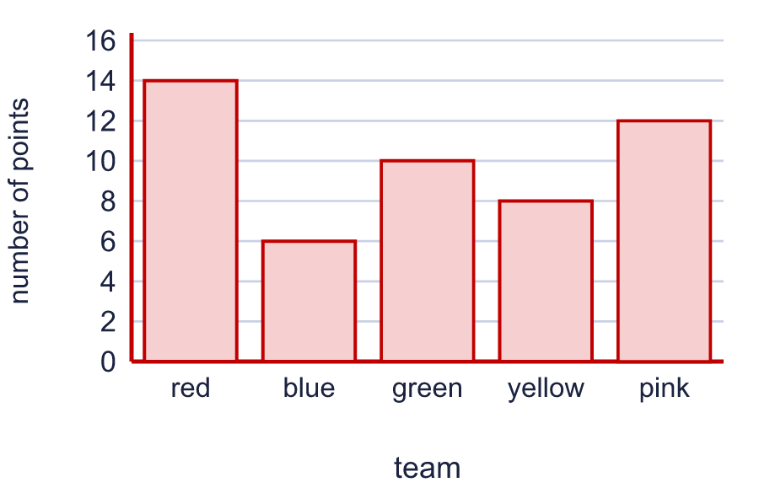  Use your chart. How many more for red than for blue? 8
  8 | Use the bar chart to complete the table.  red: 10  green: 5  pink: 25
  9 | The table shows the number of visitors. Draw a bar chart of the data in your book. The scale goes up in 2s.  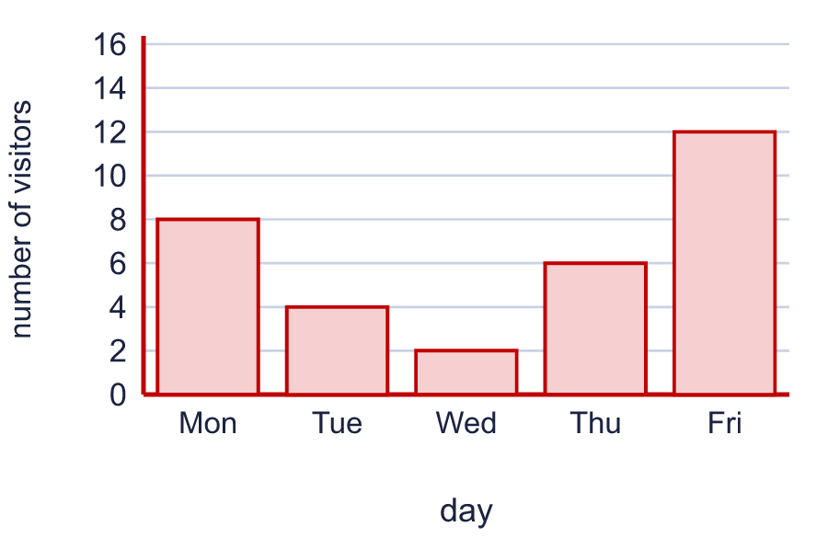  Use your chart. How many more for Thu than for Tue? 2
  10 | How many more were counted for France than for Italy? 5
  11 | The bar chart shows how many were counted.  How many were counted altogether? 75
  12 | Look at the bar chart.  Which has the most? Tue  Which has the least? Mon
  13 | The table shows the number of children. Draw a bar chart of the data in your book. The scale goes up in 10s.  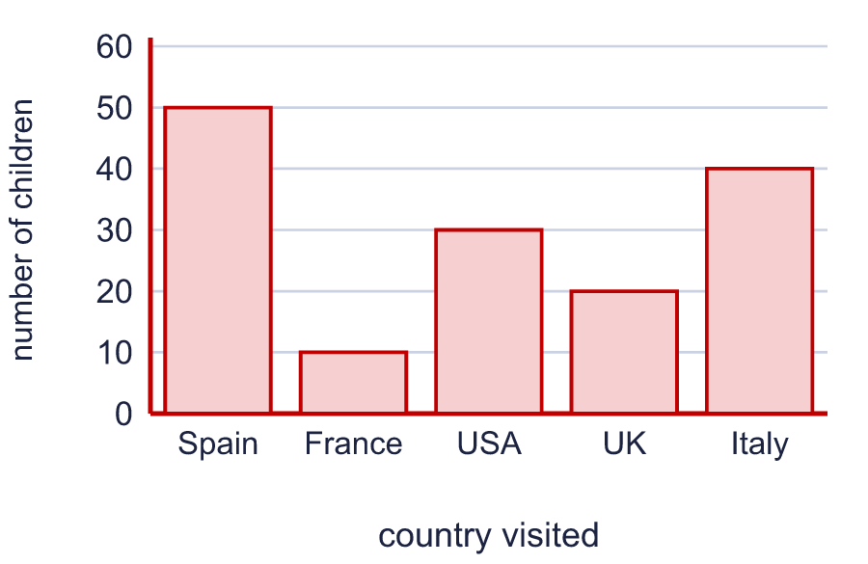  Use your chart. How many more for USA than for France? 20
  14 | How many more were counted for Spain than for Italy? 6

