  Year 3 · Statistics · Step 5  Collect and represent data | 
  Year 3 · Statistics · Step 5
  Collect and represent data
  1 | The tally chart shows how many children chose each one. Four strokes with a line across make 5.  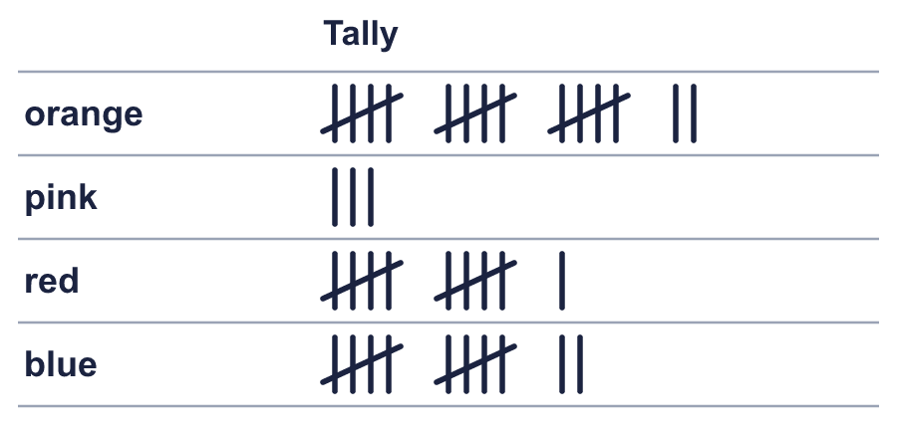
    How many chose orange?
    How many chose blue?
  1 | The tally chart shows how many children chose each one. Four strokes with a line across make 5.
    How many chose orange?
    How many chose blue?
  2 | The tally chart shows how many children chose each one.  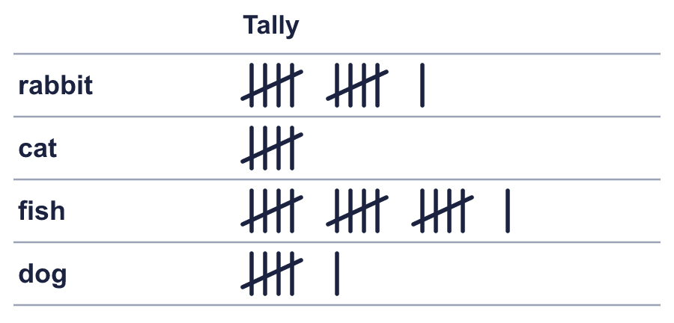
    Which was chosen by the most children?
    How many children chose one of these altogether?
  2 | The tally chart shows how many children chose each one.
    Which was chosen by the most children?
    How many children chose one of these altogether?
  3 | 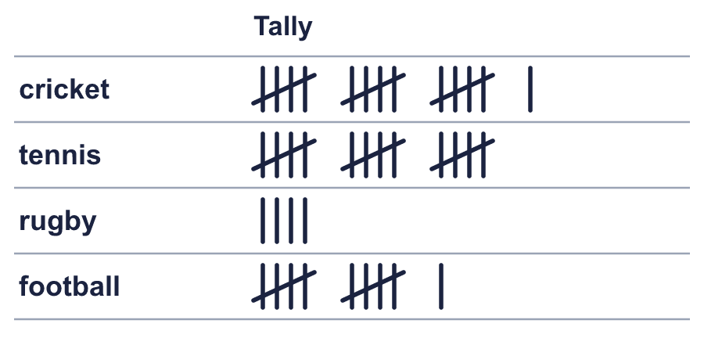
    How many more children chose cricket than tennis?
  3
    How many more children chose cricket than tennis?
  4 | 17 children chose netball. Draw the tally marks for netball in your book.  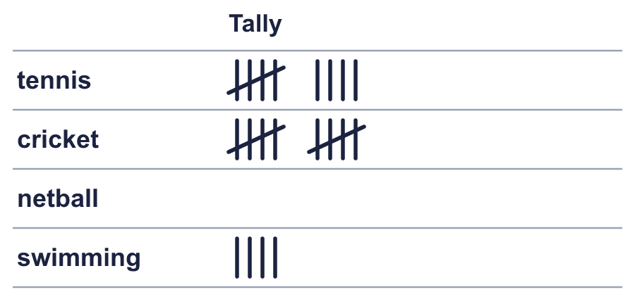
    How many children chose swimming?
  4 | 17 children chose netball. Draw the tally marks for netball in your book.
    How many children chose swimming?
  5 | The table shows what children in two classes chose.  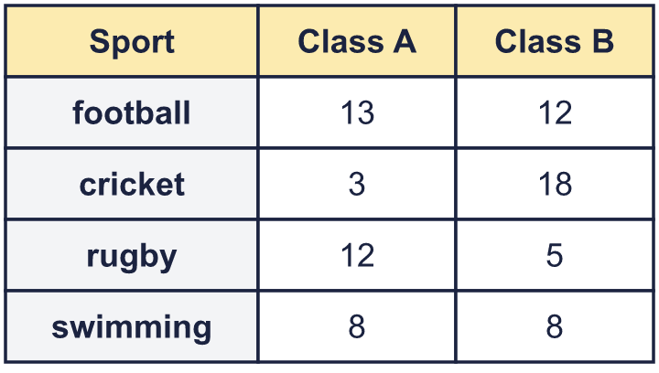
    How many children in Class A chose cricket?
    How many children are in Class A altogether?
    How many children are in Class B altogether?
  5 | The table shows what children in two classes chose.
    How many children in Class A chose cricket?
    How many children are in Class A altogether?
    How many children are in Class B altogether?
  6 | The tally chart shows how many children chose each one. Four strokes with a line across make 5.  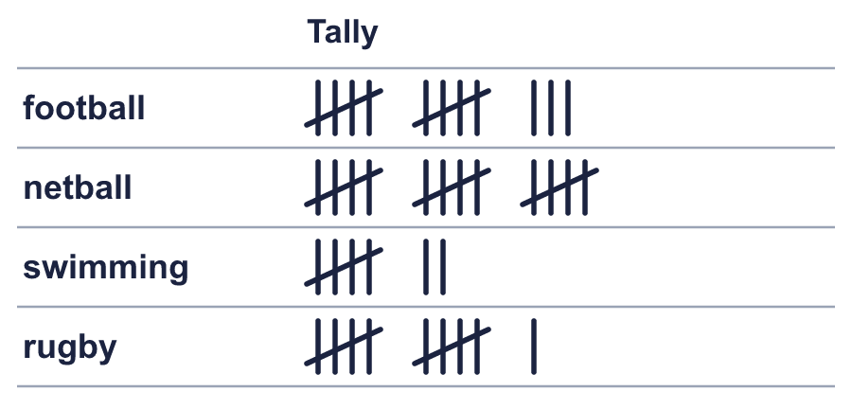
    How many chose rugby?
    How many chose netball?
  6 | The tally chart shows how many children chose each one. Four strokes with a line across make 5.
    How many chose rugby?
    How many chose netball?
  7 | 11 children chose rabbit. Draw the tally marks for rabbit in your book.  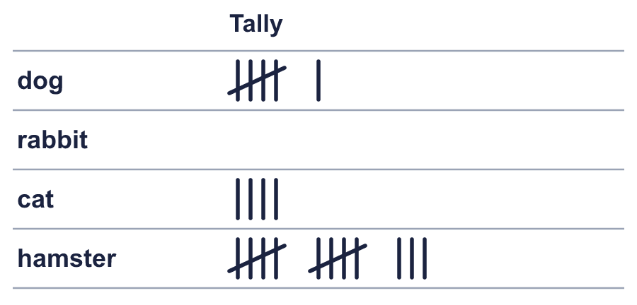
    How many children chose cat?
  7 | 11 children chose rabbit. Draw the tally marks for rabbit in your book.
    How many children chose cat?
  8 | The tally chart shows how many children chose each one.  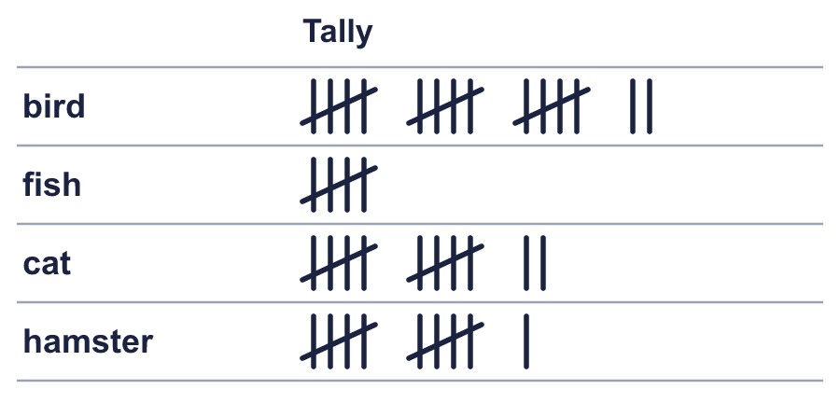
    Which was chosen by the most children?
    How many children chose one of these altogether?
  8 | The tally chart shows how many children chose each one.
    Which was chosen by the most children?
    How many children chose one of these altogether?

  9 | 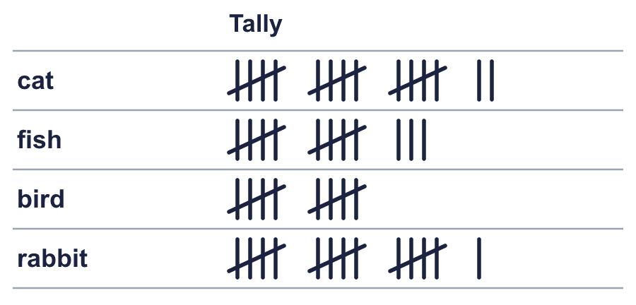  Is Rosie correct? Circle yes or no.  Yes / No  Explain how you know.
     | 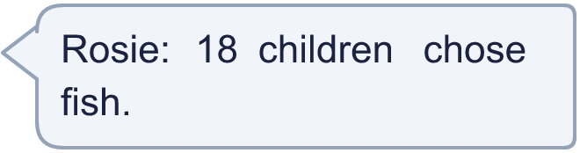
  9 | Is Rosie correct? Circle yes or no.  Yes / No  Explain how you know.
  10 | 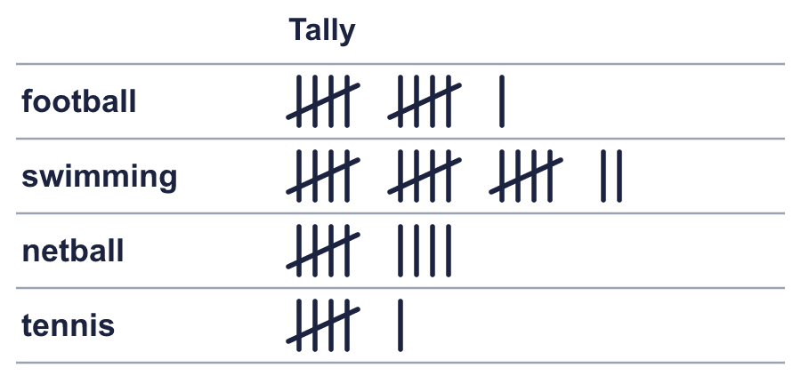
    How many more children chose swimming than netball?
  10
    How many more children chose swimming than netball?
  11 | The table shows what children in two classes chose.  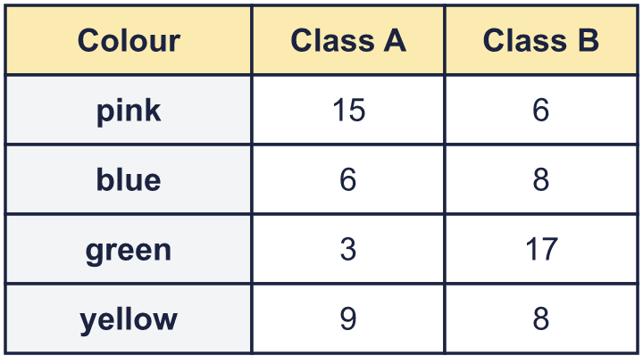
    How many children in Class B chose pink?
    How many children are in Class A altogether?
    How many children are in Class B altogether?
  11 | The table shows what children in two classes chose.
    How many children in Class B chose pink?
    How many children are in Class A altogether?
    How many children are in Class B altogether?
  12 | 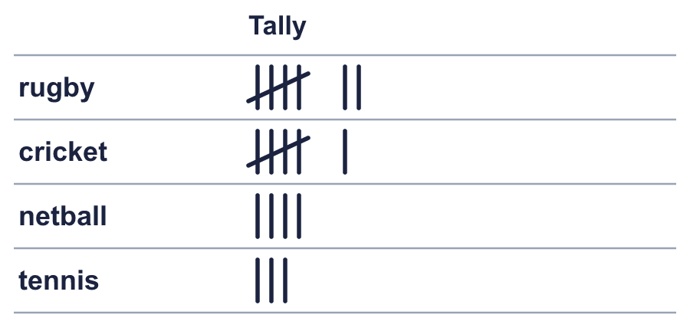  Is Mo correct? Circle yes or no.  Yes / No  Explain how you know.
    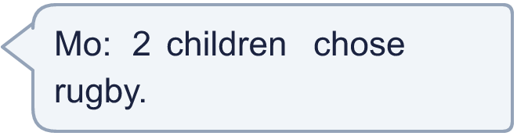
  12 | Is Mo correct? Circle yes or no.  Yes / No  Explain how you know.
  13 | 4 children chose rugby. Draw the tally marks for rugby in your book.  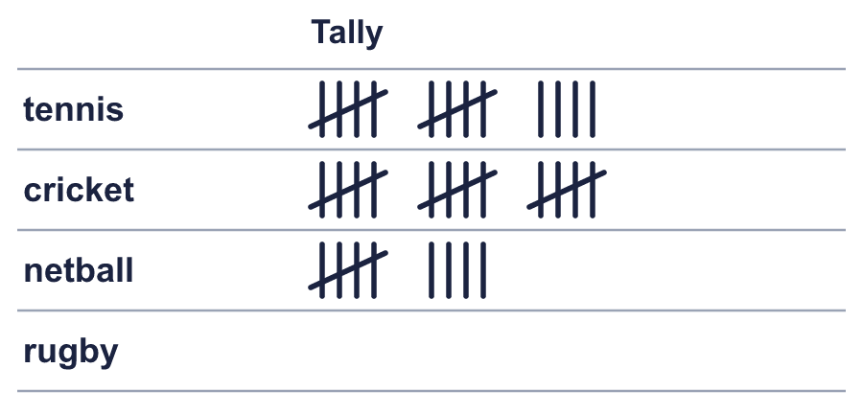
    How many children chose tennis?
  13 | 4 children chose rugby. Draw the tally marks for rugby in your book.
    How many children chose tennis?
  14 | The tally chart shows how many children chose each one.  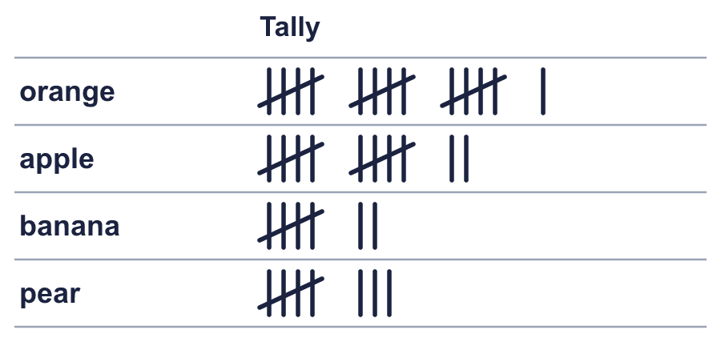
    Which was chosen by the most children?
    How many children chose one of these altogether?
  14 | The tally chart shows how many children chose each one.
    Which was chosen by the most children?
    How many children chose one of these altogether?

Year 3 · Statistics · Step 5
Collect and represent data
Answers (teacher copy)

  1 | The tally chart shows how many children chose each one. Four strokes with a line across make 5.  How many chose orange? 17  How many chose blue? 12
  2 | The tally chart shows how many children chose each one.  Which was chosen by the most children? fish  How many children chose one of these altogether? 38
  3 | How many more children chose cricket than tennis? 1
  4 | 17 children chose netball. Draw the tally marks for netball in your book.  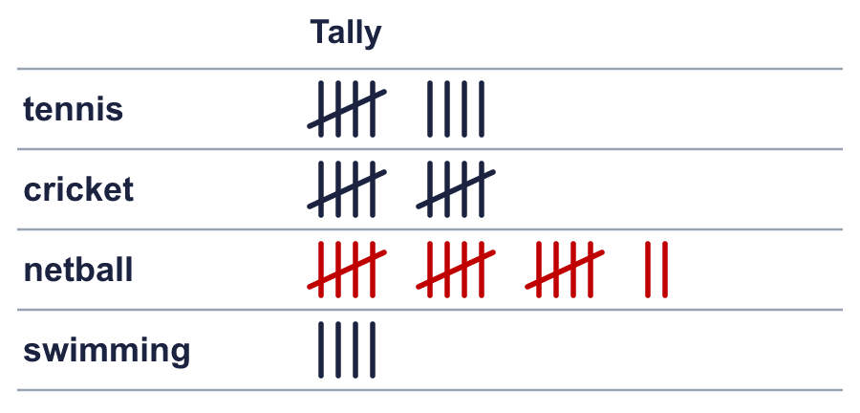  How many children chose swimming? 4
  5 | The table shows what children in two classes chose.  How many children in Class A chose cricket? 3  How many children are in Class A altogether? 36  How many children are in Class B altogether? 43
  6 | The tally chart shows how many children chose each one. Four strokes with a line across make 5.  How many chose rugby? 11  How many chose netball? 15
  7 | 11 children chose rabbit. Draw the tally marks for rabbit in your book.  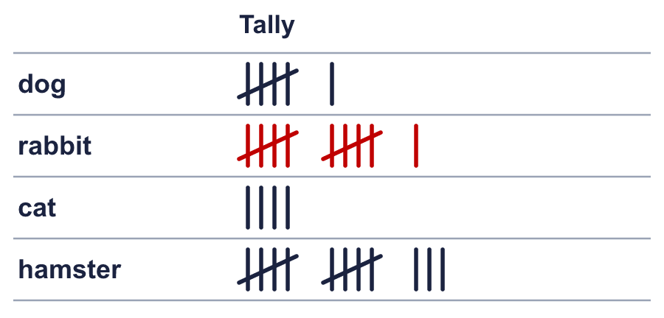  How many children chose cat? 4
  8 | The tally chart shows how many children chose each one.  Which was chosen by the most children? bird  How many children chose one of these altogether? 45
  9 | Is Rosie correct? Circle yes or no.  Yes / No  Explain how you know.  No. The tally shows 13 for fish.
  10 | How many more children chose swimming than netball? 8
  11 | The table shows what children in two classes chose.  How many children in Class B chose pink? 6  How many children are in Class A altogether? 33  How many children are in Class B altogether? 39
  12 | Is Mo correct? Circle yes or no.  Yes / No  Explain how you know.  No. The tally shows 7 for rugby.
  13 | 4 children chose rugby. Draw the tally marks for rugby in your book.  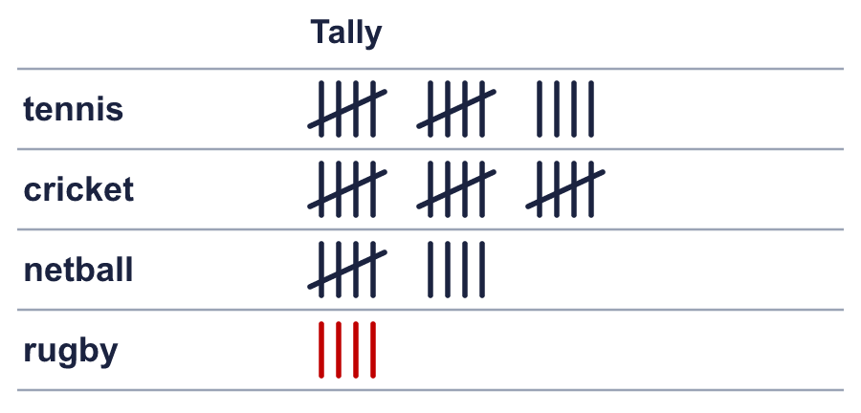  How many children chose tennis? 14
  14 | The tally chart shows how many children chose each one.  Which was chosen by the most children? orange  How many children chose one of these altogether? 43

