  Year 3 · Shape · Step 1  Turns and angles | 
  Year 3 · Shape · Step 1
  Turns and angles
  1 | The child is facing east. Which way will the child face after each turn?  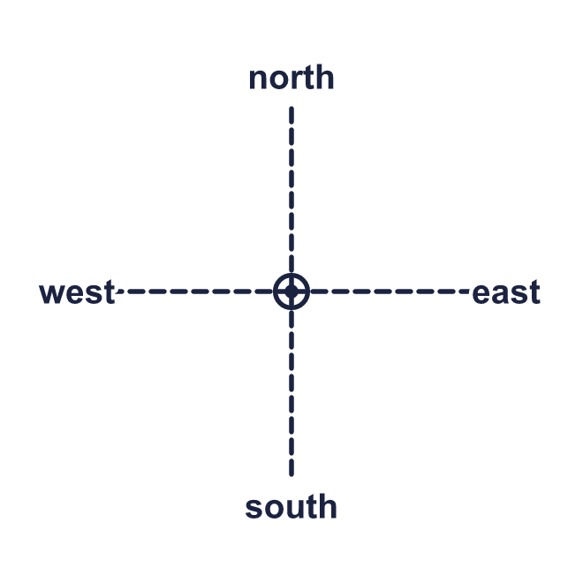  a) a quarter turn clockwise:  b) a half turn anticlockwise:  c) a three-quarter turn anticlockwise:
  1 | The child is facing east. Which way will the child face after each turn?  a) a quarter turn clockwise:  b) a half turn anticlockwise:  c) a three-quarter turn anticlockwise:
  2 | Look at the picture. Write quarter, half or three-quarter for the size of each turn.  a) south to west, anticlockwise:  b) south to east, anticlockwise:  c) north to east, anticlockwise:
  2 | Look at the picture. Write quarter, half or three-quarter for the size of each turn.  a) south to west, anticlockwise:  b) south to east, anticlockwise:  c) north to east, anticlockwise:
  3 | Look at the picture. Write clockwise or anticlockwise.  a) a quarter turn from west to south:  b) a quarter turn from north to west:  c) a three-quarter turn from west to south:
  3 | Look at the picture. Write clockwise or anticlockwise.  a) a quarter turn from west to south:  b) a quarter turn from north to west:  c) a three-quarter turn from west to south:
  4 | How many quarter turns make each turn?  a) a full turn:  b) a half turn:  c) a three-quarter turn:
  4 | How many quarter turns make each turn?  a) a full turn:  b) a half turn:  c) a three-quarter turn:
  5 | The minute hand of a clock points to a number. It makes a turn. Which number does it point to now?  a) It starts at 3 and makes a three-quarter turn anticlockwise:  b) It starts at 9 and makes a half turn clockwise:  c) It starts at 12 and makes a half turn anticlockwise:
  5 | The minute hand of a clock points to a number. It makes a turn. Which number does it point to now?  a) It starts at 3 and makes a three-quarter turn anticlockwise:  b) It starts at 9 and makes a half turn clockwise:  c) It starts at 12 and makes a half turn anticlockwise:
  6 | Complete the sentences. Write quarter, half or three-quarter.  a) a three-quarter turn clockwise is the same as a ___ turn anticlockwise:  b) a quarter turn anticlockwise is the same as a ___ turn clockwise:
  6 | Complete the sentences. Write quarter, half or three-quarter.  a) a three-quarter turn clockwise is the same as a ___ turn anticlockwise:  b) a quarter turn anticlockwise is the same as a ___ turn clockwise:
  7 | The child is facing south. The child makes a half turn anticlockwise and then a three-quarter turn anticlockwise.  a) Which way is the child facing now?
  7 | The child is facing south. The child makes a half turn anticlockwise and then a three-quarter turn anticlockwise.  a) Which way is the child facing now?
  8 | After a half turn anticlockwise the child is facing east.  a) Which way was the child facing before the turn?
  8 | After a half turn anticlockwise the child is facing east.  a) Which way was the child facing before the turn?

  9 | Alex is facing east.  Is Alex correct? Circle yes or no.  Yes / No  Explain how you know.
     | 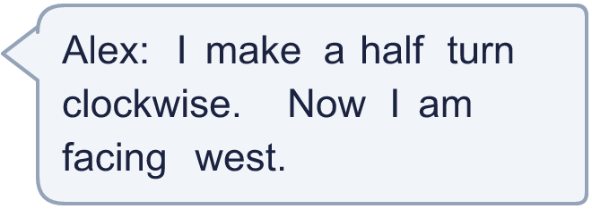
  9 | Alex is facing east.  Is Alex correct? Circle yes or no.  Yes / No  Explain how you know.
  10 | The child is facing north. Which of these turns make the child face the same way as a quarter turn anticlockwise? Write the letters.  A: a half turn clockwise  B: a three-quarter turn clockwise  C: a quarter turn clockwise  D: a quarter turn anticlockwise
  10 | The child is facing north. Which of these turns make the child face the same way as a quarter turn anticlockwise? Write the letters.  A: a half turn clockwise  B: a three-quarter turn clockwise  C: a quarter turn clockwise  D: a quarter turn anticlockwise
  11 | The minute hand starts at 12. It makes a quarter turn clockwise and then a three-quarter turn clockwise.  a) Which number does it point to now?
  11 | The minute hand starts at 12. It makes a quarter turn clockwise and then a three-quarter turn clockwise.  a) Which number does it point to now?
  12 | Tia is facing west. Tia makes a full turn clockwise and then a three-quarter turn anticlockwise.  a) Which way is Tia facing now?
  12 | Tia is facing west. Tia makes a full turn clockwise and then a three-quarter turn anticlockwise.  a) Which way is Tia facing now?
  13 | A quarter of an hour is a quarter turn of the minute hand. Which number does the minute hand point to?  a) It starts at 12 and makes a three-quarter turn anticlockwise:  b) It starts at 9 and makes a half turn clockwise:
  13 | A quarter of an hour is a quarter turn of the minute hand. Which number does the minute hand point to?  a) It starts at 12 and makes a three-quarter turn anticlockwise:  b) It starts at 9 and makes a half turn clockwise:
  14 | Challenge  Alex makes a three-quarter turn anticlockwise and then a half turn. Alex is now facing west.  a) Which way was Alex facing at the start?
  14 | Challenge  Alex makes a three-quarter turn anticlockwise and then a half turn. Alex is now facing west.  a) Which way was Alex facing at the start?

Year 3 · Shape · Step 1
Turns and angles
Answers (teacher copy)

  1 | The child is facing east. Which way will the child face after each turn?  a) a quarter turn clockwise: south  b) a half turn anticlockwise: west  c) a three-quarter turn anticlockwise: south
  2 | Look at the picture. Write quarter, half or three-quarter for the size of each turn.  a) south to west, anticlockwise: three-quarter  b) south to east, anticlockwise: quarter  c) north to east, anticlockwise: three-quarter
  3 | Look at the picture. Write clockwise or anticlockwise.  a) a quarter turn from west to south: anticlockwise  b) a quarter turn from north to west: anticlockwise  c) a three-quarter turn from west to south: clockwise
  4 | How many quarter turns make each turn?  a) a full turn: 4  b) a half turn: 2  c) a three-quarter turn: 3
  5 | The minute hand of a clock points to a number. It makes a turn. Which number does it point to now?  a) It starts at 3 and makes a three-quarter turn anticlockwise: 6  b) It starts at 9 and makes a half turn clockwise: 3  c) It starts at 12 and makes a half turn anticlockwise: 6
  6 | Complete the sentences. Write quarter, half or three-quarter.  a) a three-quarter turn clockwise is the same as a ___ turn anticlockwise: quarter  b) a quarter turn anticlockwise is the same as a ___ turn clockwise: three-quarter
  7 | The child is facing south. The child makes a half turn anticlockwise and then a three-quarter turn anticlockwise.  a) Which way is the child facing now? east
  8 | After a half turn anticlockwise the child is facing east.  a) Which way was the child facing before the turn? west
  9 | Alex is facing east.  Is Alex correct? Circle yes or no.  Yes / No  Explain how you know.  Yes. After a half turn clockwise from east the child faces west.
  10 | The child is facing north. Which of these turns make the child face the same way as a quarter turn anticlockwise? Write the letters.  A: a half turn clockwise  B: a three-quarter turn clockwise  C: a quarter turn clockwise  D: a quarter turn anticlockwise  B, D
  11 | The minute hand starts at 12. It makes a quarter turn clockwise and then a three-quarter turn clockwise.  a) Which number does it point to now? 12
  12 | Tia is facing west. Tia makes a full turn clockwise and then a three-quarter turn anticlockwise.  a) Which way is Tia facing now? north
  13 | A quarter of an hour is a quarter turn of the minute hand. Which number does the minute hand point to?  a) It starts at 12 and makes a three-quarter turn anticlockwise: 3  b) It starts at 9 and makes a half turn clockwise: 3
  14 | Challenge  Alex makes a three-quarter turn anticlockwise and then a half turn. Alex is now facing west.  a) Which way was Alex facing at the start? north

