  Year 3 · Shape · Step 2  Right angles | 
  Year 3 · Shape · Step 2
  Right angles
  1 | Look at the four angles. One of them is a right angle.  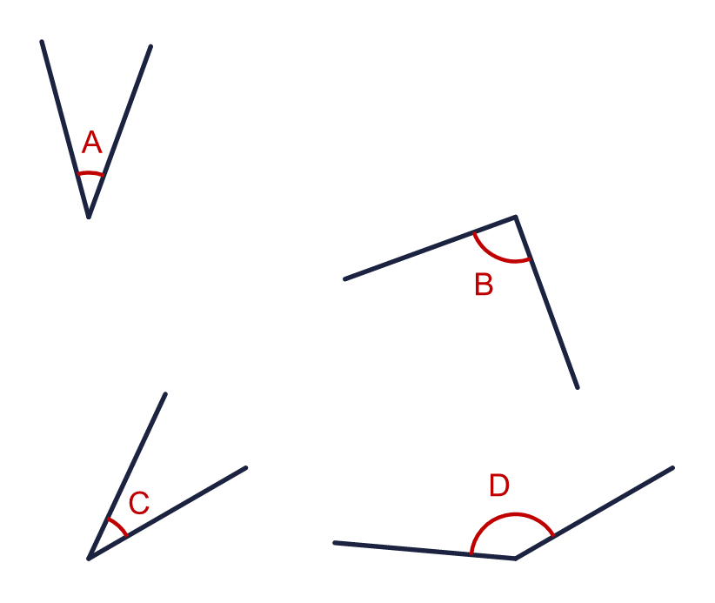
    Right angle:
    Less than a right angle:
    Greater than a right angle:
  1 | Look at the four angles. One of them is a right angle.
    Right angle:
    Less than a right angle:
    Greater than a right angle:
  2 | A right angle is a quarter turn. How many right angles make each turn?  a) a half turn:  b) a full turn:  c) a three-quarter turn:
  2 | A right angle is a quarter turn. How many right angles make each turn?  a) a half turn:  b) a full turn:  c) a three-quarter turn:
  3 | Look at the six angles.  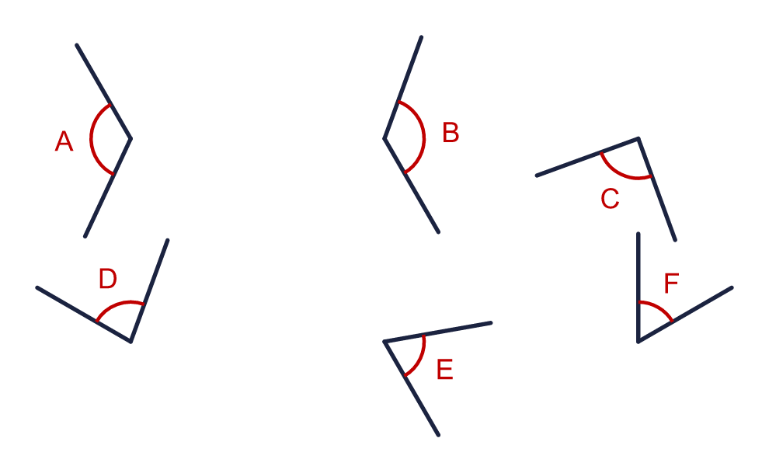  Which angles are less than a right angle? Write the letters.
  3 | Look at the six angles.  Which angles are less than a right angle? Write the letters.
  4 | Look at the six angles.  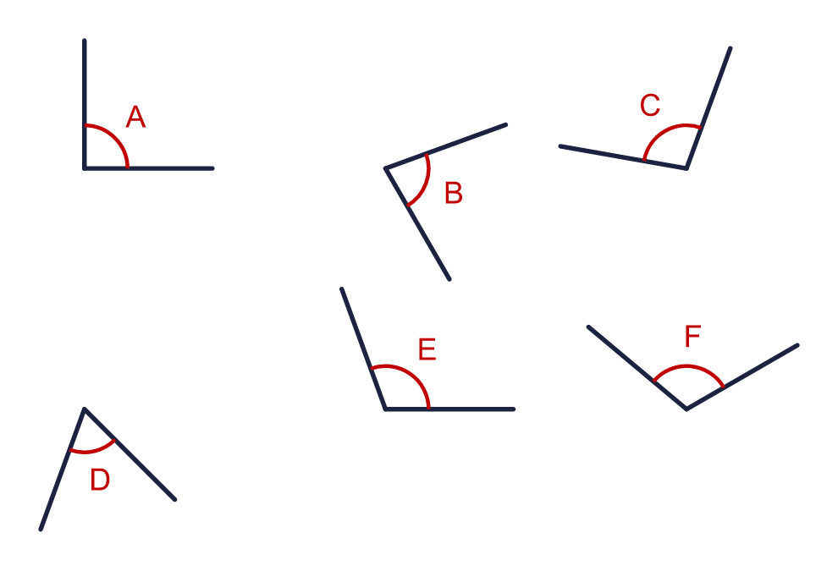  Which angles are greater than a right angle? Write the letters.
  4 | Look at the six angles.  Which angles are greater than a right angle? Write the letters.
  5 | Here are six angles. None of them is a right angle.  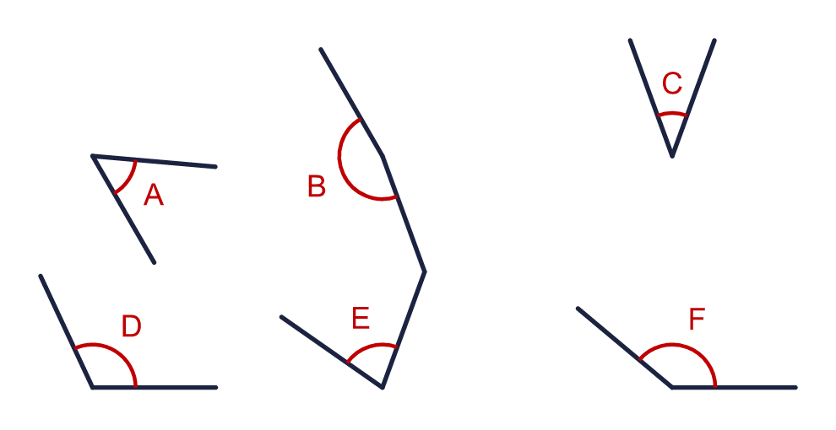  a) How many are less than a right angle?  b) How many are greater than a right angle?
  5 | Here are six angles. None of them is a right angle.  a) How many are less than a right angle?  b) How many are greater than a right angle?
  6 | The right angles are marked with squares.  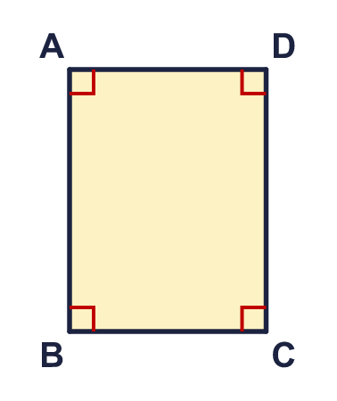  a) How many right angles does the shape have?
  6 | The right angles are marked with squares.  a) How many right angles does the shape have?
  7 | Look at the four angles.  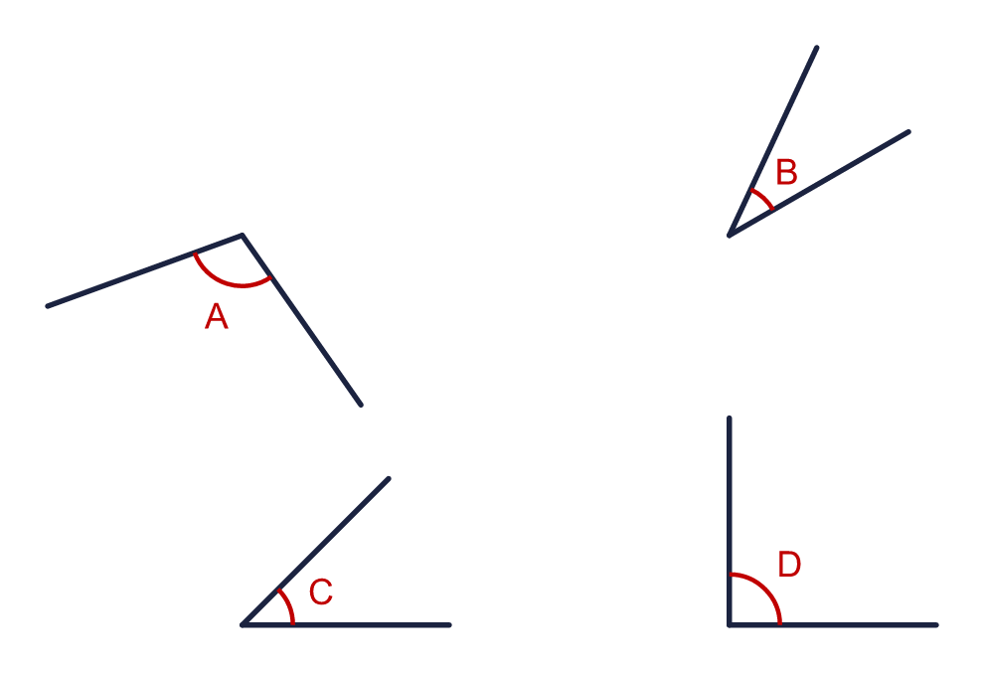  Which angle is a right angle? Write the letter.
  7 | Look at the four angles.  Which angle is a right angle? Write the letter.
  8 | Look at the shape.  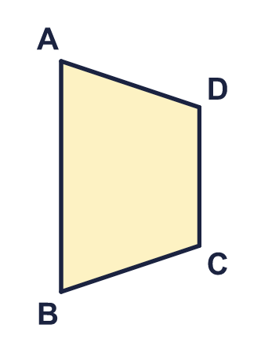  a) How many angles are less than a right angle?  b) How many angles are greater than a right angle?
  8 | Look at the shape.  a) How many angles are less than a right angle?  b) How many angles are greater than a right angle?

  9 | Sam has drawn the angle a.  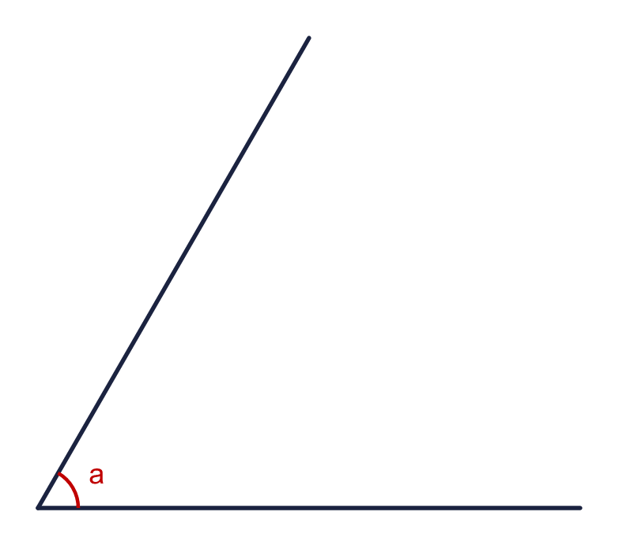  Is Sam correct? Circle yes or no.  Yes / No  Explain how you know.
     | 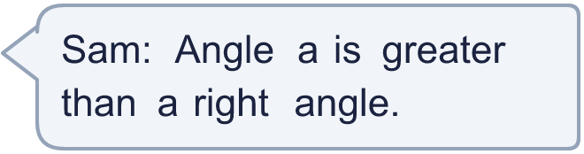
  9 | Sam has drawn the angle a.  Is Sam correct? Circle yes or no.  Yes / No  Explain how you know.
  10 | How many right angles are in each turn? Use what you know about quarter turns.  a) a full turn:  b) a half turn:  c) a quarter turn:
  10 | How many right angles are in each turn? Use what you know about quarter turns.  a) a full turn:  b) a half turn:  c) a quarter turn:
  11 | The right angles are marked with squares.  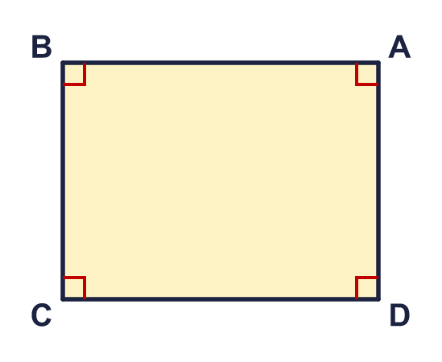  a) How many angles are not right angles?
  11 | The right angles are marked with squares.  a) How many angles are not right angles?
  12 | Look at the six angles.  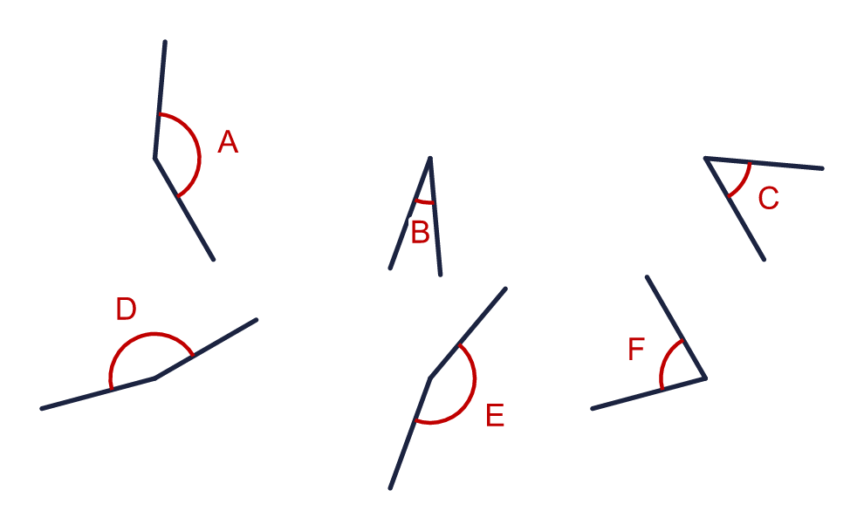  a) How many angles are greater than a right angle?  b) How many angles are less than a right angle?
  12 | Look at the six angles.  a) How many angles are greater than a right angle?  b) How many angles are less than a right angle?
  13 | Is the statement always true, sometimes true or never true?  A polygon has a right angle.  Write always, sometimes or never.
  13 | Is the statement always true, sometimes true or never true?  A polygon has a right angle.  Write always, sometimes or never.
  14 | Challenge  Here are six angles. Two of them are right angles.  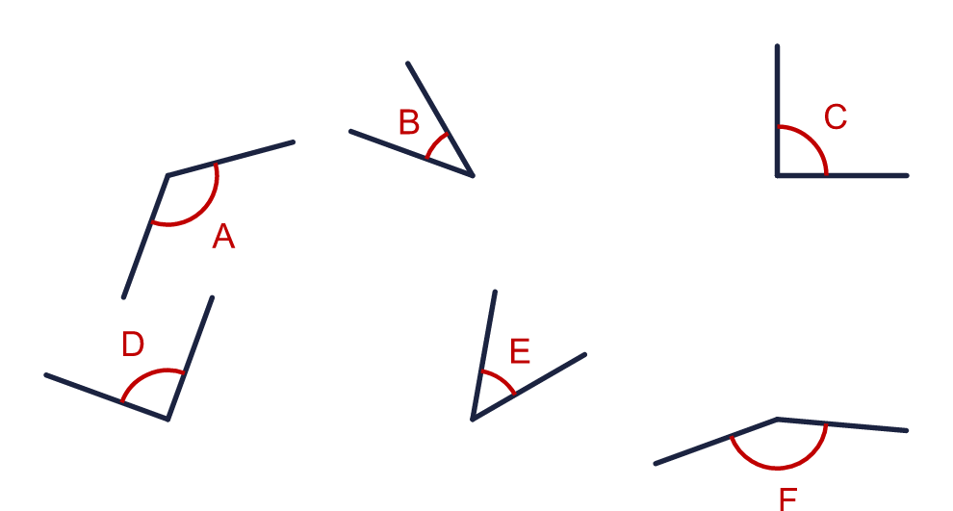  Write the letters of the two right angles.
  14 | Challenge  Here are six angles. Two of them are right angles.  Write the letters of the two right angles.

Year 3 · Shape · Step 2
Right angles
Answers (teacher copy)

  1 | Look at the four angles. One of them is a right angle.  Right angle: B  Less than a right angle: A, C  Greater than a right angle: D
  2 | A right angle is a quarter turn. How many right angles make each turn?  a) a half turn: 2  b) a full turn: 4  c) a three-quarter turn: 3
  3 | Look at the six angles.  Which angles are less than a right angle? Write the letters. D, E, F
  4 | Look at the six angles.  Which angles are greater than a right angle? Write the letters. C, E, F
  5 | Here are six angles. None of them is a right angle.  a) How many are less than a right angle? 3  b) How many are greater than a right angle? 3
  6 | The right angles are marked with squares.  a) How many right angles does the shape have? 4
  7 | Look at the four angles.  Which angle is a right angle? Write the letter. D
  8 | Look at the shape.  a) How many angles are less than a right angle? 2  b) How many angles are greater than a right angle? 2
  9 | Sam has drawn the angle a.  Is Sam correct? Circle yes or no.  Yes / No  Explain how you know.  No. Angle a is less than a right angle.
  10 | How many right angles are in each turn? Use what you know about quarter turns.  a) a full turn: 4  b) a half turn: 2  c) a quarter turn: 1
  11 | The right angles are marked with squares.  a) How many angles are not right angles? 0
  12 | Look at the six angles.  a) How many angles are greater than a right angle? 3  b) How many angles are less than a right angle? 3
  13 | Is the statement always true, sometimes true or never true?  A polygon has a right angle.  Write always, sometimes or never. sometimes
  14 | Challenge  Here are six angles. Two of them are right angles.  Write the letters of the two right angles. C, D

