  Year 3 · Shape · Step 9  Recognise and describe 3-D shapes | 
  Year 3 · Shape · Step 9
  Recognise and describe 3-D shapes
  1 | Write the mathematical name of each 3-D shape. The names are: cube, cuboid, square-based pyramid, triangular prism, cylinder, cone and sphere.  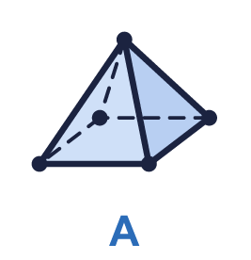  a) Shape A  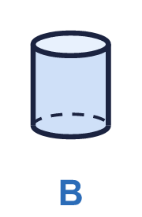  b) Shape B  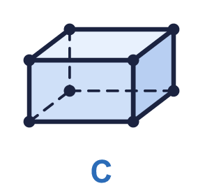  c) Shape C
  1 | Write the mathematical name of each 3-D shape. The names are: cube, cuboid, square-based pyramid, triangular prism, cylinder, cone and sphere.  a) Shape A  b) Shape B  c) Shape C
  2 | How many faces, edges and vertices does this shape have? Dashed lines are edges that you cannot see.  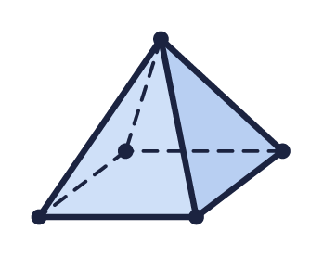  a) Faces  b) Edges  c) Vertices
  2 | How many faces, edges and vertices does this shape have? Dashed lines are edges that you cannot see.  a) Faces  b) Edges  c) Vertices
  3 | How many faces, edges and vertices does this shape have?  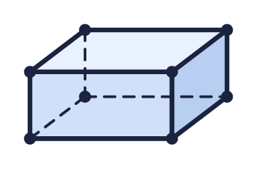  a) Faces  b) Edges  c) Vertices
  3 | How many faces, edges and vertices does this shape have?  a) Faces  b) Edges  c) Vertices
  4 | This shape has a curved surface. Count only the flat faces.  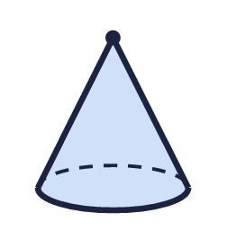  a) Flat faces  b) Edges  c) Vertices
  4 | This shape has a curved surface. Count only the flat faces.  a) Flat faces  b) Edges  c) Vertices
  5 | Look at the three shapes.  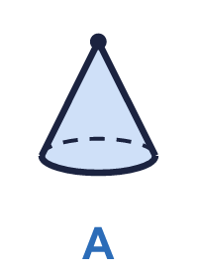  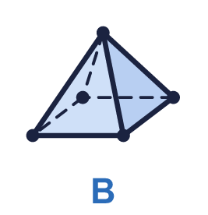  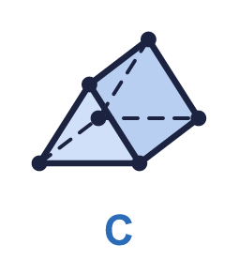  Which shape has a curved surface? Write the letter.
  5 | Look at the three shapes.  Which shape has a curved surface? Write the letter.
  6 | Which 3-D shape am I? Write the name.  1. I have 12 edges and every face is a square.  a) Shape 1  2. I have 6 flat faces, all rectangles but not all squares.  b) Shape 2
  6 | Which 3-D shape am I? Write the name.  1. I have 12 edges and every face is a square.  a) Shape 1  2. I have 6 flat faces, all rectangles but not all squares.  b) Shape 2
  7 | Complete the sentences about this square-based pyramid. It has one square face.  a) Number of triangular faces  b) Total number of faces
  7 | Complete the sentences about this square-based pyramid. It has one square face.  a) Number of triangular faces  b) Total number of faces
  8 | How many vertices does this cube have?  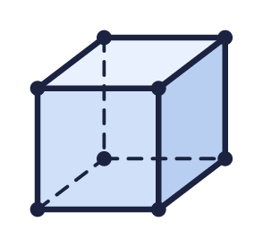  a) Vertices
  8 | How many vertices does this cube have?  a) Vertices

  9 | Ron has drawn a cuboid made of unit cubes on isometric paper.  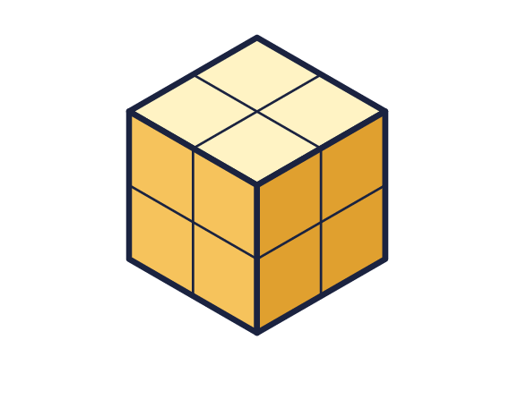  a) How many faces does the cuboid have?  b) How many edges does it have?  c) How many unit cubes make the cuboid?
  9 | Ron has drawn a cuboid made of unit cubes on isometric paper.  a) How many faces does the cuboid have?  b) How many edges does it have?  c) How many unit cubes make the cuboid?
  10 | Look at the square-based pyramid.  Is Jack correct? Circle yes or no.  Yes / No  Explain how you know.
     | 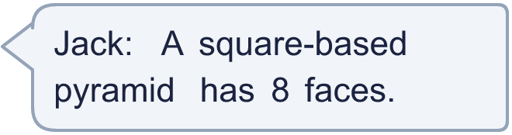
  10 | Look at the square-based pyramid.  Is Jack correct? Circle yes or no.  Yes / No  Explain how you know.
  11 | Which 3-D shape is each person thinking of?  a) Jack is thinking of a  b) Whitney is thinking of a
     | 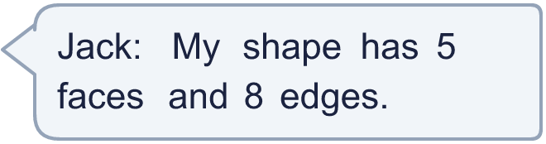
     | 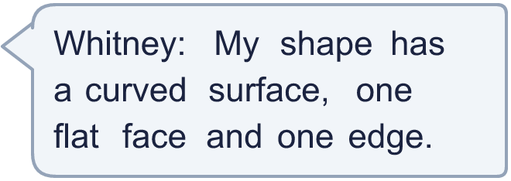
  11 | Which 3-D shape is each person thinking of?  a) Jack is thinking of a  b) Whitney is thinking of a
  12 | How many faces, edges and vertices does this shape have?  a) Faces  b) Edges  c) Vertices
  12 | How many faces, edges and vertices does this shape have?  a) Faces  b) Edges  c) Vertices
  13 | Look at the three shapes. A shape can roll if it has a curved surface.  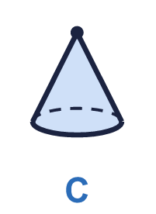  a) How many of the shapes can roll?
  13 | Look at the three shapes. A shape can roll if it has a curved surface.  a) How many of the shapes can roll?
  14 | Look at the three shapes.  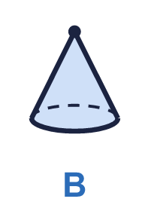  a) Which shape has the most edges? Write the letter.  b) How many edges does it have?
  14 | Look at the three shapes.  a) Which shape has the most edges? Write the letter.  b) How many edges does it have?

Year 3 · Shape · Step 9
Recognise and describe 3-D shapes
Answers (teacher copy)

  1 | Write the mathematical name of each 3-D shape. The names are: cube, cuboid, square-based pyramid, triangular prism, cylinder, cone and sphere.  a) Shape A square-based pyramid  b) Shape B cylinder  c) Shape C cuboid
  2 | How many faces, edges and vertices does this shape have? Dashed lines are edges that you cannot see.  a) Faces 5  b) Edges 8  c) Vertices 5
  3 | How many faces, edges and vertices does this shape have?  a) Faces 6  b) Edges 12  c) Vertices 8
  4 | This shape has a curved surface. Count only the flat faces.  a) Flat faces 1  b) Edges 1  c) Vertices 1
  5 | Look at the three shapes.  Which shape has a curved surface? Write the letter. A
  6 | Which 3-D shape am I? Write the name.  1. I have 12 edges and every face is a square.  a) Shape 1 cube  2. I have 6 flat faces, all rectangles but not all squares.  b) Shape 2 cuboid
  7 | Complete the sentences about this square-based pyramid. It has one square face.  a) Number of triangular faces 4  b) Total number of faces 5
  8 | How many vertices does this cube have?  a) Vertices 8
  9 | Ron has drawn a cuboid made of unit cubes on isometric paper.  a) How many faces does the cuboid have? 6  b) How many edges does it have? 12  c) How many unit cubes make the cuboid? 8
  10 | Look at the square-based pyramid.  Is Jack correct? Circle yes or no.  Yes / No  Explain how you know.  No. It has 4 triangular faces and 1 square face, so it has 5 faces altogether, not 8.
  11 | Which 3-D shape is each person thinking of?  a) Jack is thinking of a square-based pyramid  b) Whitney is thinking of a cone
  12 | How many faces, edges and vertices does this shape have?  a) Faces 5  b) Edges 8  c) Vertices 5
  13 | Look at the three shapes. A shape can roll if it has a curved surface.  a) How many of the shapes can roll? 2
  14 | Look at the three shapes.  a) Which shape has the most edges? Write the letter. C  b) How many edges does it have? 9

