  Year 3 · Shape · Step 7  Recognise and describe 2-D shapes | 
  Year 3 · Shape · Step 7
  Recognise and describe 2-D shapes
  1 | Write the mathematical name of each shape. Use the words: triangle, square, rectangle, pentagon, hexagon, octagon or circle.  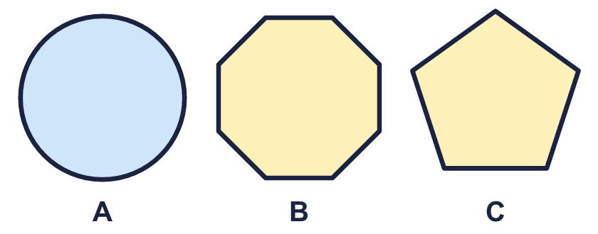
    A:
    B:
    C:
  1 | Write the mathematical name of each shape. Use the words: triangle, square, rectangle, pentagon, hexagon, octagon or circle.
    A:
    B:
    C:
  2 | How many sides and vertices (corners) does each shape have?  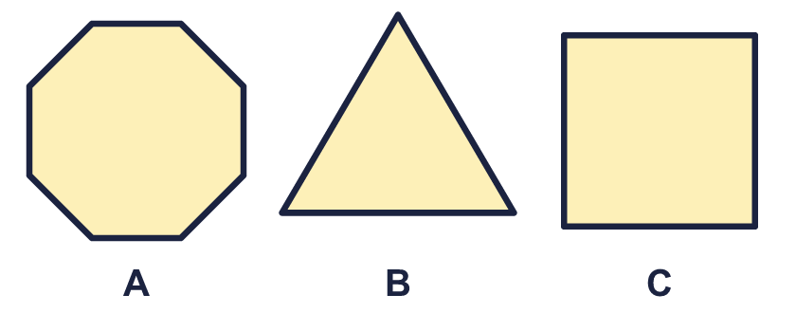
    A: sides
    A: vertices
    B: sides
    B: vertices
    C: sides
    C: vertices
  2 | How many sides and vertices (corners) does each shape have?
    A: sides
    A: vertices
    B: sides
    B: vertices
    C: sides
    C: vertices
  3 | Look at the shapes.  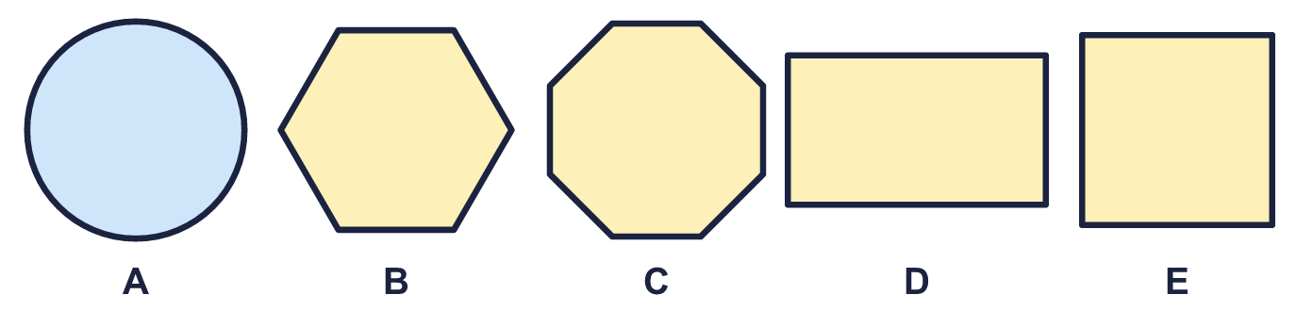
    Which shapes are quadrilaterals (four sides)? Write the letters.
  3 | Look at the shapes.
    Which shapes are quadrilaterals (four sides)? Write the letters.
  4 | Which shape am I? Write the name.  1. I have 8 straight sides.  2. I have 5 straight sides.  3. I have 3 straight sides.
  4 | Which shape am I? Write the name.  1. I have 8 straight sides.  2. I have 5 straight sides.  3. I have 3 straight sides.
  5 | How many right angles does each shape have?  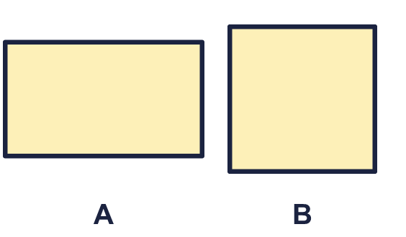
    A:
    B:
  5 | How many right angles does each shape have?
    A:
    B:
  6 | Write the mathematical name of each shape. Use the words: triangle, square, rectangle, pentagon, hexagon, octagon or circle.  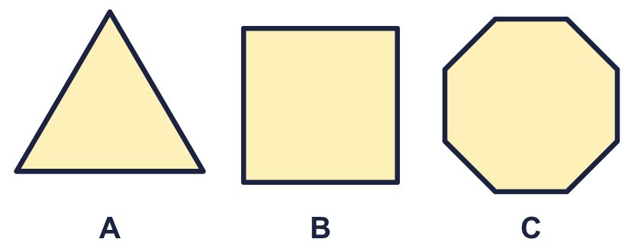
    A:
    B:
    C:
  6 | Write the mathematical name of each shape. Use the words: triangle, square, rectangle, pentagon, hexagon, octagon or circle.
    A:
    B:
    C:
  7 | Look at the shapes.  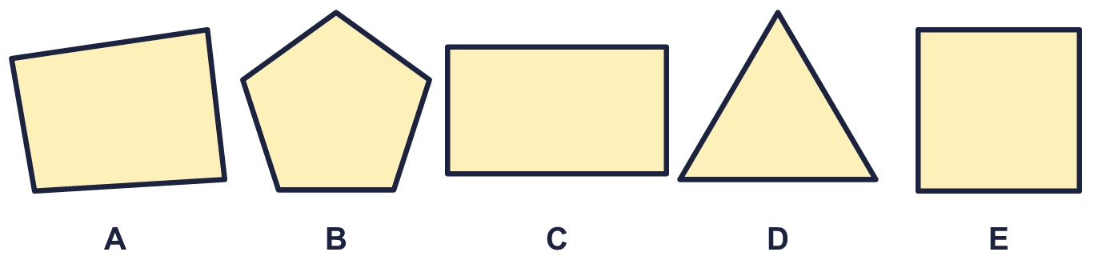
    Which shapes are quadrilaterals (four sides)? Write the letters.
  7 | Look at the shapes.
    Which shapes are quadrilaterals (four sides)? Write the letters.
  8 | How many sides and vertices (corners) does each shape have?  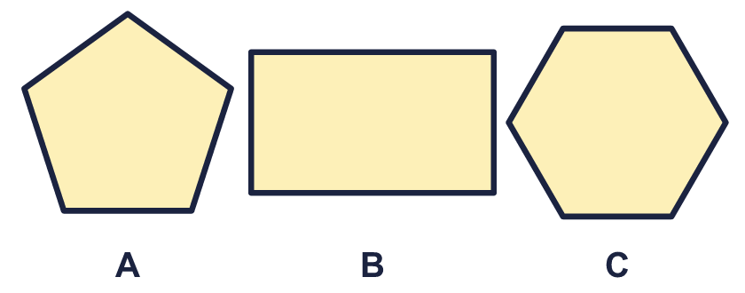
    A: sides
    A: vertices
    B: sides
    B: vertices
    C: sides
    C: vertices
  8 | How many sides and vertices (corners) does each shape have?
    A: sides
    A: vertices
    B: sides
    B: vertices
    C: sides
    C: vertices

  9 | 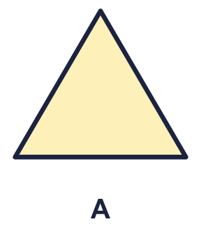  Is Rosie correct? Circle yes or no.  Yes / No  Explain how you know.
     | 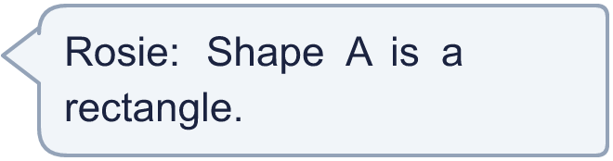
  9 | Is Rosie correct? Circle yes or no.  Yes / No  Explain how you know.
  10 | 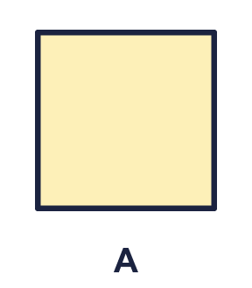  Is Amir correct? Circle yes or no.  Yes / No  Explain how you know.
    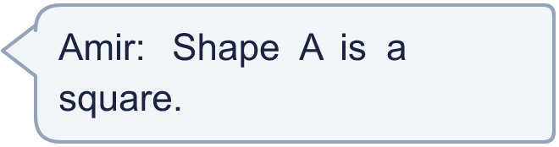
  10 | Is Amir correct? Circle yes or no.  Yes / No  Explain how you know.
  11 | Which shape am I? Write the name.  1. I have 3 straight sides.  2. I have 5 straight sides.  3. I have 6 straight sides.
  11 | Which shape am I? Write the name.  1. I have 3 straight sides.  2. I have 5 straight sides.  3. I have 6 straight sides.
  12 | Look at the shapes.  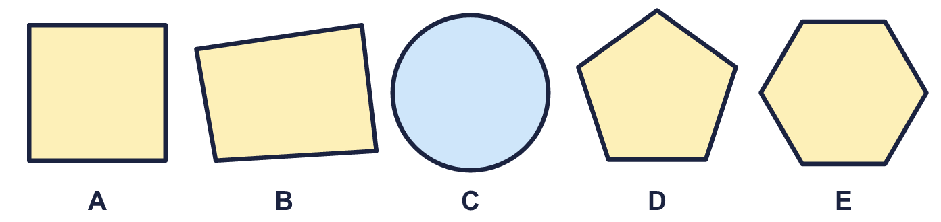
    Which shapes are quadrilaterals (four sides)? Write the letters.
  12 | Look at the shapes.
    Which shapes are quadrilaterals (four sides)? Write the letters.
  13 | How many right angles does each shape have?  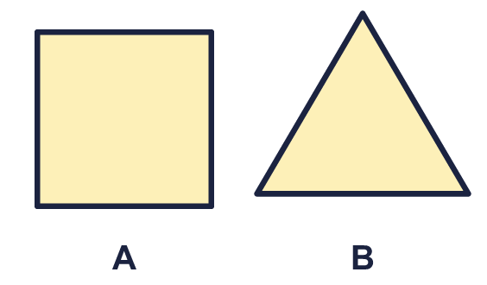
    A:
    B:
  13 | How many right angles does each shape have?
    A:
    B:
  14 | 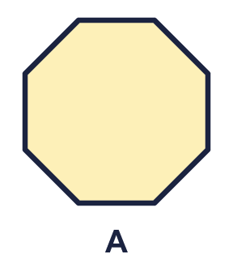  Is Dora correct? Circle yes or no.  Yes / No  Explain how you know.
    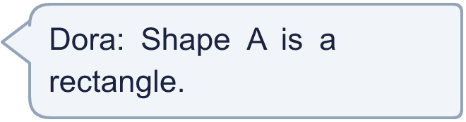
  14 | Is Dora correct? Circle yes or no.  Yes / No  Explain how you know.

Year 3 · Shape · Step 7
Recognise and describe 2-D shapes
Answers (teacher copy)

  1 | Write the mathematical name of each shape. Use the words: triangle, square, rectangle, pentagon, hexagon, octagon or circle.  A: circle  B: octagon  C: pentagon
  2 | How many sides and vertices (corners) does each shape have?  A: sides 8  A: vertices 8  B: sides 3  B: vertices 3  C: sides 4  C: vertices 4
  3 | Look at the shapes.  Which shapes are quadrilaterals (four sides)? Write the letters. D, E
  4 | Which shape am I? Write the name.  1. I have 8 straight sides. octagon  2. I have 5 straight sides. pentagon  3. I have 3 straight sides. triangle
  5 | How many right angles does each shape have?  A: 4  B: 4
  6 | Write the mathematical name of each shape. Use the words: triangle, square, rectangle, pentagon, hexagon, octagon or circle.  A: triangle  B: square  C: octagon
  7 | Look at the shapes.  Which shapes are quadrilaterals (four sides)? Write the letters. A, C, E
  8 | How many sides and vertices (corners) does each shape have?  A: sides 5  A: vertices 5  B: sides 4  B: vertices 4  C: sides 6  C: vertices 6
  9 | Is Rosie correct? Circle yes or no.  Yes / No  Explain how you know.  No. Shape A is a triangle.
  10 | Is Amir correct? Circle yes or no.  Yes / No  Explain how you know.  Yes. Shape A is a square.
  11 | Which shape am I? Write the name.  1. I have 3 straight sides. triangle  2. I have 5 straight sides. pentagon  3. I have 6 straight sides. hexagon
  12 | Look at the shapes.  Which shapes are quadrilaterals (four sides)? Write the letters. A, B
  13 | How many right angles does each shape have?  A: 4  B: 0
  14 | Is Dora correct? Circle yes or no.  Yes / No  Explain how you know.  No. Shape A is a octagon.

