  Year 3 · Shape · Step 6  Parallel and perpendicular | 
  Year 3 · Shape · Step 6
  Parallel and perpendicular
  1 | Each box shows two lines.  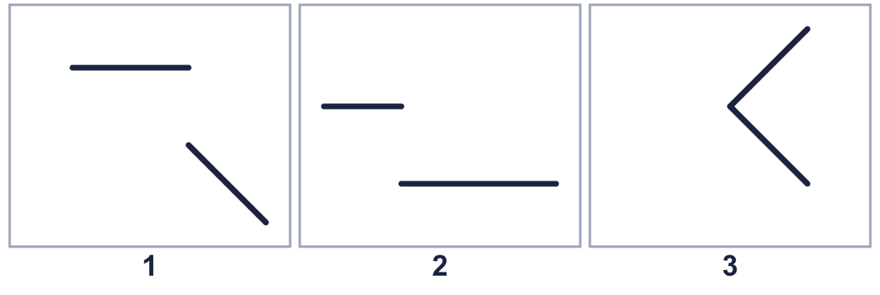
    Which box shows parallel lines?
    Which box shows perpendicular lines?
  1 | Each box shows two lines.
    Which box shows parallel lines?
    Which box shows perpendicular lines?
  2 | Each box shows two lines.  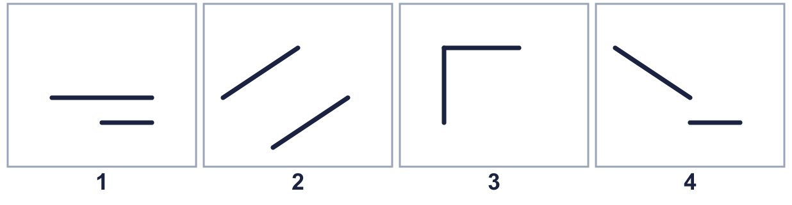
    How many boxes show parallel lines?
  2 | Each box shows two lines.
    How many boxes show parallel lines?
  3 | Each box shows two lines.  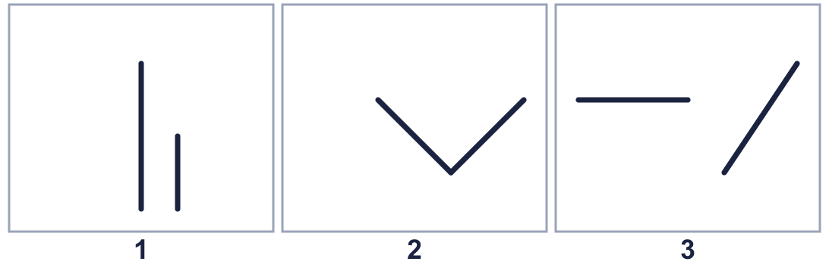
    Which box shows parallel lines?
    Which box shows perpendicular lines?
  3 | Each box shows two lines.
    Which box shows parallel lines?
    Which box shows perpendicular lines?
  4 | Look at the two lines.  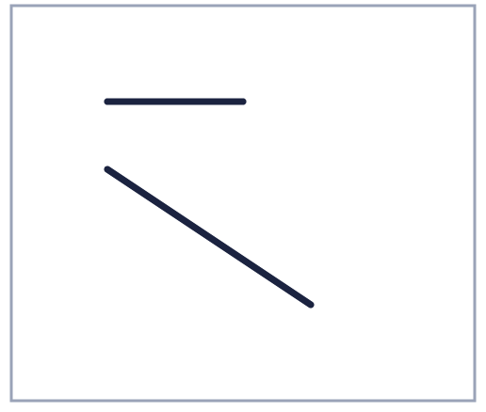  Is Mo correct? Circle yes or no.  Yes / No  Explain how you know.
     | 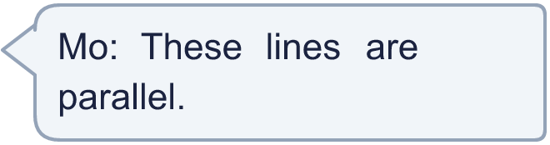
  4 | Look at the two lines.  Is Mo correct? Circle yes or no.  Yes / No  Explain how you know.
  5 | Each box shows two lines.  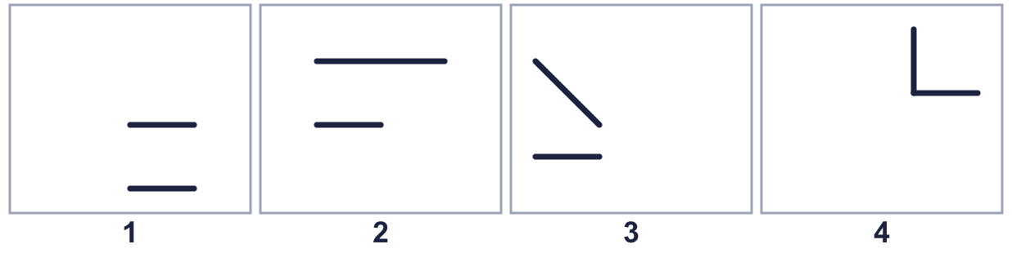
    How many boxes show perpendicular lines?
  5 | Each box shows two lines.
    How many boxes show perpendicular lines?
  6 | Each box shows two lines.  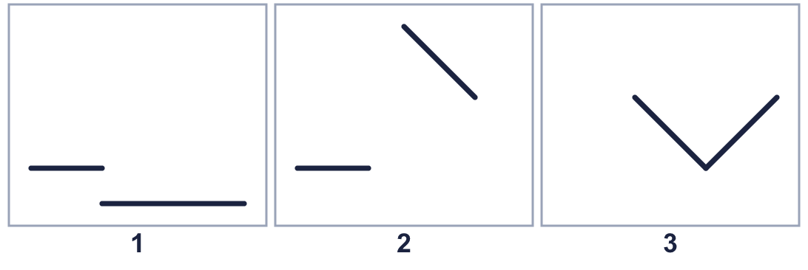
    Which box shows parallel lines?
    Which box shows perpendicular lines?
  6 | Each box shows two lines.
    Which box shows parallel lines?
    Which box shows perpendicular lines?
  7 | Look at the two lines.  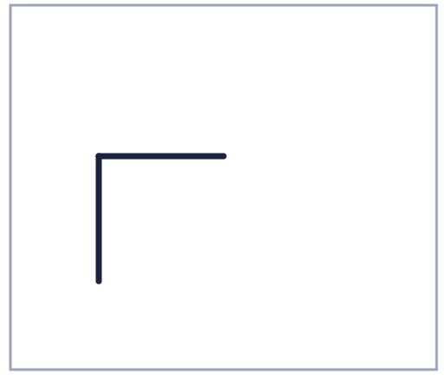  Is Filip correct? Circle yes or no.  Yes / No  Explain how you know.
    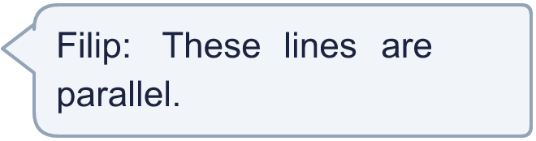
  7 | Look at the two lines.  Is Filip correct? Circle yes or no.  Yes / No  Explain how you know.
  8 | Look at the lines.  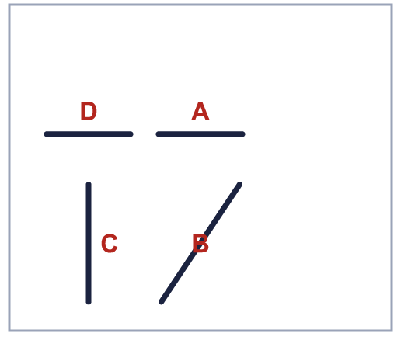
    Horizontal lines:
    Vertical lines:
  8 | Look at the lines.
    Horizontal lines:
    Vertical lines:

  9 | Look at the two lines.  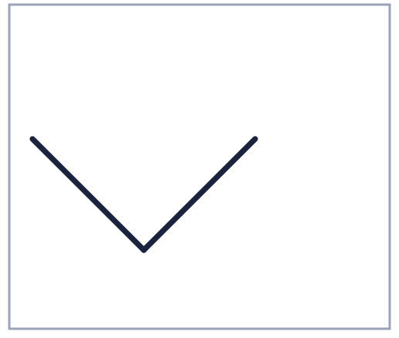  Is Nina correct? Circle yes or no.  Yes / No  Explain how you know.
    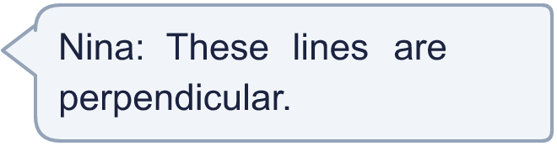
  9 | Look at the two lines.  Is Nina correct? Circle yes or no.  Yes / No  Explain how you know.
  10 | Each box shows two lines.  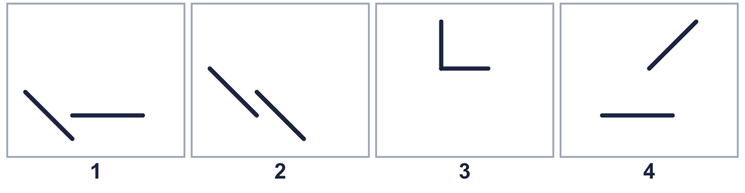
    How many boxes show parallel lines?
  10 | Each box shows two lines.
    How many boxes show parallel lines?
  11 | Each box shows two lines.  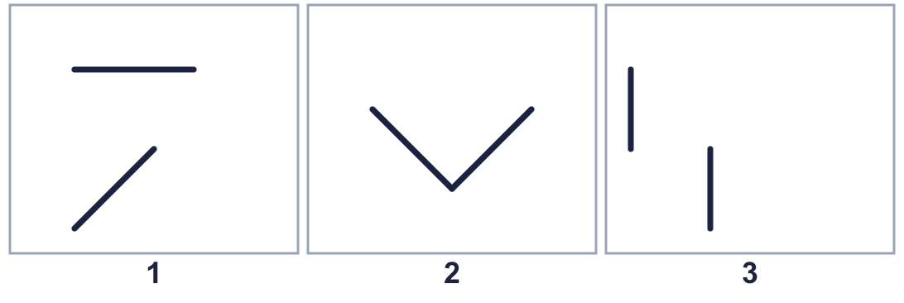
    Which box shows parallel lines?
    Which box shows perpendicular lines?
  11 | Each box shows two lines.
    Which box shows parallel lines?
    Which box shows perpendicular lines?
  12 | Look at the two lines.  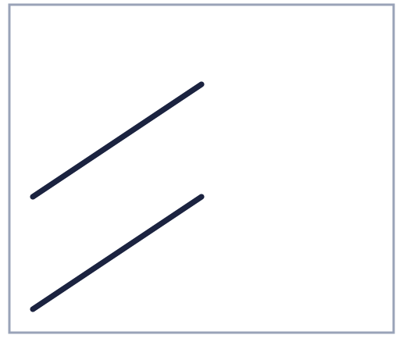  Is Ron correct? Circle yes or no.  Yes / No  Explain how you know.
    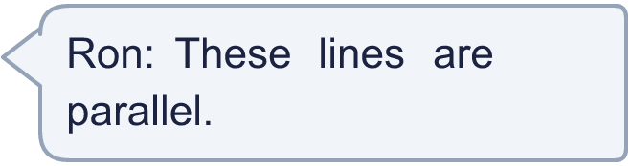
  12 | Look at the two lines.  Is Ron correct? Circle yes or no.  Yes / No  Explain how you know.
  13 | Each box shows two lines.  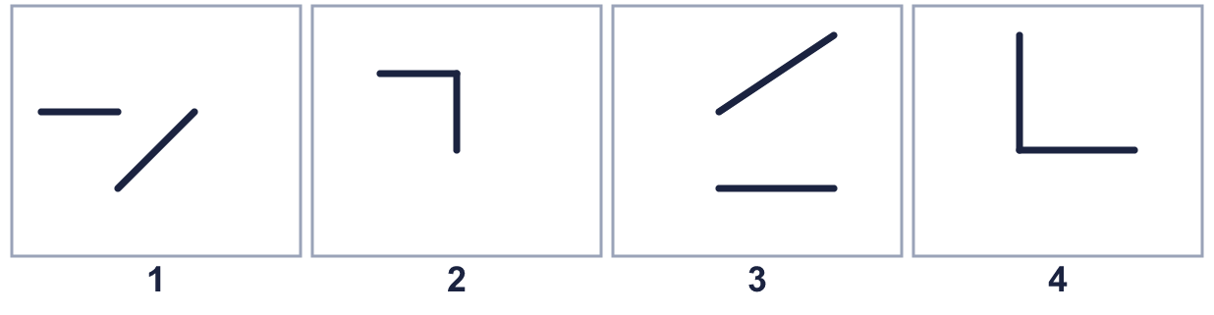
    How many boxes show perpendicular lines?
  13 | Each box shows two lines.
    How many boxes show perpendicular lines?
  14 | Look at the two lines.  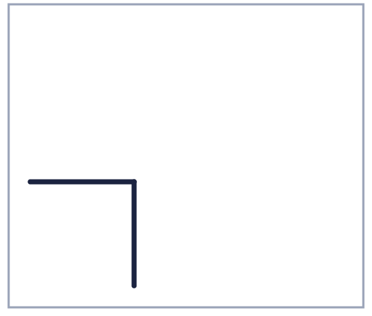  Is Zach correct? Circle yes or no.  Yes / No  Explain how you know.
    
  14 | Look at the two lines.  Is Zach correct? Circle yes or no.  Yes / No  Explain how you know.

Year 3 · Shape · Step 6
Parallel and perpendicular
Answers (teacher copy)

  1 | Each box shows two lines.  Which box shows parallel lines? 2  Which box shows perpendicular lines? 3
  2 | Each box shows two lines.  How many boxes show parallel lines? 2
  3 | Each box shows two lines.  Which box shows parallel lines? 1  Which box shows perpendicular lines? 2
  4 | Look at the two lines.  Is Mo correct? Circle yes or no.  Yes / No  Explain how you know.  No. The lines are not parallel.
  5 | Each box shows two lines.  How many boxes show perpendicular lines? 1
  6 | Each box shows two lines.  Which box shows parallel lines? 1  Which box shows perpendicular lines? 3
  7 | Look at the two lines.  Is Filip correct? Circle yes or no.  Yes / No  Explain how you know.  No. The lines are not parallel.
  8 | Look at the lines.  Horizontal lines: A, D  Vertical lines: C
  9 | Look at the two lines.  Is Nina correct? Circle yes or no.  Yes / No  Explain how you know.  Yes. The lines are perpendicular.
  10 | Each box shows two lines.  How many boxes show parallel lines? 1
  11 | Each box shows two lines.  Which box shows parallel lines? 3  Which box shows perpendicular lines? 2
  12 | Look at the two lines.  Is Ron correct? Circle yes or no.  Yes / No  Explain how you know.  Yes. The lines are parallel.
  13 | Each box shows two lines.  How many boxes show perpendicular lines? 2
  14 | Look at the two lines.  Is Zach correct? Circle yes or no.  Yes / No  Explain how you know.  No. The lines are not parallel.

