  Year 3 · Shape · Step 4  Measure and draw lines accurately | 
  Year 3 · Shape · Step 4
  Measure and draw lines accurately
  1 | Use the ruler to measure each line.  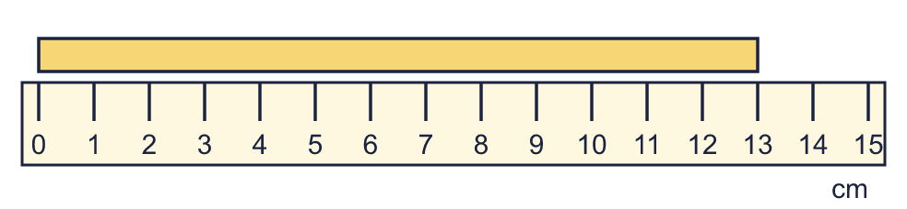  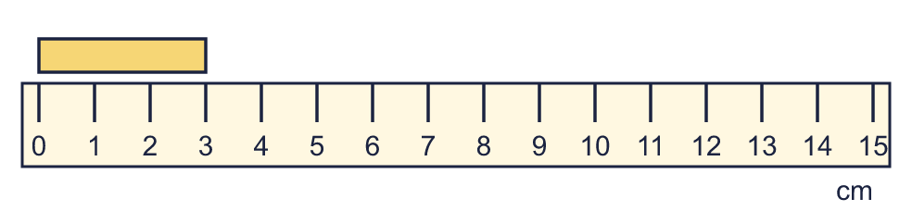
    a) | The line is |  | cm long.
    b) | The line is |  | cm long.
  1 | Use the ruler to measure each line.
    a) | The line is |  | cm long.
    b) | The line is |  | cm long.
  2 | Use a ruler to draw a line that is 10 cm long. Start at 0.  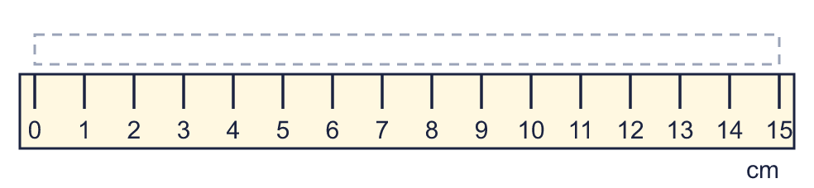
  2 | Use a ruler to draw a line that is 10 cm long. Start at 0.
  3 | Use the ruler to measure each line.  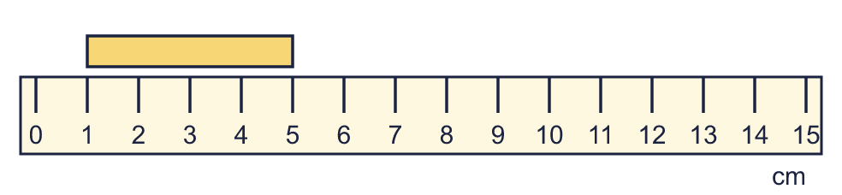
    a) | The line is |  | cm long.
  3 | Use the ruler to measure each line.
    a) | The line is |  | cm long.
  4 | How long is each line in millimetres?  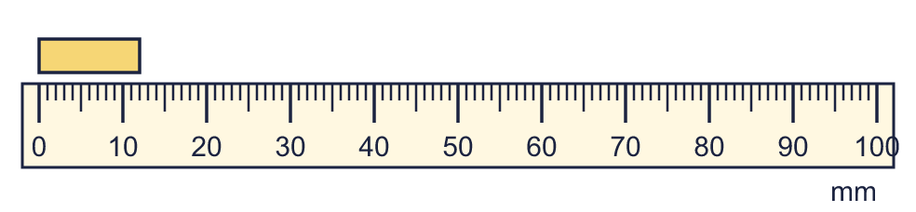  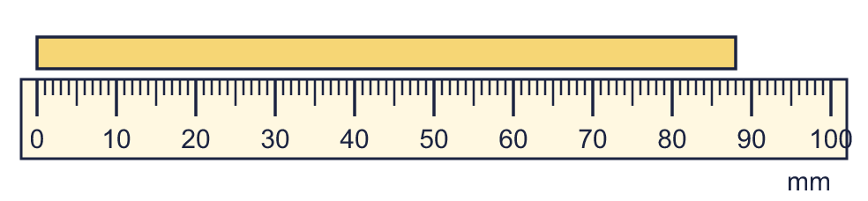
    a) | The line is |  | mm long.
    b) | The line is |  | mm long.
  4 | How long is each line in millimetres?
    a) | The line is |  | mm long.
    b) | The line is |  | mm long.
  5 | Use a ruler to draw a line that is 25 mm long. Start at 0.  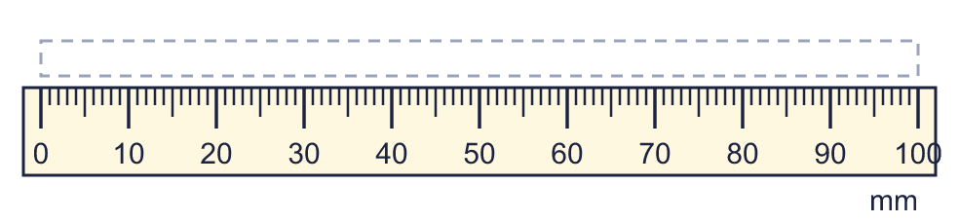
  5 | Use a ruler to draw a line that is 25 mm long. Start at 0.
  6 | Write <, > or = in each box.
    a) | 1 m 25 cm |  | 135 cm
    b) | 1 m 5 cm |  | 1 m 50 cm
  6 | Write <, > or = in each box.
    a) | 1 m 25 cm |  | 135 cm
    b) | 1 m 5 cm |  | 1 m 50 cm
  7 | How long is each line? Write it in centimetres and millimetres.  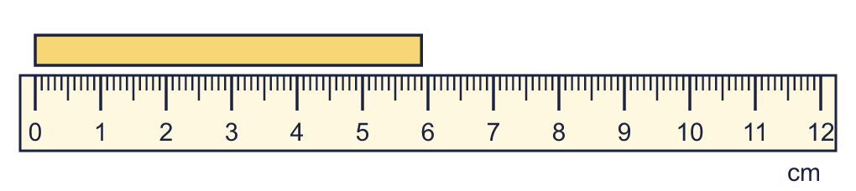
    a) |  | cm and |  | mm
  7 | How long is each line? Write it in centimetres and millimetres.
    a) |  | cm and |  | mm
  8 | Work out the calculations. Write each answer in the form shown.
    a) | 86 cm + 23 cm = |  | cm
    b) | 31 cm + 81 cm =
  8 | Work out the calculations. Write each answer in the form shown.
    a) | 86 cm + 23 cm = |  | cm
    b) | 31 cm + 81 cm =

  9 | Is Boba correct? Circle yes or no.  Yes / No  Explain how you know.
     | 
  9 | Is Boba correct? Circle yes or no.  Yes / No  Explain how you know.
  10 | Use a ruler to draw a line that is 10 cm long. Start at 0.
  10 | Use a ruler to draw a line that is 10 cm long. Start at 0.
  11 | Leo is 1 m 20 cm tall. Mo is 113 cm tall.  a) Who is taller?
    b) | How much taller? Write the difference in centimetres.
    cm
  11 | Leo is 1 m 20 cm tall. Mo is 113 cm tall.  a) Who is taller?
    b) | How much taller? Write the difference in centimetres.
    cm
  12 | Write the lengths in order. Start with the shortest.  4 cm 1 mm 10 cm 8 mm 3 cm 2 mm 16 cm 7 mm
  12 | Write the lengths in order. Start with the shortest.  4 cm 1 mm 10 cm 8 mm 3 cm 2 mm 16 cm 7 mm
  13 | Is Boba correct? Circle yes or no.  Yes / No  Explain how you know.
    
  13 | Is Boba correct? Circle yes or no.  Yes / No  Explain how you know.
  14 | Dora is 102 cm tall. Mia is 25 cm taller than Dora.  How tall is Mia? Write the answer in m and cm.
  14 | Dora is 102 cm tall. Mia is 25 cm taller than Dora.  How tall is Mia? Write the answer in m and cm.

Year 3 · Shape · Step 4
Measure and draw lines accurately
Answers (teacher copy)

  1 | Use the ruler to measure each line.  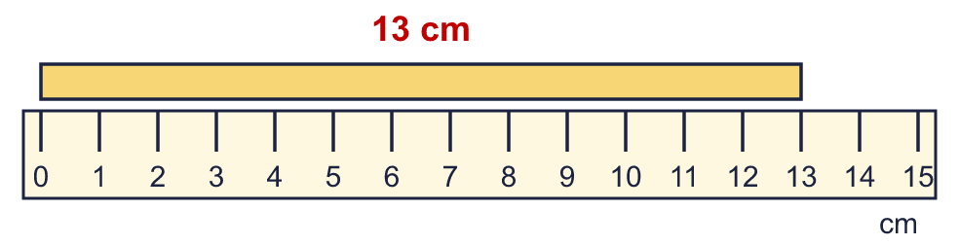  a) The line is 13 cm long.  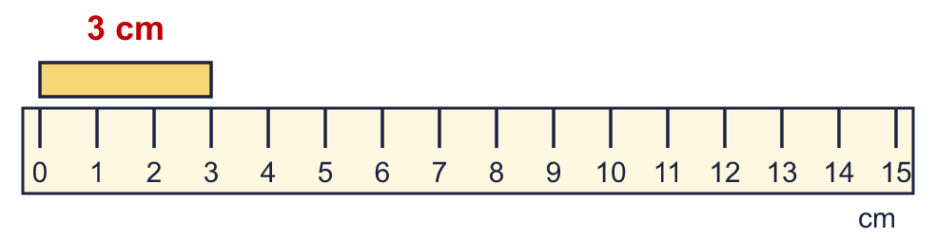  b) The line is 3 cm long.
  2 | Use a ruler to draw a line that is 10 cm long. Start at 0.  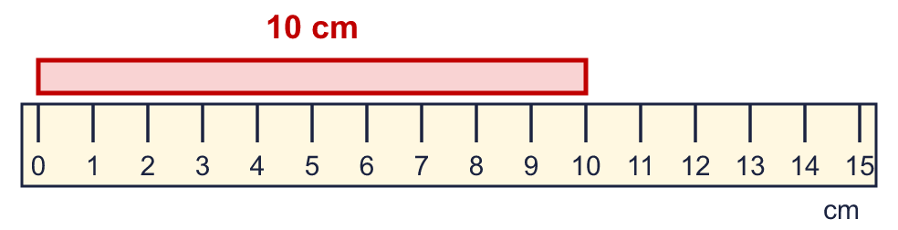
  3 | Use the ruler to measure each line.  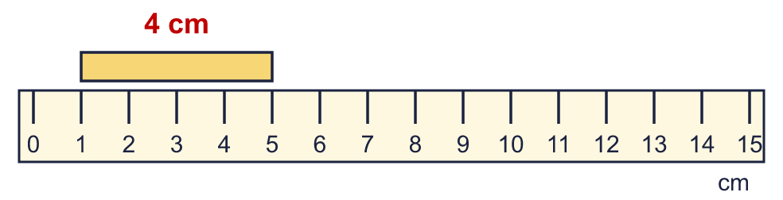  a) The line is 4 cm long.
  4 | How long is each line in millimetres?  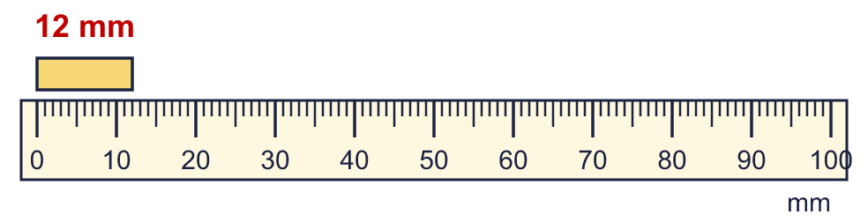  a) The line is 12 mm long.  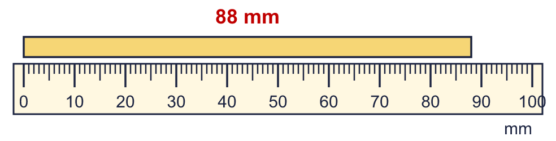  b) The line is 88 mm long.
  5 | Use a ruler to draw a line that is 25 mm long. Start at 0.  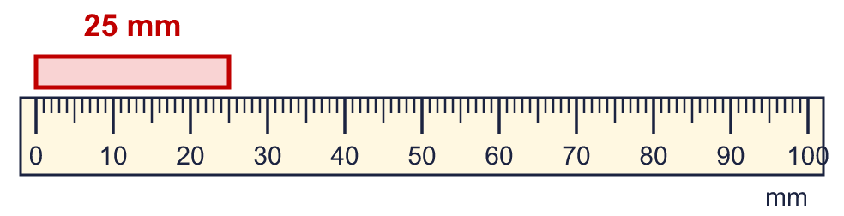
  6 | Write <, > or = in each box.  a) 1 m 25 cm < 135 cm  b) 1 m 5 cm < 1 m 50 cm
  7 | How long is each line? Write it in centimetres and millimetres.  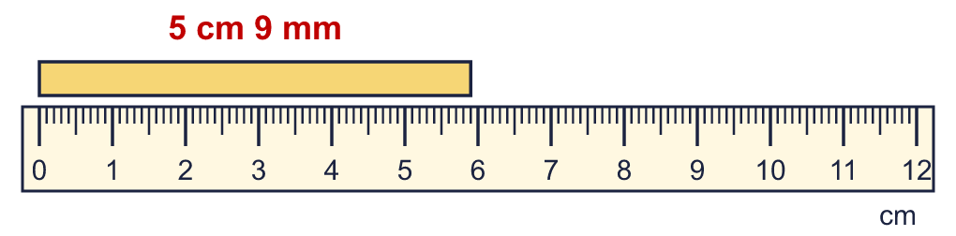  a) 5 cm and 9 mm
  8 | Work out the calculations. Write each answer in the form shown.  a) 86 cm + 23 cm = 109 cm  b) 31 cm + 81 cm = 1 m 12 cm
  9 | Is Boba correct? Circle yes or no.  Yes / No  Explain how you know.  There are 10 millimetres in 1 centimetre, so 5 cm = 50 mm, not 500 mm.
  10 | Use a ruler to draw a line that is 10 cm long. Start at 0.
  11 | Leo is 1 m 20 cm tall. Mo is 113 cm tall.  a) Who is taller? Leo  b) How much taller? Write the difference in centimetres. 7 cm
  12 | Write the lengths in order. Start with the shortest.  4 cm 1 mm 10 cm 8 mm 3 cm 2 mm 16 cm 7 mm  3 cm 2 mm, 4 cm 1 mm, 10 cm 8 mm, 16 cm 7 mm
  13 | Is Boba correct? Circle yes or no.  Yes / No  Explain how you know.  There are 10 millimetres in 1 centimetre, so 7 cm = 70 mm, not 700 mm.
  14 | Dora is 102 cm tall. Mia is 25 cm taller than Dora.  How tall is Mia? Write the answer in m and cm. 1 m 27 cm

