  Year 3 · Shape · Step 10  Make 3-D shapes | 
  Year 3 · Shape · Step 10
  Make 3-D shapes
  1 | Dexter has made a 3-D shape from cubes. How many cubes did he use? There are no hidden cubes.  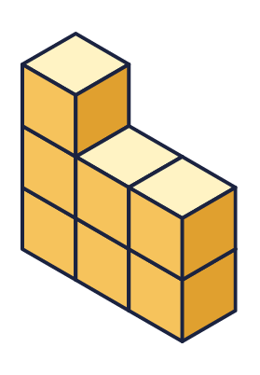
    Number of cubes =
  1 | Dexter has made a 3-D shape from cubes. How many cubes did he use? There are no hidden cubes.
    Number of cubes =
  2 | How many cubes are needed to make each shape? There are no hidden cubes.  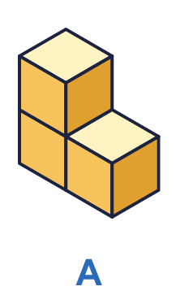  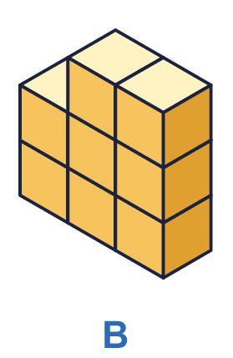
    a) Shape A: |  | cubes
    b) Shape B: |  | cubes
  2 | How many cubes are needed to make each shape? There are no hidden cubes.
    a) Shape A: |  | cubes
    b) Shape B: |  | cubes
  3 | The cuboid is made from cubes. Count the cubes in one layer, then work out the total.  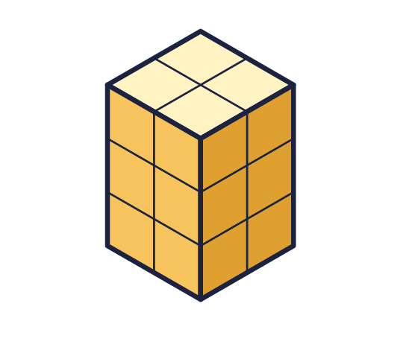
    Cubes in one layer =
    Number of layers =
    Total cubes =
  3 | The cuboid is made from cubes. Count the cubes in one layer, then work out the total.
    Cubes in one layer =
    Number of layers =
    Total cubes =
  4 | Look at the two shapes. There are no hidden cubes.  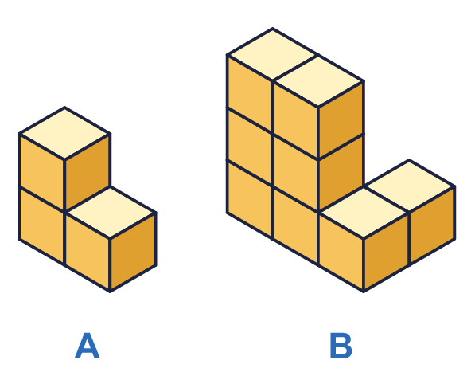
    Shape A: |  | cubes
    Shape B: |  | cubes
    Shape B needs
    more cubes than shape A.
  4 | Look at the two shapes. There are no hidden cubes.
    Shape A: |  | cubes
    Shape B: |  | cubes
    Shape B needs
    more cubes than shape A.
  5 | Annie makes a cube from straws and marshmallows. The straws are the edges and the marshmallows are the vertices.  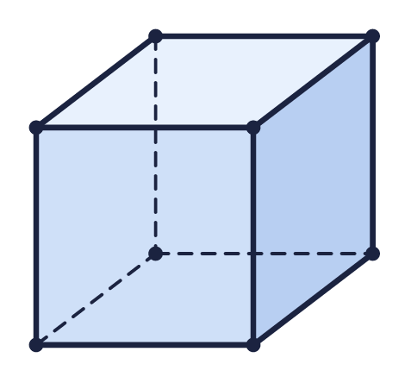  a) How many straws does she need?  b) How many marshmallows does she need?
  5 | Annie makes a cube from straws and marshmallows. The straws are the edges and the marshmallows are the vertices.  a) How many straws does she need?  b) How many marshmallows does she need?
  6 | A cuboid is made from cubes. It is 2 cubes long, 3 cubes wide and 4 cubes high.
    Number of cubes =
  6 | A cuboid is made from cubes. It is 2 cubes long, 3 cubes wide and 4 cubes high.
    Number of cubes =
  7 | A box is filled with 5 layers of cubes. Each layer has 6 cubes.
    Number of cubes =
  7 | A box is filled with 5 layers of cubes. Each layer has 6 cubes.
    Number of cubes =
  8 | Look at the two shapes. Which shape needs more cubes to make it? There are no hidden cubes.  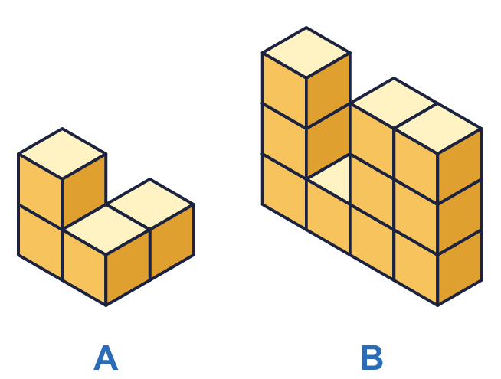
    Shape |  | needs more cubes.
  8 | Look at the two shapes. Which shape needs more cubes to make it? There are no hidden cubes.
    Shape |  | needs more cubes.

  9 | Here is a shape made from cubes. There are no hidden cubes.  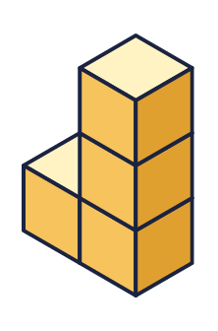  Is Ron correct? Circle yes or no.  Yes / No  Explain how you know.
    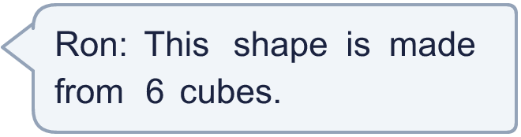
  9 | Here is a shape made from cubes. There are no hidden cubes.  Is Ron correct? Circle yes or no.  Yes / No  Explain how you know.
  10 | Ron has 8 cubes. He uses all of them to make a cuboid. A cuboid that is 1 cube by 2 cubes by 4 cubes is the same as one that is 2 by 4 by 1.
    How many different cuboids can Ron make?
  10 | Ron has 8 cubes. He uses all of them to make a cuboid. A cuboid that is 1 cube by 2 cubes by 4 cubes is the same as one that is 2 by 4 by 1.
    How many different cuboids can Ron make?
  11 | A cuboid is made from 24 cubes. It is 4 cubes long and 3 cubes wide.
    It is |  | cubes high.
  11 | A cuboid is made from 24 cubes. It is 4 cubes long and 3 cubes wide.
    It is |  | cubes high.
  12 | A box holds 30 cubes in 5 equal layers. Each layer is 2 cubes wide.
    Cubes in one layer =
    Each layer is |  | cubes long.
  12 | A box holds 30 cubes in 5 equal layers. Each layer is 2 cubes wide.
    Cubes in one layer =
    Each layer is |  | cubes long.
  13 | A cube is made from 8 small cubes.
    Each edge of the big cube is
    small cubes long.
  13 | A cube is made from 8 small cubes.
    Each edge of the big cube is
    small cubes long.
  14 | Tom makes the frame of a cuboid from straws and marshmallows.  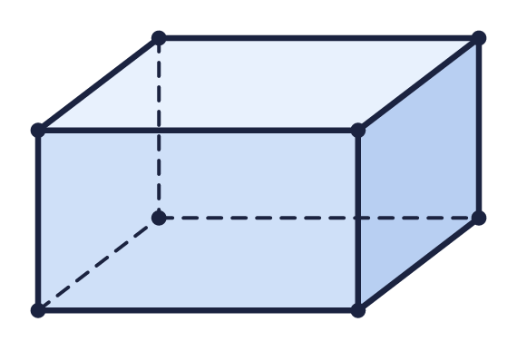  a) How many straws does he need for the edges?  b) How many marshmallows does he need for the vertices?
  14 | Tom makes the frame of a cuboid from straws and marshmallows.  a) How many straws does he need for the edges?  b) How many marshmallows does he need for the vertices?

Year 3 · Shape · Step 10
Make 3-D shapes
Answers (teacher copy)

  1 | Dexter has made a 3-D shape from cubes. How many cubes did he use? There are no hidden cubes.  Number of cubes = 7
  2 | How many cubes are needed to make each shape? There are no hidden cubes.  a) Shape A: 3 cubes  b) Shape B: 8 cubes
  3 | The cuboid is made from cubes. Count the cubes in one layer, then work out the total.  Cubes in one layer = 4  Number of layers = 3  Total cubes = 12
  4 | Look at the two shapes. There are no hidden cubes.  Shape A: 3 cubes  Shape B: 8 cubes  Shape B needs 5 more cubes than shape A.
  5 | Annie makes a cube from straws and marshmallows. The straws are the edges and the marshmallows are the vertices.  a) How many straws does she need? 12  b) How many marshmallows does she need? 8
  6 | A cuboid is made from cubes. It is 2 cubes long, 3 cubes wide and 4 cubes high.  Number of cubes = 24
  7 | A box is filled with 5 layers of cubes. Each layer has 6 cubes.  Number of cubes = 30
  8 | Look at the two shapes. Which shape needs more cubes to make it? There are no hidden cubes.  Shape B needs more cubes.
  9 | Here is a shape made from cubes. There are no hidden cubes.  Is Ron correct? Circle yes or no.  Yes / No  Explain how you know.  No. There are 4 cubes in the shape.
  10 | Ron has 8 cubes. He uses all of them to make a cuboid. A cuboid that is 1 cube by 2 cubes by 4 cubes is the same as one that is 2 by 4 by 1.  How many different cuboids can Ron make? 3
  11 | A cuboid is made from 24 cubes. It is 4 cubes long and 3 cubes wide.  It is 2 cubes high.
  12 | A box holds 30 cubes in 5 equal layers. Each layer is 2 cubes wide.  Cubes in one layer = 6  Each layer is 3 cubes long.
  13 | A cube is made from 8 small cubes.  Each edge of the big cube is 2 small cubes long.
  14 | Tom makes the frame of a cuboid from straws and marshmallows.  a) How many straws does he need for the edges? 12  b) How many marshmallows does he need for the vertices? 8

