  Year 3 · Shape · Step 5  Horizontal and vertical | 
  Year 3 · Shape · Step 5
  Horizontal and vertical
  1 | Look at the lines.  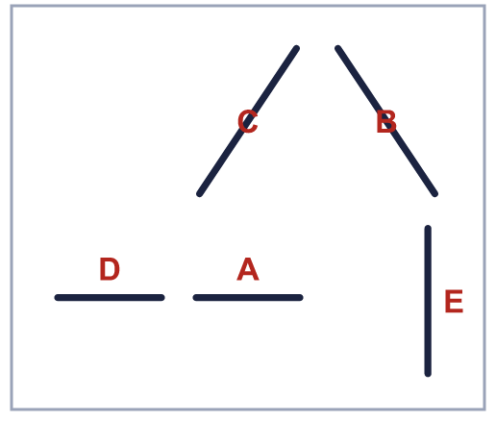
    Horizontal lines:
    Vertical lines:
  1 | Look at the lines.
    Horizontal lines:
    Vertical lines:
  2 | Look at the lines.  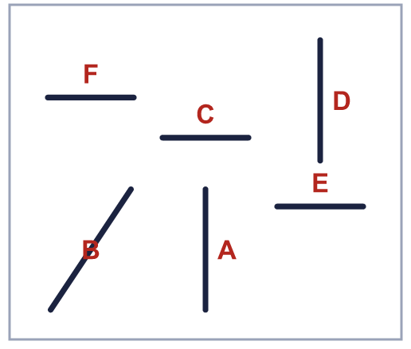
    How many lines are horizontal?
  2 | Look at the lines.
    How many lines are horizontal?
  3 | Look at the lines.  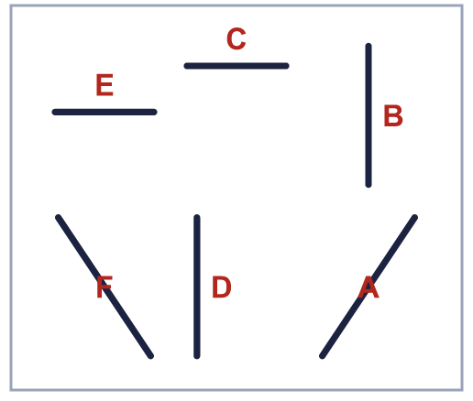
    Horizontal lines:
    Vertical lines:
  3 | Look at the lines.
    Horizontal lines:
    Vertical lines:
  4 | Look at the lines.  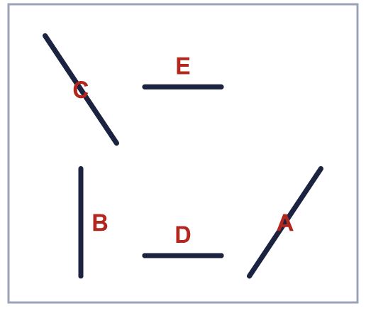  Is Dora correct? Circle yes or no.  Yes / No  Explain how you know.
     | 
  4 | Look at the lines.  Is Dora correct? Circle yes or no.  Yes / No  Explain how you know.
  5 | Look at the lines.  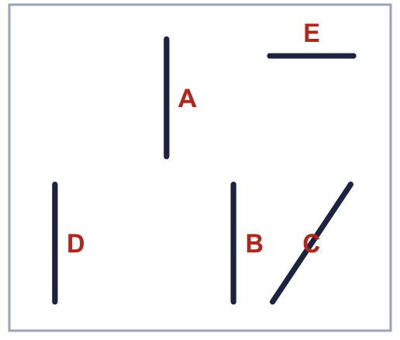
    How many lines are vertical?
  5 | Look at the lines.
    How many lines are vertical?
  6 | Look at the lines.  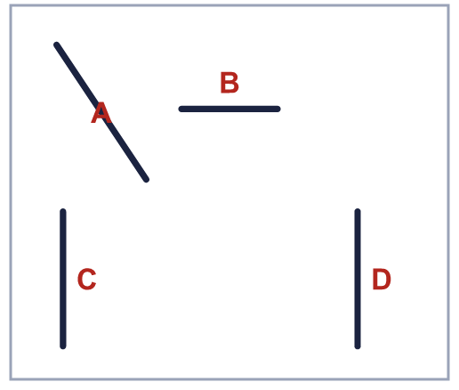
    Horizontal lines:
    Vertical lines:
  6 | Look at the lines.
    Horizontal lines:
    Vertical lines:
  7 | Look at the lines.  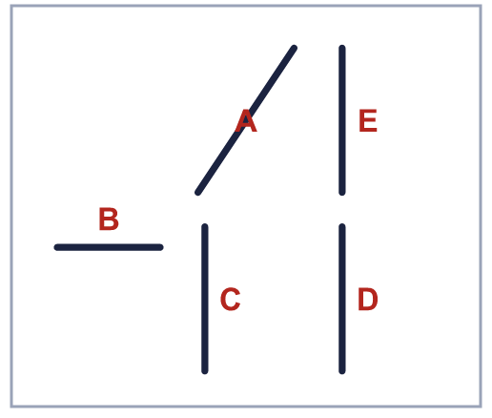
    How many lines are vertical?
  7 | Look at the lines.
    How many lines are vertical?
  8 | Look at the lines.  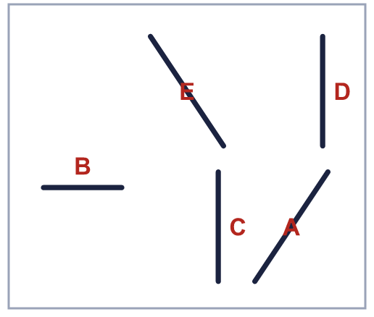  Is Alex correct? Circle yes or no.  Yes / No  Explain how you know.
    
  8 | Look at the lines.  Is Alex correct? Circle yes or no.  Yes / No  Explain how you know.

  9 | Look at the lines.  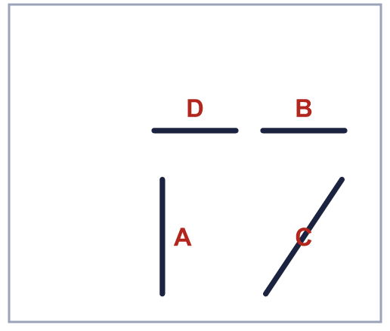  Is Kim correct? Circle yes or no.  Yes / No  Explain how you know.
    
  9 | Look at the lines.  Is Kim correct? Circle yes or no.  Yes / No  Explain how you know.
  10 | Look at the lines.  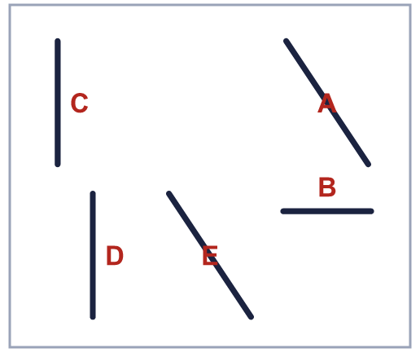
    Horizontal lines:
    Vertical lines:
  10 | Look at the lines.
    Horizontal lines:
    Vertical lines:
  11 | Look at the lines.  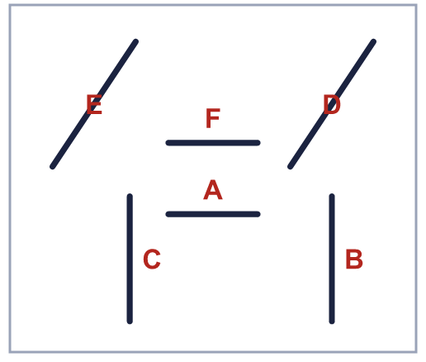
    How many lines are horizontal?
  11 | Look at the lines.
    How many lines are horizontal?
  12 | Look at the lines.  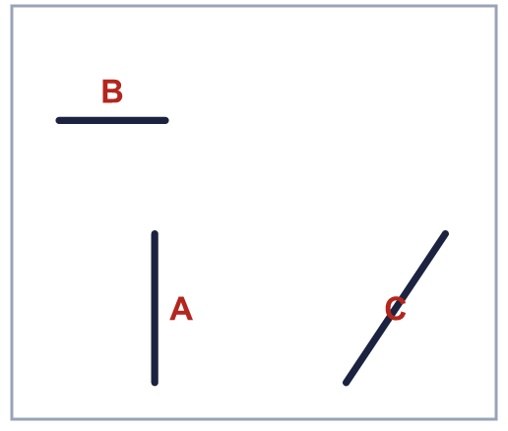  Is Jo correct? Circle yes or no.  Yes / No  Explain how you know.
    
  12 | Look at the lines.  Is Jo correct? Circle yes or no.  Yes / No  Explain how you know.
  13 | Look at the lines.  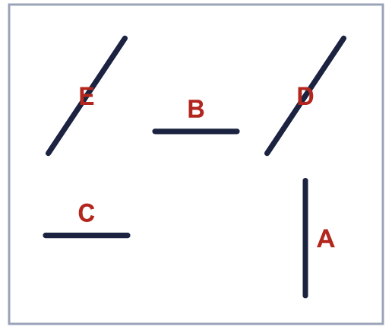
    Horizontal lines:
    Vertical lines:
  13 | Look at the lines.
    Horizontal lines:
    Vertical lines:
  14 | Look at the lines.  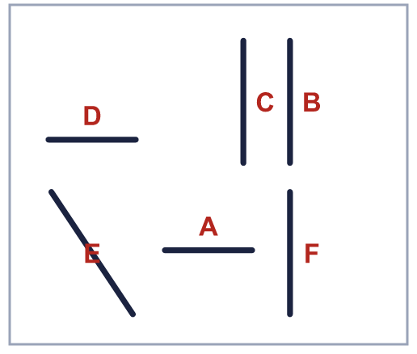
    How many lines are vertical?
  14 | Look at the lines.
    How many lines are vertical?

Year 3 · Shape · Step 5
Horizontal and vertical
Answers (teacher copy)

  1 | Look at the lines.  Horizontal lines: A, D  Vertical lines: E
  2 | Look at the lines.  How many lines are horizontal? 3
  3 | Look at the lines.  Horizontal lines: C, E  Vertical lines: B, D
  4 | Look at the lines.  Is Dora correct? Circle yes or no.  Yes / No  Explain how you know.  No. Line A is not horizontal and not vertical.
  5 | Look at the lines.  How many lines are vertical? 3
  6 | Look at the lines.  Horizontal lines: B  Vertical lines: C, D
  7 | Look at the lines.  How many lines are vertical? 3
  8 | Look at the lines.  Is Alex correct? Circle yes or no.  Yes / No  Explain how you know.  No. Line E is not horizontal and not vertical.
  9 | Look at the lines.  Is Kim correct? Circle yes or no.  Yes / No  Explain how you know.  No. Line C is not horizontal and not vertical.
  10 | Look at the lines.  Horizontal lines: B  Vertical lines: C, D
  11 | Look at the lines.  How many lines are horizontal? 2
  12 | Look at the lines.  Is Jo correct? Circle yes or no.  Yes / No  Explain how you know.  No. Line C is not horizontal and not vertical.
  13 | Look at the lines.  Horizontal lines: B, C  Vertical lines: A
  14 | Look at the lines.  How many lines are vertical? 3

