  Year 3 · Shape · Step 8  Draw polygons | 
  Year 3 · Shape · Step 8
  Draw polygons
  1 | Three corners of a square are drawn on the dot grid. Which lettered dot is the fourth corner?  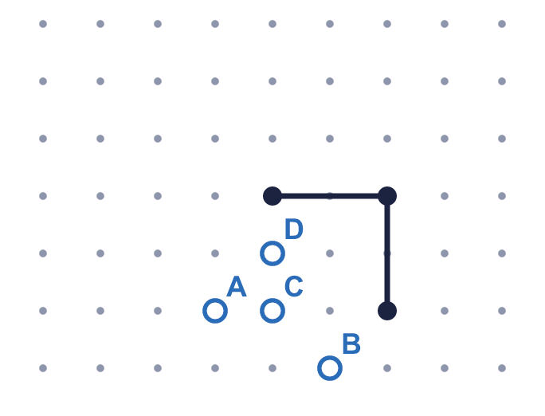
    The fourth corner is dot
  1 | Three corners of a square are drawn on the dot grid. Which lettered dot is the fourth corner?
    The fourth corner is dot
  2 | Three corners of a rectangle are drawn on the dot grid. Which lettered dot is the fourth corner?  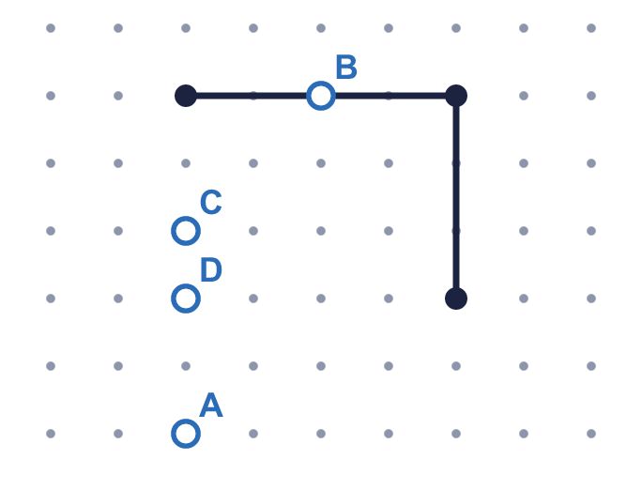
    The fourth corner is dot
  2 | Three corners of a rectangle are drawn on the dot grid. Which lettered dot is the fourth corner?
    The fourth corner is dot
  3 | Complete the sentences.
    A hexagon has |  | sides.
    A hexagon has |  | vertices.
    A pentagon has |  | sides.
    A pentagon has |  | vertices.
  3 | Complete the sentences.
    A hexagon has |  | sides.
    A hexagon has |  | vertices.
    A pentagon has |  | sides.
    A pentagon has |  | vertices.
  4 | Three corners of a square are drawn on the dot grid. Which lettered dot is the fourth corner?  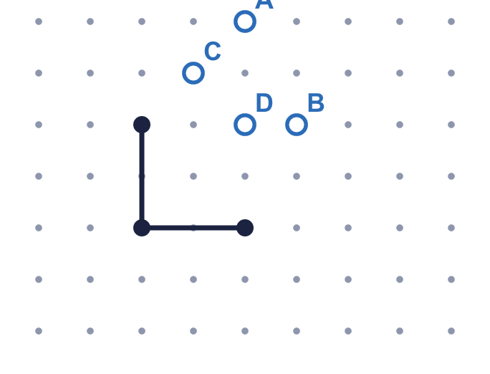
    The fourth corner is dot
  4 | Three corners of a square are drawn on the dot grid. Which lettered dot is the fourth corner?
    The fourth corner is dot
  5 | Which shape am I? Write the name.  1. I have 4 straight sides and 4 right angles. All my sides are the same length.  2. I have 4 straight sides and 4 right angles. My sides are not all the same length.  3. I have 5 straight sides.
  5 | Which shape am I? Write the name.  1. I have 4 straight sides and 4 right angles. All my sides are the same length.  2. I have 4 straight sides and 4 right angles. My sides are not all the same length.  3. I have 5 straight sides.
  6 | Three corners of a rectangle are drawn on the dot grid. Which lettered dot is the fourth corner?  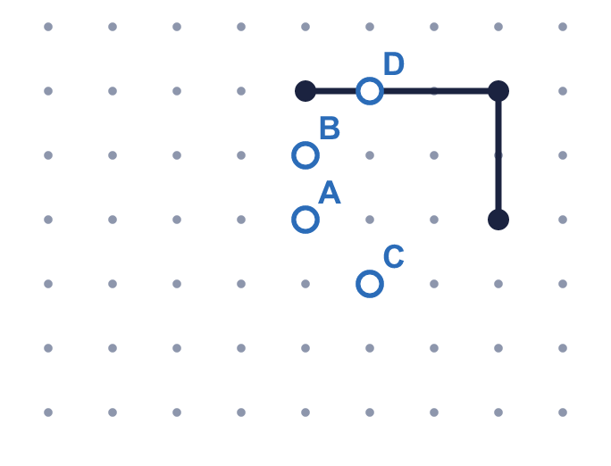
    The fourth corner is dot
  6 | Three corners of a rectangle are drawn on the dot grid. Which lettered dot is the fourth corner?
    The fourth corner is dot
  7 | Complete the sentences.
    A triangle has |  | sides.
    A triangle has |  | vertices.
    A pentagon has |  | sides.
    A pentagon has |  | vertices.
  7 | Complete the sentences.
    A triangle has |  | sides.
    A triangle has |  | vertices.
    A pentagon has |  | sides.
    A pentagon has |  | vertices.
  8 | Write the mathematical name of each shape. Use the words: triangle, square, rectangle, pentagon, hexagon, octagon or circle.  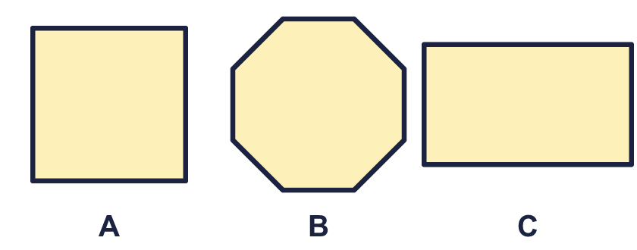
    A:
    B:
    C:
  8 | Write the mathematical name of each shape. Use the words: triangle, square, rectangle, pentagon, hexagon, octagon or circle.
    A:
    B:
    C:

  9 | Three corners of a square are drawn on the dot grid. Which lettered dot is the fourth corner?  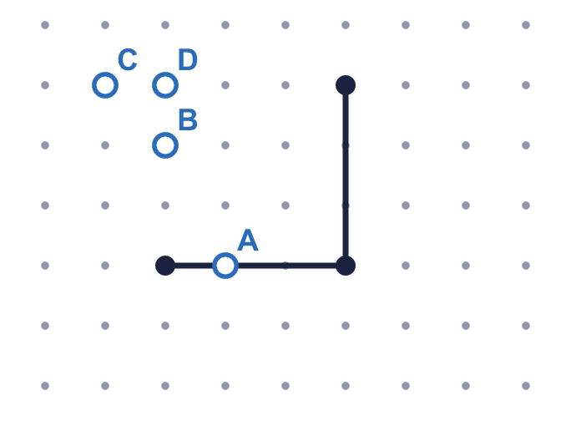
    The fourth corner is dot
  9 | Three corners of a square are drawn on the dot grid. Which lettered dot is the fourth corner?
    The fourth corner is dot
  10 | 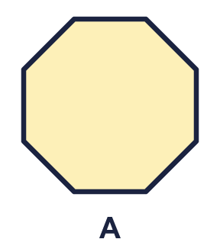  Is Filip correct? Circle yes or no.  Yes / No  Explain how you know.
     | 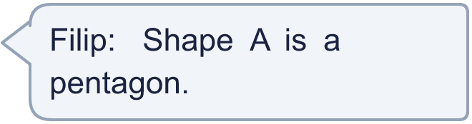
  10 | Is Filip correct? Circle yes or no.  Yes / No  Explain how you know.
  11 | Three corners of a square are drawn on the dot grid. Which lettered dot is the fourth corner?  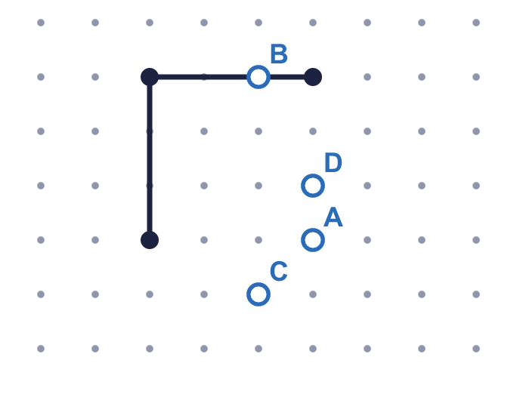
    The fourth corner is dot
  11 | Three corners of a square are drawn on the dot grid. Which lettered dot is the fourth corner?
    The fourth corner is dot
  12 | 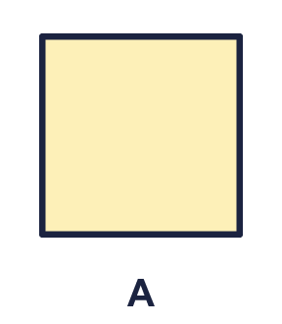  Is Sam correct? Circle yes or no.  Yes / No  Explain how you know.
    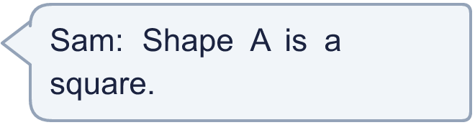
  12 | Is Sam correct? Circle yes or no.  Yes / No  Explain how you know.
  13 | Three corners of a rectangle are drawn on the dot grid. Which lettered dot is the fourth corner?  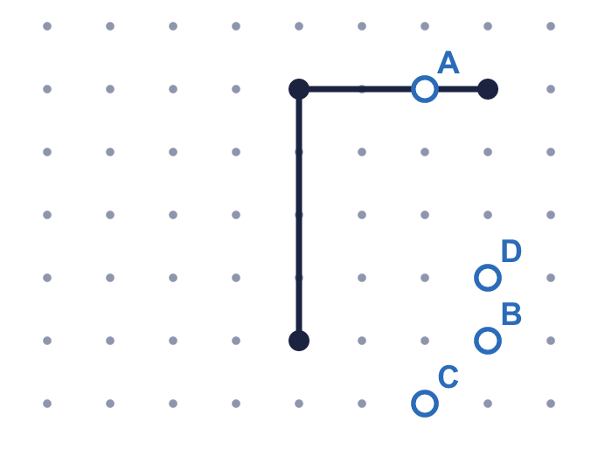
    The fourth corner is dot
  13 | Three corners of a rectangle are drawn on the dot grid. Which lettered dot is the fourth corner?
    The fourth corner is dot
  14 | Which shape am I? Write the name.  1. I have 5 straight sides.  2. I have 3 straight sides.  3. I have 6 straight sides.
  14 | Which shape am I? Write the name.  1. I have 5 straight sides.  2. I have 3 straight sides.  3. I have 6 straight sides.

Year 3 · Shape · Step 8
Draw polygons
Answers (teacher copy)

  1 | Three corners of a square are drawn on the dot grid. Which lettered dot is the fourth corner?  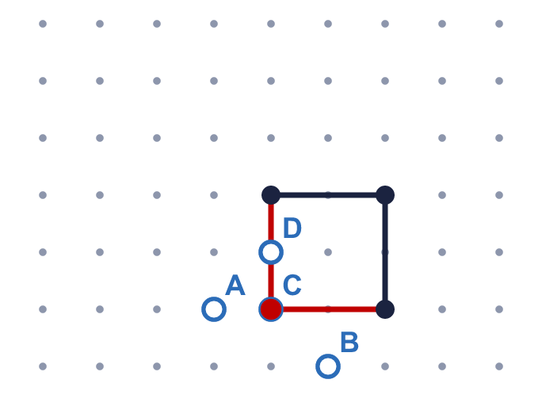  The fourth corner is dot C
  2 | Three corners of a rectangle are drawn on the dot grid. Which lettered dot is the fourth corner?  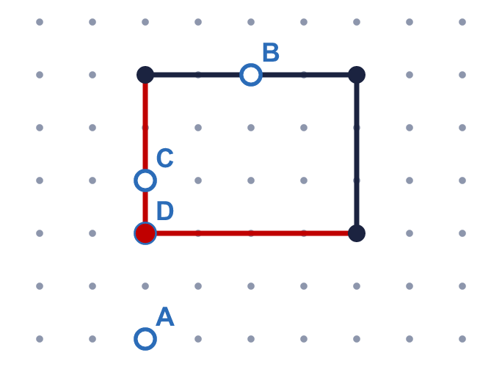  The fourth corner is dot D
  3 | Complete the sentences.  A hexagon has 6 sides.  A hexagon has 6 vertices.  A pentagon has 5 sides.  A pentagon has 5 vertices.
  4 | Three corners of a square are drawn on the dot grid. Which lettered dot is the fourth corner?  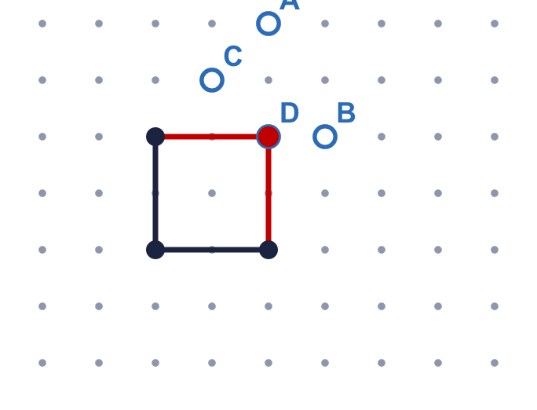  The fourth corner is dot D
  5 | Which shape am I? Write the name.  1. I have 4 straight sides and 4 right angles. All my sides are the same length. square  2. I have 4 straight sides and 4 right angles. My sides are not all the same length. rectangle  3. I have 5 straight sides. pentagon
  6 | Three corners of a rectangle are drawn on the dot grid. Which lettered dot is the fourth corner?  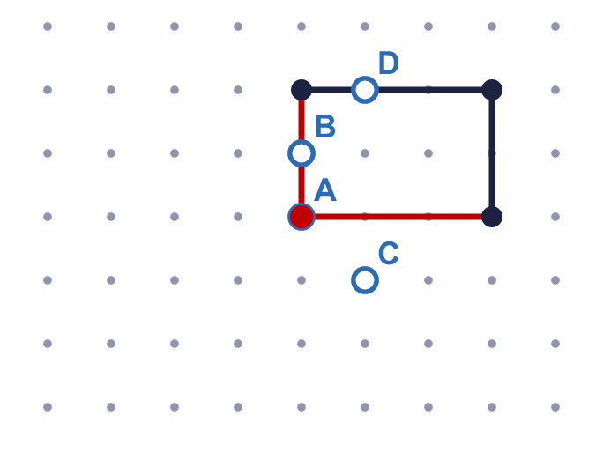  The fourth corner is dot A
  7 | Complete the sentences.  A triangle has 3 sides.  A triangle has 3 vertices.  A pentagon has 5 sides.  A pentagon has 5 vertices.
  8 | Write the mathematical name of each shape. Use the words: triangle, square, rectangle, pentagon, hexagon, octagon or circle.  A: square  B: octagon  C: rectangle
  9 | Three corners of a square are drawn on the dot grid. Which lettered dot is the fourth corner?  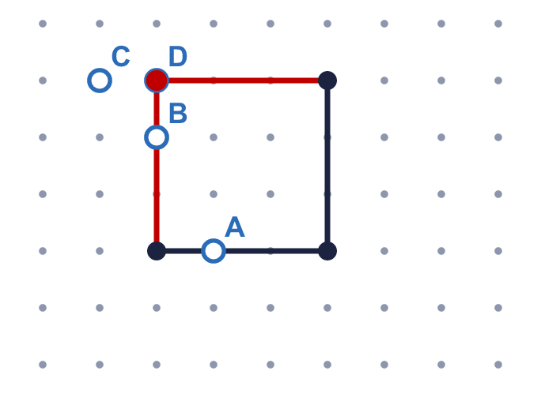  The fourth corner is dot D
  10 | Is Filip correct? Circle yes or no.  Yes / No  Explain how you know.  No. Shape A is a octagon.
  11 | Three corners of a square are drawn on the dot grid. Which lettered dot is the fourth corner?  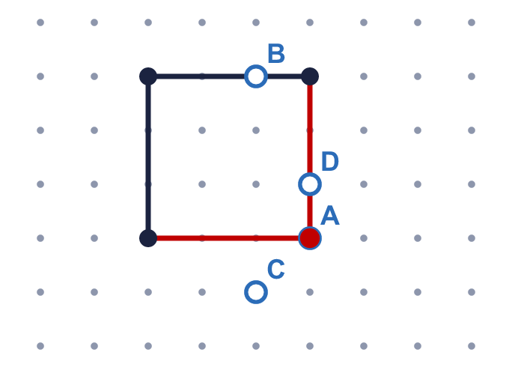  The fourth corner is dot A
  12 | Is Sam correct? Circle yes or no.  Yes / No  Explain how you know.  Yes. Shape A is a square.
  13 | Three corners of a rectangle are drawn on the dot grid. Which lettered dot is the fourth corner?  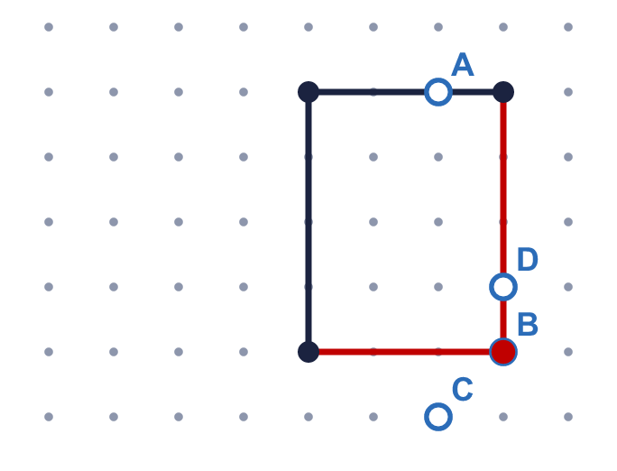  The fourth corner is dot B
  14 | Which shape am I? Write the name.  1. I have 5 straight sides. pentagon  2. I have 3 straight sides. triangle  3. I have 6 straight sides. hexagon

