  Year 3 · Shape · Step 3  Compare angles | 
  Year 3 · Shape · Step 3
  Compare angles
  1 | Look at the four angles.  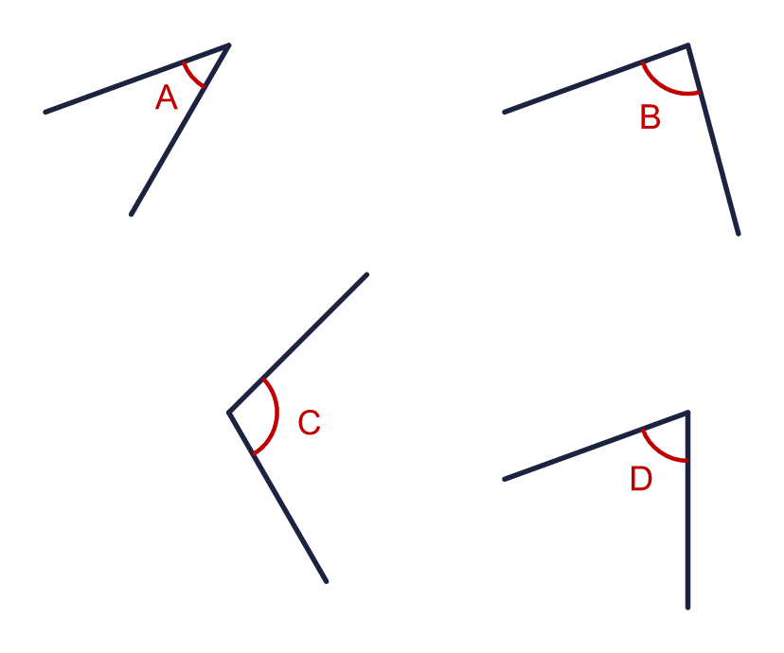
    Which angle is the greatest? Write the letter.
  1 | Look at the four angles.
    Which angle is the greatest? Write the letter.
  2 | Look at the four angles.  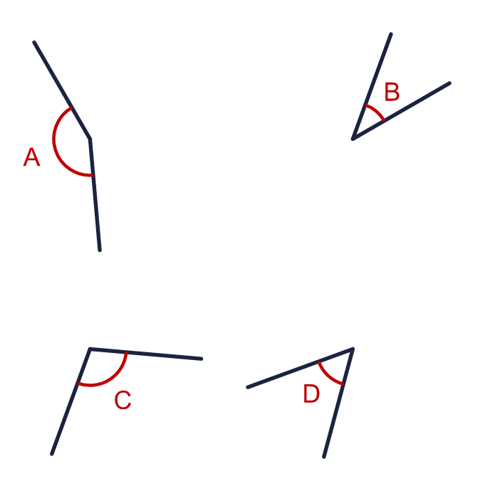
    Which angle is the smallest? Write the letter.
  2 | Look at the four angles.
    Which angle is the smallest? Write the letter.
  3 | Look at the four angles.  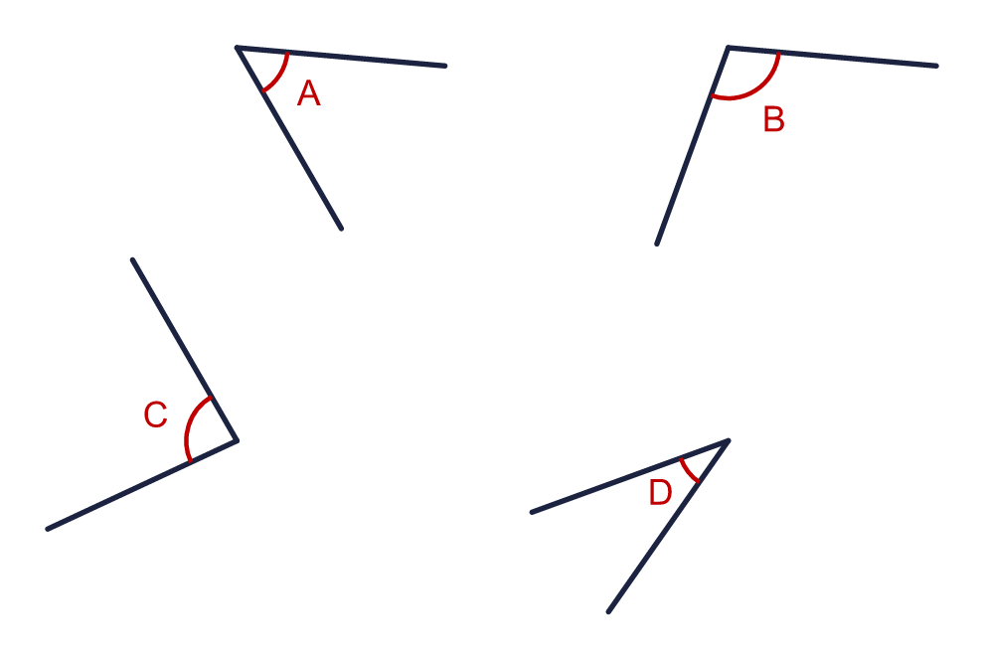  Write the letters in order, starting with the smallest angle.
  3 | Look at the four angles.  Write the letters in order, starting with the smallest angle.
  4 | Look at the four angles.  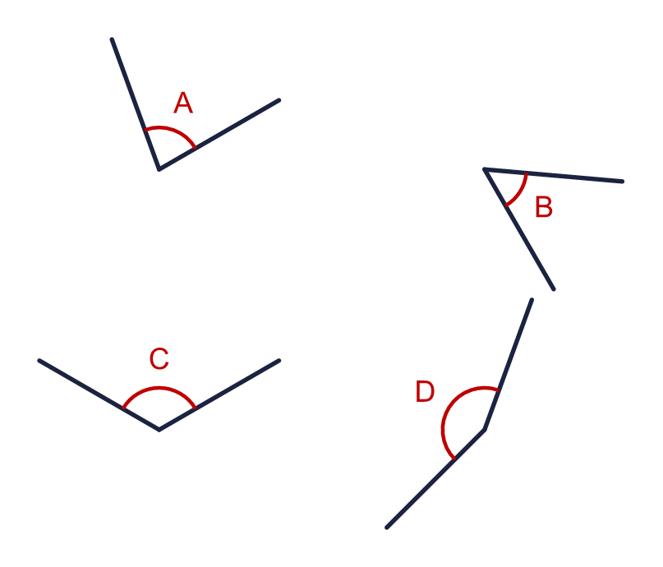  Write the letters in order, starting with the greatest angle.
  4 | Look at the four angles.  Write the letters in order, starting with the greatest angle.
  5 | Look at the two angles.  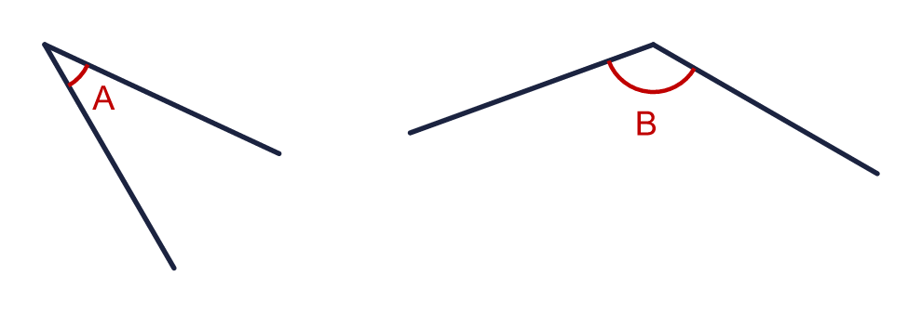
    Which angle is greater than a right angle?
    Which angle is less than a right angle?
  5 | Look at the two angles.
    Which angle is greater than a right angle?
    Which angle is less than a right angle?
  6 | Look at the two angles.  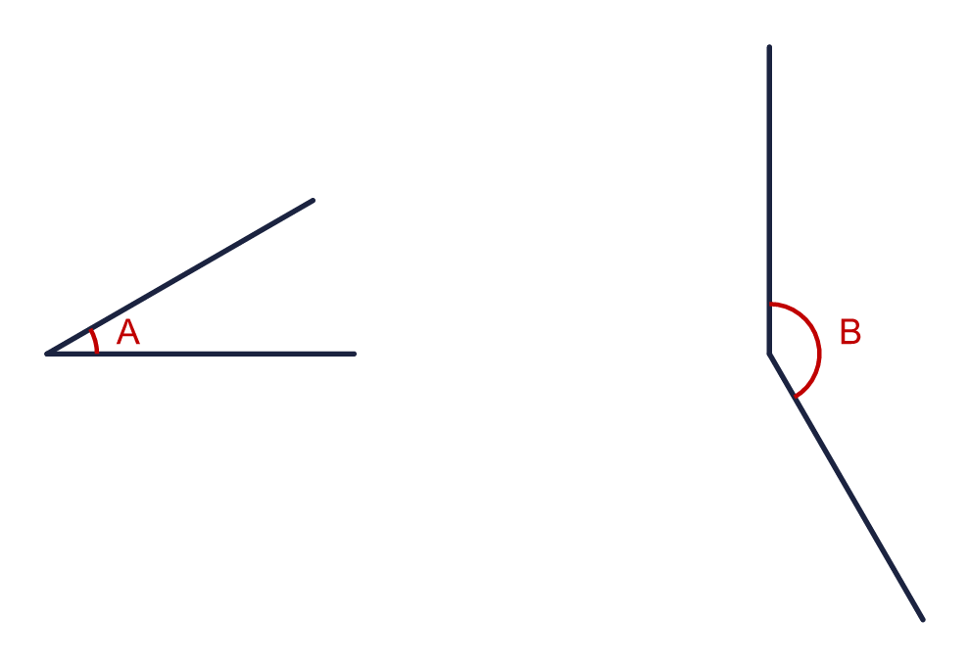
    Which angle is greater? Write the letter.
  6 | Look at the two angles.
    Which angle is greater? Write the letter.
  7 | Look at the four angles.  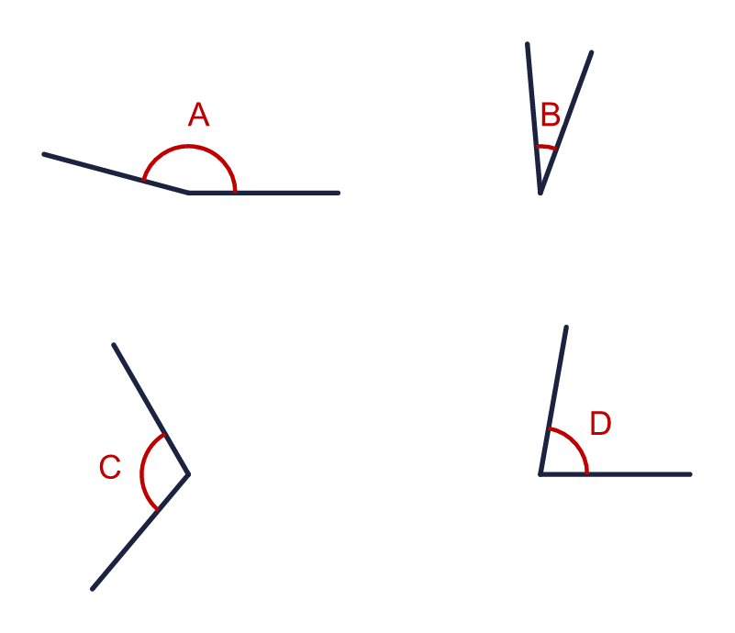
    Which angle is closest to a right angle? Write the letter.
  7 | Look at the four angles.
    Which angle is closest to a right angle? Write the letter.
  8 | Four angles are marked in the quadrilateral.  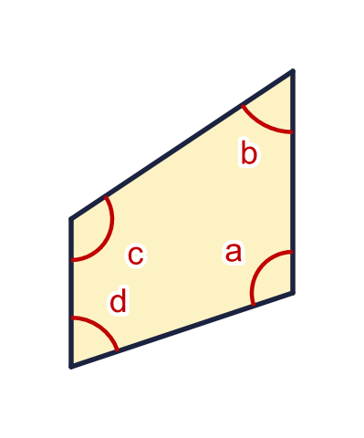
    Which angle is the greatest? Write the letter.
  8 | Four angles are marked in the quadrilateral.
    Which angle is the greatest? Write the letter.

  9 | 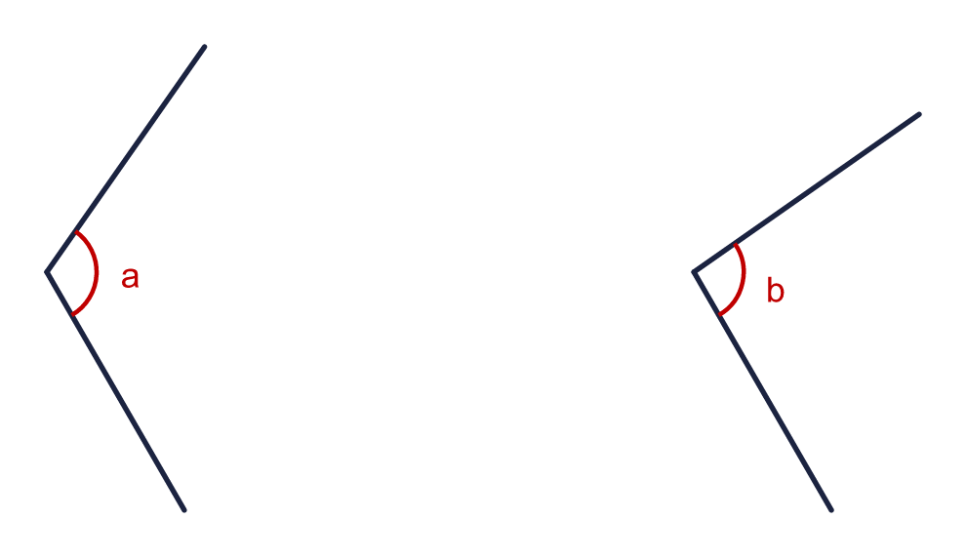  Is Ron correct? Circle yes or no.  Yes / No  Explain how you know.
     | 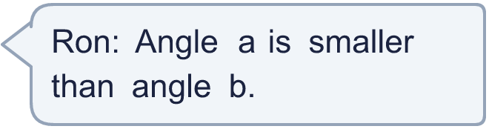
  9 | Is Ron correct? Circle yes or no.  Yes / No  Explain how you know.
  10 | Four angles are marked in the quadrilateral.  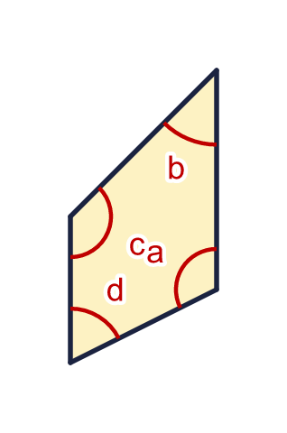  Write the letters in order, starting with the smallest angle.
  10 | Four angles are marked in the quadrilateral.  Write the letters in order, starting with the smallest angle.
  11 | Four angles are marked in the quadrilateral.  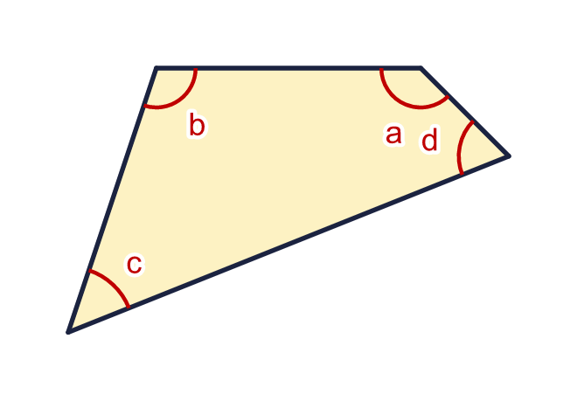
    Which angle is the smallest? Write the letter.
  11 | Four angles are marked in the quadrilateral.
    Which angle is the smallest? Write the letter.
  12 | Look at the three angles. Two of them are the same size.  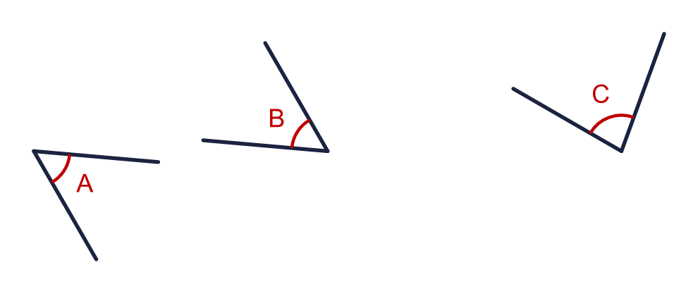  Write the letters of the two angles that are the same size.
  12 | Look at the three angles. Two of them are the same size.  Write the letters of the two angles that are the same size.
  13 | Look at the four angles.  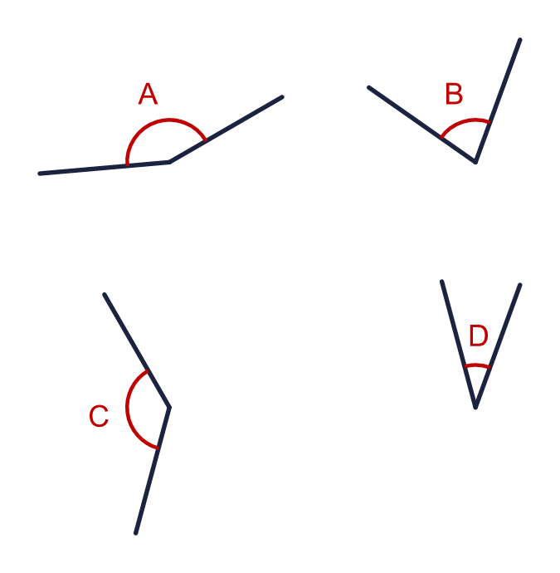
    Which angle is the greatest?
    Which angle is the smallest?
  13 | Look at the four angles.
    Which angle is the greatest?
    Which angle is the smallest?
  14 | Challenge  Look at the four angles.  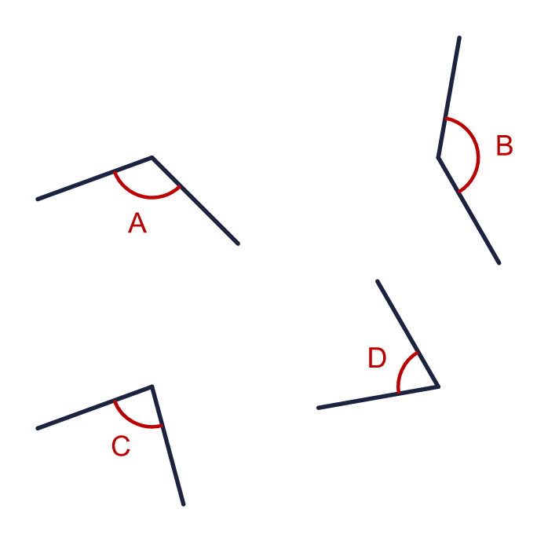  Write the letters in order, starting with the greatest angle.
  14 | Challenge  Look at the four angles.  Write the letters in order, starting with the greatest angle.

Year 3 · Shape · Step 3
Compare angles
Answers (teacher copy)

  1 | Look at the four angles.  Which angle is the greatest? Write the letter. C
  2 | Look at the four angles.  Which angle is the smallest? Write the letter. B
  3 | Look at the four angles.  Write the letters in order, starting with the smallest angle.  D, A, C, B
  4 | Look at the four angles.  Write the letters in order, starting with the greatest angle.  D, C, A, B
  5 | Look at the two angles.  Which angle is greater than a right angle? B  Which angle is less than a right angle? A
  6 | Look at the two angles.  Which angle is greater? Write the letter. B
  7 | Look at the four angles.  Which angle is closest to a right angle? Write the letter. D
  8 | Four angles are marked in the quadrilateral.  Which angle is the greatest? Write the letter. c
  9 | Is Ron correct? Circle yes or no.  Yes / No  Explain how you know.  No. Angle a is greater than angle b. The arms of angle a are opened wider.
  10 | Four angles are marked in the quadrilateral.  Write the letters in order, starting with the smallest angle.  b, d, a, c
  11 | Four angles are marked in the quadrilateral.  Which angle is the smallest? Write the letter. c
  12 | Look at the three angles. Two of them are the same size.  Write the letters of the two angles that are the same size. A, B
  13 | Look at the four angles.  Which angle is the greatest? A  Which angle is the smallest? D
  14 | Challenge  Look at the four angles.  Write the letters in order, starting with the greatest angle.  B, A, C, D

