  Year 3 · Fractions B · Step 4  Unit fractions of a set of objects | 
  Year 3 · Fractions B · Step 4
  Unit fractions of a set of objects
  1 | The bar shows 70 split into 10 equal parts. One part is shaded.  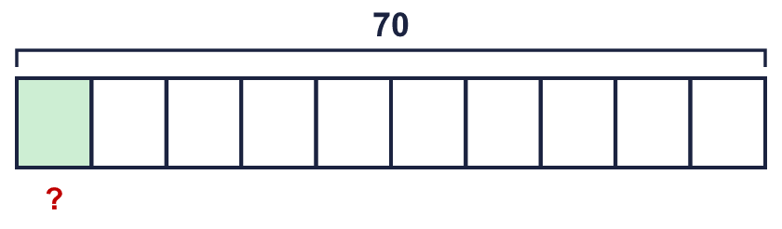  ¹⁄₁₀ of 70 =
  1 | The bar shows 70 split into 10 equal parts. One part is shaded.  ¹⁄₁₀ of 70 =
  2 | Work out each fraction of the amount.  a) ¹⁄₅ of 10 =  b) ¹⁄₁₀ of 20 =  c) ¹⁄₅ of 25 =
  2 | Work out each fraction of the amount.  a) ¹⁄₅ of 10 =  b) ¹⁄₁₀ of 20 =  c) ¹⁄₅ of 25 =
  3 | The bar shows 24 split into 3 equal parts. One part is shaded.  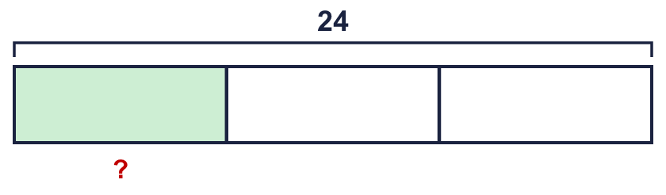  ¹⁄₃ of 24 =
  3 | The bar shows 24 split into 3 equal parts. One part is shaded.  ¹⁄₃ of 24 =
  4 | Ana has 16 marbles. Ana gives ¹⁄₈ of them to a friend.  How many marbles does the friend get?
  4 | Ana has 16 marbles. Ana gives ¹⁄₈ of them to a friend.  How many marbles does the friend get?
  5 | Work out each fraction of the amount.  a) ¹⁄₁₀ of 30 =  b) ¹⁄₁₀ of 70 =  c) ¹⁄₅ of 50 =  d) ¹⁄₂ of 10 =
  5 | Work out each fraction of the amount.  a) ¹⁄₁₀ of 30 =  b) ¹⁄₁₀ of 70 =  c) ¹⁄₅ of 50 =  d) ¹⁄₂ of 10 =
  6 | The bar shows 21 split into 3 equal parts. One part is shaded.  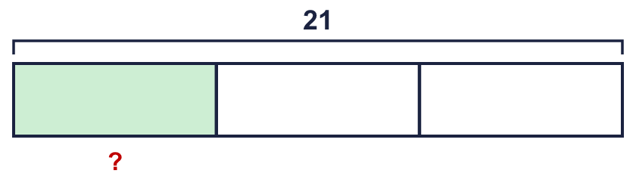  ¹⁄₃ of 21 =
  6 | The bar shows 21 split into 3 equal parts. One part is shaded.  ¹⁄₃ of 21 =
  7 | Ben has 20 cards. Ben gives ¹⁄₄ of them to a friend.  How many cards does the friend get?
  7 | Ben has 20 cards. Ben gives ¹⁄₄ of them to a friend.  How many cards does the friend get?
  8 | Work out each fraction of the amount.  a) ¹⁄₈ of 32 =  b) ¹⁄₈ of 40 =  c) ¹⁄₄ of 36 =
  8 | Work out each fraction of the amount.  a) ¹⁄₈ of 32 =  b) ¹⁄₈ of 40 =  c) ¹⁄₄ of 36 =

  9 | Is Boba correct? Circle yes or no.  Yes / No  Explain the mistake.
     | 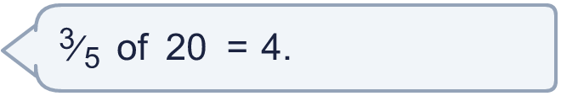
  9 | Is Boba correct? Circle yes or no.  Yes / No  Explain the mistake.
  10 | Ana has 25 cards. Ana gives ¹⁄₅ of them to a friend.  How many cards does Ana have left?
  10 | Ana has 25 cards. Ana gives ¹⁄₅ of them to a friend.  How many cards does Ana have left?
  11 | Write <, > or = in each box.
    a) | ¹⁄₄ of 24 |  | ³⁄₄ of 24
    b) | ³⁄₅ of 15 |  | ²⁄₅ of 15
    c) | ³⁄₄ of 20 |  | ¹⁄₄ of 20
  11 | Write <, > or = in each box.
    a) | ¹⁄₄ of 24 |  | ³⁄₄ of 24
    b) | ³⁄₅ of 15 |  | ²⁄₅ of 15
    c) | ³⁄₄ of 20 |  | ¹⁄₄ of 20
  12 | Is Boba correct? Circle yes or no.  Yes / No  Explain the mistake.
    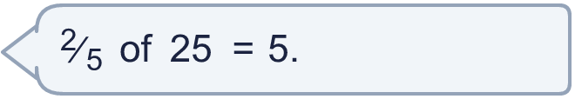
  12 | Is Boba correct? Circle yes or no.  Yes / No  Explain the mistake.
  13 | A box has 64 counters. ²⁄₈ of the counters are red and ⁵⁄₈ of the counters are blue. The rest are yellow.  How many counters are yellow?
  13 | A box has 64 counters. ²⁄₈ of the counters are red and ⁵⁄₈ of the counters are blue. The rest are yellow.  How many counters are yellow?
  14 | Is Dexter correct? Circle yes or no.  Yes / No  Explain your answer.
     | 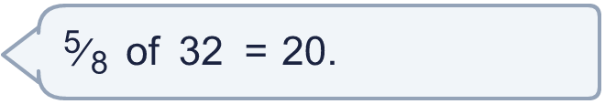
  14 | Is Dexter correct? Circle yes or no.  Yes / No  Explain your answer.

Year 3 · Fractions B · Step 4
Unit fractions of a set of objects
Answers (teacher copy)

  1 | The bar shows 70 split into 10 equal parts. One part is shaded.  ¹⁄₁₀ of 70 = 7
  2 | Work out each fraction of the amount.  a) ¹⁄₅ of 10 = 2  b) ¹⁄₁₀ of 20 = 2  c) ¹⁄₅ of 25 = 5
  3 | The bar shows 24 split into 3 equal parts. One part is shaded.  ¹⁄₃ of 24 = 8
  4 | Ana has 16 marbles. Ana gives ¹⁄₈ of them to a friend.  How many marbles does the friend get? 2
  5 | Work out each fraction of the amount.  a) ¹⁄₁₀ of 30 = 3  b) ¹⁄₁₀ of 70 = 7  c) ¹⁄₅ of 50 = 10  d) ¹⁄₂ of 10 = 5
  6 | The bar shows 21 split into 3 equal parts. One part is shaded.  ¹⁄₃ of 21 = 7
  7 | Ben has 20 cards. Ben gives ¹⁄₄ of them to a friend.  How many cards does the friend get? 5
  8 | Work out each fraction of the amount.  a) ¹⁄₈ of 32 = £4  b) ¹⁄₈ of 40 = £5  c) ¹⁄₄ of 36 = £9
  9 | Is Boba correct? Circle yes or no.  Yes / No  Explain the mistake.  No. ¹⁄₅ of 20 = 4. ³⁄₅ of 20 = 3 × 4 = 12.
  10 | Ana has 25 cards. Ana gives ¹⁄₅ of them to a friend.  How many cards does Ana have left? 20
  11 | Write <, > or = in each box.  a) ¹⁄₄ of 24 < ³⁄₄ of 24  b) ³⁄₅ of 15 > ²⁄₅ of 15  c) ³⁄₄ of 20 > ¹⁄₄ of 20
  12 | Is Boba correct? Circle yes or no.  Yes / No  Explain the mistake.  No. ¹⁄₅ of 25 = 5. ²⁄₅ of 25 = 2 × 5 = 10.
  13 | A box has 64 counters. ²⁄₈ of the counters are red and ⁵⁄₈ of the counters are blue. The rest are yellow.  How many counters are yellow? 8
  14 | Is Dexter correct? Circle yes or no.  Yes / No  Explain your answer.  ⁵⁄₈ of 32 = 20. The statement is correct.

