  Year 3 · Fractions B · Step 2  Subtract fractions | 
  Year 3 · Fractions B · Step 2
  Subtract fractions
  1 | Work out the subtractions.  a) ³⁄₃ − ¹⁄₃ =  b) ⁵⁄₈ − ²⁄₈ =  c) ⁷⁄₈ − ⁴⁄₈ =
  1 | Work out the subtractions.  a) ³⁄₃ − ¹⁄₃ =  b) ⁵⁄₈ − ²⁄₈ =  c) ⁷⁄₈ − ⁴⁄₈ =
  2 | Complete the part-whole model.  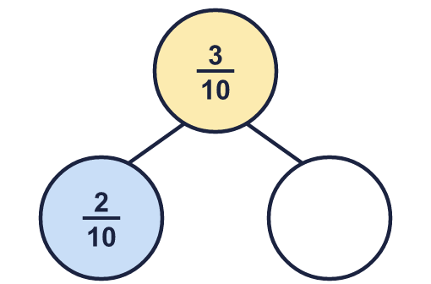
    The missing part is
  2 | Complete the part-whole model.
    The missing part is
  3 | Work out the subtractions.  a) ⁴⁄₅ − ¹⁄₅ =  b) ³⁄₃ − ¹⁄₃ =  c) ⁹⁄₁₀ − ⁶⁄₁₀ =
  3 | Work out the subtractions.  a) ⁴⁄₅ − ¹⁄₅ =  b) ³⁄₃ − ¹⁄₃ =  c) ⁹⁄₁₀ − ⁶⁄₁₀ =
  4 | Work out the subtractions. Remember that 1 whole is the same as the denominator over itself.  a) 1 − ⁹⁄₁₀ =  b) 1 − ¹⁄₆ =  c) 1 − ³⁄₄ =
  4 | Work out the subtractions. Remember that 1 whole is the same as the denominator over itself.  a) 1 − ⁹⁄₁₀ =  b) 1 − ¹⁄₆ =  c) 1 − ³⁄₄ =
  5 | Work out the subtractions.  a) ⁴⁄₁₀ − ¹⁄₁₀ =  b) ³⁄₅ − ¹⁄₅ =
  5 | Work out the subtractions.  a) ⁴⁄₁₀ − ¹⁄₁₀ =  b) ³⁄₅ − ¹⁄₅ =
  6 | Complete the part-whole model.  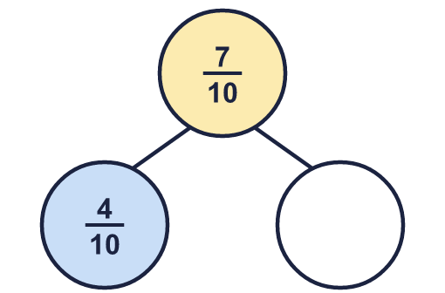
    The missing part is
  6 | Complete the part-whole model.
    The missing part is
  7 | Fay has ⁶⁄₈ of a chocolate bar. Fay eats ¹⁄₈ of the bar.  What fraction of the bar is left?
  7 | Fay has ⁶⁄₈ of a chocolate bar. Fay eats ¹⁄₈ of the bar.  What fraction of the bar is left?
  8 | Work out the subtractions.  a) ⁴⁄₅ − ²⁄₅ =  b) ⁵⁄₁₀ − ²⁄₁₀ =  c) ³⁄₃ − ¹⁄₃ =
  8 | Work out the subtractions.  a) ⁴⁄₅ − ²⁄₅ =  b) ⁵⁄₁₀ − ²⁄₁₀ =  c) ³⁄₃ − ¹⁄₃ =

  9 | Is Boba correct? Circle yes or no.  Yes / No  Explain the mistake.
     | 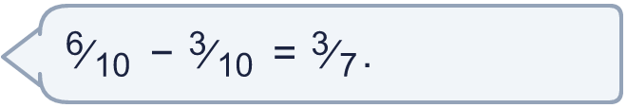
  9 | Is Boba correct? Circle yes or no.  Yes / No  Explain the mistake.
  10 | Dee has ⁶⁄₁₀ of a chocolate bar. Dee eats ³⁄₁₀ of the bar.  What fraction of the bar is left?
  10 | Dee has ⁶⁄₁₀ of a chocolate bar. Dee eats ³⁄₁₀ of the bar.  What fraction of the bar is left?
  11 | Complete the part-whole model.  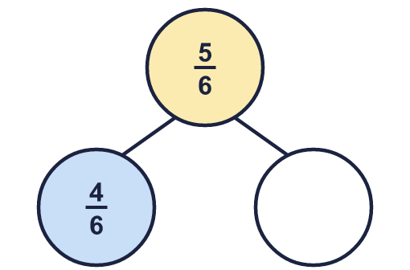
    The missing part is
  11 | Complete the part-whole model.
    The missing part is
  12 | Is Boba correct? Circle yes or no.  Yes / No  Explain the mistake.
    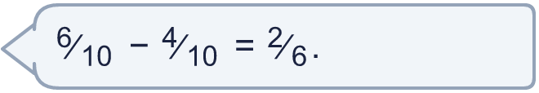
  12 | Is Boba correct? Circle yes or no.  Yes / No  Explain the mistake.
  13 | Work out the subtractions. Remember that 1 whole is the same as the denominator over itself.  a) 1 − ³⁄₅ =  b) 1 − ³⁄₄ =
  13 | Work out the subtractions. Remember that 1 whole is the same as the denominator over itself.  a) 1 − ³⁄₅ =  b) 1 − ³⁄₄ =
  14 | Ana has ⁴⁄₅ of a chocolate bar. Ana eats ²⁄₅ of the bar.  What fraction of the bar is left?
  14 | Ana has ⁴⁄₅ of a chocolate bar. Ana eats ²⁄₅ of the bar.  What fraction of the bar is left?

Year 3 · Fractions B · Step 2
Subtract fractions
Answers (teacher copy)

  1 | Work out the subtractions.  a) ³⁄₃ − ¹⁄₃ = ²⁄₃  b) ⁵⁄₈ − ²⁄₈ = ³⁄₈  c) ⁷⁄₈ − ⁴⁄₈ = ³⁄₈
  2 | Complete the part-whole model.  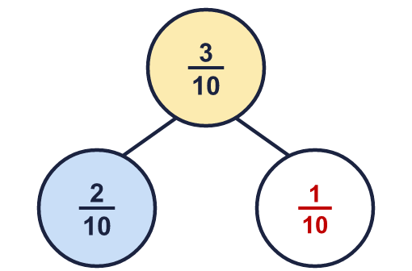  The missing part is ¹⁄₁₀
  3 | Work out the subtractions.  a) ⁴⁄₅ − ¹⁄₅ = ³⁄₅  b) ³⁄₃ − ¹⁄₃ = ²⁄₃  c) ⁹⁄₁₀ − ⁶⁄₁₀ = ³⁄₁₀
  4 | Work out the subtractions. Remember that 1 whole is the same as the denominator over itself.  a) 1 − ⁹⁄₁₀ = ¹⁄₁₀  b) 1 − ¹⁄₆ = ⁵⁄₆  c) 1 − ³⁄₄ = ¹⁄₄
  5 | Work out the subtractions.  a) ⁴⁄₁₀ − ¹⁄₁₀ = ³⁄₁₀  b) ³⁄₅ − ¹⁄₅ = ²⁄₅
  6 | Complete the part-whole model.  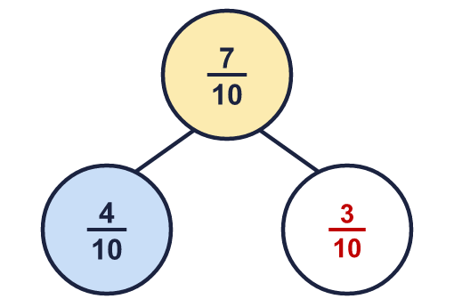  The missing part is ³⁄₁₀
  7 | Fay has ⁶⁄₈ of a chocolate bar. Fay eats ¹⁄₈ of the bar.  What fraction of the bar is left? ⁵⁄₈
  8 | Work out the subtractions.  a) ⁴⁄₅ − ²⁄₅ = ²⁄₅  b) ⁵⁄₁₀ − ²⁄₁₀ = ³⁄₁₀  c) ³⁄₃ − ¹⁄₃ = ²⁄₃
  9 | Is Boba correct? Circle yes or no.  Yes / No  Explain the mistake.  No. ⁶⁄₁₀ − ³⁄₁₀ = ³⁄₁₀. The denominator stays the same when you subtract.
  10 | Dee has ⁶⁄₁₀ of a chocolate bar. Dee eats ³⁄₁₀ of the bar.  What fraction of the bar is left? ³⁄₁₀
  11 | Complete the part-whole model.  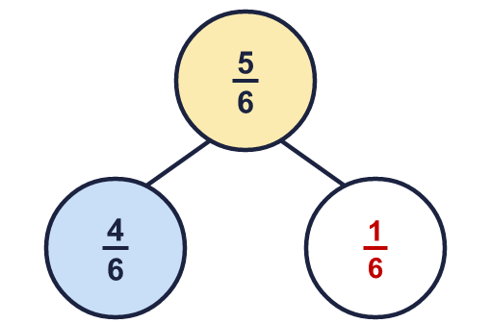  The missing part is ¹⁄₆
  12 | Is Boba correct? Circle yes or no.  Yes / No  Explain the mistake.  No. ⁶⁄₁₀ − ⁴⁄₁₀ = ¹⁄₅. The denominator stays the same when you subtract.
  13 | Work out the subtractions. Remember that 1 whole is the same as the denominator over itself.  a) 1 − ³⁄₅ = ²⁄₅  b) 1 − ³⁄₄ = ¹⁄₄
  14 | Ana has ⁴⁄₅ of a chocolate bar. Ana eats ²⁄₅ of the bar.  What fraction of the bar is left? ²⁄₅

