  Year 3 · Fractions B · Step 3  Partition the whole | 
  Year 3 · Fractions B · Step 3
  Partition the whole
  1 | What fraction of the bar is shaded? What fraction is not shaded?  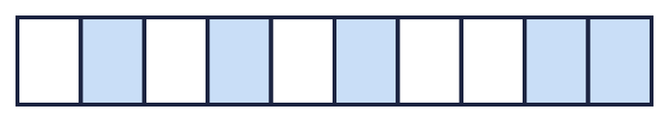
  1 | What fraction of the bar is shaded? What fraction is not shaded?
  2 | Complete the additions to make 1 whole.  a) ¹⁄₆ + ?⁄₆ = 1  b) ²⁄₃ + ?⁄₃ = 1  c) ³⁄₁₀ + ?⁄₁₀ = 1
  2 | Complete the additions to make 1 whole.  a) ¹⁄₆ + ?⁄₆ = 1  b) ²⁄₃ + ?⁄₃ = 1  c) ³⁄₁₀ + ?⁄₁₀ = 1
  3 | Complete the part-whole model.  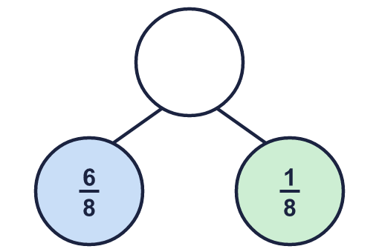
    The whole is
  3 | Complete the part-whole model.
    The whole is
  4 | Work out the subtractions. Remember that 1 whole is the same as the denominator over itself.  a) 1 − ¹⁄₃ =  b) 1 − ¹⁄₁₀ =  c) 1 − ⁴⁄₅ =
  4 | Work out the subtractions. Remember that 1 whole is the same as the denominator over itself.  a) 1 − ¹⁄₃ =  b) 1 − ¹⁄₁₀ =  c) 1 − ⁴⁄₅ =
  5 | What fraction of the bar is shaded? What fraction is not shaded?  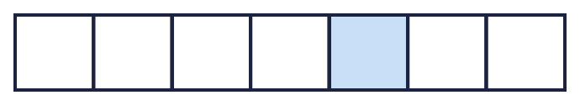
  5 | What fraction of the bar is shaded? What fraction is not shaded?
  6 | Complete the additions to make 1 whole.  a) ¹⁄₄ + ?⁄₄ = 1  b) ¹⁄₃ + ?⁄₃ = 1
  6 | Complete the additions to make 1 whole.  a) ¹⁄₄ + ?⁄₄ = 1  b) ¹⁄₃ + ?⁄₃ = 1
  7 | A pie is cut into 8 equal pieces. Cal eats 5 of the pieces.  What fraction of the pie is left?
  7 | A pie is cut into 8 equal pieces. Cal eats 5 of the pieces.  What fraction of the pie is left?
  8 | All of the parts of this bar are shaded.  
    The whole is split into
    equal parts.
    of the parts are shaded.
    As a fraction the whole is
  8 | All of the parts of this bar are shaded.
    The whole is split into
    equal parts.
    of the parts are shaded.
    As a fraction the whole is

  9 | Is Boba correct? Circle yes or no.  Yes / No  Explain the mistake.
     | 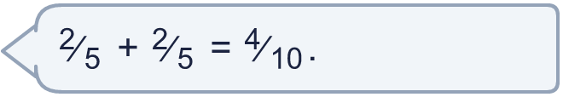
  9 | Is Boba correct? Circle yes or no.  Yes / No  Explain the mistake.
  10 | A pizza is cut into 4 equal pieces. Fay eats 3 of the pieces.  What fraction of the pizza is left?
  10 | A pizza is cut into 4 equal pieces. Fay eats 3 of the pieces.  What fraction of the pizza is left?
  11 | Complete the part-whole model.  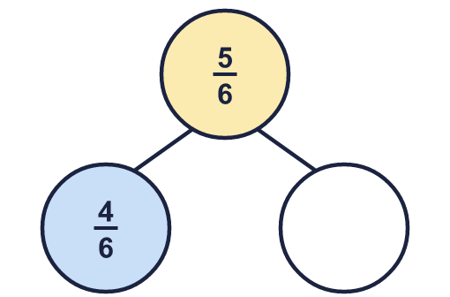
    The missing part is
  11 | Complete the part-whole model.
    The missing part is
  12 | Is Boba correct? Circle yes or no.  Yes / No  Explain the mistake.
     | 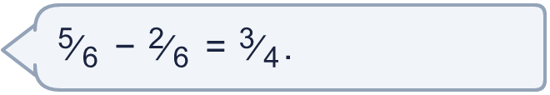
  12 | Is Boba correct? Circle yes or no.  Yes / No  Explain the mistake.
  13 | Work out the subtractions. Remember that 1 whole is the same as the denominator over itself.  a) 1 − ²⁄₅ =  b) 1 − ¹⁄₄ =
  13 | Work out the subtractions. Remember that 1 whole is the same as the denominator over itself.  a) 1 − ²⁄₅ =  b) 1 − ¹⁄₄ =
  14 | Complete the additions to make 1 whole.  a) ³⁄₄ + ?⁄₄ = 1  b) ²⁄₈ + ?⁄₈ = 1  c) ⁶⁄₁₀ + ?⁄₁₀ = 1
  14 | Complete the additions to make 1 whole.  a) ³⁄₄ + ?⁄₄ = 1  b) ²⁄₈ + ?⁄₈ = 1  c) ⁶⁄₁₀ + ?⁄₁₀ = 1

Year 3 · Fractions B · Step 3
Partition the whole
Answers (teacher copy)

  1 | What fraction of the bar is shaded? What fraction is not shaded?  Shaded: ⁵⁄₁₀  Not shaded: ⁵⁄₁₀
  2 | Complete the additions to make 1 whole.  a) ¹⁄₆ + ?⁄₆ = 1 5  b) ²⁄₃ + ?⁄₃ = 1 1  c) ³⁄₁₀ + ?⁄₁₀ = 1 7
  3 | Complete the part-whole model.  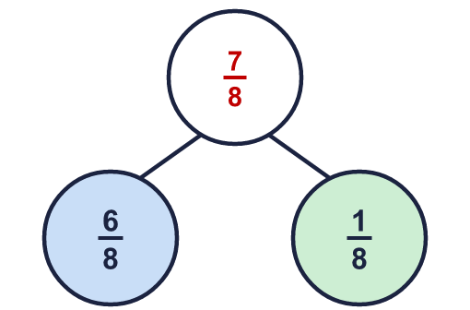  The whole is ⁷⁄₈
  4 | Work out the subtractions. Remember that 1 whole is the same as the denominator over itself.  a) 1 − ¹⁄₃ = ²⁄₃  b) 1 − ¹⁄₁₀ = ⁹⁄₁₀  c) 1 − ⁴⁄₅ = ¹⁄₅
  5 | What fraction of the bar is shaded? What fraction is not shaded?  Shaded: ¹⁄₇  Not shaded: ⁶⁄₇
  6 | Complete the additions to make 1 whole.  a) ¹⁄₄ + ?⁄₄ = 1 3  b) ¹⁄₃ + ?⁄₃ = 1 2
  7 | A pie is cut into 8 equal pieces. Cal eats 5 of the pieces.  What fraction of the pie is left? ³⁄₈
  8 | All of the parts of this bar are shaded.  The whole is split into 6 equal parts.  6 of the parts are shaded.  As a fraction the whole is ⁶⁄₆
  9 | Is Boba correct? Circle yes or no.  Yes / No  Explain the mistake.  No. ²⁄₅ + ²⁄₅ = ⁴⁄₅. When the denominators are the same you add the numerators and keep the denominator.
  10 | A pizza is cut into 4 equal pieces. Fay eats 3 of the pieces.  What fraction of the pizza is left? ¹⁄₄
  11 | Complete the part-whole model.  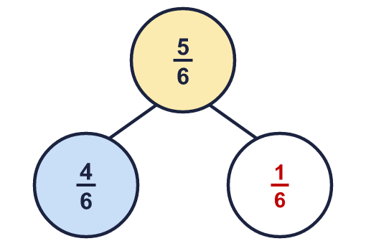  The missing part is ¹⁄₆
  12 | Is Boba correct? Circle yes or no.  Yes / No  Explain the mistake.  No. ⁵⁄₆ − ²⁄₆ = ¹⁄₂. The denominator stays the same when you subtract.
  13 | Work out the subtractions. Remember that 1 whole is the same as the denominator over itself.  a) 1 − ²⁄₅ = ³⁄₅  b) 1 − ¹⁄₄ = ³⁄₄
  14 | Complete the additions to make 1 whole.  a) ³⁄₄ + ?⁄₄ = 1 1  b) ²⁄₈ + ?⁄₈ = 1 6  c) ⁶⁄₁₀ + ?⁄₁₀ = 1 4

