  Year 3 · Fractions B · Step 5  Non-unit fractions of a set of objects | 
  Year 3 · Fractions B · Step 5
  Non-unit fractions of a set of objects
  1 | The bar shows 36 split into 4 equal parts. 2 parts are shaded.  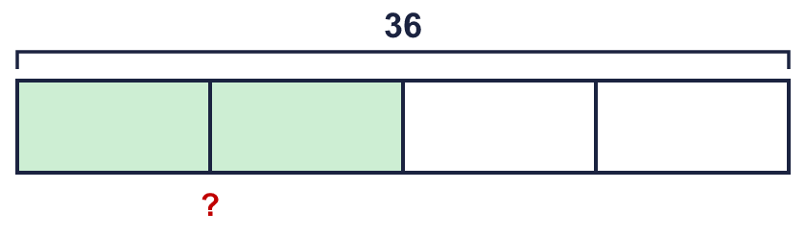  ²⁄₄ of 36 =
  1 | The bar shows 36 split into 4 equal parts. 2 parts are shaded.  ²⁄₄ of 36 =
  2 | Work out each fraction of the amount.  a) ²⁄₅ of 45 =  b) ⁴⁄₈ of 72 =  c) ⁷⁄₈ of 48 =
  2 | Work out each fraction of the amount.  a) ²⁄₅ of 45 =  b) ⁴⁄₈ of 72 =  c) ⁷⁄₈ of 48 =
  3 | The bar shows 18 split into 3 equal parts. 2 parts are shaded.  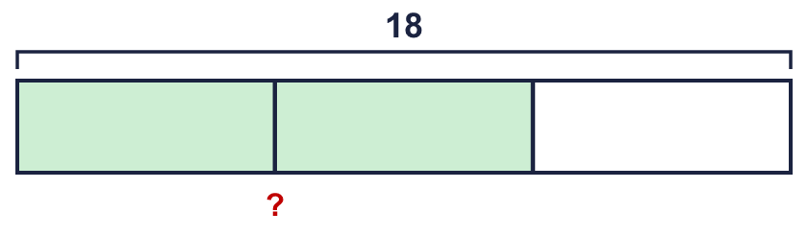  ²⁄₃ of 18 =
  3 | The bar shows 18 split into 3 equal parts. 2 parts are shaded.  ²⁄₃ of 18 =
  4 | Ben has 12 cards. Ben gives ³⁄₄ of them to a friend.  How many cards does the friend get?
  4 | Ben has 12 cards. Ben gives ³⁄₄ of them to a friend.  How many cards does the friend get?
  5 | Work out each fraction of 64. What do you notice?  a) ¹⁄₈ of 64 =  b) ⁴⁄₈ of 64 =  c) ⁵⁄₈ of 64 =
  5 | Work out each fraction of 64. What do you notice?  a) ¹⁄₈ of 64 =  b) ⁴⁄₈ of 64 =  c) ⁵⁄₈ of 64 =
  6 | The bar shows 21 split into 3 equal parts. 2 parts are shaded.  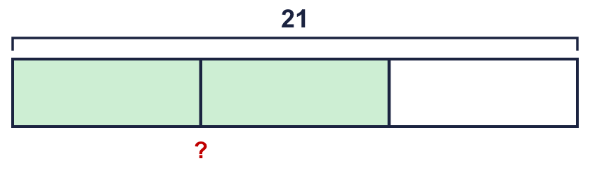  ²⁄₃ of 21 =
  6 | The bar shows 21 split into 3 equal parts. 2 parts are shaded.  ²⁄₃ of 21 =
  7 | Dee has 72 cards. Dee gives ³⁄₈ of them to a friend.  How many cards does the friend get?
  7 | Dee has 72 cards. Dee gives ³⁄₈ of them to a friend.  How many cards does the friend get?
  8 | Work out each fraction of the amount.  a) ³⁄₈ of 24 =  b) ⁹⁄₁₀ of 30 =  c) ³⁄₅ of 50 =
  8 | Work out each fraction of the amount.  a) ³⁄₈ of 24 =  b) ⁹⁄₁₀ of 30 =  c) ³⁄₅ of 50 =

  9 | Is Boba correct? Circle yes or no.  Yes / No  Explain the mistake.
     | 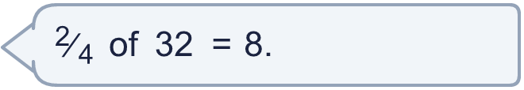
  9 | Is Boba correct? Circle yes or no.  Yes / No  Explain the mistake.
  10 | Ben has 28 cards. Ben gives ²⁄₄ of them to a friend.  How many cards does Ben have left?
  10 | Ben has 28 cards. Ben gives ²⁄₄ of them to a friend.  How many cards does Ben have left?
  11 | Write <, > or = in each box.
    a) | ³⁄₅ of 35 |  | ¹⁄₅ of 35
    b) | ²⁄₄ of 28 |  | ¹⁄₄ of 28
    c) | ²⁄₅ of 35 |  | ³⁄₅ of 35
  11 | Write <, > or = in each box.
    a) | ³⁄₅ of 35 |  | ¹⁄₅ of 35
    b) | ²⁄₄ of 28 |  | ¹⁄₄ of 28
    c) | ²⁄₅ of 35 |  | ³⁄₅ of 35
  12 | Is Boba correct? Circle yes or no.  Yes / No  Explain the mistake.
    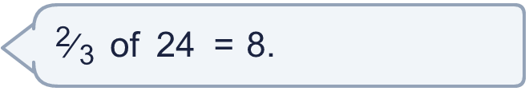
  12 | Is Boba correct? Circle yes or no.  Yes / No  Explain the mistake.
  13 | A box has 56 counters. ⁵⁄₈ of the counters are red and ¹⁄₈ of the counters are blue. The rest are yellow.  How many counters are yellow?
  13 | A box has 56 counters. ⁵⁄₈ of the counters are red and ¹⁄₈ of the counters are blue. The rest are yellow.  How many counters are yellow?
  14 | Is Alex correct? Circle yes or no.  Yes / No  Explain your answer.
     | 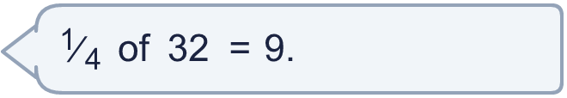
  14 | Is Alex correct? Circle yes or no.  Yes / No  Explain your answer.

Year 3 · Fractions B · Step 5
Non-unit fractions of a set of objects
Answers (teacher copy)

  1 | The bar shows 36 split into 4 equal parts. 2 parts are shaded.  ²⁄₄ of 36 = 18
  2 | Work out each fraction of the amount.  a) ²⁄₅ of 45 = 18  b) ⁴⁄₈ of 72 = 36  c) ⁷⁄₈ of 48 = 42
  3 | The bar shows 18 split into 3 equal parts. 2 parts are shaded.  ²⁄₃ of 18 = 12
  4 | Ben has 12 cards. Ben gives ³⁄₄ of them to a friend.  How many cards does the friend get? 9
  5 | Work out each fraction of 64. What do you notice?  a) ¹⁄₈ of 64 = 8  b) ⁴⁄₈ of 64 = 32  c) ⁵⁄₈ of 64 = 40
  6 | The bar shows 21 split into 3 equal parts. 2 parts are shaded.  ²⁄₃ of 21 = 14
  7 | Dee has 72 cards. Dee gives ³⁄₈ of them to a friend.  How many cards does the friend get? 27
  8 | Work out each fraction of the amount.  a) ³⁄₈ of 24 = £9  b) ⁹⁄₁₀ of 30 = £27  c) ³⁄₅ of 50 = £30
  9 | Is Boba correct? Circle yes or no.  Yes / No  Explain the mistake.  No. ¹⁄₄ of 32 = 8. ²⁄₄ of 32 = 2 × 8 = 16.
  10 | Ben has 28 cards. Ben gives ²⁄₄ of them to a friend.  How many cards does Ben have left? 14
  11 | Write <, > or = in each box.  a) ³⁄₅ of 35 > ¹⁄₅ of 35  b) ²⁄₄ of 28 > ¹⁄₄ of 28  c) ²⁄₅ of 35 < ³⁄₅ of 35
  12 | Is Boba correct? Circle yes or no.  Yes / No  Explain the mistake.  No. ¹⁄₃ of 24 = 8. ²⁄₃ of 24 = 2 × 8 = 16.
  13 | A box has 56 counters. ⁵⁄₈ of the counters are red and ¹⁄₈ of the counters are blue. The rest are yellow.  How many counters are yellow? 14
  14 | Is Alex correct? Circle yes or no.  Yes / No  Explain your answer.  ¹⁄₄ of 32 = 8. The statement is not correct.

