  Year 3 · Fractions B · Step 1  Add fractions | 
  Year 3 · Fractions B · Step 1
  Add fractions
  1 | Work out the additions.  a) ¹⁄₃ + ¹⁄₃ =  b) ⁴⁄₈ + ³⁄₈ =  c) ²⁄₅ + ²⁄₅ =
  1 | Work out the additions.  a) ¹⁄₃ + ¹⁄₃ =  b) ⁴⁄₈ + ³⁄₈ =  c) ²⁄₅ + ²⁄₅ =
  2 | Complete the part-whole model.  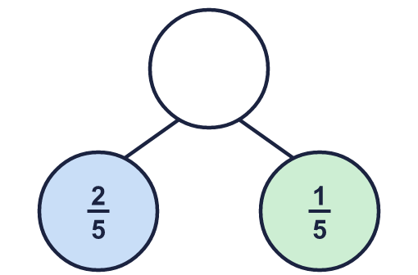
    The whole is
  2 | Complete the part-whole model.
    The whole is
  3 | Work out the additions.  a) ¹⁄₃ + ¹⁄₃ =  b) ²⁄₄ + ¹⁄₄ =  c) ³⁄₅ + ¹⁄₅ =
  3 | Work out the additions.  a) ¹⁄₃ + ¹⁄₃ =  b) ²⁄₄ + ¹⁄₄ =  c) ³⁄₅ + ¹⁄₅ =
  4 | Complete the additions to make 1 whole.  a) ¹⁄₄ + ?⁄₄ = 1  b) ²⁄₄ + ?⁄₄ = 1  c) ¹⁄₃ + ?⁄₃ = 1
  4 | Complete the additions to make 1 whole.  a) ¹⁄₄ + ?⁄₄ = 1  b) ²⁄₄ + ?⁄₄ = 1  c) ¹⁄₃ + ?⁄₃ = 1
  5 | Work out the additions.  a) ⁶⁄₈ + ¹⁄₈ =  b) ⁴⁄₆ + ¹⁄₆ =
  5 | Work out the additions.  a) ⁶⁄₈ + ¹⁄₈ =  b) ⁴⁄₆ + ¹⁄₆ =
  6 | Complete the part-whole model.  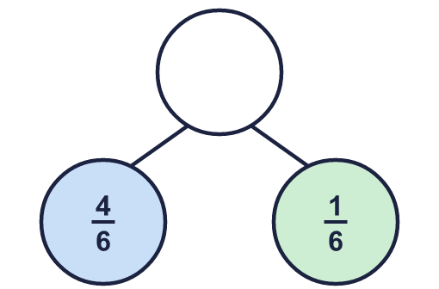
    The whole is
  6 | Complete the part-whole model.
    The whole is
  7 | Dee walks ⁶⁄₁₀ of a path in the morning. Dee walks ¹⁄₁₀ of the path in the afternoon.  What fraction of the path has been walked altogether?
  7 | Dee walks ⁶⁄₁₀ of a path in the morning. Dee walks ¹⁄₁₀ of the path in the afternoon.  What fraction of the path has been walked altogether?
  8 | Work out the additions.  a) ²⁄₅ + ¹⁄₅ =  b) ⁶⁄₈ + ¹⁄₈ =  c) ³⁄₈ + ⁴⁄₈ =
  8 | Work out the additions.  a) ²⁄₅ + ¹⁄₅ =  b) ⁶⁄₈ + ¹⁄₈ =  c) ³⁄₈ + ⁴⁄₈ =

  9 | Is Boba correct? Circle yes or no.  Yes / No  Explain the mistake.
     | 
  9 | Is Boba correct? Circle yes or no.  Yes / No  Explain the mistake.
  10 | Fay walks ³⁄₁₀ of a path in the morning. Fay walks ⁴⁄₁₀ of the path in the afternoon.  What fraction of the path has been walked altogether?
  10 | Fay walks ³⁄₁₀ of a path in the morning. Fay walks ⁴⁄₁₀ of the path in the afternoon.  What fraction of the path has been walked altogether?
  11 | Complete the part-whole model.  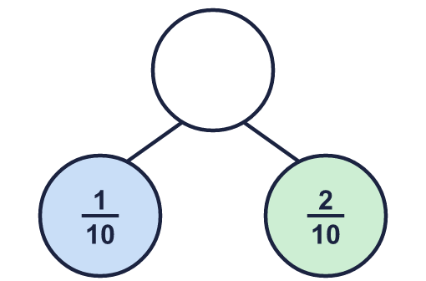
    The whole is
  11 | Complete the part-whole model.
    The whole is
  12 | Is Boba correct? Circle yes or no.  Yes / No  Explain the mistake.
    
  12 | Is Boba correct? Circle yes or no.  Yes / No  Explain the mistake.
  13 | Complete the additions to make 1 whole.  a) ⁵⁄₈ + ?⁄₈ = 1  b) ⁹⁄₁₀ + ?⁄₁₀ = 1  c) ⁵⁄₆ + ?⁄₆ = 1
  13 | Complete the additions to make 1 whole.  a) ⁵⁄₈ + ?⁄₈ = 1  b) ⁹⁄₁₀ + ?⁄₁₀ = 1  c) ⁵⁄₆ + ?⁄₆ = 1
  14 | Fay walks ⁷⁄₁₀ of a path in the morning. Fay walks ²⁄₁₀ of the path in the afternoon.  What fraction of the path has been walked altogether?
  14 | Fay walks ⁷⁄₁₀ of a path in the morning. Fay walks ²⁄₁₀ of the path in the afternoon.  What fraction of the path has been walked altogether?

Year 3 · Fractions B · Step 1
Add fractions
Answers (teacher copy)

  1 | Work out the additions.  a) ¹⁄₃ + ¹⁄₃ = ²⁄₃  b) ⁴⁄₈ + ³⁄₈ = ⁷⁄₈  c) ²⁄₅ + ²⁄₅ = ⁴⁄₅
  2 | Complete the part-whole model.  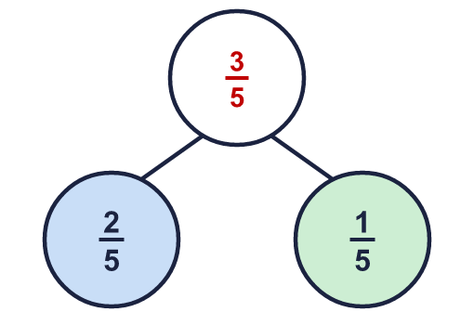  The whole is ³⁄₅
  3 | Work out the additions.  a) ¹⁄₃ + ¹⁄₃ = ²⁄₃  b) ²⁄₄ + ¹⁄₄ = ³⁄₄  c) ³⁄₅ + ¹⁄₅ = ⁴⁄₅
  4 | Complete the additions to make 1 whole.  a) ¹⁄₄ + ?⁄₄ = 1 3  b) ²⁄₄ + ?⁄₄ = 1 2  c) ¹⁄₃ + ?⁄₃ = 1 2
  5 | Work out the additions.  a) ⁶⁄₈ + ¹⁄₈ = ⁷⁄₈  b) ⁴⁄₆ + ¹⁄₆ = ⁵⁄₆
  6 | Complete the part-whole model.  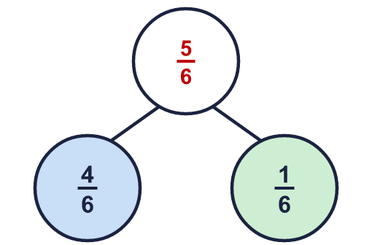  The whole is ⁵⁄₆
  7 | Dee walks ⁶⁄₁₀ of a path in the morning. Dee walks ¹⁄₁₀ of the path in the afternoon.  What fraction of the path has been walked altogether? ⁷⁄₁₀
  8 | Work out the additions.  a) ²⁄₅ + ¹⁄₅ = ³⁄₅  b) ⁶⁄₈ + ¹⁄₈ = ⁷⁄₈  c) ³⁄₈ + ⁴⁄₈ = ⁷⁄₈
  9 | Is Boba correct? Circle yes or no.  Yes / No  Explain the mistake.  No. ³⁄₅ + ¹⁄₅ = ⁴⁄₅. When the denominators are the same you add the numerators and keep the denominator.
  10 | Fay walks ³⁄₁₀ of a path in the morning. Fay walks ⁴⁄₁₀ of the path in the afternoon.  What fraction of the path has been walked altogether? ⁷⁄₁₀
  11 | Complete the part-whole model.  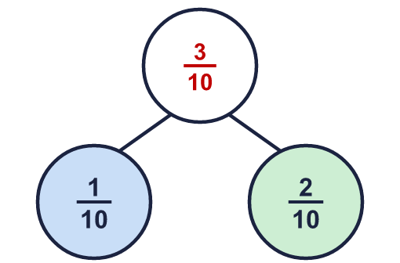  The whole is ³⁄₁₀
  12 | Is Boba correct? Circle yes or no.  Yes / No  Explain the mistake.  No. ⁶⁄₈ + ¹⁄₈ = ⁷⁄₈. When the denominators are the same you add the numerators and keep the denominator.
  13 | Complete the additions to make 1 whole.  a) ⁵⁄₈ + ?⁄₈ = 1 3  b) ⁹⁄₁₀ + ?⁄₁₀ = 1 1  c) ⁵⁄₆ + ?⁄₆ = 1 1
  14 | Fay walks ⁷⁄₁₀ of a path in the morning. Fay walks ²⁄₁₀ of the path in the afternoon.  What fraction of the path has been walked altogether? ⁹⁄₁₀

