  Year 3 · Multiplication and division B · Step 10  Scaling | 
  Year 3 · Multiplication and division B · Step 10
  Scaling
  1 | There are 3 red flags. There are 2 times as many blue flags.  a) How many blue flags are there?  b) How many flags are there altogether?
  1 | There are 3 red flags. There are 2 times as many blue flags.  a) How many blue flags are there?  b) How many flags are there altogether?
  2 | There are 3 apples. There are 9 strawberries.  How many times as many strawberries as apples are there?
  2 | There are 3 apples. There are 9 strawberries.  How many times as many strawberries as apples are there?
  3 | There are 7 red ribbons. There are 4 times as many blue ribbons.  a) How many blue ribbons are there?  b) How many ribbons are there altogether?
  3 | There are 7 red ribbons. There are 4 times as many blue ribbons.  a) How many blue ribbons are there?  b) How many ribbons are there altogether?
  4 | There are 4 apples. There are 24 strawberries.  How many times as many strawberries as apples are there?
  4 | There are 4 apples. There are 24 strawberries.  How many times as many strawberries as apples are there?
  5 | a) How long is the yellow ribbon?  b) How much longer is the yellow ribbon than the red ribbon?
     | 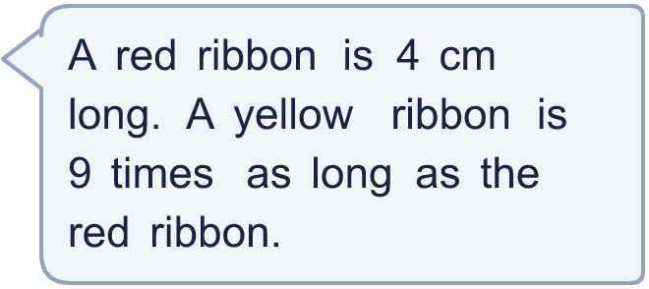
  5 | a) How long is the yellow ribbon?  b) How much longer is the yellow ribbon than the red ribbon?
  6 | Work out the multiplications.  a) 10 × 4 =  b) 9 × 4 =  c) 2 × 4 =
  6 | Work out the multiplications.  a) 10 × 4 =  b) 9 × 4 =  c) 2 × 4 =
  7 | Dani buys 7 packs of stickers. There are 4 stickers in each pack.  a) How many stickers does Dani buy?  b) She gives 3 stickers to a friend. How many does she have now?
  7 | Dani buys 7 packs of stickers. There are 4 stickers in each pack.  a) How many stickers does Dani buy?  b) She gives 3 stickers to a friend. How many does she have now?
  8 | There are 3 purple ribbons. There are 5 times as many pink ribbons.  a) How many pink ribbons are there?  b) How many ribbons are there altogether?
  8 | There are 3 purple ribbons. There are 5 times as many pink ribbons.  a) How many pink ribbons are there?  b) How many ribbons are there altogether?

  9 | a) How long is the yellow ribbon?  b) How much longer is the yellow ribbon than the red ribbon?
    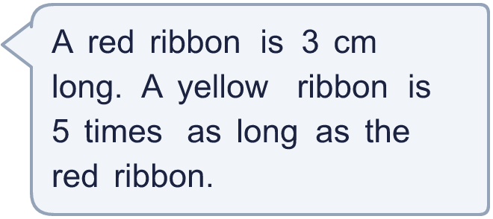
  9 | a) How long is the yellow ribbon?  b) How much longer is the yellow ribbon than the red ribbon?
  10 | Write true or false for each statement.
    a) | 3 × 4 = 4 × 4 + 4
    b) | 3 × 4 = 4 × 3
    c) | 3 × 4 = 3 × 5 - 4
    d) | 6 × 4 = 3 × 8
  10 | Write true or false for each statement.
    a) | 3 × 4 = 4 × 4 + 4
    b) | 3 × 4 = 4 × 3
    c) | 3 × 4 = 3 × 5 - 4
    d) | 6 × 4 = 3 × 8
  11 | Is Boba correct? Circle yes or no.  Yes / No  What is the correct answer?  Explain Boba’s mistake.
    
  11 | Is Boba correct? Circle yes or no.  Yes / No  What is the correct answer?  Explain Boba’s mistake.
  12 | There are 4 players in a team. 3 teams have signed up for a tournament.  a) How many players have signed up?  b) The tournament needs 24 players. How many more teams are needed?
  12 | There are 4 players in a team. 3 teams have signed up for a tournament.  a) How many players have signed up?  b) The tournament needs 24 players. How many more teams are needed?
  13 | There are 2 red ribbons. There are 4 times as many blue ribbons.  a) How many blue ribbons are there?  b) How many ribbons are there altogether?
  13 | There are 2 red ribbons. There are 4 times as many blue ribbons.  a) How many blue ribbons are there?  b) How many ribbons are there altogether?
  14 | There are 3 red cubes. There are 12 blue cubes.  How many times as many blue cubes as red cubes are there?
  14 | There are 3 red cubes. There are 12 blue cubes.  How many times as many blue cubes as red cubes are there?

Year 3 · Multiplication and division B · Step 10
Scaling
Answers (teacher copy)

  1 | There are 3 red flags. There are 2 times as many blue flags.  a) How many blue flags are there? 6  b) How many flags are there altogether? 9
  2 | There are 3 apples. There are 9 strawberries.  How many times as many strawberries as apples are there? 3
  3 | There are 7 red ribbons. There are 4 times as many blue ribbons.  a) How many blue ribbons are there? 28  b) How many ribbons are there altogether? 35
  4 | There are 4 apples. There are 24 strawberries.  How many times as many strawberries as apples are there? 6
  5 | a) How long is the yellow ribbon? 36 cm  b) How much longer is the yellow ribbon than the red ribbon? 32 cm
  6 | Work out the multiplications.  a) 10 × 4 = 40  b) 9 × 4 = 36  c) 2 × 4 = 8
  7 | Dani buys 7 packs of stickers. There are 4 stickers in each pack.  a) How many stickers does Dani buy? 28  b) She gives 3 stickers to a friend. How many does she have now? 25
  8 | There are 3 purple ribbons. There are 5 times as many pink ribbons.  a) How many pink ribbons are there? 15  b) How many ribbons are there altogether? 18
  9 | a) How long is the yellow ribbon? 15 cm  b) How much longer is the yellow ribbon than the red ribbon? 12 cm
  10 | Write true or false for each statement.  a) 3 × 4 = 4 × 4 + 4 False  b) 3 × 4 = 4 × 3 True  c) 3 × 4 = 3 × 5 - 4 False  d) 6 × 4 = 3 × 8 True
  11 | Is Boba correct? Circle yes or no.  Yes / No  What is the correct answer? 9  Explain Boba’s mistake.  3 × 3 = 9. Boba’s answer is not 3 groups of 3: 3 groups of 3 make 9.
  12 | There are 4 players in a team. 3 teams have signed up for a tournament.  a) How many players have signed up? 12  b) The tournament needs 24 players. How many more teams are needed? 3
  13 | There are 2 red ribbons. There are 4 times as many blue ribbons.  a) How many blue ribbons are there? 8  b) How many ribbons are there altogether? 10
  14 | There are 3 red cubes. There are 12 blue cubes.  How many times as many blue cubes as red cubes are there? 4

