  Year 3 · Multiplication and division B · Step 5  Multiply 2-digit by 1-digit with exchange | 
  Year 3 · Multiplication and division B · Step 5
  Multiply 2-digit by 1-digit with exchange
  1 | Work out the multiplications.  a) 14 × 5 =  b) 15 × 2 =  c) 13 × 6 =
  1 | Work out the multiplications.  a) 14 × 5 =  b) 15 × 2 =  c) 13 × 6 =
  2 | Write the missing digits in the multiplication 48 × 2.  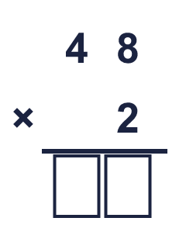  Missing digits, from top to bottom and left to right:
  2 | Write the missing digits in the multiplication 48 × 2.  Missing digits, from top to bottom and left to right:
  3 | Work out the multiplications.  a) 15 × 5 =  b) 39 × 2 =
  3 | Work out the multiplications.  a) 15 × 5 =  b) 39 × 2 =
  4 | A baker makes 17 buns each day for 3 days.  How many buns does the baker make?
  4 | A baker makes 17 buns each day for 3 days.  How many buns does the baker make?
  5 | Work out the multiplications.  a) 92 × 5 =  b) 19 × 3 =
  5 | Work out the multiplications.  a) 92 × 5 =  b) 19 × 3 =
  6 | Write the missing digits in the multiplication 37 × 2.  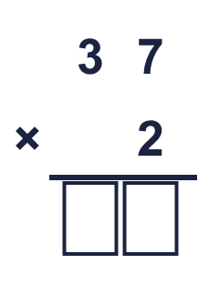  Missing digits, from top to bottom and left to right:
  6 | Write the missing digits in the multiplication 37 × 2.  Missing digits, from top to bottom and left to right:
  7 | A box holds 45 pencils. A shop has 5 boxes.  How many pencils are there?
  7 | A box holds 45 pencils. A shop has 5 boxes.  How many pencils are there?
  8 | Work out the multiplications.  a) 24 × 3 =  b) 15 × 4 =
  8 | Work out the multiplications.  a) 24 × 3 =  b) 15 × 4 =

  9 | Is Boba correct? Circle yes or no.  Yes / No  Explain how you know.
     | 
  9 | Is Boba correct? Circle yes or no.  Yes / No  Explain how you know.
  10 | What number did I start with?
     | 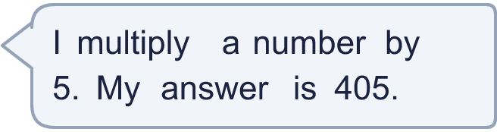
  10 | What number did I start with?
  11 | Use this fact to work out the other multiplications. You do not need to use the column method.  a) 90 × 4 =  b) 90 × 6 =
    
  11 | Use this fact to work out the other multiplications. You do not need to use the column method.  a) 90 × 4 =  b) 90 × 6 =
  12 | Is each statement correct? Circle yes or no.  a) 58 × 4 < 86 × 3  Yes / No  b) 50 × 5 < 86 × 2  Yes / No
  12 | Is each statement correct? Circle yes or no.  a) 58 × 4 < 86 × 3  Yes / No  b) 50 × 5 < 86 × 2  Yes / No
  13 | A packet has 13 stickers. Tia buys 6 packets.  How many stickers does Tia buy?
  13 | A packet has 13 stickers. Tia buys 6 packets.  How many stickers does Tia buy?
  14 | Is Boba correct? Circle yes or no.  Yes / No  Explain how you know.
    
  14 | Is Boba correct? Circle yes or no.  Yes / No  Explain how you know.

Year 3 · Multiplication and division B · Step 5
Multiply 2-digit by 1-digit with exchange
Answers (teacher copy)

  1 | Work out the multiplications.  a) 14 × 5 = 70  b) 15 × 2 = 30  c) 13 × 6 = 78
  2 | Write the missing digits in the multiplication 48 × 2.  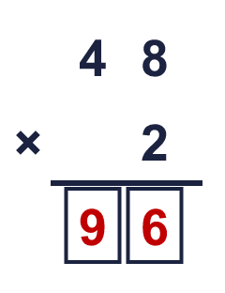  Missing digits, from top to bottom and left to right: 9 6
  3 | Work out the multiplications.  a) 15 × 5 = 75  b) 39 × 2 = 78
  4 | A baker makes 17 buns each day for 3 days.  How many buns does the baker make? 51
  5 | Work out the multiplications.  a) 92 × 5 = 460  b) 19 × 3 = 57
  6 | Write the missing digits in the multiplication 37 × 2.  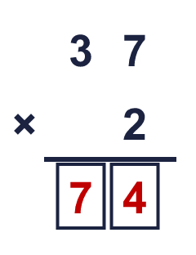  Missing digits, from top to bottom and left to right: 7 4
  7 | A box holds 45 pencils. A shop has 5 boxes.  How many pencils are there? 225
  8 | Work out the multiplications.  a) 24 × 3 = 72  b) 15 × 4 = 60
  9 | Is Boba correct? Circle yes or no.  Yes / No  Explain how you know.  7 × 3 = 21, so the ones digit of the answer should be 1. The correct answer is 17 × 3 = 51, not 41.
  10 | What number did I start with? 81
  11 | Use this fact to work out the other multiplications. You do not need to use the column method.  a) 90 × 4 = 360  b) 90 × 6 = 540
  12 | Is each statement correct? Circle yes or no.  a) 58 × 4 < 86 × 3  Yes / No  b) 50 × 5 < 86 × 2  Yes / No
  13 | A packet has 13 stickers. Tia buys 6 packets.  How many stickers does Tia buy? 78
  14 | Is Boba correct? Circle yes or no.  Yes / No  Explain how you know.  4 × 5 = 20, so the ones digit of the answer should be 0. The correct answer is 54 × 5 = 270, not 280.

